
UIT University
Department of Electrical Engineering
Digital Image Processing
(CE430)
Fall 2025

Project
Number Plate Detection for Challan System
Group Members
Taha Amir 22FA-016-CE
Fariha Muzaffer 22FA-043-CE
Hassan Raza 22FA-046-CE
Ahmera Kamran 22FA-072-CE

INSTRUCTOR: Sir Ghanzanfer

Abstract:
The automatic number plate recognition and detection system is an image processing technology which identifies the vehicles license plates. This system plays an important role in modern intelligent transportation systems (ITS). It is a python-based system using digital image processing techniques to process captured images of vehicles by traffic monitoring cameras. It automatically recognizes the vehicle, narrowing down the license plate, and extracting the alphanumeric data. Moreover, the used techniques include image preprocessing (resizing, colored to grayscale conversion), edge detection (by Sobel filtering), noise removal (by Gaussian filter), thresholding, and morphological operations. Due to the use of EasyOCR (Optical Character Recognition) in the system; the characters in the number plate are recognized and displayed. This data can be used in automated challan generation if linked with vehicle databases. Following the system with Python’s Tkinter GUI makes this project user friendly and efficient. Allowing the users to load vehicle images and view detected plates. The system may not be 100% accurate due to depending on certain factors involving lighting, plate quality, camera angle, and image quality, etc. This project presents the practical application of DIP concepts in traffic surveillance and law enforcement.
Introduction:
Due to the rapid growth in vehicles, it is impossible for vehicle manual traffic monitoring and law enforcement to be efficient or even error-free. An effective solution lies in applying image processing to automate vehicle identification using ANPR. Other applications of the Automatic Number Plate Recognition systems include traffic monitoring, toll collection, parking management, and security.
Digital Image Processing is the backbone of ANPR systems. The general Digital Image Processing techniques allow the enhancement, segmentation, and analysis for the extraction of any useful information from images. This project develops an ANPR system using Python, which does not use MATLAB. Instead, all its image processing operations have been performed using OpenCV, while EasyOCR has been used for optical character recognition. Python was preferred because of its flexibility, open-source libraries, and ease of integration with GUI frameworks.
It inputs the vehicle image, processes it for the detection of the number plate region, and extracts the characters present on the plate. The final recognized text is then utilized to generate automated challans by integrating it with the traffic database. This project allows us to understand how different concepts of Digital Image Processing, including preprocessing, edge detection, morphological operations, and OCR, may be combined and used in developing any real-world application.

DIP Implementation and Process:
Image Acquisition:
The input data is images of the vehicles that are loaded by GUI using Tkinter. They are mainly in PNG or JPEG format. It is then used for further processing
Pre-processing:
Image pre-processing is to make sure that the images are ready for plate detection. It is done to increase the chances of accuracy in image detection. Techniques that are applied are as following:
Resizing the image for a standard dimension of 600 x 400. This means that the image won’t be varying in size making it easier to work with.
Then the colored image is converted to gray scale. This is to simplify the processing.
Edge Detection:
For this Sobel Filter is used. This is done in horizontal (x) direction underlining character edges which are vertical. This rejects the horizontal edges.
Noise Reduction:
Noise reduction is done by Gaussian filter which gives a smooth image.
Binary Thresholding:
Otsu’s thresholding is used. It converts the image to binary form. Binary form is easy to work wit.
Morphological Operations:
Rectangular bounding box are used thus morphological operation detects number plate region. A kernel of size 25 x 5 is applied (rectangular).
Contour Detection:
After converting the image in gray scale form, contour detection can easily be implemented. In this the boundaries are in shape of rectangle with the aspect ratio of the Pakistan’s number plates to differentiate it from the bumpers, head lights etc.
Character Recognition:
Easy OCR is applied as it can identify Alphanumeric data. When the license plate is detected the area needed is extracted only. Filters are used to preserve edges.
Graphical User Interface:
In this system, Tkinter library is used to generate the GUI. GUI consist of options like loading the image, detection of the license plate which in turns help generating the E-challan. GUI is user friendly and efficient for ANPR system.
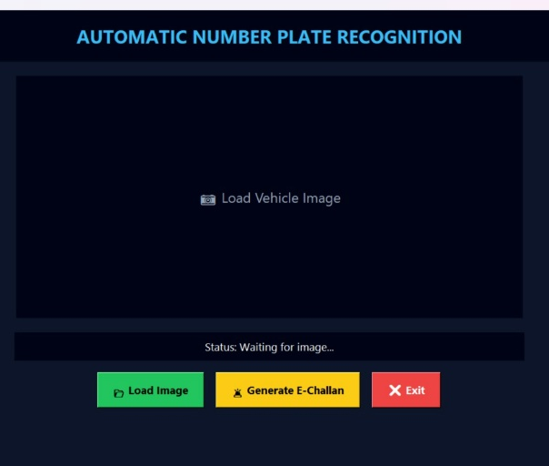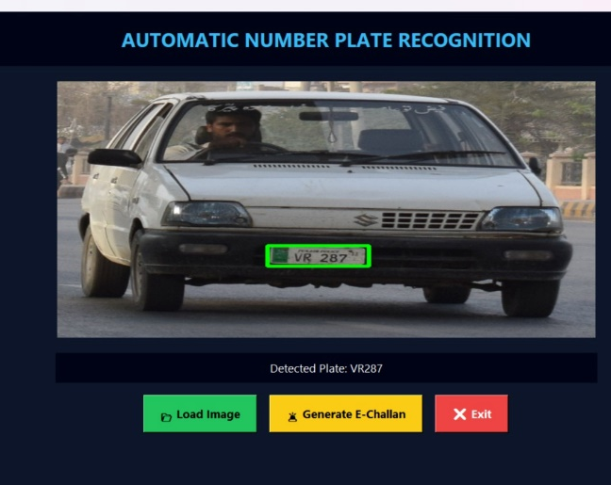
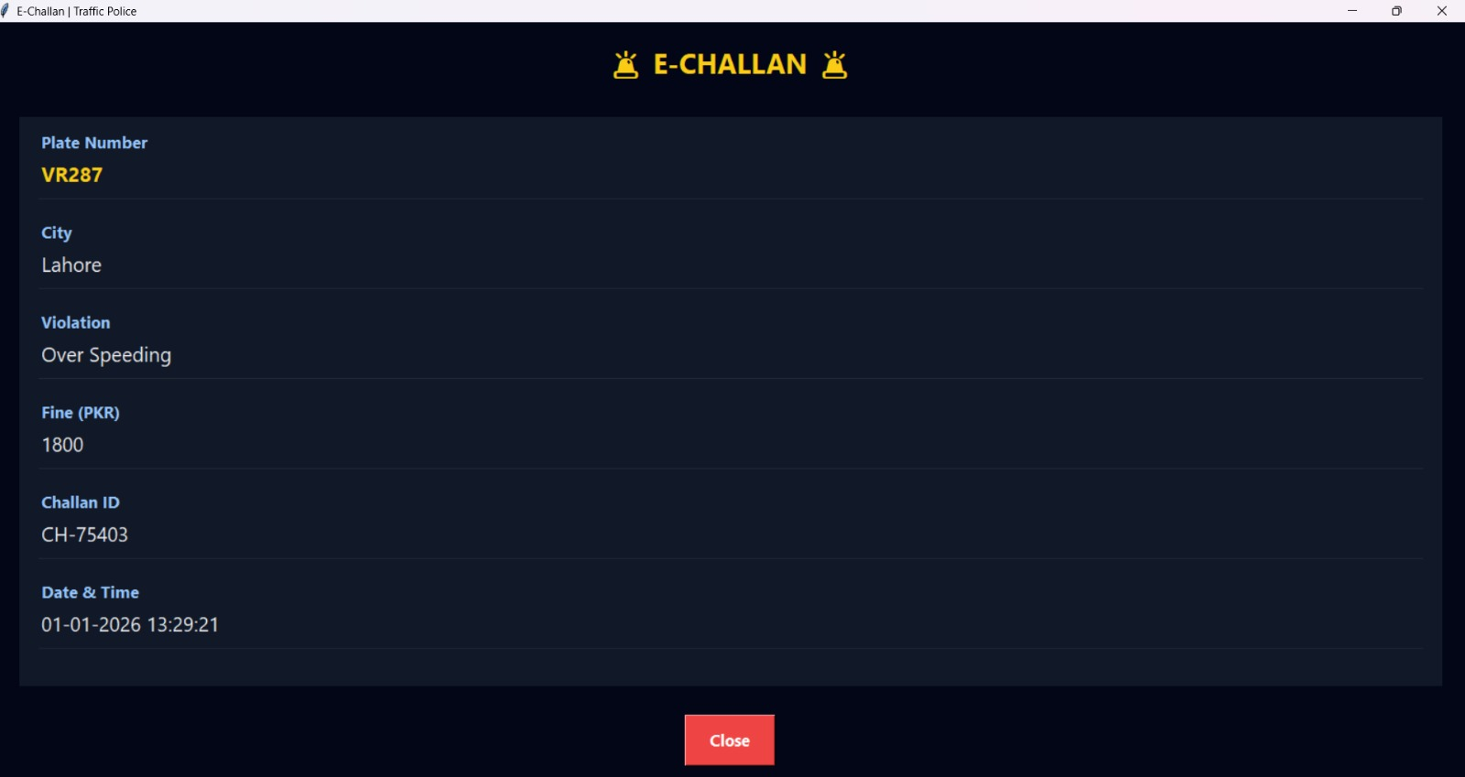
OVERALL ANPR SYSTEM FLOWCHART
End
Display Bounding Box & Text
NO
Display “NOT FOUND”
•
YES
Extract Plate Region
Start
Process
Load Vehicle Image
(Python Tkinter GUI)
Valid Number Plate Found? & Area
Apply EasyOCR
(Alphanumeric Only)
Contour Detection
Convert RGB to Detection
Convert RGB to Grayscale
Sobel Edge Detection
Gaussian Blur
Otsu’s Thresholding
Morphological Closing

DIP & Image Processing (OpenCV)
Aspect Bounding Box & Aspect Ratio
Load Vehicle Image
(600×400)
Results and Discussion:
Results:
The developed system is successfully detecting license plates. Moreover, extracts the information and recognizes the number plates under normal lighting and front‑facing vehicle images. OCR accuracy is best when license plates are clear, visible, and free from any obstruction. The detection box highlights areas of interest, which are the license plates of vehicles. The data is then visualized on the GUI as it provides easy to use interface for testing images. Lastly, E-Challan is issued upon complete recognition.
Discussion:
While implementing the ANPR system on python we came to know that, even the ANPR System is detecting and recognizing the number plate characters at ease, however we still can’t say that the systems is 100% accurate. No system that is 100% accurate. To support this statement, we also worked on Matlab to implement the ANPR system. But on Matlab we were able to extract the rectangular shaped plate with at least of 80- 85% accuracy, still failed to do the character recognition with only percent 15-10%. That’s where the Python OCR comes, the library Opencv and EasyOCR uses AI and Ml. In our case it is using Ml according to Pakistan’s style number plates where letter placement, fonts, row column’s matter in character recognition which Matlab was failing to do so. In Image processing, to extract any information the image should be free from any type of noise, it should be clear and enhanced which is sometimes a hard task that’s why we can’t get that 100 % accuracy from the system. Only a human eye can go 100% percent in detecting but for a system it’s difficult to be that precise.
Future Direction:
No system is perfect, thus there are ways to improve this system.
- Deep learning-based detection model can be used for plate detection as it works in various scenarios, complex conditions (Models like YOLO, SSD, Faster R-CNN). These models are much more accurate as they can detect vehicles in the image even when it is half blocked, crowd image, poor lighting etc.
- Training the system solely for Pakistan’s license plate using a custom OCR. As the fonts, format of license plate is different for all countries. We can specifically target Pakistan and a particular city like Karachi.
- Techniques can be applied to refine the performance on tilted images of plates. The number plates can be adjusted to straight, rectangular view.
- This system can be linked to a proper vehicle database. This will help in instant recognition of vehicles. Through the information, the challan system can automatically be applied in real time.
- This system can farther be applied to real-time video based, rather than static images. For this, the system will input continuous vehicles that are being captured from a video and then detect the plates and automatically check the information in the database.
References:
Digital Image Processing 3rd ed. - R. Gonzalez, R. Woods
https://www.geeksforgeeks.org/computer-vision/automatic-license-number-plate-recognition-system/
https://www.researchgate.net/publication/236888959_Automatic_Number_Plate_Recognition_System_ANPR_A_Survey
Mastering OpenCV with Practical Computer Vision Projectsby Shervin Emami
https://en.wikipedia.org/wiki/Automatic_number-plate_recognition

