Create a empty repository
Create empty folder in your local compueropen vs open git bahs terminalgit clone the projectpush the code into created empty repository in github
Open aws console create a security group with name
Create one security group:
Name: ecommerce-sg
Description: Security group for CloudCart DevOps demo
VPC: Default VPC
Use these inbound rules:
Type | Protocol | Port | Source | Purpose
SSH | TCP | 22 | My IP | SSH to all 3 servers
Custom TCP | TCP | 9000 | My IP | SonarQube browser
Custom TCP | TCP | 8080 | My IP | Temporary app frontend test
Custom TCP | TCP | 8081 | My IP | Temporary app backend test
The important rule is the self-reference:
Type: Custom TCP
Port: 9000
Source: ecommerce-sg save itedit the sg add one more inbound Rule
Custom TCP | TCP | 9000 | ecommerce-sg itself | Runner → SonarQube

Create a EC2 instance for runner:
Name: ecomm-runner
Application and OS Images: Ubuntu Server 24.04 LTS 64-bit (x86)
Instance type: c7i-flex-large
Key pair : ecommerce-key
security group: ecommerce-sg
Storage : 40 GiB gp3

Create EC2 instance for SonarQube:
Name: ecomm-sonarqube
Application and OS Images: Ubuntu Server 24.04 LTS 64-bit (x86),ssd volume type
Instance type: c7i-flex-large
Key pair : ecommerce-key
security group: ecommerce-sg
Storage : 40 GiB gp3

Create EC2 instance for Server:
Name: ecomm-server
Application and OS Images: Ubuntu Server 24.04 LTS 64-bit (x86)
Instance type: c7i-flex-large
Key pair : ecommerce-key
security group: ecommerce-sg
Storage : 40 GiB gp3

Open gitbash terminal
ssh -i Downloads/ecommerce-key.pem ubuntu@<publicip of runner ec2 instance>
sudo hostnamectl set-hostname ecommerce-runner
/bin/bash
ubuntu@ecommerce-runner:~
sudo apt update
sudo apt upgrade -y

Open another gitbash terminal
ssh -i Downloads/ecommerce-key.pem ubuntu@<publicip of sonarqube ec2 instance>
sudo hostnamectl set-hostname sonarqube
/bin/bash
ubuntu@sonarqube:~
sudo apt update
sudo apt upgrade -y

Open gitbash terminal
ssh -i Downloads/ecommerce-key.pem ubuntu@<publicip of server ec2 instance>

sudo hostnamectl set-hostname server
/bin/bash
ubuntu@ecommerce-server:~
sudo apt update
sudo apt upgrade -y

Install Git and Docker prerequisites in SERVER EC2 :
Open server ec2 gitbash terminal:
sudo apt install -y git curl ca-certificates gnupg
git --version
Install Docker
sudo install -m 0755 -d /etc/apt/keyrings
sudo curl -fsSL https://download.docker.com/linux/ubuntu/gpg \
-o /etc/apt/keyrings/docker.asc
sudo chmod a+r /etc/apt/keyrings/docker.asc
echo \
"deb [arch=$(dpkg --print-architecture) signed-by=/etc/apt/keyrings/docker.asc] https://download.docker.com/linux/ubuntu \
$(. /etc/os-release && echo "${UBUNTU_CODENAME:-$VERSION_CODENAME}") stable" \
| sudo tee /etc/apt/sources.list.d/docker.list > /dev/null
sudo apt update
sudo apt install -y \
docker-ce \
docker-ce-cli \
containerd.io \
docker-buildx-plugin \
docker-compose-plugin
sudo systemctl enable docker
sudo systemctl start docker
sudo systemctl status docker
output must be Active: active (running)
press q
Give Ubuntu user Docker permission
sudo usermod -aG docker $USER
exit
ssh -i Downloads/ecommerce-key.pem ubuntu@<SERVER_PUBLIC_IP>
docker --version
docker compose version
docker ps
docker run --rm hello-world
Clone our ecommerce repository
cd ~
git clone https://github.com/harathi-mutyam/multi-svc-ecommrce-app-cicd.git
ls
cd multi-svc-ecommrce-app-cicd
ls
ls -la
docker compose config
docker compose up -d --build
docker compose ps
docker ps

If something failed
Don't immediately change the application.
Run:
docker compose ps -a
Then:
docker compose logs --tail=100
For example, if Product Service failed:
docker compose logs product-service --tail=100
For Order Service:
docker compose logs order-service --tail=100
For User Service:
docker compose logs user-service --tail=100
For database:
docker compose logs product-db --tail=100
Send me the output and we'll fix the actual cause.

STEP 14 — Test API Gateway
SERVER EC2 gitbash terminal
Test gateway:
curl http://localhost:8081/health
Then User Service:
curl http://localhost:8081/users/health
Product Service:
curl http://localhost:8081/products/health
Order Service:
curl http://localhost:8081/orders/health
All should return healthy responses.
Test Product data
curl http://localhost:8081/products
You should see JSON containing products such as:
Developer Laptop
Studio Headphones
Mechanical Keyboard
STEP 16 — Test Users
Run:
curl http://localhost:8081/users
You should receive user data.
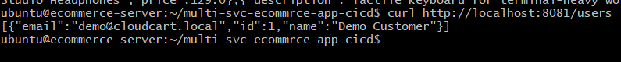
STEP 17 — Test Orders
Run:
curl http://localhost:8081/orders
Initially, this could be an empty list or existing demo orders depending on your project data.
Check frontend:
curl -I http://localhost:8080
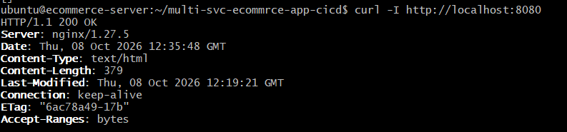
Open browser-> copy the publicip of server ec2 instance
http://<ECOMM-SERVER-PUBLIC-IP>:8080

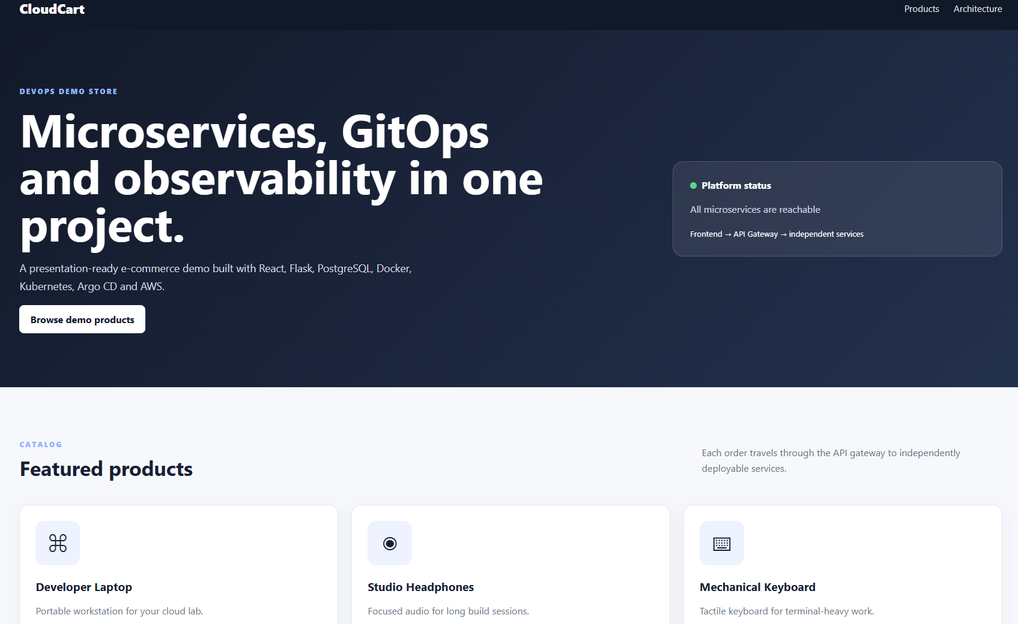

GitHub Push Authentication in server EC2 Ubuntu
ubuntu@ecommerce-server:~/multi-svc-ecommrce-app-cicd$
git config --global user.name "harathi-mutyam"
git config --global user.email "YOUR_GITHUB_EMAIL"
git status
git add .gitignore #your changed file names here
git commit -m "Redesign CloudCart frontend as Ecommerce Cart"
Create GitHub Personal Access Token (PAT)
Open github in browser select your project repository
Profile Picture Settings Developer Settings Personal Access Tokens Tokens (classic)
Generate new token (classic)
Token configuration:
Setting | Value
Note | Ecommerce EC2 Git Push
Expiration | 30 days or as required
Scope | Select repo
Additional scope | Select workflow, if updating workflow files

Click on generate save the personal_access_token at somewhere
Open server ec2 gitbash terminal
git remote -v
git push -u origin main
Username: harathi-mutyam
Password: paste YOUR_PERSONAL_ACCESS_TOKEN
git status

STEP 21 — Install SonarQube on ecomm-sonarqube
Open sonarqube ec2 gitbash terminal
sudo apt update
sudo apt upgrade -y
sudo apt install -y curl ca-certificates gnupg
Configure Linux for SonarQube
Run:
sudo sysctl -w vm.max_map_count=524288
Then:
sudo sysctl -w fs.file-max=131072
Make these persistent:
echo "vm.max_map_count=524288" | sudo tee /etc/sysctl.d/99-sonarqube.conf
echo "fs.file-max=131072" | sudo tee -a /etc/sysctl.d/99-sonarqube.conf
Verify:
sysctl vm.max_map_count
Expected:
vm.max_map_count = 524288
STEP 22 — Install Docker on SonarQube EC2
sudo install -m 0755 -d /etc/apt/keyrings
sudo curl -fsSL https://download.docker.com/linux/ubuntu/gpg \
-o /etc/apt/keyrings/docker.asc
sudo chmod a+r /etc/apt/keyrings/docker.asc
Add Docker repository:
echo \
"deb [arch=$(dpkg --print-architecture) signed-by=/etc/apt/keyrings/docker.asc] https://download.docker.com/linux/ubuntu \
$(. /etc/os-release && echo "${UBUNTU_CODENAME:-$VERSION_CODENAME}") stable" \
| sudo tee /etc/apt/sources.list.d/docker.list > /dev/null
Then:
sudo apt update
sudo apt install -y \
docker-ce \
docker-ce-cli \
containerd.io \
docker-buildx-plugin \
docker-compose-plugin
Enable Docker:
sudo systemctl enable --now docker
Add your user:
sudo usermod -aG docker $USER
Exit:
exit
Reconnect:
ssh -i Downloads/ecommerce-key.pem ubuntu@<SONARQUBE_PUBLIC_IP>
Test:
docker --version
and:
docker ps
STEP 23 — Create SonarQube storage
Run on SonarQube EC2:
docker volume create sonarqube_data
docker volume create sonarqube_extensions
docker volume create sonarqube_logs
Check:
docker volume ls
You should see all three volumes.
STEP 24 — Start SonarQube
For this demo environment, run:
docker run -d \
--name sonarqube \
--restart unless-stopped \
-p 9000:9000 \
-v sonarqube_data:/opt/sonarqube/data \
-v sonarqube_extensions:/opt/sonarqube/extensions \
-v sonarqube_logs:/opt/sonarqube/logs \
sonarqube:lts-community
Check:
docker ps
You want:
sonarqube Up ...
Watch startup:
docker logs -f sonarqube
SonarQube takes some time to initialize.
When you see that it is operational, press:
Ctrl+C
This only stops following the logs; it does not stop SonarQube.
Verify again:
docker ps

STEP 25 — Test SonarQube inside the sonarqube gitbash terminal
Run:
curl http://localhost:9000/api/system/status
Once fully started, you should get something containing:
{"status":"UP"}
If you get:
Connection refused
wait a little and check:
docker logs --tail=100 sonarqube

STEP 26 — Open SonarQube in your browser
On Windows Chrome open:
http://<SONARQUBE_PUBLIC_IP>:9000
You should reach the SonarQube login page.
Complete the initial SonarQube login and password-change flow shown by the UI.

STEP 27 — Create Ecommerce Cart project in SonarQube
SONARQUBE BROWSER
After logging in,
Projects → Create Project → Local Project
select: Manually
Enter Project Details
Project display name: Ecommerce-Cart-Microservices
Project key: ecommerce-microservices-demo

Main branch: main
Select Set Up button now
When SonarQube asks how you want to analyze the repository, choose the option for analyzing it with your CI/CD pipeline rather than manually running analysis on this SonarQube machine.
Select Analysis Method page will opened Select: GitHub Actions
Token name: ecommerce-github-actions
Click Generate. Save the token in notepad
Add sonar_token in in project github repository:
Create SONAR_TOKEN Secret

Generate SonarQube Token administrationsecurity click on users under tokens in table place the mouse click on that symbol provide name: ecommerce-github-actions click on generate button

open project GitHub repository in browser Settings
Secrets and variables Actions Secrets New repository secret
Name: SONAR_TOKEN
Secret: <Your generated SonarQube token>
Click Add secret.
Create SONAR_HOST_URL Variable
Settings Secrets and variables Actions VariablesNew repository variable
Enter:
Name: SONAR_HOST_URL
Value: http://<privateip of sonarqube>:9000
Click Add variable.

Understand Public IP vs Private IP
Explanation about why I saved private ip as sonar_host_url
Browser → SonarQube
From your Windows computer, use the SonarQube public IP:
Windows PC
│
│ Internet
▼
SonarQube Public IP
│
│ :9000
▼
SonarQube
For example:
http://13.62.56.90:9000
The corresponding security-group rule is:
Type: Custom TCP
Port: 9000
Source: My IP
Runner → SonarQube
The self-hosted runner should use the SonarQube private IP:
ecomm-runner
│
│ AWS private network
│ TCP 9000
▼
ecomm-sonarqube
172.31.19.251
The corresponding security-group rule is:
Type: Custom TCP
Port: 9000
Source: ecommerce-sg
Therefore:
Browser access → Public IP

CI/CD Runner access → Private IP
STEP 28— Test Runner → SonarQube
Open runner ec2 instance gitbash terminal and check it
ubuntu@ecommerce-runner:~$
curl --connect-timeout 5 \
http://172.31.19.251:9000/api/system/status
output must be in json format
{ "id": "...", "version": "...", "status": "UP"}

STEP 29 — Configure sonar-project.properties
Open SERVER EC2 gitbash terminal
cd ~/multi-svc-ecommrce-app-cicd
ls -l sonar-project.properties
vim sonar-project.properties
delete old content replace with new content press dd
# SonarQube Project Configuration

sonar.projectKey=ecommerce-microservices-demo
sonar.projectName=Ecommerce Cart - Microservices
sonar.projectVersion=1.0

# Source Code
sonar.sources=services,frontend/src,api-gateway

# Exclusions
sonar.exclusions=**/node_modules/**,**/__pycache__/**,**/.venv/**,**/dist/**,**/build/**,**/.git/**

# Python
sonar.python.version=3.12

# Encoding
sonar.sourceEncoding=UTF-8

push changes to git hub repository from server ec2 instance gitbash
git add sonar-project.properties
git status
git commit -m "Configure SonarQube analysis for Ecommerce Cart"
git push origin main
provide username and github token here
STEP 30 — Prepare the Runner EC2
Open runner gitbash terminal

sudo apt install -y \
git \
curl \
wget \
unzip \
jq \
ca-certificates \
gnupg \
python3 \
python3-pip \
python3-venv

git --version
python3 --version
pip3 --version
curl --version

Install Docker on Runner
sudo install -m 0755 -d /etc/apt/keyrings

sudo curl -fsSL https://download.docker.com/linux/ubuntu/gpg \
-o /etc/apt/keyrings/docker.asc

echo \
"deb [arch=$(dpkg --print-architecture) signed-by=/etc/apt/keyrings/docker.asc] https://download.docker.com/linux/ubuntu \
$(. /etc/os-release && echo "${UBUNTU_CODENAME:-$VERSION_CODENAME}") stable" \
| sudo tee /etc/apt/sources.list.d/docker.list > /dev/null
sudo apt update

sudo apt install -y \
docker-ce \
docker-ce-cli \
containerd.io \
docker-buildx-plugin \
docker-compose-plugin

sudo systemctl enable --now docker

sudo systemctl status docker

press q
sudo usermod -aG docker $USER
exit
exit

ssh -i Downloads/ecommerce-key.pem ubuntu@<RUNNER_PUBLIC_IP>

docker --version
docker compose version
docker ps
docker run --rm hello-world

Install Node.js 20
curl -fsSL https://deb.nodesource.com/setup_20.x | sudo -E bash -

sudo apt install -y nodejs

node --version
npm --version
output must be Node 20.x.
STEP 30 — Install AWS CLI in Runner Ec2 gitbash terminal
Later, our CI pipeline will push Docker images to Amazon ECR.
sudo apt update
sudo apt install unzip curl -y

curl "https://awscli.amazonaws.com/awscli-exe-linux-x86_64.zip" \
-o "awscliv2.zip"

unzip awscliv2.zip

sudo ./aws/install

aws --version

rm -rf aws awscliv2.zip

open aws console login and create for your iam user access and secret keys save it and use at aws configure

openrunner ec2 gitbahs terminal:

aws configure

access key:

secret key:

regions: eu-north-1

format: json

STEP 31 — Install Trivy in Runner Ec2 gitbash terminal
Trivy will be used for container-image vulnerability scanning.
wget -qO - https://aquasecurity.github.io/trivy-repo/deb/public.key \
| gpg --dearmor \
| sudo tee /usr/share/keyrings/trivy.gpg >/dev/null

echo "deb [signed-by=/usr/share/keyrings/trivy.gpg] https://aquasecurity.github.io/trivy-repo/deb generic main" \
| sudo tee /etc/apt/sources.list.d/trivy.list

sudo apt update

sudo apt install -y trivy

trivy --version

echo "===== Git ====="
git --version

echo "===== Python ====="
python3 --version
pip3 --version

echo "===== Node ====="
node --version
npm --version

echo "===== Docker ====="
docker --version
docker compose version

echo "===== AWS CLI ====="
aws --version

echo "===== Trivy ====="
trivy --version

After installation finished Verify Runner is connected SonarQube or not
In Runner ec2 instance gitbash terminal run the below command
Use the current private IP of your SonarQube EC2:
curl --connect-timeout 5 \
http://<privateip of sonarqube ec2 instance >:9000/api/system/status

output must be "status":"UP"
STEP 32 — Register the GitHub Self-Hosted Runner
Connect runner ec2 instance to our project github repository
Open project github repository in browser select settings actionsRunners new self-hosted-runner select Runner image: Linux Architecture: x64
Copy Download related commands
Open runner EC2 gitbash terminal paste the commands and run it
cd ~
mkdir -p actions-runner
cd actions-runner
ubuntu@ecommerce-runner:~/actions-runner$

go back to github repository in browser copy remaining commands curl and tar commands
run those commands in runner ec2 in gitbash terminal
again copy the configure related commands from git hub repository and run those commands in runner ec2 gitbash terminal.During configuration
Enter the name of the runner group: press enter key
Enter the name of runner: ecommerce-runner
For additional labels : enter ecommerce-runner,self-hosted, Linux,X64
if you want to add more lables just place a comma docker,aws,ecr,trivy

Enter name of work folder: press enter key
Install Runner as a Service
cd ~/actions-runner
./run.sh
Current runner version: '2.337.0'
2026-10-08 16:28:32Z: Listening for Jobs

Optinal commands

Open one more runner gitbash terminal ssh login
cd ~/actions-runner
sudo ./svc.sh install
sudo ./svc.sh start
sudo ./svc.sh status
Verify Runner in GitHub refresh the page in browser or
Open github project repositorysettingsActionsRunner
We can see Status: Idle or Active

Open Server EC2 instance gitbash terminal
cd ~/multi-svc-ecommrce-app-cicd
git status
git pull origin main
ls -la .github/workflows/
cat .github/workflows/ci-cd.yml

Open Runner ec2 instance gitbash terminal
aws sts get-caller-identity
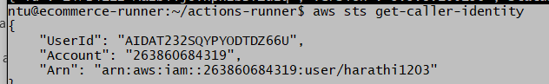
copy the account id: 263860684319
aws configure get region
copy the region also
Verify ECR Access
aws ecr describe-repositories \
--region eu-north-1 \
--query 'repositories[*].repositoryName' \
--output table
Output must be empty here first time
Second time you get repository names

STEP 33 — Create ECR Repositories

cd ..

aws ecr create-repository \
--repository-name ecommerce/frontend \
--region eu-north-1

aws ecr create-repository \
--repository-name ecommerce/api-gateway \
--region eu-north-1

aws ecr create-repository \
--repository-name ecommerce/user-service \
--region eu-north-1

aws ecr create-repository \
--repository-name ecommerce/product-service \
--region eu-north-1

aws ecr create-repository \
--repository-name ecommerce/order-service \
--region eu-north-1

Each successful command will return JSON containing information such as:
repositoryName ,repositoryArn , repositoryUri ,registryId
aws ecr describe-repositories \
--region eu-north-1 \
--query 'repositories[*].repositoryName' \
--output table

---------------------------------
| DescribeRepositories |
+-------------------------------+
| ecommerce/frontend |
| ecommerce/api-gateway |
| ecommerce/user-service |
| ecommerce/product-service |
| ecommerce/order-service |
+-------------------------------+
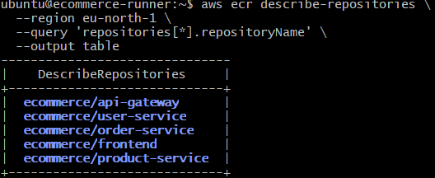

Open aws console in broser search ECR open it

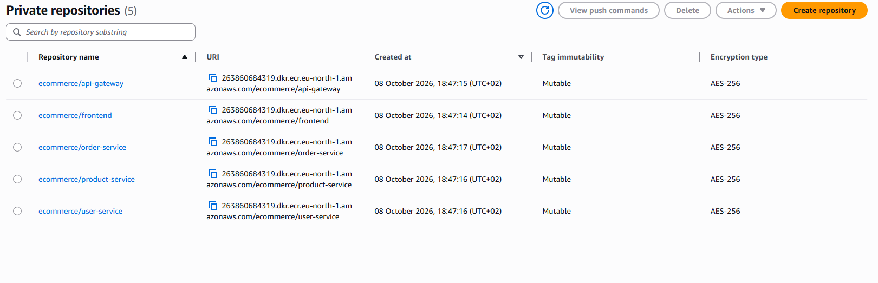

Test Docker Login to Amazon ECR
Open runner gitbash terminal
aws ecr get-login-password \
--region eu-north-1 \
| docker login \
--username AWS \
--password-stdin \
263860684319.dkr.ecr.eu-north-1.amazonaws.com

Output will Login Succeeded

Step 34: Create GitHub Repository Variables
Open project git hub repository in browserselect settingssecrets and variablesactions variablesnew repository variable
Name: AWS_REGION
Value:eu-north-1 <your application region name>
Click on save
Create one more repository variable
Name: ECR_REGISTRY
Value:263860684319.dkr.ecr.eu-north-1.amazonaws.com
<your --password-stdin value here>copy value is from aws console browser ecr263860684319.dkr.ecr.eu-north-1.amazonaws.com Do not put /ecommerce after the ECR registry URL.
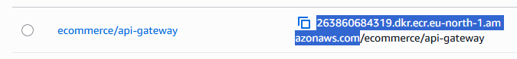
Create AWS GitHub Secrets
In ci-cd.yml contains:
aws-access-key-id: ${{ secrets.AWS_ACCESS_KEY_ID }}
aws-secret-access-key: ${{ secrets.AWS_SECRET_ACCESS_KEY }}

we need aws iam access_key and secret key save those values in github secrets
add Secret:
Name: AWS_ACCESS_KEY_ID
Secret: <your AWS access key ID>
Add one more secret:
Name:AWS_SECRET_ACCESS_KEY
Secret:<your AWS secret access key>
Step 35: Verify Runner Service
Open runner gitbash terminal
cd ~/actions-runner
sudo ./svc.sh status

If output is running
Optional step:
Open project github repository in browser—>settings actionsrunners check runner is idle or not

Step 36: Verify Kubernetes Image Lines Before First CI/CD Run
Open server gitbash terminal
cd ~/multi-svc-ecommrce-app-cicd
git status
git pull origin main

grep -n "image:" \
k8s/05-user-service.yaml \
k8s/06-product-service.yaml \
k8s/07-order-service.yaml \
k8s/08-api-gateway.yaml \
k8s/09-frontend.yaml
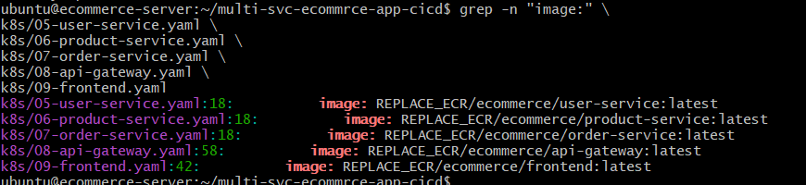

Step 37: First CI/CD Pipeline Run manual way
Open project github repository Actions on left hand side select E-Commerce Microservices CI/CD click Run workflow select Branch: main select Run workflow

Verify GitHub Self-Hosted Runner
open RUNNER EC2 gitbash terminal — ecommerce-runner
cd ~/actions-runner
Check the runner service:
sudo ./svc.sh status
The service should show:
Active: active (running)
Check the listener:
ps -ef | grep Runner.Listener | grep -v grep
A correctly service-managed runner should contain:
Runner.Listener run --startuptype service

Debugging procedure:
GitHub Actions runs-on requires a runner matching all specified labels.
self-hosted ,linux ,x64 ,ecommerce-runner

open project Github repository Settings ActionsRunners
ecommerce-runner
The workflow and runner labels should match.
Root cause of error is
The runner had previously been manually started using: ./run.sh
Later, the same runner was installed as a systemd service:
sudo ./svc.sh install
sudo ./svc.sh start
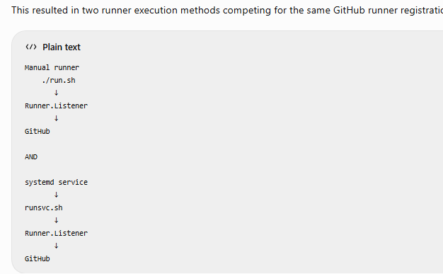
RUNNER EC2 Gitbash terminal
ps -ef | grep -E 'Runner.Listener|run.sh|runsvc.sh' | grep -v grep
output shown us
/bin/bash ./run.sh
/home/ubuntu/actions-runner/bin/Runner.Listener run
Stop the Manual Runner
kill 34229 34237 (PID numbers whatever you got)
ps -ef | grep -E 'Runner.Listener|run.sh|runsvc.sh' | grep -v grep
sleep 5
ps -ef | grep -E 'Runner.Listener|run.sh|runsvc.sh' | grep -v grep
Start GitHub Runner Correctly as a Service
cd ~/actions-runner
sudo ./svc.sh start
sudo ./svc.sh status
output must be: Active: active (running)
The logs should also show:
Connected to GitHub
Current runner version: '2.337.0'
Listening for Jobs
Verify the listener:
ps -ef | grep Runner.Listener | grep -v grep
open github project repository in browser Actions
E-Commerce Microservices CI/CDselect mainselect Rerun jobs or Rerun workflow
Step 38: Install Terraform on Runner EC2
Open Ruunner EC2 gitbash terminal
cd ~
sudo apt update
sudo apt install -y \
gnupg \
software-properties-common \
curl \
wget

wget -O- https://apt.releases.hashicorp.com/gpg \
| gpg --dearmor \
| sudo tee /usr/share/keyrings/hashicorp-archive-keyring.gpg >/dev/null

echo "deb [signed-by=/usr/share/keyrings/hashicorp-archive-keyring.gpg] https://apt.releases.hashicorp.com $(lsb_release -cs) main" \
| sudo tee /etc/apt/sources.list.d/hashicorp.list

sudo apt update
sudo apt install -y terraform
terraform version

Verify AWS CLI Credentials
aws sts get-caller-identity

output must be your aws account number
aws configure get region
you will get your region: here I got eu-north-1
aws configure set region eu-north-1
aws configure get region
Terraform will create chargeable AWS resources. Make sure the AWS account and region are correct before continuing.
STEP 39 — Install kubectl
Open run gitbash terminal install kubectl
curl -LO \
"https://dl.k8s.io/release/v1.36.0/bin/linux/amd64/kubectl"

curl -LO \
"https://dl.k8s.io/release/v1.36.0/bin/linux/amd64/kubectl.sha256"

echo "$(cat kubectl.sha256) kubectl" | sha256sum --check

Expected: kubectl: OK
sudo install -o root -g root -m 0755 kubectl /usr/local/bin/kubectl

kubectl version --client

Install Helm
Helm deployment: Third-party components such as Prometheus, Grafana, Loki and Alloy.
curl -fsSL -o get_helm.sh \
https://raw.githubusercontent.com/helm/helm/main/scripts/get-helm-3

Review the installation script if desired:
less get_helm.sh

press q
chmod 700 get_helm.sh

./get_helm.sh

helm version

Verify EKS Kubernetes Versions
aws eks describe-cluster-versions \
--region eu-north-1 \
--query 'clusterVersions[*].[clusterVersion,status]' \
--output table

cd ~
ls

git clone https://github.com/harathi-mutyam/multi-svc-ecommrce-app-cicd.git

cd ~/multi-svc-ecommrce-app-cicd

git pull origin main

ls -la
find . -maxdepth 3 \
\( -name "*.tf" -o -name "*.tfvars" \) \
-print

Step: 40 Install dependencies in server ec2

Install AWS CLI on SERVER EC2 ecommerce-server gitbash terminal
Open Server Ec2 gitbahs terminal
cd ~
sudo apt update
sudo apt install -y unzip curl
curl "https://awscli.amazonaws.com/awscli-exe-linux-x86_64.zip" \
-o "awscliv2.zip"

unzip awscliv2.zip
sudo ./aws/install
aws --version
Expected approximately:
aws-cli/2.x.x Python/... Linux/...
Cleanup:
rm -rf aws awscliv2.zip

Configure AWS Credentials on SERVER ec2
aws configure
It will ask:
AWS Access Key ID: <your IAM access key>
AWS Secret Access Key: <your IAM secret key>
Default region name: eu-north-1
Default output format: json

aws sts get-caller-identity
263860684319
aws configure get region
eu-north-1
Install Terraform in server ec2 gitbash terminal

cd ~
sudo apt update
sudo apt install -y \
gnupg \
software-properties-common \
curl \
wget

wget -O- https://apt.releases.hashicorp.com/gpg \
| gpg --dearmor \
| sudo tee /usr/share/keyrings/hashicorp-archive-keyring.gpg >/dev/null

echo "deb [signed-by=/usr/share/keyrings/hashicorp-archive-keyring.gpg] https://apt.releases.hashicorp.com $(lsb_release -cs) main" \
| sudo tee /etc/apt/sources.list.d/hashicorp.list

sudo apt update
sudo apt install -y terraform
terraform version

Verify AWS CLI Credentials
aws sts get-caller-identity

output must be your aws account number
aws configure get region
you will get your region: here I got eu-north-1
aws configure set region eu-north-1
aws configure get region
Terraform will create chargeable AWS resources. Make sure the AWS account and region are correct before continuing.
Install kubectl
Open run gitbash terminal install kubectl
curl -LO \
"https://dl.k8s.io/release/v1.36.0/bin/linux/amd64/kubectl"

curl -LO \
"https://dl.k8s.io/release/v1.36.0/bin/linux/amd64/kubectl.sha256"

echo "$(cat kubectl.sha256) kubectl" | sha256sum --check

Expected: kubectl: OK
sudo install -o root -g root -m 0755 kubectl /usr/local/bin/kubectl

kubectl version --client

Install Helm
Helm deployment: Third-party components such as Prometheus, Grafana, Loki and Alloy.
curl -fsSL -o get_helm.sh \
https://raw.githubusercontent.com/helm/helm/main/scripts/get-helm-3

Review the installation script if desired:
less get_helm.sh

press q
chmod 700 get_helm.sh

./get_helm.sh

helm version

Verify EKS Kubernetes Versions
aws eks describe-cluster-versions \
--region eu-north-1 \
--query 'clusterVersions[*].[clusterVersion,status]' \
--output table

aws eks list-clusters \
--region eu-north-1 \
--output table
echo "===== AWS ====="
aws --version
aws sts get-caller-identity

echo "===== Terraform ====="
terraform version

echo "===== kubectl ====="
kubectl version --client

echo "===== Helm ====="
helm version

cd ~/multi-svc-ecommrce-app-cicd
git status

git pull origin main

ls -la
find . -maxdepth 3 \
\( -name "*.tf" -o -name "*.tfvars" \) \
-print

ls -la terraform/
Check AWS AZs before designing VPC
aws ec2 describe-availability-zones \
--region eu-north-1 \
--filters Name=state,Values=available \
--query 'AvailabilityZones[*].[ZoneName,State]' \
--output table

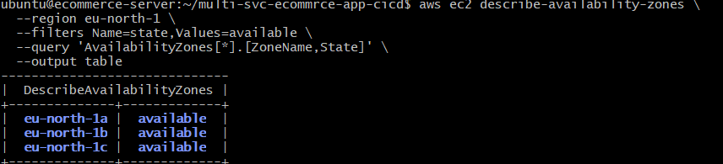
echo "===== versions.tf ====="
cat terraform/versions.tf
echo "===== provider.tf ====="
cat terraform/provider.tf
echo "===== variables.tf ====="
cat terraform/variables.tf
echo "===== main.tf ====="
cat terraform/main.tf
echo "===== ecr.tf ====="
cat terraform/ecr.tf
echo "===== outputs.tf ====="
cat terraform/outputs.tf
Step 41: Initialize and validate Terraform
cd ~/multi-svc-ecommrce-app-cicd/terraform
terraform init
terraform validate
Bring existing ECR repositories under Terraform
terraform import \
'aws_ecr_repository.repo["ecommerce/frontend"]' \
ecommerce/frontend

terraform import \
'aws_ecr_repository.repo["ecommerce/api-gateway"]' \
ecommerce/api-gateway

terraform import \
'aws_ecr_repository.repo["ecommerce/user-service"]' \
ecommerce/user-service

terraform import \
'aws_ecr_repository.repo["ecommerce/product-service"]' \
ecommerce/product-service

terraform import \
'aws_ecr_repository.repo["ecommerce/order-service"]' \
ecommerce/order-service

cd ~/multi-svc-ecommrce-app-cicd/terraform
vim main.tf
data "aws_availability_zones" "available" {}

module "vpc" {
source = "terraform-aws-modules/vpc/aws"
version = "~> 6.0"

name = "ecommerce-vpc"
cidr = "10.30.0.0/16"

azs = slice(data.aws_availability_zones.available.names, 0, 2)
private_subnets = ["10.30.1.0/24", "10.30.2.0/24"]
public_subnets = ["10.30.101.0/24", "10.30.102.0/24"]

enable_nat_gateway = true
single_nat_gateway = true
enable_dns_hostnames = true

public_subnet_tags = {
"kubernetes.io/role/elb" = 1
}

private_subnet_tags = {
"kubernetes.io/role/internal-elb" = 1
}
}

module "eks" {
source = "terraform-aws-modules/eks/aws"
version = "~> 21.0"

name = var.cluster_name
kubernetes_version = "1.36"

endpoint_public_access = true

addons = {
coredns = {}
kube-proxy = {}
vpc-cni = {}
eks-pod-identity-agent = {}

aws-ebs-csi-driver = {
pod_identity_association = [
{
role_arn = aws_iam_role.ebs_csi.arn
service_account = "ebs-csi-controller-sa"
}
]
}
}

vpc_id = module.vpc.vpc_id
subnet_ids = module.vpc.private_subnets

enable_cluster_creator_admin_permissions = true

eks_managed_node_groups = {
main = {
kubernetes_version = "1.36"

instance_types = ["c7i-flex.large"]

min_size = 1
desired_size = 2
max_size = 3
}
}
}

Configure EBS CSI IAM Role
vim ebs-csi.tf
data "aws_iam_policy_document" "ebs_csi_assume_role" {
statement {
effect = "Allow"

principals {
type = "Service"
identifiers = [
"pods.eks.amazonaws.com"
]
}

actions = [
"sts:AssumeRole",
"sts:TagSession"
]
}
}

resource "aws_iam_role" "ebs_csi" {
name = "${var.cluster_name}-ebs-csi-role"

assume_role_policy = data.aws_iam_policy_document.ebs_csi_assume_role.json
}

resource "aws_iam_role_policy_attachment" "ebs_csi" {
role = aws_iam_role.ebs_csi.name

policy_arn = "arn:aws:iam::aws:policy/service-role/AmazonEBSCSIDriverPolicy"
}

terraform fmt

terraform validate

grep -n -E \
'kubernetes_version|endpoint_public_access|instance_types|min_size|desired_size|max_size|aws-ebs-csi-driver|pod_identity' \
main.tf

Expected values:
kubernetes_version = "1.36"
endpoint_public_access = true

aws-ebs-csi-driver
pod_identity_association

kubernetes_version = "1.36"
instance_types = ["c7i-flex.large"]
min_size = 1
desired_size = 2
max_size = 3

terraform plan -out=tfplan
terraform show -no-color tfplan | \
grep -B 3 -A 12 "will be updated in-place"
Each repository changes: scan_on_push = false -> true
terraform apply tfplan

Here I got error creation of eks cluster

Terraform Destroy Procedure — Preserve ECR
WHERE: ecommerce-server
STEP 1 — Go to Terraform Directory
cd ~/multi-svc-ecommrce-app-cicd/terraform
STEP 2 — Backup Terraform State
terraform state pull > terraform.tfstate.before-destroy.json
STEP 3 — Remove ECR from Terraform State
terraform state rm 'aws_ecr_repository.repo["ecommerce/frontend"]'
terraform state rm 'aws_ecr_repository.repo["ecommerce/api-gateway"]'
terraform state rm 'aws_ecr_repository.repo["ecommerce/user-service"]'
terraform state rm 'aws_ecr_repository.repo["ecommerce/product-service"]'
terraform state rm 'aws_ecr_repository.repo["ecommerce/order-service"]'
Verify:
terraform state list | grep aws_ecr_repository
Expected: No output
STEP 4 — Temporarily Move ECR Files
mv ecr.tf ecr.tf.pause
mv outputs.tf outputs.tf.pause
STEP 5 — Validate
terraform validate
STEP 6 — Create Destroy Plan
terraform plan -destroy -out=destroy.tfplan
STEP 7 — Make Sure ECR Is NOT Being Deleted
terraform show -no-color destroy.tfplan | grep -i ecr_repository
Expected: No output
STEP 8 — Destroy Infrastructure
terraform apply destroy.tfplan
Wait for:
Destroy complete!
STEP 9 — Restore Terraform Files
mv ecr.tf.pause ecr.tf
mv outputs.tf.pause outputs.tf
STEP 10 — Verify EKS Is Deleted
aws eks list-clusters \
--region eu-north-1 \
--output table
STEP 11 — Verify ECR Is Preserved
aws ecr describe-repositories \
--region eu-north-1 \
--query 'repositories[*].repositoryName' \
--output table
STEP 12 — Verify Terraform State
terraform state list
Expected: No output
STEP 13 — Remove Destroy Plan
rm -f destroy.tfplan
Final Result:
EKS / VPC / Nodes → Destroyed
ECR Repositories → Preserved
Docker Images → Preserved
Terraform Code → Preserved

1. Stop GitHub Actions Runner
WHERE: ecommerce-runner EC2
cd ~/actions-runner
sudo ./svc.sh stop
sudo ./svc.sh status
Expected:
Active: inactive (dead)
This confirms the GitHub Actions Runner is stopped.

2. Stop SonarQube
WHERE: ecomm-sonarqube EC2
Check:
docker ps
Stop SonarQube:
docker stop sonarqube
Verify:
docker ps -a
SonarQube should show as Exited.
Do not remove the SonarQube container or Docker volumes.

3. Stop Application Containers
WHERE: ecommerce-server EC2
cd ~/multi-svc-ecommrce-app-cicd
docker ps
If the Docker Compose application is running:
docker compose down
Verify:
docker ps
Do not use docker compose down -v, because it removes volumes.

4. Stop the EC2 Instances
WHERE: AWS Console
Go to:
EC2 → Instances
Select:
ecommerce-runner
ecomm-sonarqube
ecommerce-server
Then:
Instance state → Stop instance
STOP only. Do not TERMINATE.

STEP 49 — Check Terraform Outputs
After successful apply:
terraform output
Expected outputs include:
cluster_name = "ecommerce-cluster"

cluster_endpoint = "https://..."
and ECR repository URLs.
Check Terraform state:
terraform state list
After successful infrastructure creation, the state will contain considerably more resources than the five ECR repositories.

STEP 50 — Configure kubectl for EKS
WHERE: SERVER EC2 — ecommerce-server
Run:
aws eks update-kubeconfig \
--region eu-north-1 \
--name ecommerce-cluster
Then:
kubectl config current-context
Check nodes:
kubectl get nodes
Detailed check:
kubectl get nodes -o wide
Since the node group's desired capacity is:
desired_size = 2
normally we expect two worker nodes:
NAME STATUS ROLES AGE
node-1 Ready <none> ...
node-2 Ready <none> ...

STEP 51 — Verify EKS System Pods
Run:
kubectl get pods -A
Check kube-system:
kubectl get pods -n kube-system
Important components include:
coredns
kube-proxy
aws-node
eks-pod-identity-agent
ebs-csi-controller
ebs-csi-node
Pods should eventually be:
Running

STEP 52 — Verify EKS Add-ons from AWS
Run:
aws eks list-addons \
--cluster-name ecommerce-cluster \
--region eu-north-1
Expected add-ons:
coredns
kube-proxy
vpc-cni
eks-pod-identity-agent
aws-ebs-csi-driver
Check EBS CSI specifically:
aws eks describe-addon \
--cluster-name ecommerce-cluster \
--addon-name aws-ebs-csi-driver \
--region eu-north-1 \
--query 'addon.status' \
--output text
Expected:
ACTIVE

STEP 53 — Verify EBS CSI Pods
Run:
kubectl get pods -n kube-system | grep ebs
You should see the EBS CSI controller and node pods.
Also check:
kubectl get csidriver
Look for:
ebs.csi.aws.com
This confirms Kubernetes knows about the EBS CSI driver.

STEP 54 — Verify Storage Classes
Run:
kubectl get storageclass
or:
kubectl get sc
We need an EBS-backed StorageClass before deploying PostgreSQL PVCs.
Do not proceed with PostgreSQL PVC deployment until the EBS CSI driver is healthy.

STEP 55 — Push Terraform Changes to GitHub
Do this after we have successfully created and verified the infrastructure, as you requested.
WHERE: SERVER EC2 — ecommerce-server
Go back to the repository root:
cd ~/multi-svc-ecommrce-app-cicd
First check:
git status

Very important: Terraform state must NOT go to GitHub
Your current Terraform directory contains:
terraform.tfstate
terraform.tfstate.backup
tfplan
These are local Terraform operational files and should not be committed.
Check .gitignore:
cat .gitignore
Make sure it contains:
# Terraform
**/.terraform/*
*.tfstate
*.tfstate.*
*.tfplan
tfplan
crash.log
crash.*.log

# Terraform variable files that may contain secrets
*.tfvars
*.tfvars.json

# Terraform CLI configuration
.terraformrc
terraform.rc
Do not ignore:
terraform/.terraform.lock.hcl
The lock file should normally be committed because it records the selected provider versions.
Also, main.tf.backup is your manual backup and should normally not be committed. Add:
*.tf.backup
Then check:
git status
Your source changes should include files such as:
terraform/main.tf
terraform/ebs-csi.tf
terraform/ecr.tf
terraform/provider.tf
terraform/variables.tf
terraform/outputs.tf
terraform/versions.tf
terraform/.terraform.lock.hcl
Depending on which files were already present in GitHub, some will show as modified and others as new.
Before committing:
git diff -- terraform/
Then:
git add .gitignore
git add terraform/main.tf
git add terraform/ebs-csi.tf
git add terraform/ecr.tf
git add terraform/provider.tf
git add terraform/variables.tf
git add terraform/outputs.tf
git add terraform/versions.tf
If the lock file exists:
git add terraform/.terraform.lock.hcl
Check exactly what will be committed:
git status
Make sure you do not see:
terraform.tfstate
terraform.tfstate.backup
tfplan
.terraform/
Then commit:
git commit -m "Configure Terraform EKS infrastructure and EBS CSI"
Push:
git push origin main

