**Challenge #1**

A 3-tier environment is a common setup. Use a tool of your choosing/familiarity create these resources. Please remember we will not be judged on the outcome but more focusing on the approach, style and reproducibility.

Output:

**Note: The detail explanation about the code is mention in Readme.md files**

Created Vnet, Subnet & Resource Groups using Terraform under 1st wave.

Plan:

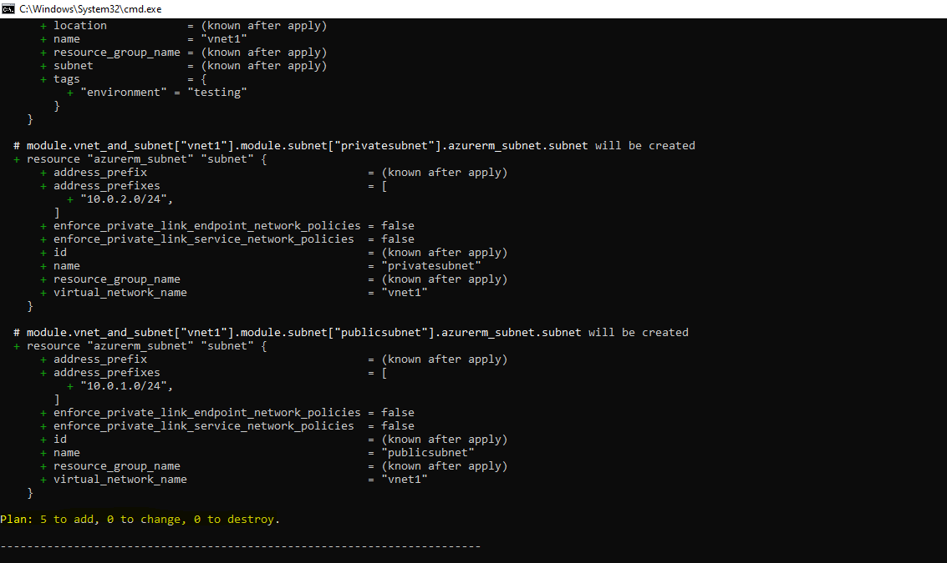

Apply:

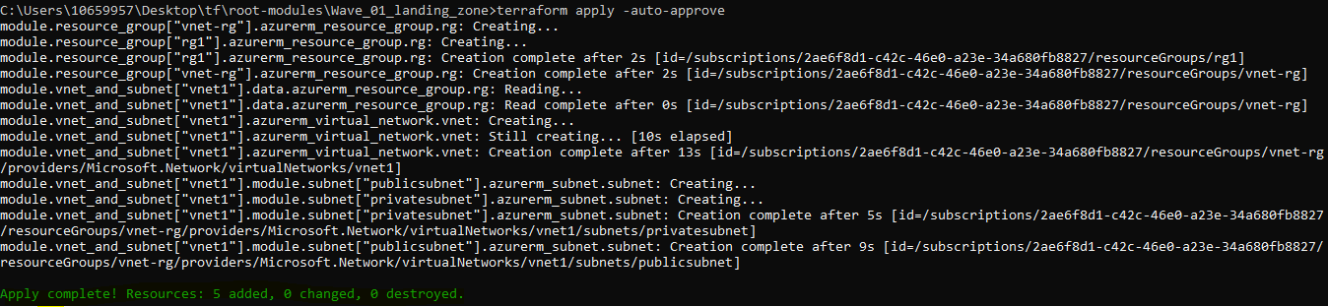

Portal:



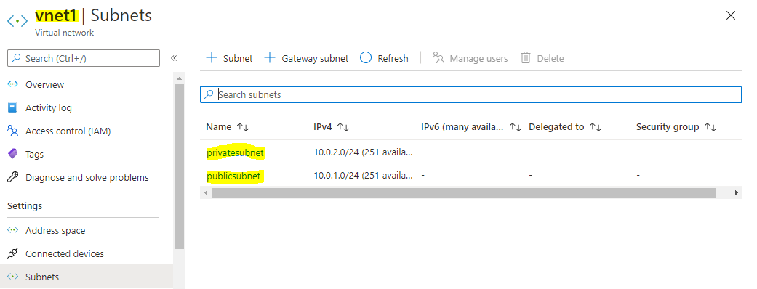

Created 3 tier architecture by creating DB, Web and App VM

Plan:

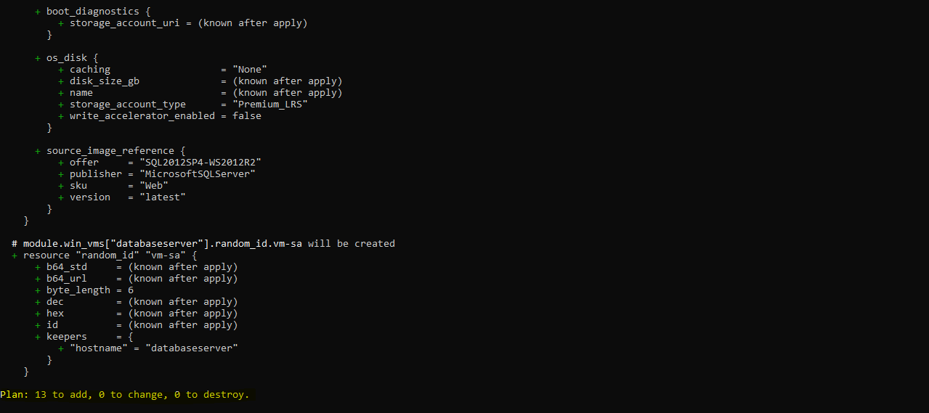

Apply:

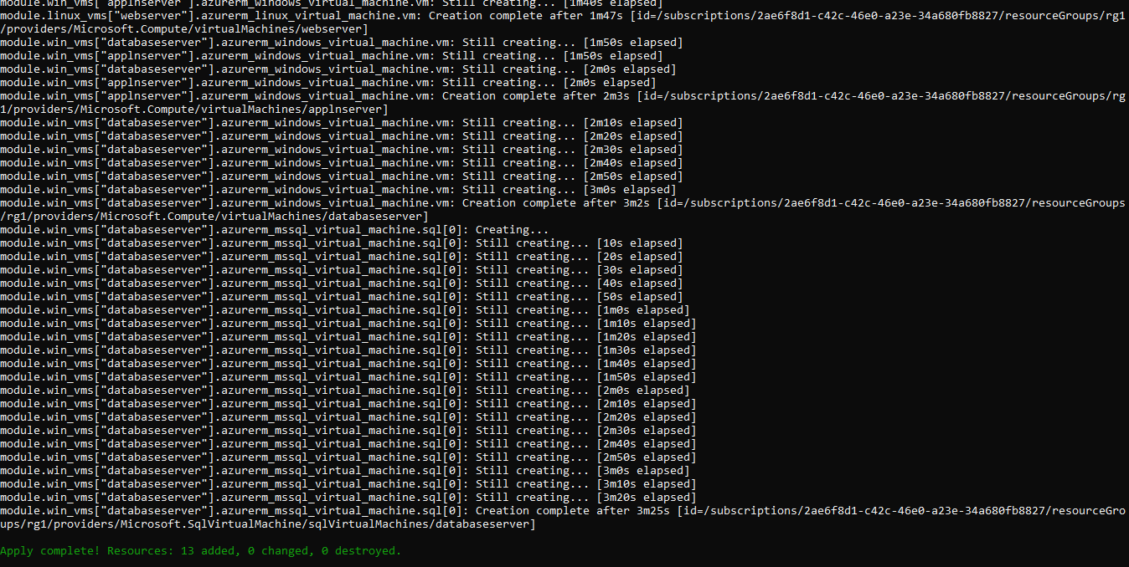

Portal:





**Challenge #2**

We need to write code that will query the meta data of an instance within AWS and provide a json formatted output. The choice of language and implementation is up to you.

**Bonus Points**

The code allows for a particular data key to be retrieved individually

Hints

·         Aws Documentation (<https://docs.aws.amazon.com/>)

·         Azure Documentation (<https://docs.microsoft.com/en-us/azure/?product=featured>)

·         Google Documentation (<https://cloud.google.com/docs>)

**Output**:

Note: We should pass the value for parameter “keyrequired”. If you require entire metadata, then the value should be “all”. If a particular nested key is required the value should be “network/interface”

On passing the parameter “keyrequired” as “all”, we get the entire metadata as output. PFB snippet.

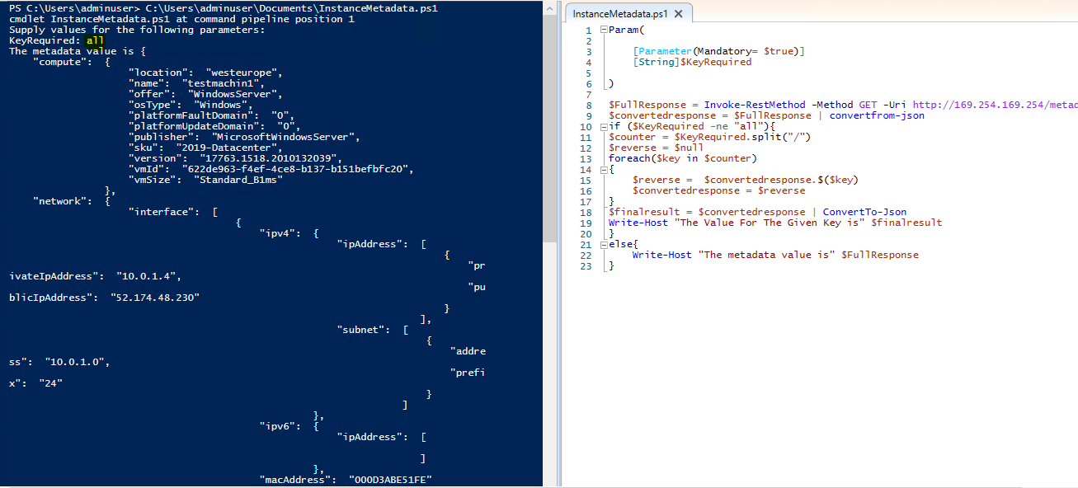

On passing the parameter “keyrequired” as “network/interface/mac”, we get the mac address in a Json object. PFB snippet.

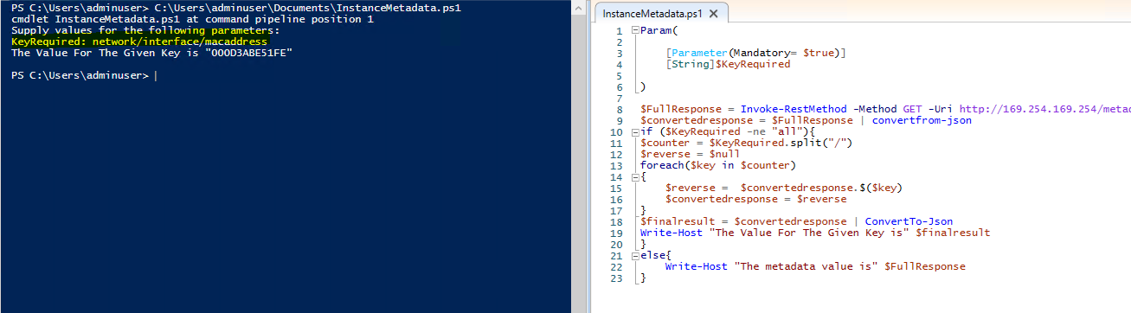

**Challenge #3**

We have a nested object, we would like a function that you pass in the object and a key and get back the value. How this is implemented is up to you.

Example Inputs

object = {“a”:{“b”:{“c”:”d”}}}

key = a/b/c

object = {“x”:{“y”:{“z”:”a”}}}

key = x/y/z

value = a

Hints:

*We would like to see some tests. A quick read to help you along the way*

*We would expect it in any other language apart from elixir.*

[*A quick read to help you along the way*](https://hexdocs.pm/elixir/master/Kernel.html#get_in/2)

**Output**:

Created a function by name “Get-NestedObjectValue” and passed two arguments (nestedobject, keys). PFB snippet for the same.

