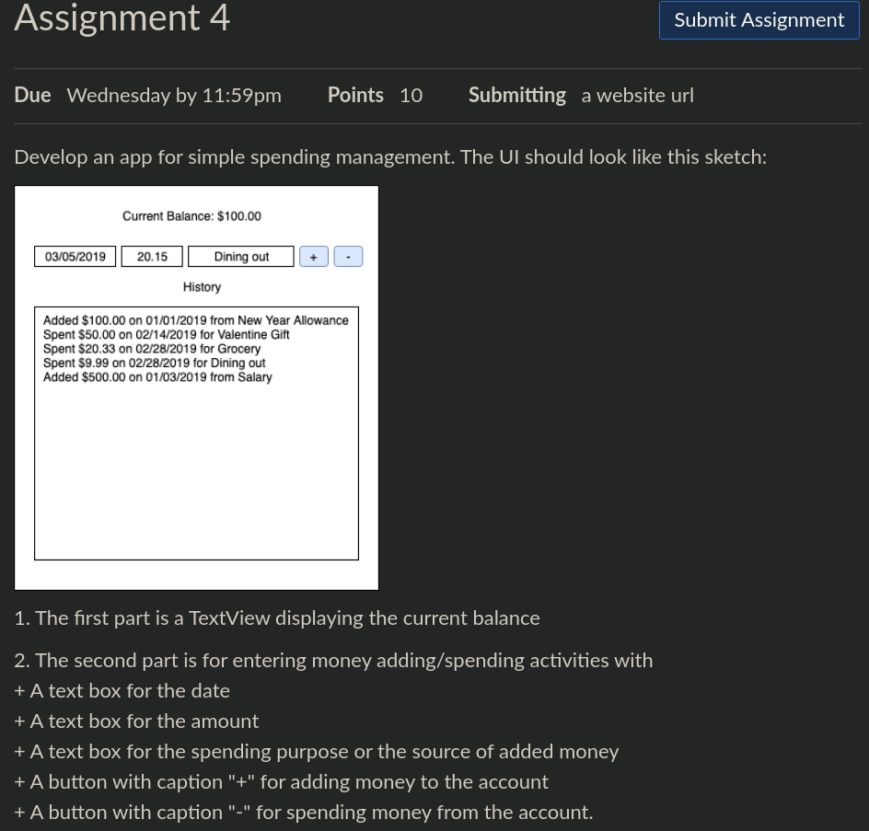
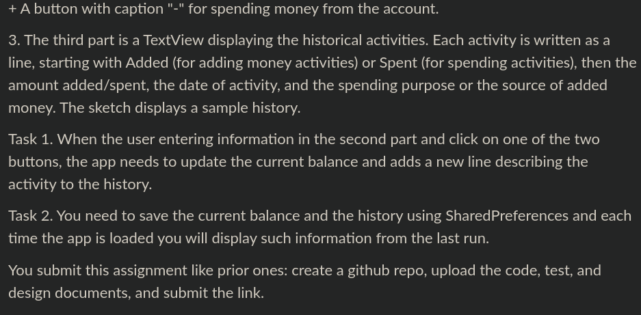
Task 1. When the user enters information in the second part and clicks on one of the two buttons, the app needs to update the current balance and add a new line describing the activity to the history.

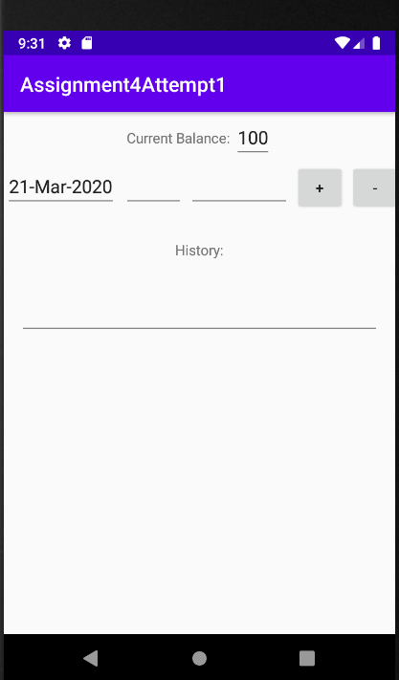
This is what it looks like when you open it after a fresh install.
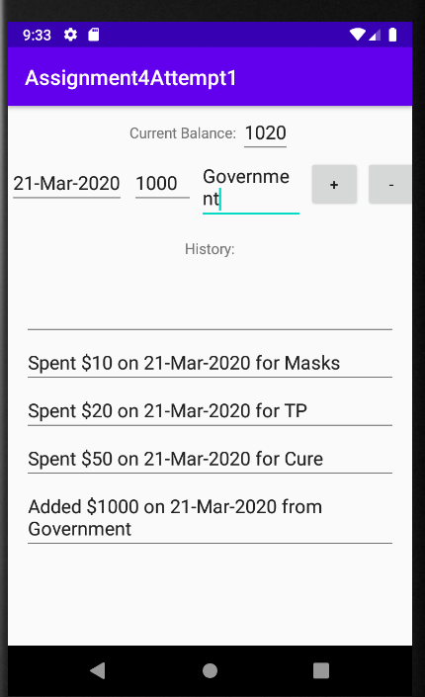
Then when the user enters information and clicks on one of the two buttons the app updates dynamically like this

Task 2. You need to save the current balance and the history using SharedPreferences and each time the app is loaded you need to display information from the last run.

Using Shared Preferences the information in the top part of the app is stored and restored upon exiting and closing the app.
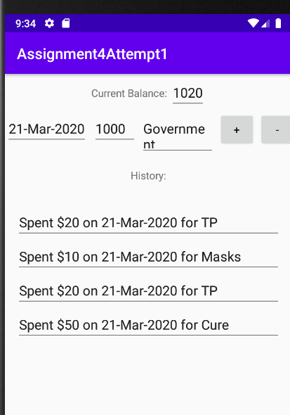
The information in the history section of the app is re-generated using strings stored in shared preferences and keeping track of the number of times an entry was committed the previous time the app was open.

