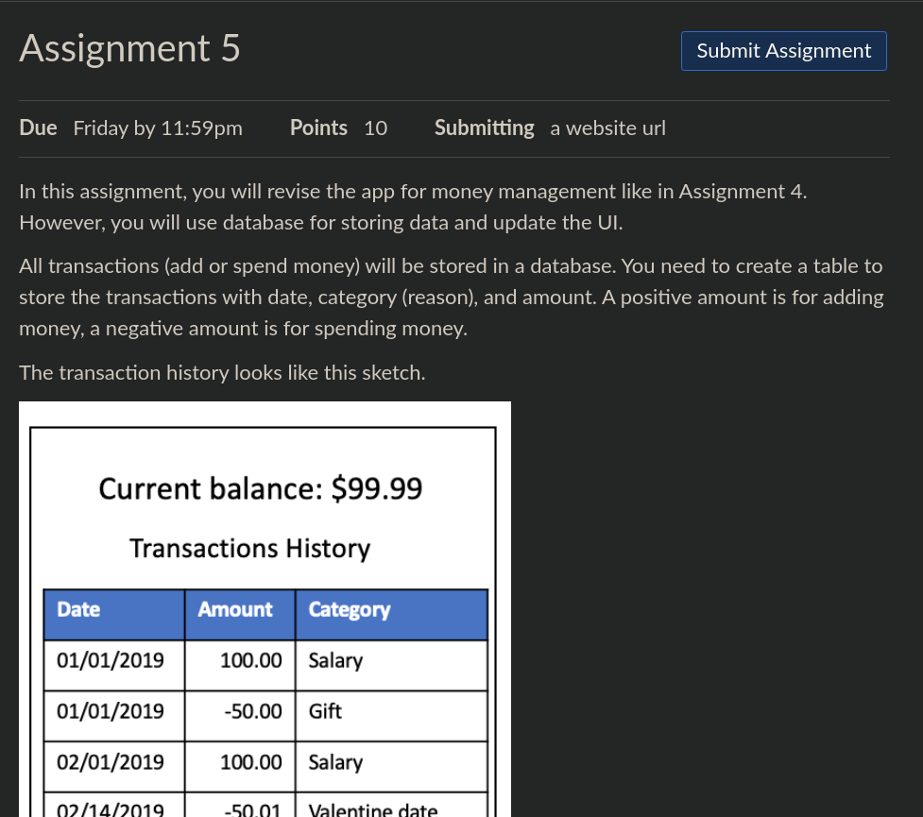

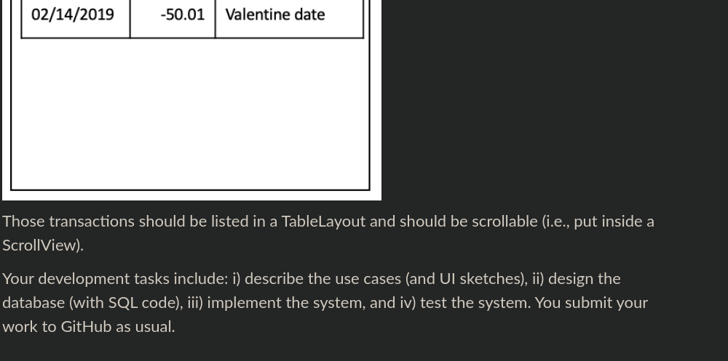

I) use cases:

Customer wants to log their expenses in an app to track their spending.

Customer wants to know the balance of their account after the result of all of their spending.

Customer wants to be able to view the history of past expenditures that is going to be saved through a SQL database.

UI:

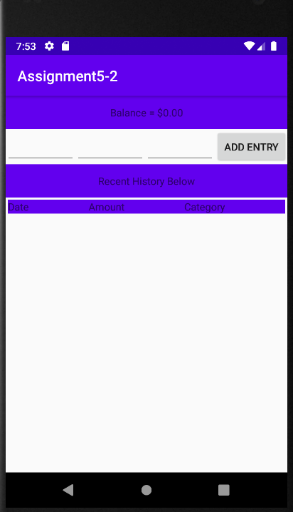ii) done

iii) done

iv) Test Screenshots:

