Assignment 6

Travis Harbin

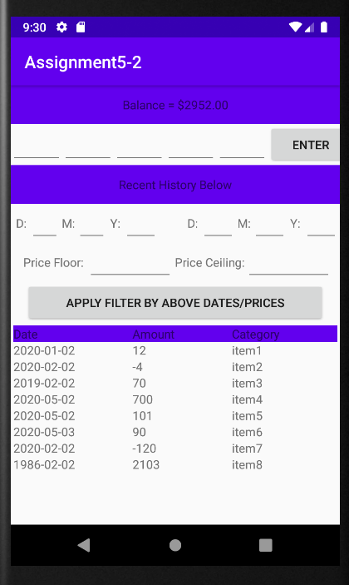

Here is the default ui with the test items loaded into the database:

1) Describe the use cases

1. A user might want to filter all transactions starting on a certain day such as jan 1 2020

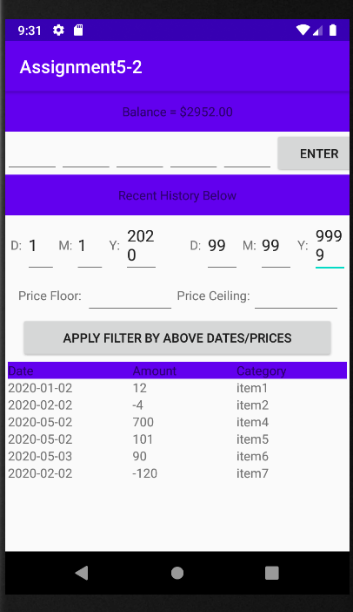

2) A user might want to filter all transactions in the database based on if the balance increased as a result of the entry, and filter those results by a date range:

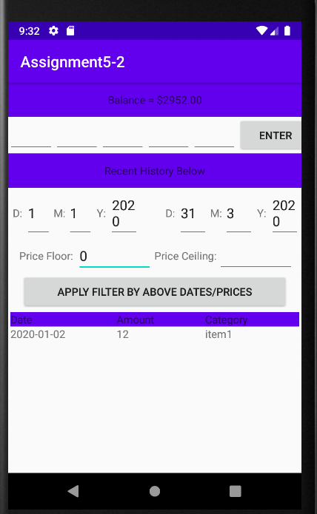

3) A user might want to filter all transactions in the database based on if the balance decreased 100$ or more as a result of the entry, and filter those results by a date range:

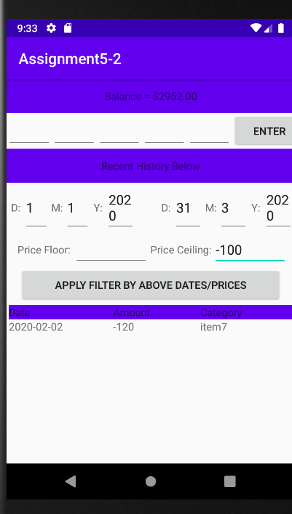

4) A user might want to filter all transactions in the database based on if the balance decreased 100$ to 500$ as a result of the entry, and filter those results by a date range:

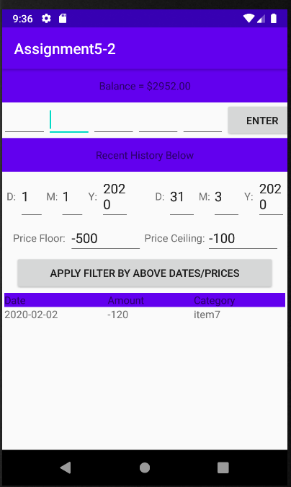

5) A user might want to filter all transactions in the database based on if the balance of a transaction was over 1000$:

