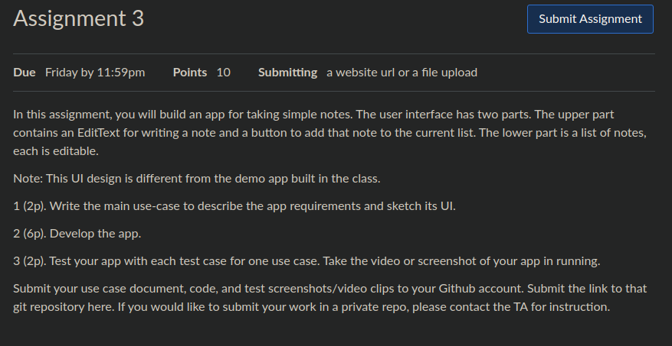

1. Main use-case:

The main use case would be that a user writes a note into the top edit text and clicks a button. The application would respond by taking the content in the top edit text and add it to the lower part dynamically.

Sketch the UI:

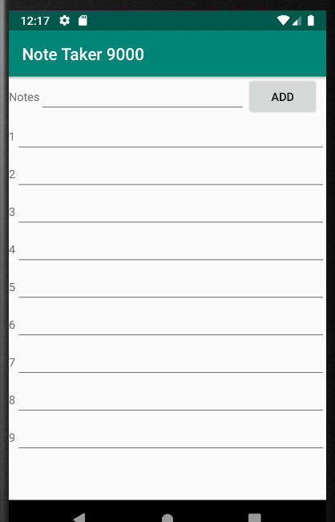

2. Develop the app: done

3. Test your app with each test case for one use case

Test screenshot:

