Integration Test Defects

1. **Submit button not loading Employee details page after clicking:**

After populating the fields on the ACME Corporation Employee Registration page with the provided test data, the browser does not load the Employee details page.

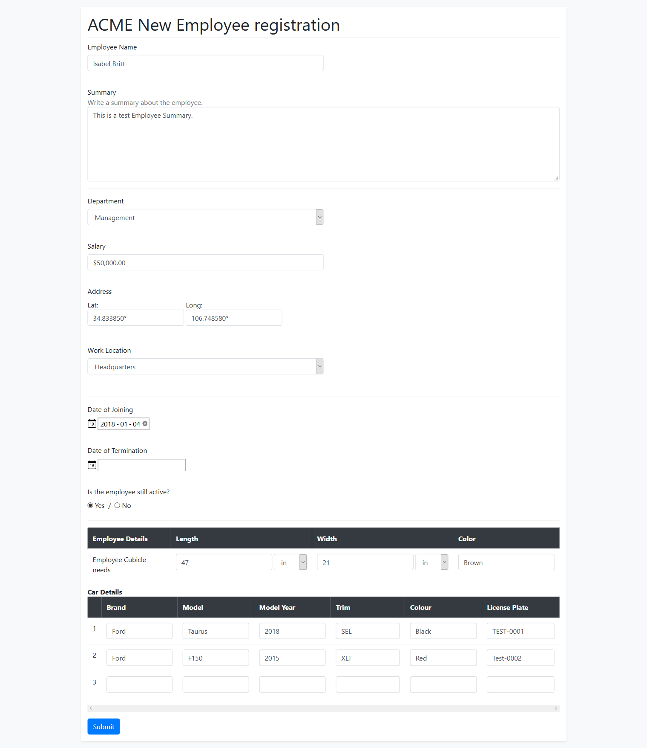

After inspecting the ‘Submit’ button the following error is displayed on the console:

***Content Security Policy: The page’s settings blocked the loading of a resource at inline (“script-src”).***

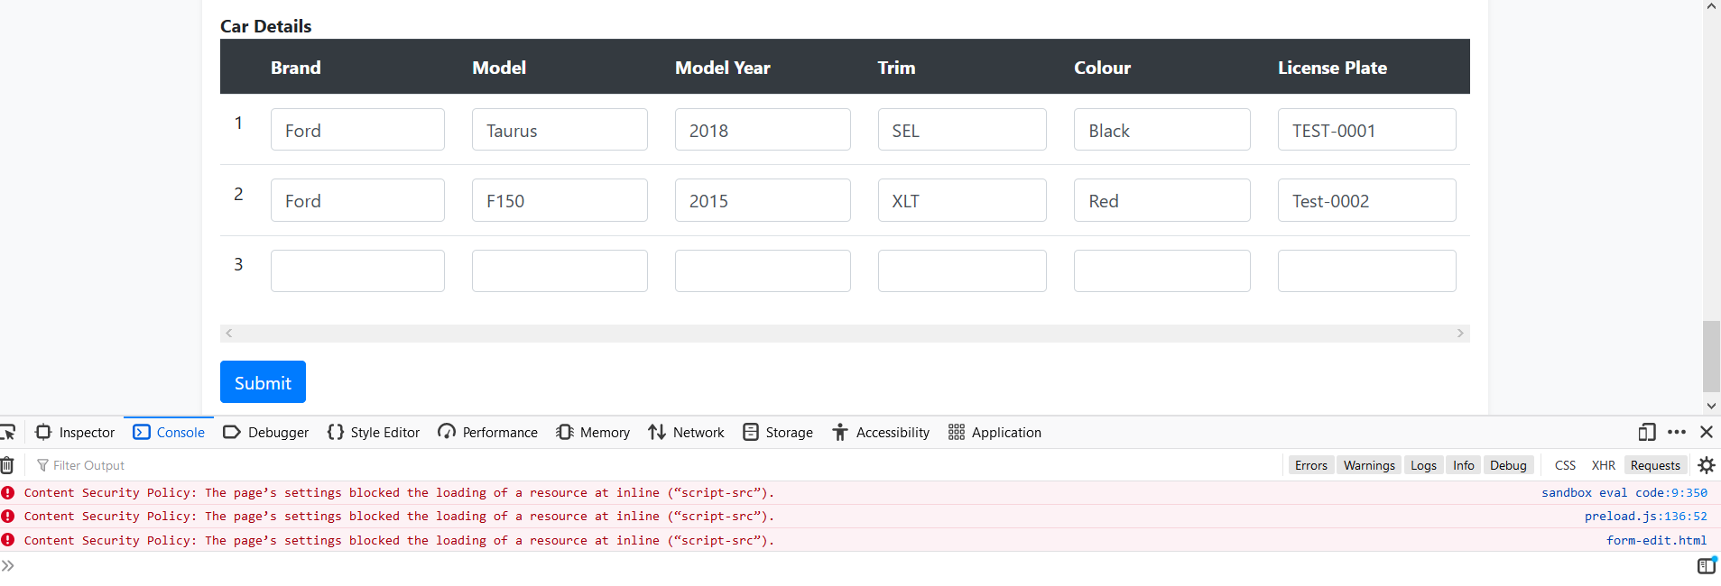

Expected Behaviour:

Employee details page is loaded in the browser.

1. **Date of Joining field mismatch:**

The date entered in the ‘Date of Joining’ text field on the ACME Corporation Employee Registration page is not displaying correctly on the Employee details page.

After entering “2018-01-04” (yyyy-mm-dd) in the text field:



Date of Joining is displayed as the following on the Employee details page:



Expected Behaviour:

Date of Joining field is populated with “Jan 4, 2018”

