Project Sprint 1

May 9, 2014

Herbivorous Grazing Cows

Brandon Cox, David Gartzke, Josh Harbison

**All data does get through**

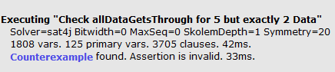

**All data does not get through**

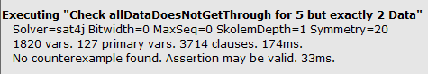

**Trace of 2 data being sent through 5 system states**

Initial state. The first sender (Sender3) has all the data (Data0 and Data1) in its buffer. The currentReciever (Reciever0) has no data in its buffer.

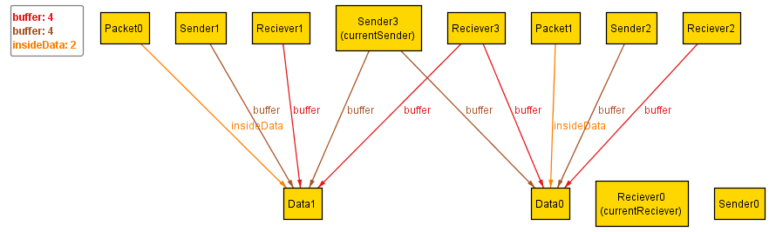

First send. The currentSender (Sender1) packeted one of the Datas in its buffer (Data0) into a Packet (Packet1) and is now inflight.

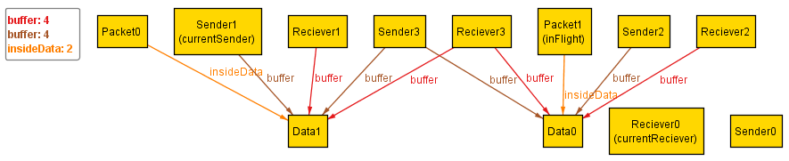

First receive. Reciever2 got the packeted data (Data0) from the packet (Packet1) and stores the data in its buffer.

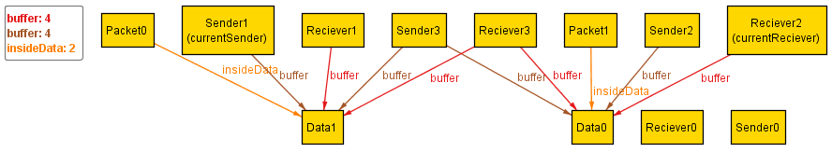

Second send. The sender (Sender0) packeted the last of its data (Data1) in to a packet (Packet0) and it is in flight.

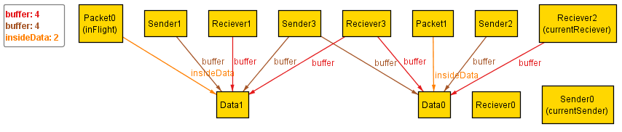

Second receive (final state). The reciever (Reciever3) has extracted the last of the data from the packet (Packet0) and stored it in its buffer. Now all the data is in the reciever’s buffer and none of the data is in the sender’s buffer, which is our final state.

