Project Sprint 2

May 16, 2014

Herbivorous Grazing Cows

Brandon Cox, David Gartzke, Josh Harbison

**Trace of 2 data being sent through 5 system states**

Initial state. DataPayload0 and DataPayload1 are in the sendbuffer. Packet0, Packet1, Packet2, Packet3, Ack0, and Ack1 are just there. We tried to limit the model to exclude extra Packets and data objects, but it ended up causing errors and producing strange results.

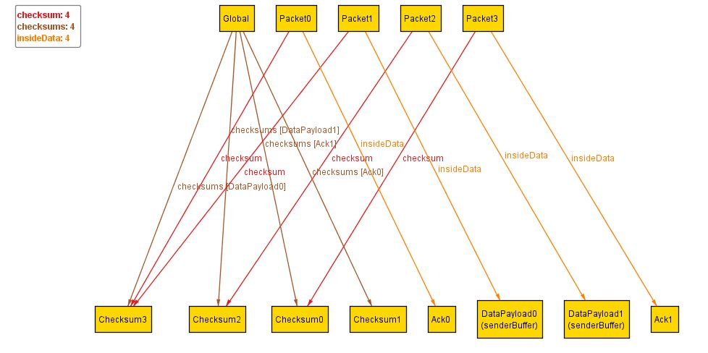

The sender has put DataPayload0 into Packet1 and it is currently in flight to the receiver. DataPayload0 is also put in the mostRecentlySent. The checksum for the packet is correct (Checksum3). Again, Packet2, Packet3, Packet0, Ack0, and Ack1 have no effect on the system.

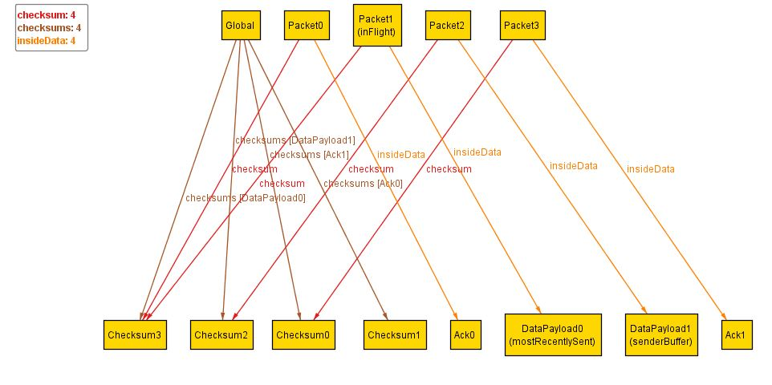

Since the checksum passed in Packet1, the receiver sends back Packet3 to the sender with an Ack1 with a correct checksum.

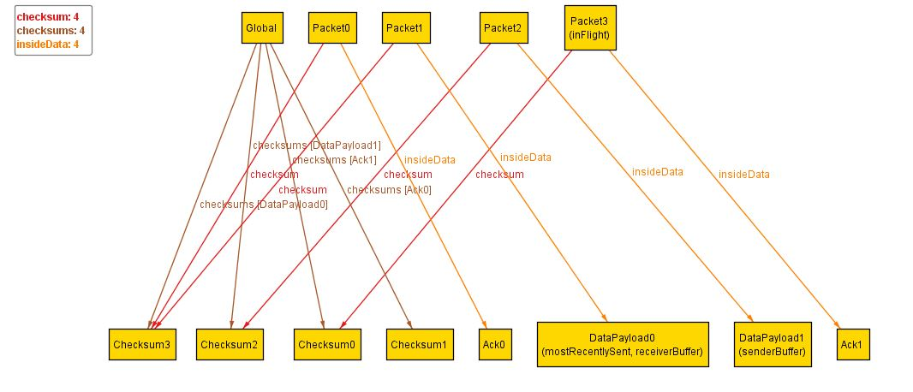

Since the checksum for Ack0 passed, the sender takes DataPayload1 out of the SendBufffer and puts it into Packet2 and sets mostRecentlySent to DataPayload1.

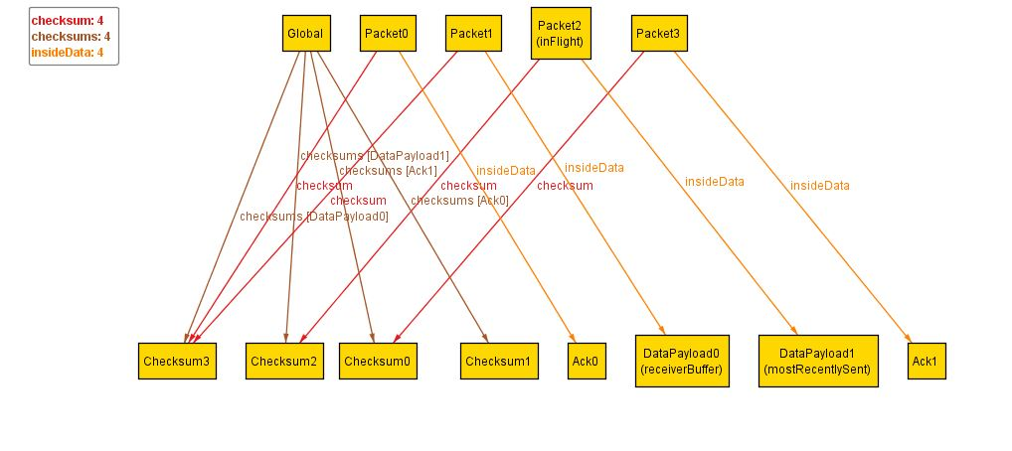

The receiver gets Packet2, extracts DataPayload1, and puts it in the receiverBuffer because Packet2’s checksum passed. Then the receiver sends an Ack1 in Packet3 to the sender to let it know Packet2 was received. 