Set0

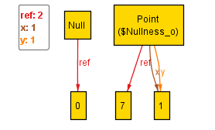

**public** **static** **void** main(String[] args) {

Point p = **new** Point(7, 5);

**boolean** result = p.equals(**null**);

System.out.println("Result of point equal to null was : " + result + " Expected: false");

}

Alloy gives a counterexample showing how, given the current design of the code, a Point can be evaluated as equal to a Null.

Set1

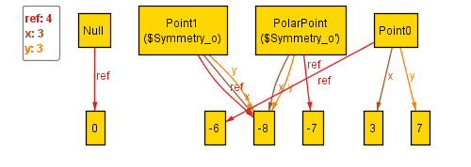

**public** **static** **void** main(String[] args) {

Point p = **new** Point(7, 1);

PolarPoint pp = **new** PolarPoint(p);

System.out.println("Should be: true");

System.out.println("It is: " + pp.equals(pp));

}

Alloy gives a counterexample showing how, given the current design of the code, a PolarPoint created from a Point is not equal to itself.