Lab Step 3:

1)

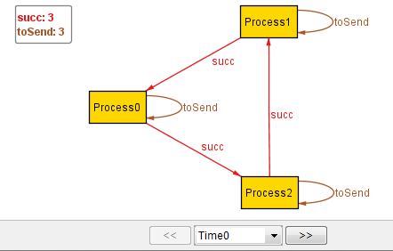

The initial state where all process pools contain only themselves

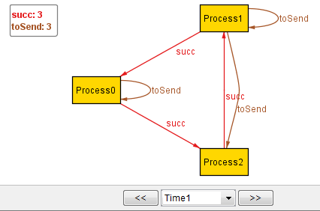

Process 2 sends itself to Process 1 whose pool now contains the ids for p1 and p2

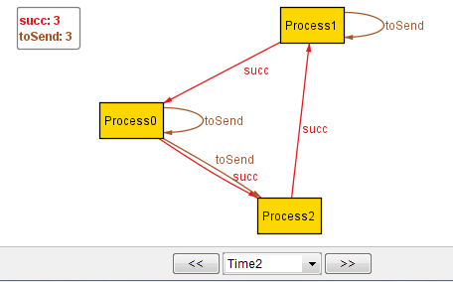

Process 1 determines Process2’s id is larger and sends it along to Process 0 whose pool now contains the ids of p0 and p2

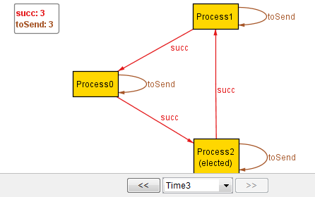

Process 0 determines Process2’s id is larger so it sends it along to Process2 who sees that it received its own id back so elects itself leader

2)

The assertion is valid

3)

All processes chose to skip so nothing happened

4)

The assertion is valid because we constrained it on “progress” so a process can’t chose to skip if it has an id it can send forward

5)

By not getting an instance for scope of 13 we can conclude that a scope of 12 is enough to reach all states for a three-node ring

Homework Questions:

Q2)

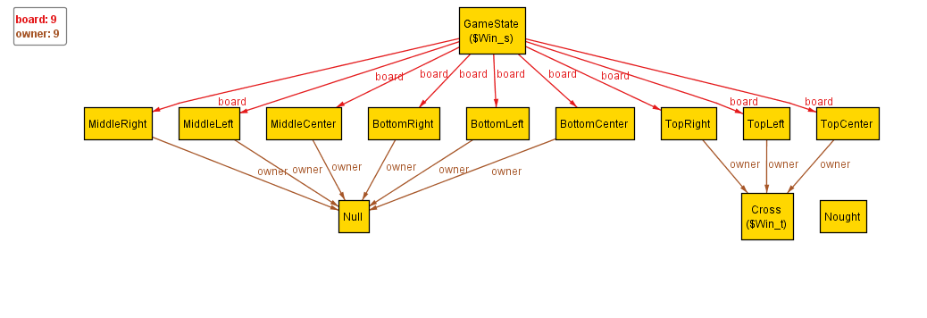

|  |  |  |
| --- | --- | --- |
| X | X | X |
|  |  |  |
|  |  |  |

Based on my predicate Alloy produced a correct win state but not a valid win state. By this I mean that, yes, technically the Cross player has won the game but it is not a valid gamestate because it is not possible for a player to own three positions without the other player, Nought, owning any positions since each player takes turns claiming one position. This particular instance shows Cross winning by have three along the top row like so:

Q3)

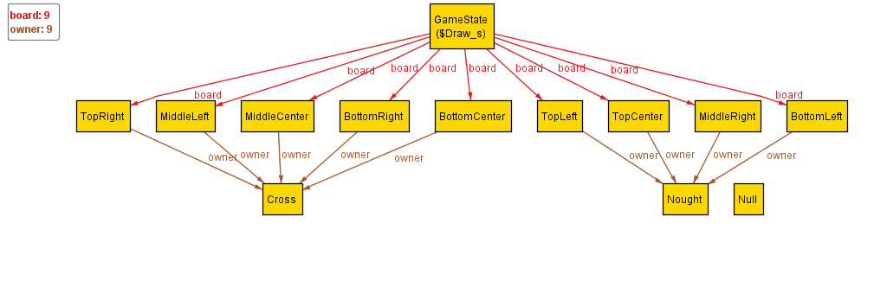

My predicate produced this instance of a valid draw state in which all positions are claimed by either Cross or Nought, and neither player has won.

|  |  |  |
| --- | --- | --- |
| O | O | X |
| X | X | O |
| O | X | X |

Q8)

Could not produce a trace to show here as I could not get Transition to function correctly

Q9)

Same as Q8