The home page will consist of a fixed navbar containing the elements “Home” “About us” “Teams” “Contact” and “Upcoming Games (I forgot to put that in the picture, have it to the right side before contact)”.

Directly below will be a jumbotron saying “Cornwall’s Premier Summer Basketball League”, and below this (still in the jumbotron) will be two buttons next to one another. One will be the option “Join a team”, and the other will be “Make a team”.

Below the jumbotron will be the “About us” section, and below that will be the Contact section. Clicking on the About Us or Contact section on the navbar should redirect the person to the appropriate part of the page.

If a player selects upcoming games redirect them to a page that will state when each time is playing and who they are playing. (this will have to be constantly updated by me).

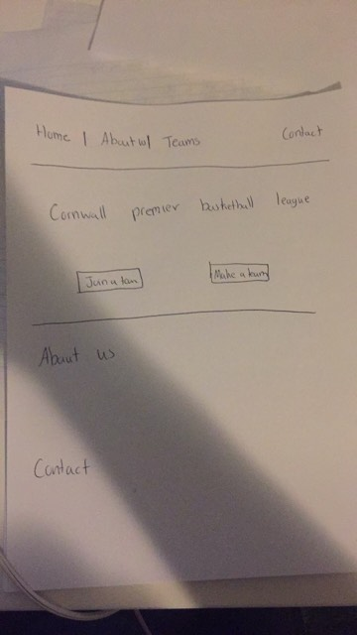

If they click on “Make a team” ask them for the following information:

* First Name
* Last Name
* Phone
* Address
* Email (if possible, after they sign up can we automatically send them an email)
* Team Name
* Player number (Chose a number not already taken by a teammate; range from 0-99)
* Have them pay $99.99

If they click on “Join a team”, show them all the available teams at the moment. When they click on a team allow them to see the players already on it. Give them the option “Join this team”, and then ask them for all the above information and also have them pay $99.99. If no teams are available (because none have been made yet) tell them “There are no teams currently available, would you like to make one? And then redirect them to the “Make a team” page.

When clicking on the team option on the navbar, redirect the user to a different page. In this page I would like a list of all the teams enrolled in this basketball tournament. I want their team name, their record (wins and loss, which needs to be constantly updated by me), and their leading scorer (also consistently updated by me). Below the list, I would like a playoff bracket, that shows the top 8 teams. This will also need to be consistently updated based on the changes to the teams record over the course of the tournament. When you click on a team on the list, I would like it to redirect the user to a page that states all the players on that particular team. When you click on a player, have something toggle down stating how much that particular player averages in points, assists and rebounds (this needs to be updated by me).

