Supplementary Materials for
Factors determining taxonomic and phylogenetic beta-diversity of plants across Chinese university campuses

This file includes:
Appendix S1 Methods
- S1.1 Data compilation
- S1.2 Data analysis
Appendix S2 Results
Appendix S3 Tables and Figures
- Tables S1 to S4
- Figures S1 to S4
References

Appendix S1 Methods

S1.1 Data compilation
To assess whether the inclusion of horticultural species influenced our results, we used the checklist of horticultural taxa from the Catalogue of Cultivated Plants in China (Lin, 2018) to exclude horticultural species and retain only non-horticultural ones. The filtered campus-level dataset comprised 272 occurrence records across 27 campuses (220 native, 44 non-invasive alien, and 8 invasive). Because too few invasive records remained (only one non-horticultural invasive species, recorded on 8 campuses), we repeated the beta-diversity analysis for all species except the invasive one.

S1.2 Data analysis
Multiple Regression on Distance Matrices (MRM) was used to assess statistical associations between beta-diversity matrices and predictor variables represented as distance matrices. MRM analyses were conducted for taxonomic beta-diversity and phylogenetic beta-diversity, and for three response components: total beta diversity, turnover, and nestedness. For each diversity type and component, models were fitted separately for all species, native species, and non-invasive alien species. The significance of regression coefficients was evaluated using permutation tests.
To disentangle the relative importance of environmental versus anthropogenic drivers, we conducted variance decomposition on the MRM models by comparing the R² values of models containing each predictor group separately and in combination. Environmental factors included campus distance, elevation, mean annual precipitation (MAP), and mean annual temperature (MAT); anthropogenic factors included campus age, campus area, GDP per area, population density, and urbanization level. This approach quantified the unique contribution of each category, their shared explanatory power, and the unexplained proportion of beta-diversity.

Appendix S2 Results
After excluding horticultural-list species, the updated MRM models for taxonomic beta-diversity explained 5.7%-16.4% of variation across the retained groups and components. Most predictor variables were not significant. The only significant relationship was detected for native species, for which total taxonomic beta-diversity increased with greater campus distance (coefficient = 0.030, p = 0.033). No significant predictors were detected for turnover or nestedness components after horticultural-list species were excluded.
The variance decomposition indicated that most variation in taxonomic beta-diversity remained unexplained (83.6%-94.3%). Environmental factors explained more variation than anthropogenic factors for total beta diversity and turnover in all three species groups. In contrast, anthropogenic factors explained more variation than environmental factors for nestedness, especially in all species and native species.
The updated MRM models for phylogenetic beta-diversity explained 3.8%-21.8% of variation. Significant relationships were detected only for total phylogenetic beta-diversity. Across all species, total phylogenetic beta-diversity increased with greater elevation differences (coefficient = 0.055, p = 0.033). For native species, total phylogenetic beta-diversity increased with both campus distance (coefficient = 0.045, p = 0.042) and elevation (coefficient = 0.051, p = 0.021). No significant predictors were detected for phylogenetic turnover or nestedness.
For phylogenetic variance decomposition, unexplained variance ranged from 78.2% to 96.2%. Environmental factors explained more variation than anthropogenic factors for total phylogenetic beta-diversity and turnover across all three species groups. By contrast, anthropogenic factors explained slightly more variation than environmental factors for phylogenetic nestedness, consistent with the corresponding taxonomic nestedness pattern.

Appendix S3 Tables and Figures
Table S1 Results of Multiple Regression on Distance Matrices (MRM) examining effects of environmental and anthropogenic factors on taxonomic β-diversity and its components (turnover and nestedness) across three plant status groups after excluding horticultural-list species. The regression coefficients for each predictor variable, the associated significance levels, and R² are given. Significant coefficients are highlighted in bold. Significance levels are indicated as follows: ^{ns}p ≥ 0.05, *p < 0.05, **p < 0.01, ***p < 0.001.
Variable | All species |  |  | Native species |  |  | Non-invasive species
 | β_{tax.sor} | β_{tax.sim} | β_{tax.nes} | β_{tax.sor} | β_{tax.sim} | β_{tax.nes} | β_{tax.sor} | β_{tax.sim} | β_{tax.nes}
Urbanization level | 0.025^{ns} | 0.057^{ns} | -0.033^{ns} | -0.002^{ns} | 0.025^{ns} | -0.027^{ns} | 0.076^{ns} | 0.127^{ns} | -0.051^{ns}
Population density | -0.001^{ns} | -0.026^{ns} | 0.025^{ns} | -0.027^{ns} | -0.074^{ns} | 0.046^{ns} | 0.056^{ns} | 0.009^{ns} | 0.047^{ns}
GDP per area | -0.031^{ns} | -0.087^{ns} | 0.056^{ns} | 0.030^{ns} | -0.008^{ns} | 0.039^{ns} | -0.167^{ns} | -0.186^{ns} | 0.019^{ns}
MAP | 0.004^{ns} | 0.011^{ns} | -0.007^{ns} | -0.001^{ns} | 0.001^{ns} | -0.002^{ns} | 0.018^{ns} | 0.034^{ns} | -0.015^{ns}
MAT | 0.009^{ns} | 0.015^{ns} | -0.006^{ns} | 0.020^{ns} | 0.040^{ns} | -0.019^{ns} | -0.024^{ns} | -0.025^{ns} | 0.001^{ns}
Elevation | 0.031^{ns} | 0.033^{ns} | -0.002^{ns} | 0.014^{ns} | -0.003^{ns} | 0.017^{ns} | 0.072^{ns} | 0.095^{ns} | -0.022^{ns}
Campus distance | 0.028^{ns} | 0.036^{ns} | -0.008^{ns} | 0.030* | 0.048^{ns} | -0.018^{ns} | 0.026^{ns} | 0.029^{ns} | -0.002^{ns}
Campus area | -0.009^{ns} | -0.009^{ns} | -0.000^{ns} | 0.000^{ns} | 0.008^{ns} | -0.007^{ns} | -0.050^{ns} | -0.068^{ns} | 0.018^{ns}
Campus age | -0.000^{ns} | -0.003^{ns} | 0.003^{ns} | -0.003^{ns} | -0.004^{ns} | 0.000^{ns} | 0.019^{ns} | 0.025^{ns} | -0.006^{ns}
R² | 0.145 | 0.152 | 0.164 | 0.164 | 0.148 | 0.158 | 0.094 | 0.093 | 0.057

Table S2 Relative contributions of environmental and anthropogenic factors to taxonomic β-diversity and its components (turnover and nestedness) across three plant status groups after excluding horticultural-list species. Anthropogenic factors include urbanization level, population density, GDP per area, campus area, and campus age; environmental factors include mean annual precipitation (MAP), mean annual temperature (MAT), elevation, and campus distance.
Group | Component | R² full | Environmental | Anthropogenic | Shared | Unexplained
All species | Beta diversity | 0.145 | 0.133 | 0.009 | 0.003 | 0.855
 | Turnover | 0.152 | 0.081 | 0.062 | 0.009 | 0.848
 | Nestedness | 0.164 | 0.017 | 0.140 | 0.007 | 0.836
Native species | Beta diversity | 0.164 | 0.160 | 0.003 | 0.001 | 0.836
 | Turnover | 0.148 | 0.085 | 0.056 | 0.007 | 0.852
 | Nestedness | 0.158 | 0.034 | 0.121 | 0.004 | 0.842
Non-invasive species | Beta diversity | 0.094 | 0.060 | 0.035 | -0.001 | 0.906
 | Turnover | 0.093 | 0.057 | 0.038 | -0.002 | 0.907
 | Nestedness | 0.057 | 0.028 | 0.029 | -0.001 | 0.943

Table S3 Results of Multiple Regression on Distance Matrices (MRM) examining effects of environmental and anthropogenic factors on phylogenetic β-diversity and its components (turnover and nestedness) across three plant status groups after excluding horticultural-list species. The regression coefficients for each predictor variable, the associated significance levels, and R² are given. Significant coefficients are highlighted in bold. Significance levels are indicated as follows: ^{ns}p ≥ 0.05, *p < 0.05, **p < 0.01, ***p < 0.001.
Variable | All species |  |  | Native species |  |  | Non-invasive species
 | β_{phy.sor} | β_{phy.sim} | β_{phy.nes} | β_{phy.sor} | β_{phy.sim} | β_{phy.nes} | β_{phy.sor} | β_{phy.sim} | β_{phy.nes}
Urbanization level | -0.019^{ns} | 0.007^{ns} | -0.025^{ns} | -0.081^{ns} | -0.078^{ns} | -0.003^{ns} | 0.035^{ns} | 0.053^{ns} | -0.019^{ns}
Population density | 0.057^{ns} | 0.001^{ns} | 0.056^{ns} | 0.024^{ns} | -0.015^{ns} | 0.039^{ns} | 0.082^{ns} | 0.032^{ns} | 0.050^{ns}
GDP per area | -0.032^{ns} | -0.040^{ns} | 0.008^{ns} | 0.073^{ns} | 0.074^{ns} | -0.001^{ns} | -0.149^{ns} | -0.131^{ns} | -0.018^{ns}
MAP | 0.017^{ns} | 0.028^{ns} | -0.012^{ns} | 0.020^{ns} | 0.036^{ns} | -0.016^{ns} | -0.006^{ns} | 0.002^{ns} | -0.008^{ns}
MAT | -0.016^{ns} | -0.040^{ns} | 0.024^{ns} | -0.014^{ns} | -0.057^{ns} | 0.043^{ns} | -0.031^{ns} | -0.038^{ns} | 0.007^{ns}
Elevation | 0.055* | 0.044^{ns} | 0.012^{ns} | 0.051* | 0.037^{ns} | 0.014^{ns} | 0.047^{ns} | 0.059^{ns} | -0.012^{ns}
Campus distance | 0.039^{ns} | 0.055^{ns} | -0.017^{ns} | 0.045* | 0.071^{ns} | -0.026^{ns} | 0.048^{ns} | 0.060^{ns} | -0.011^{ns}
Campus area | -0.022^{ns} | -0.019^{ns} | -0.003^{ns} | -0.016^{ns} | -0.011^{ns} | -0.005^{ns} | -0.042^{ns} | -0.060^{ns} | 0.018^{ns}
Campus age | -0.009^{ns} | -0.015^{ns} | 0.006^{ns} | -0.014^{ns} | -0.019^{ns} | 0.005^{ns} | 0.003^{ns} | 0.004^{ns} | -0.001^{ns}
R² | 0.191 | 0.118 | 0.100 | 0.218 | 0.078 | 0.048 | 0.081 | 0.074 | 0.038

Table S4 Relative contributions of environmental and anthropogenic factors to phylogenetic β-diversity and its components (turnover and nestedness) across three plant status groups after excluding horticultural-list species. Anthropogenic factors include urbanization level, population density, GDP per area, campus area, and campus age; environmental factors include mean annual precipitation (MAP), mean annual temperature (MAT), elevation, and campus distance.
Group | Component | R² full | Environmental | Anthropogenic | Shared | Unexplained
All species | Beta diversity | 0.191 | 0.172 | 0.024 | -0.005 | 0.809
All species | Turnover | 0.118 | 0.094 | 0.025 | -0.002 | 0.882
All species | Nestedness | 0.100 | 0.016 | 0.087 | -0.004 | 0.900
Native species | Beta diversity | 0.218 | 0.188 | 0.042 | -0.011 | 0.782
Native species | Turnover | 0.078 | 0.072 | 0.011 | -0.005 | 0.922
Native species | Nestedness | 0.048 | 0.020 | 0.032 | -0.003 | 0.952
Non-invasive species | Beta diversity | 0.081 | 0.051 | 0.030 | -0.001 | 0.919
Non-invasive species | Turnover | 0.074 | 0.045 | 0.031 | -0.002 | 0.926
Non-invasive species | Nestedness | 0.038 | 0.015 | 0.024 | -0.001 | 0.962

Fig. S1 Coefficient plots from Multiple Regression on Distance Matrices (MRM) showing effects of environmental and anthropogenic factors on taxonomic β-diversity and its components (turnover and nestedness) across three species groups after excluding horticultural-list species: all species (A), native species (B), and non-invasive species (C). Predictor variables include city-level urbanization level, population density, and GDP density; campus-scale mean annual precipitation (MAP), mean annual temperature (MAT), and elevation; geographic distance between campuses; campus area; and campus age.
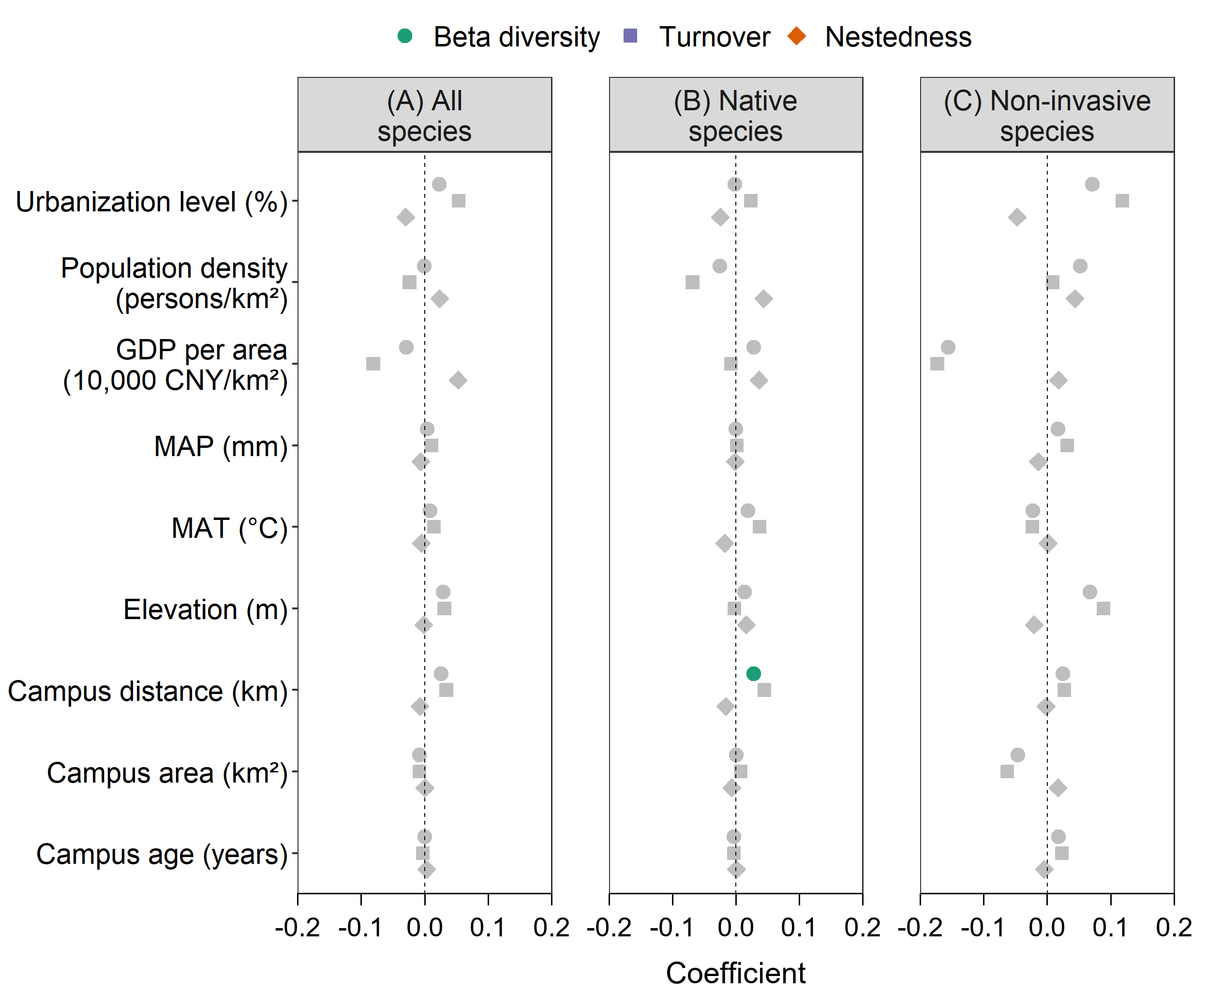

Fig. S2 Relative contributions of environmental and anthropogenic factors to taxonomic β-diversity and its components (turnover and nestedness) across three species groups after excluding horticultural-list species: all species (A), native species (B), and non-invasive species (C). Anthropogenic factors include urbanization level, population density, GDP per area, campus area, and campus age; environmental factors include mean annual precipitation (MAP), mean annual temperature (MAT), elevation, and campus distance.
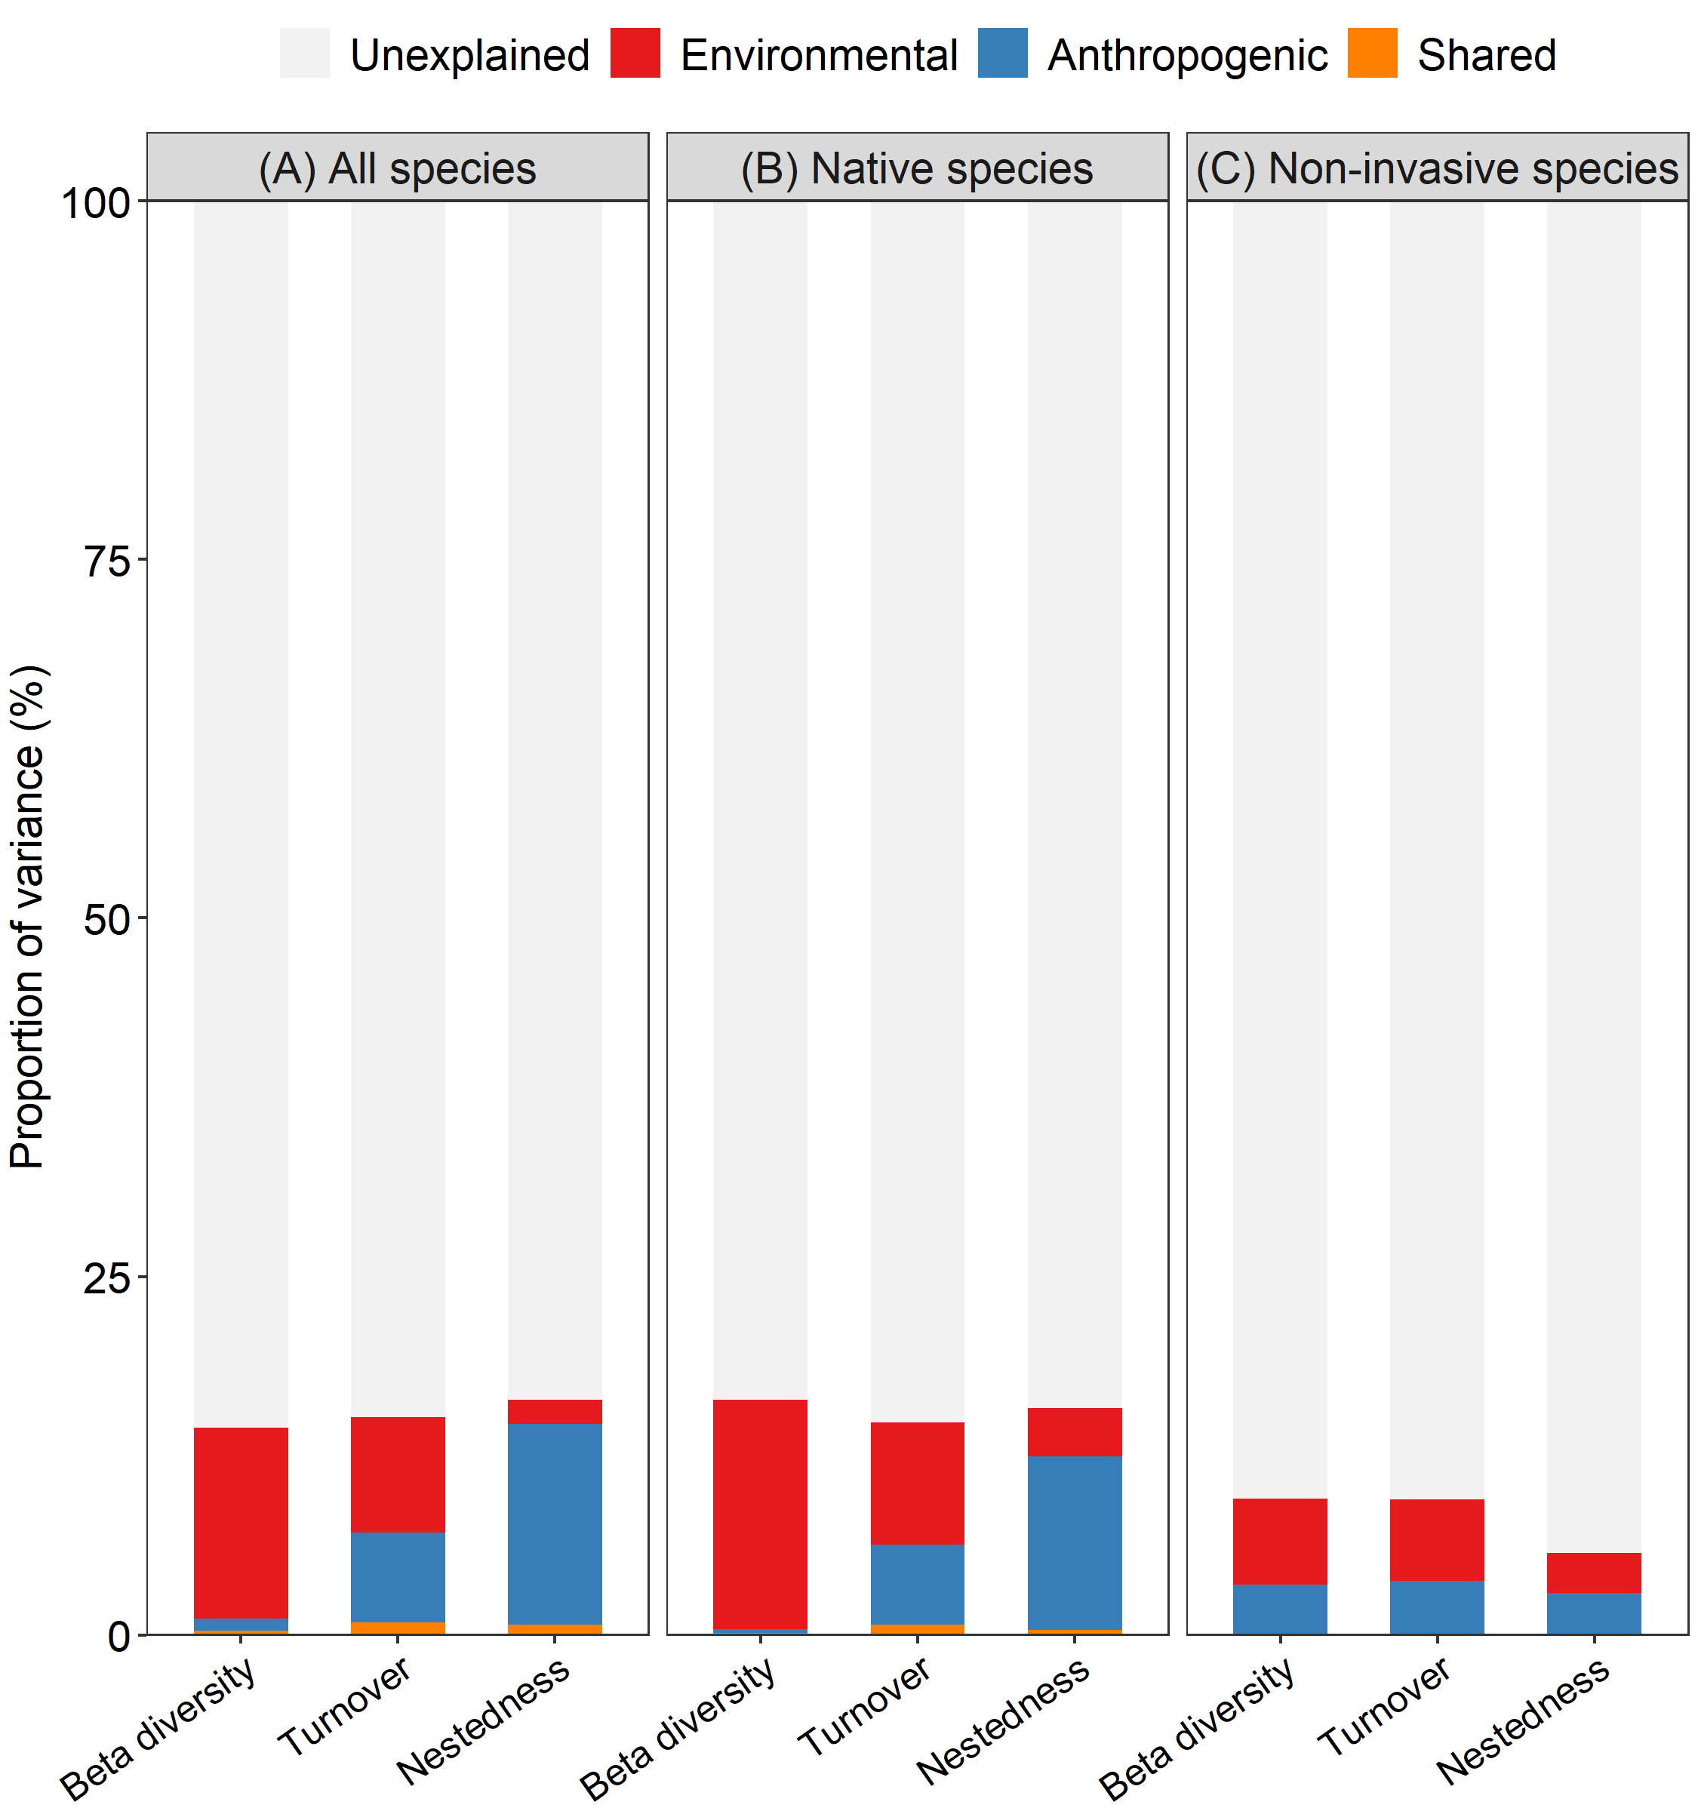

Fig. S3 Coefficient plots from Multiple Regression on Distance Matrices (MRM) showing effects of environmental and anthropogenic factors on phylogenetic β-diversity and its components (turnover and nestedness) across three species groups after excluding horticultural-list species: all species (A), native species (B), and non-invasive species (C). Predictor variables include city-level urbanization level, population density, and GDP density; campus-scale mean annual precipitation (MAP), mean annual temperature (MAT), and elevation; geographic distance between campuses; campus area; and campus age.
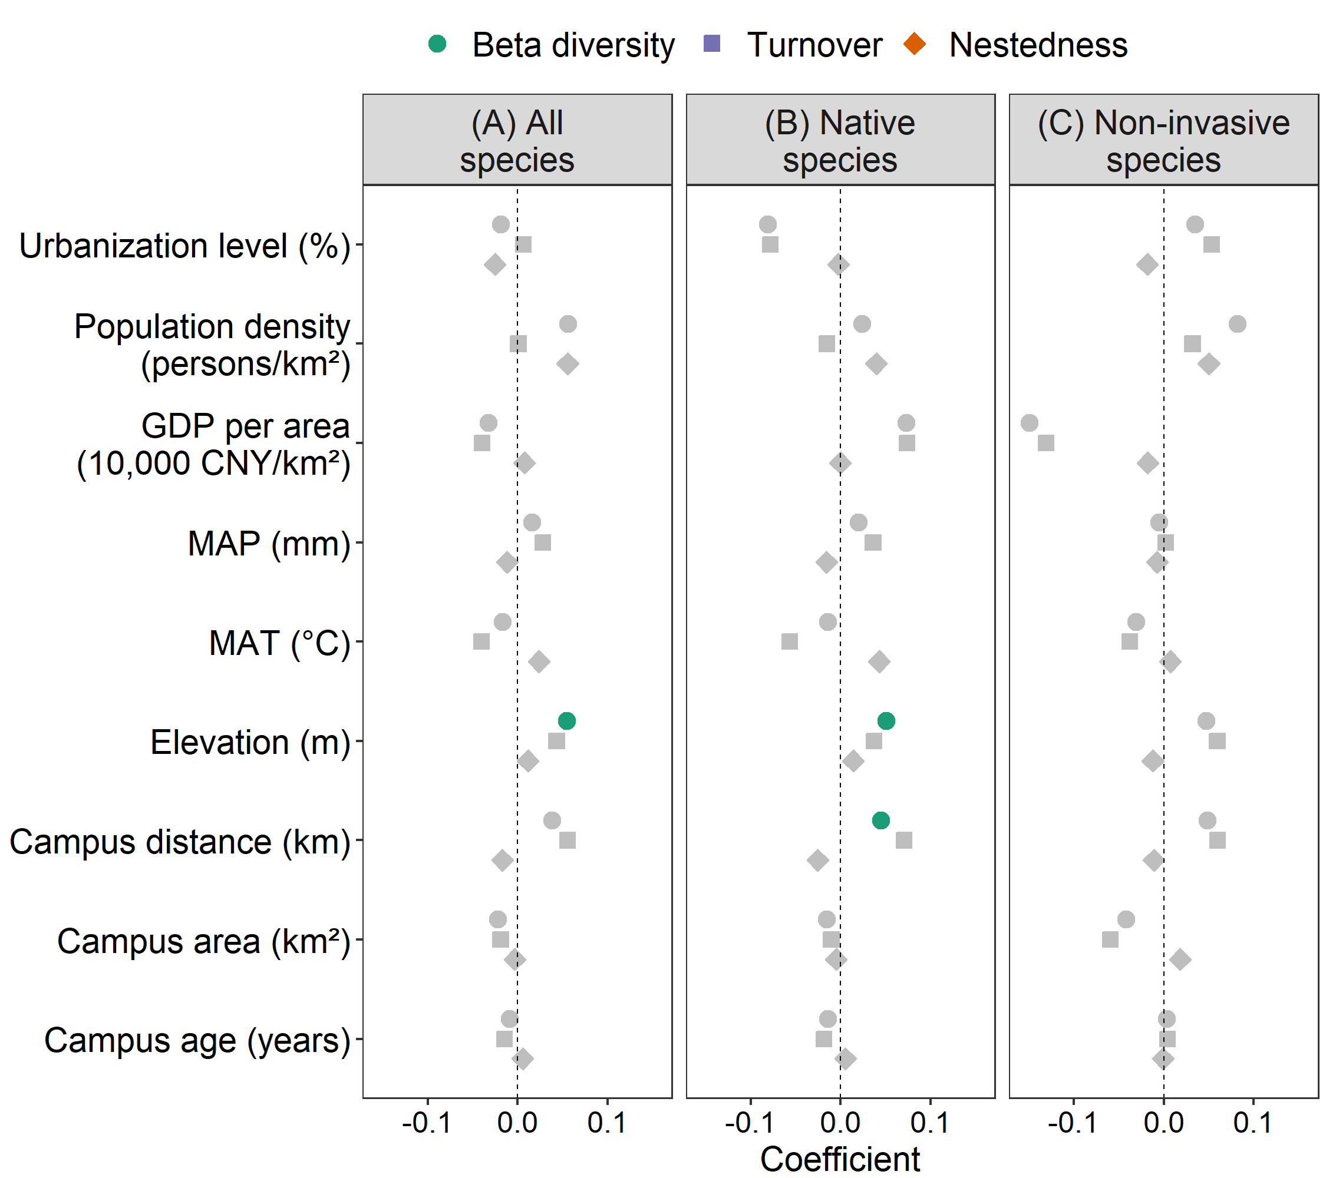

Fig. S4 Relative contributions of environmental and anthropogenic factors to phylogenetic β-diversity and its components (turnover and nestedness) across three species groups after excluding horticultural-list species: all species (A), native species (B), and non-invasive species (C). Anthropogenic factors include urbanization level, population density, GDP per area, campus area, and campus age; environmental factors include mean annual precipitation (MAP), mean annual temperature (MAT), elevation, and campus distance.
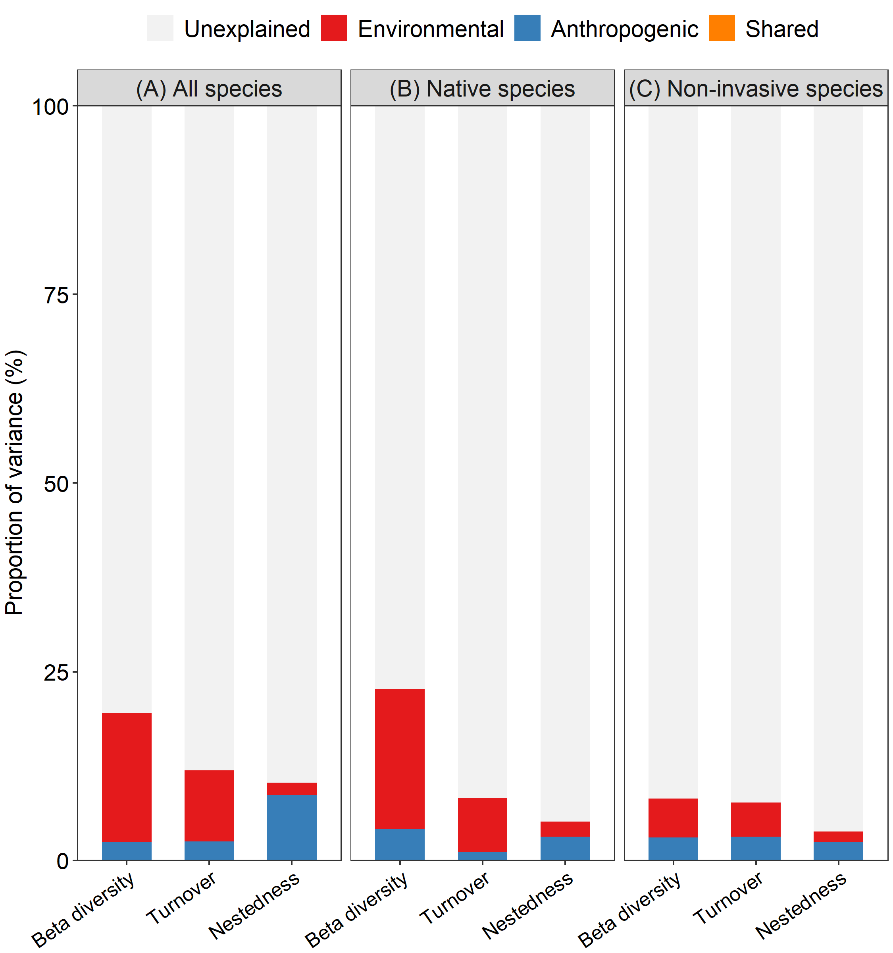

References
Lin, Q.-W. (2018). Catalogue of Cultivated Plants in China (Vols. 1-2). Beijing: Science Press. (In Chinese).

