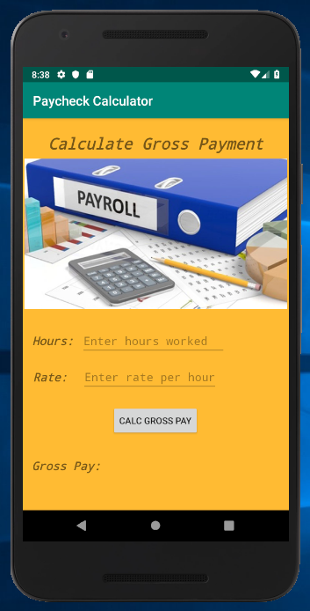

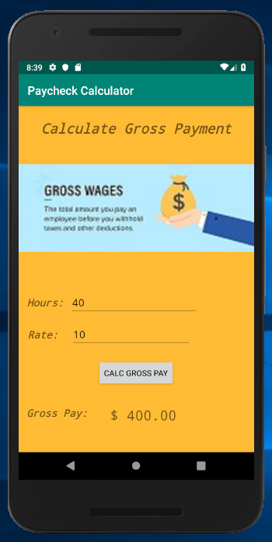

**package** com.example.paycheckcalculator;  
  
**import** android.graphics.drawable.Drawable;  
**import** android.support.v7.app.AppCompatActivity;  
**import** android.os.Bundle;  
**import** android.view.View;  
**import** android.widget.Button;  
**import** android.widget.EditText;  
**import** android.widget.ImageView;  
**import** android.widget.TextView;  
  
**public class** MainActivity **extends** AppCompatActivity {  
  
 @Override  
 **protected void** onCreate(Bundle savedInstanceState) {  
 **super**.onCreate(savedInstanceState);  
 setContentView(R.layout.***activity_main***);  
 } *// end onCreate()* **public void** calcGross(View v){  
 *// capture field inputs* **final** EditText h = (EditText) findViewById(R.id.***hrs***);  
 **final** EditText r = (EditText) findViewById(R.id.***payRate***);  
 **final** TextView g = (TextView) findViewById(R.id.***grossOutput***);  
 **final** ImageView i = (ImageView) findViewById(R.id.***logo***);  
  
 *// declare local variables* Double hours, rate, grossPay = 0.0;  
  
 *// capture text field inputs* hours = Double.*parseDouble*(h.getText().toString());  
 rate = Double.*parseDouble*(r.getText().toString());  
 grossPay = hours * rate;  
  
 *// setup output string formatting* String outputFormat = String.*format*(**"$%, .2f"**, grossPay);  
  
 *// post output to view* g.setText(outputFormat);  
  
 *// swap image within image view* i.setImageResource(R.drawable.***grosspay***);  
  
 } *// end calcGross()*} *// end MainActivity*

*<?***xml version="1.0" encoding="utf-8"***?>*<**android.support.constraint.ConstraintLayout xmlns:android="http://schemas.android.com/apk/res/android"  
 xmlns:app="http://schemas.android.com/apk/res-auto"  
 xmlns:tools="http://schemas.android.com/tools"  
 android:layout_width="match_parent"  
 android:layout_height="match_parent"  
 android:background="@android:color/holo_orange_light"  
 tools:context=".MainActivity"**>  
  
 <**TextView  
 android:id="@+id/title"  
 android:layout_width="wrap_content"  
 android:layout_height="wrap_content"  
 android:fontFamily="monospace"  
 android:text="@string/title"  
 android:textSize="24sp"  
 android:textStyle="bold|italic"  
 app:layout_constraintBottom_toBottomOf="parent"  
 app:layout_constraintLeft_toLeftOf="parent"  
 app:layout_constraintRight_toRightOf="parent"  
 app:layout_constraintTop_toTopOf="parent"  
 app:layout_constraintVertical_bias="0.039"** />  
  
 <**ImageView  
 android:id="@+id/logo"  
 android:layout_width="wrap_content"  
 android:layout_height="232dp"  
 android:contentDescription="@string/logo"  
 app:layout_constraintBottom_toBottomOf="parent"  
 app:layout_constraintHorizontal_bias="0.0"  
 app:layout_constraintLeft_toLeftOf="parent"  
 app:layout_constraintRight_toRightOf="parent"  
 app:layout_constraintTop_toTopOf="parent"  
 app:layout_constraintVertical_bias="0.166"  
 app:srcCompat="@drawable/payroll"** />  
  
 <**TextView  
 android:id="@+id/hours"  
 android:layout_width="wrap_content"  
 android:layout_height="wrap_content"  
 android:fontFamily="monospace"  
 android:text="@string/hours"  
 android:textSize="18sp"  
 android:textStyle="bold|italic"  
 app:layout_constraintBottom_toBottomOf="parent"  
 app:layout_constraintHorizontal_bias="0.043"  
 app:layout_constraintLeft_toLeftOf="parent"  
 app:layout_constraintRight_toRightOf="parent"  
 app:layout_constraintTop_toTopOf="parent"  
 app:layout_constraintVertical_bias="0.57"** />  
  
 <**EditText  
 android:id="@+id/hrs"  
 android:layout_width="224dp"  
 android:layout_height="wrap_content"  
 android:ems="10"  
 android:fontFamily="monospace"  
 android:hint="Enter hours worked"  
 android:inputType="textPersonName"  
 android:text=""  
 app:layout_constraintBottom_toBottomOf="parent"  
 app:layout_constraintHorizontal_bias="0.481"  
 app:layout_constraintLeft_toLeftOf="parent"  
 app:layout_constraintRight_toRightOf="parent"  
 app:layout_constraintTop_toTopOf="parent"  
 app:layout_constraintVertical_bias="0.574"** />  
  
 <**TextView  
 android:id="@+id/rate"  
 android:layout_width="wrap_content"  
 android:layout_height="26dp"  
 android:fontFamily="monospace"  
 android:text="@string/rate"  
 android:textSize="18sp"  
 android:textStyle="bold|italic"  
 app:layout_constraintBottom_toBottomOf="parent"  
 app:layout_constraintHorizontal_bias="0.045"  
 app:layout_constraintLeft_toLeftOf="parent"  
 app:layout_constraintRight_toRightOf="parent"  
 app:layout_constraintTop_toTopOf="parent"  
 app:layout_constraintVertical_bias="0.669"** />  
  
 <**EditText  
 android:id="@+id/payRate"  
 android:layout_width="wrap_content"  
 android:layout_height="wrap_content"  
 android:ems="10"  
 android:fontFamily="monospace"  
 android:hint="Enter rate per hour"  
 android:inputType="textPersonName"  
 android:text=""  
 app:layout_constraintBottom_toBottomOf="parent"  
 app:layout_constraintHorizontal_bias="0.454"  
 app:layout_constraintLeft_toLeftOf="parent"  
 app:layout_constraintRight_toRightOf="parent"  
 app:layout_constraintTop_toTopOf="parent"  
 app:layout_constraintVertical_bias="0.673"** />  
  
 <**TextView  
 android:id="@+id/gross"  
 android:layout_width="wrap_content"  
 android:layout_height="wrap_content"  
 android:fontFamily="monospace"  
 android:text="@string/gross"  
 android:textSize="18sp"  
 android:textStyle="bold|italic"  
 app:layout_constraintBottom_toBottomOf="parent"  
 app:layout_constraintHorizontal_bias="0.046"  
 app:layout_constraintLeft_toLeftOf="parent"  
 app:layout_constraintRight_toRightOf="parent"  
 app:layout_constraintTop_toTopOf="parent"  
 app:layout_constraintVertical_bias="0.903"** />  
  
 <**TextView  
 android:id="@+id/grossOutput"  
 android:layout_width="143dp"  
 android:layout_height="26dp"  
 android:fontFamily="monospace"  
 android:textSize="24sp"  
 app:layout_constraintBottom_toBottomOf="parent"  
 app:layout_constraintHorizontal_bias="0.597"  
 app:layout_constraintLeft_toLeftOf="parent"  
 app:layout_constraintRight_toRightOf="parent"  
 app:layout_constraintTop_toTopOf="parent"  
 app:layout_constraintVertical_bias="0.905"** />  
  
 <**Button  
 android:id="@+id/btnGrossCalc"  
 android:layout_width="wrap_content"  
 android:layout_height="wrap_content"  
 android:onClick="calcGross"  
 android:text="@string/btnGrossCalc"  
 app:layout_constraintBottom_toBottomOf="parent"  
 app:layout_constraintHorizontal_bias="0.498"  
 app:layout_constraintLeft_toLeftOf="parent"  
 app:layout_constraintRight_toRightOf="parent"  
 app:layout_constraintTop_toTopOf="parent"  
 app:layout_constraintVertical_bias="0.795"** />  
</**android.support.constraint.ConstraintLayout**>