61. How to configure firebase console setup for push notification?

**Ans:** To use firebase follow the procedure which are mentioned below

1. Go to this URL to create project <https://console.firebase.google.com/u/0/>

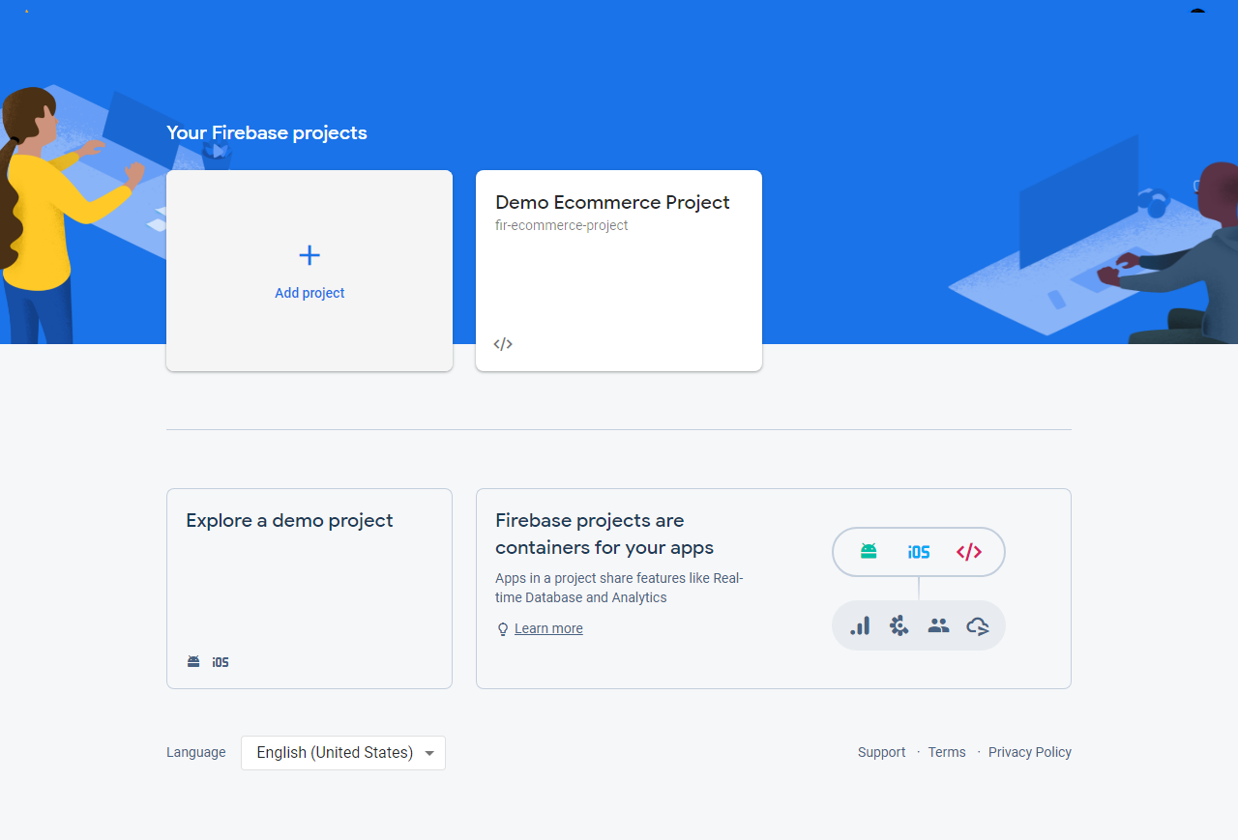

1. Enter project name and then click on **continue** button

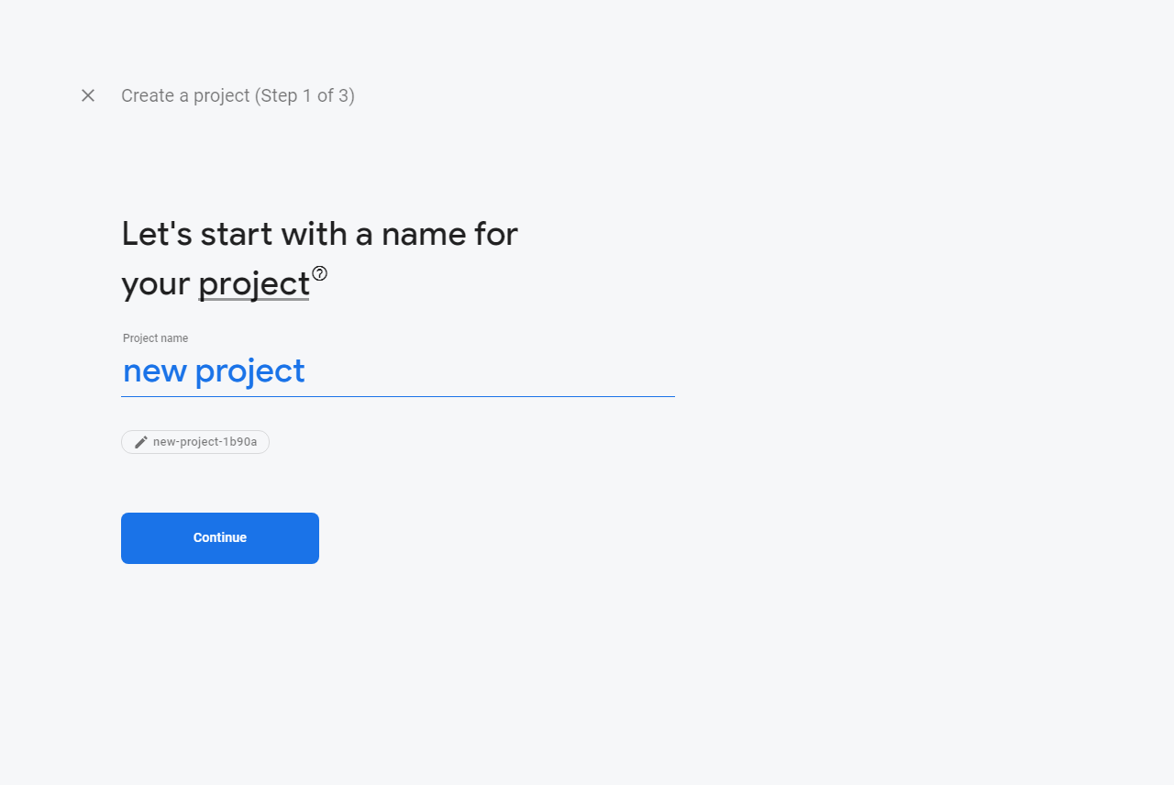

1. Disable the Google analytics for this project option and click **Create project** button

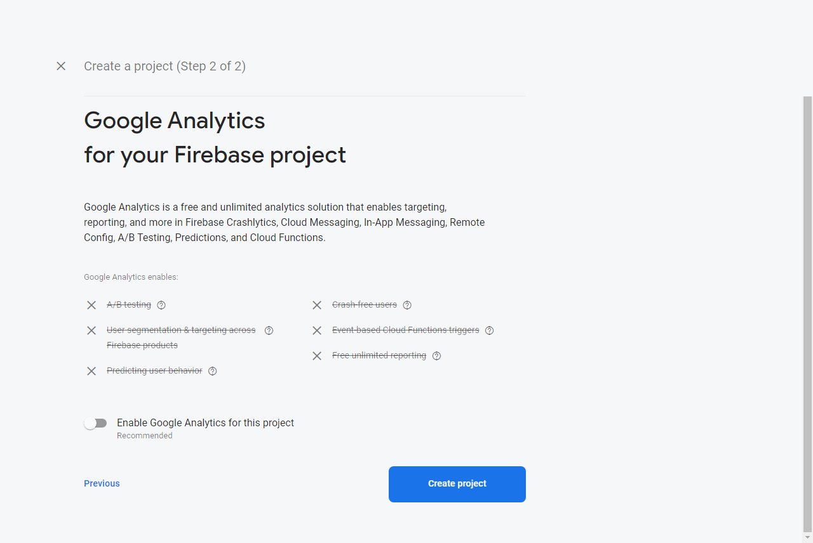

1. After then click on **continue** button

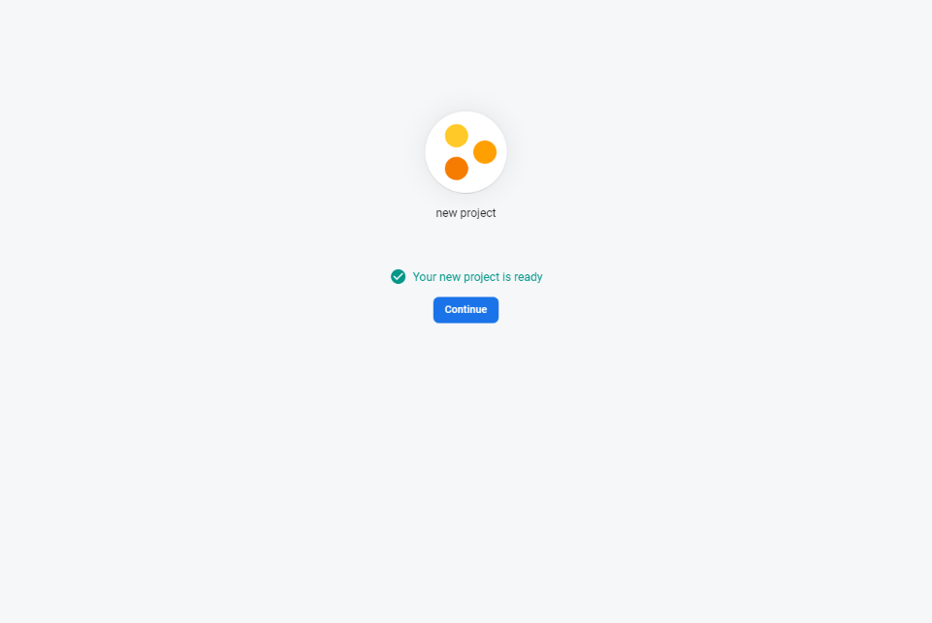

1. Now go to project settings to get server key

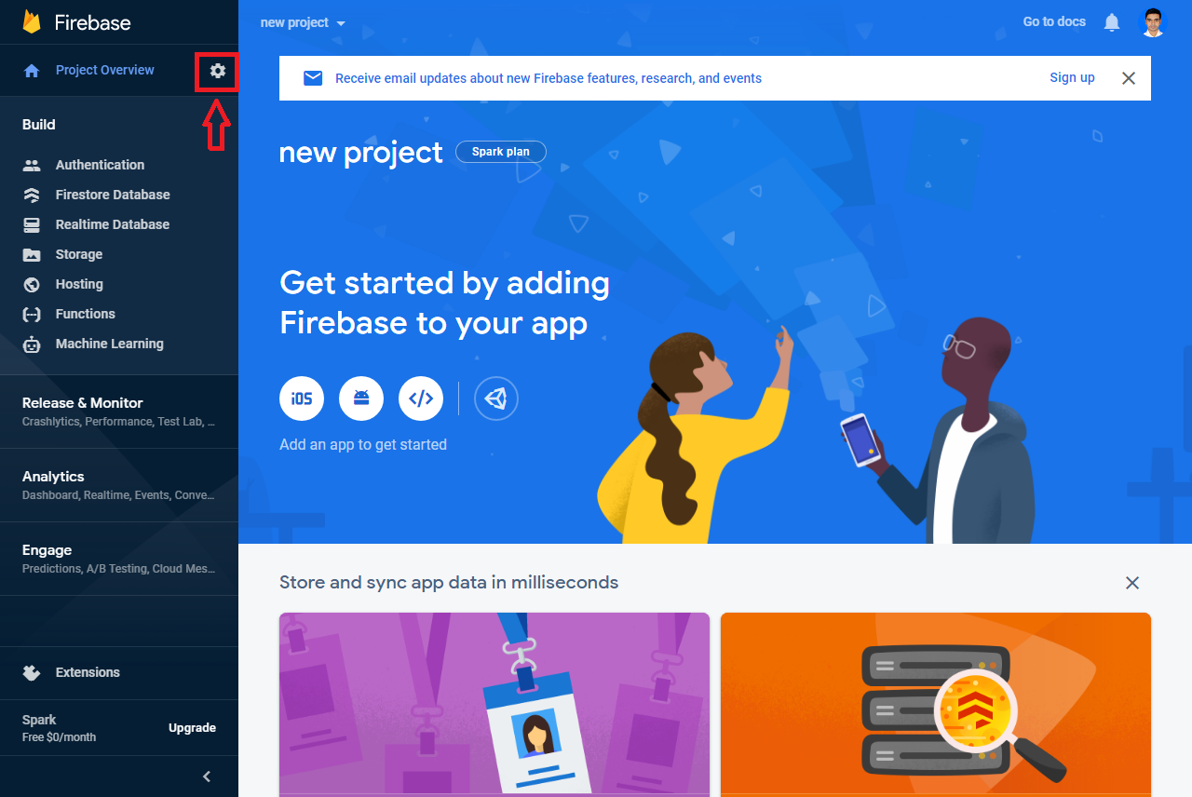

1. To get server key click on Cloud Messaging option

