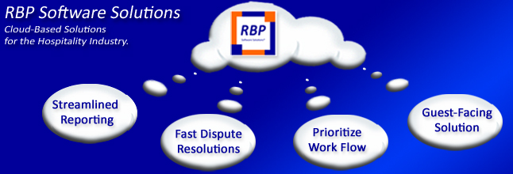

[LinkedinFollow](https://www.linkedin.com/company/rbp-software)

**Bob Murphy**

C.E.O. & General Manager

t: (619) 929-5257 e:[bob@rbpsoftwaresolutions.com](mailto:bob@rbpsoftwaresolutions.com?subject=I%20am%20interested%20in%20learning%20more%20about%20RBP's%20Solutions)

RBP Software Solutions | 1220 Rosecrans Ste. 956

San Diego, CA 92106 | [www.rbpsoftwaresolutions.com](https://www.linkedin.com/company/rbp-software)