1. "Retrieve the names and salaries of all employees who work in the Engineering department, along with their position titles, sorted by salary in descending order."

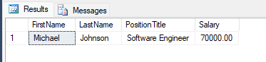

1. Retrieve the employee name, position and department name.  
     
   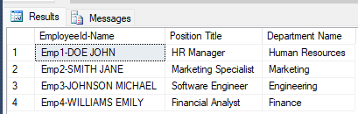
2. "Find the average salary of employees hired in the year 2015, grouped by their gender."  
     
   