Distributed Systems Lab 4 – Microservices Application

1. Introduction
This report documents the design, implementation, deployment, and architectural justification of a simple microservices-style distributed system built for Lab 4. The system consists of two Python Flask microservices (user-service and greeting-service), containerized using Docker and deployed on Kubernetes via Minikube. The goal is to demonstrate microservice boundaries, REST inter-service communication, and cloud-native deployment principles while keeping the solution intentionally simple.

2. System Design & Setup
The application is composed of two independent microservices:
- user-service: returns a hardcoded user profile.
- greeting-service: calls user-service over REST and returns a greeting.

Both services run in separate Docker containers and are deployed through two Kubernetes deployments and two services.
Architecture Diagram
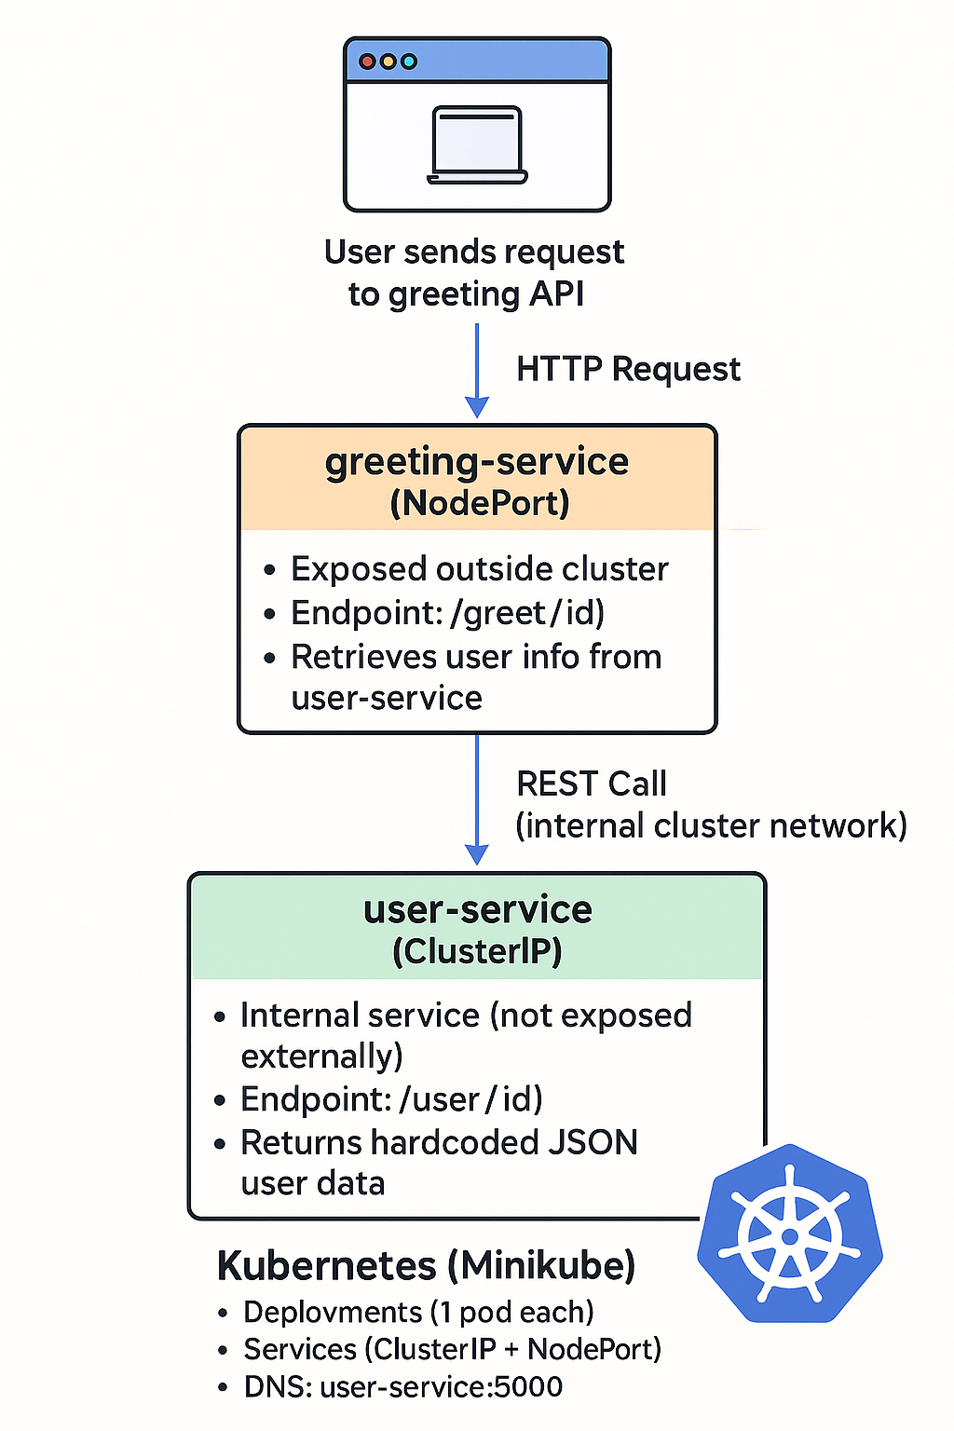

3. Containerization (Docker)
Each microservice includes a Dockerfile specifying a Python 3.10 base image, dependency installation, and the Flask application startup command. Images were built inside the Minikube Docker environment to make them accessible to Kubernetes.

Docker Images
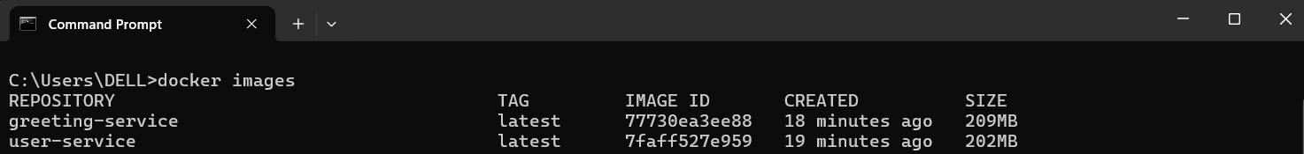

4. Kubernetes Deployment
Kubernetes was used to orchestrate the system. Each microservice has one Deployment and one Service:
- ClusterIP for user-service
- NodePort for greeting-service
The greeting-service communicates with user-service using its DNS name `user-service:5000`.
Kubernetes Pods
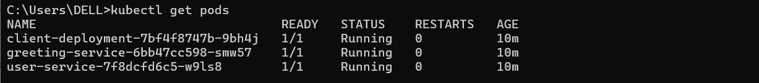
Kubernetes Services
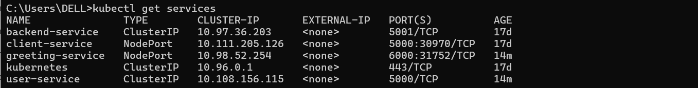

5. Application Functionality
After exposing greeting-service using `minikube service greeting-service`, the application was accessible via browser. Example outputs:
GET /greet/1 → Hello Alice!
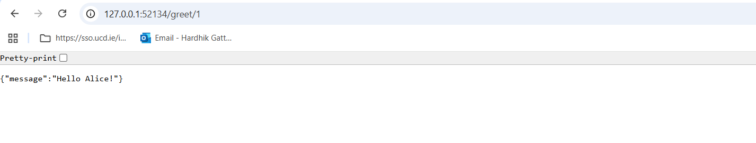
GET /greet/2 → Hello Bob!
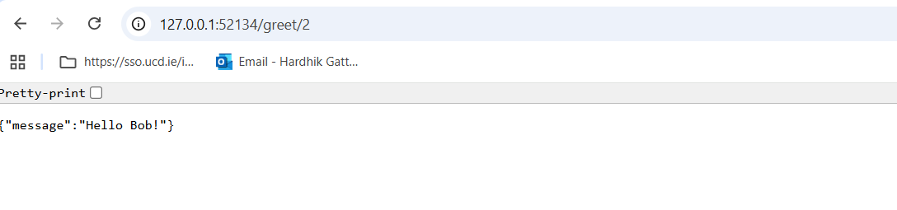

GET /greet/999 → User not found

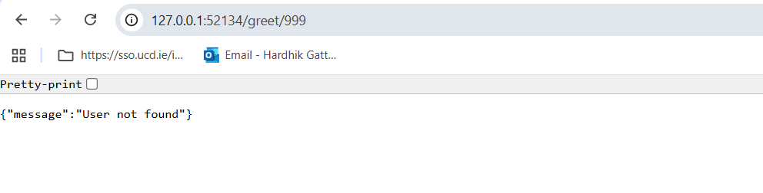6. Architectural Analysis & Justification
6.1 Microservice Granularity
The services were split based on:
- Different scalability needs
- Separation of concerns
- No shared database
- Loose coupling

6.2 Inter-Service Communication
Synchronous REST was chosen. Trade-offs:
+ Easy implementation
+ Human readable
- Increased coupling
- Network latency

6.3 Kubernetes Justification
Kubernetes provides service discovery, scaling, restarting failed pods, and declarative deployments.

7. Architectural Decision Records (ADRs)
ADR 1 – REST vs gRPC
Decision: REST
Consequence: Simple but less efficient.

ADR 2 – Flask vs FastAPI or Spring
Decision: Flask
Consequence: Minimal, lightweight, easy.

ADR 3 – Kubernetes vs Docker Compose
Decision: Kubernetes
Consequence: More realistic orchestration.

8. Conclusion
This lab provided practical experience building and deploying microservices using Docker and Kubernetes. It demonstrated service boundary design, communication trade-offs, and cloud-native deployment practices.
9. GitHub Link
https://github.com/hardhik1007-lab/DS_lab4.git

