PRACTICLE 14

The National Bank of Bharat wants to simulate an ATM machine

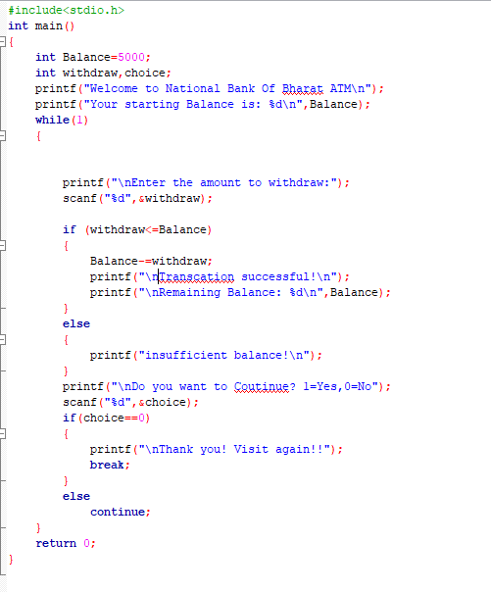

Output:

