PRACTICLE-2

Finding area and perimeter of rectangle

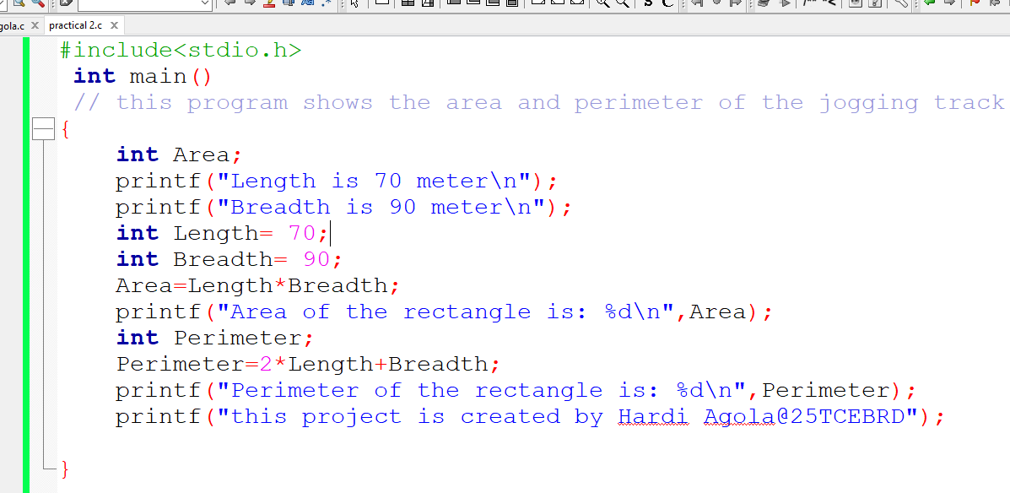

This is a program to calculate the Area and the Perimeter of the rectangle.

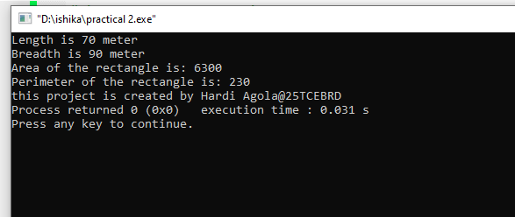

This is the output for the written program.