If you are a new player, click on ‘New Game’ when the homescreen loads.

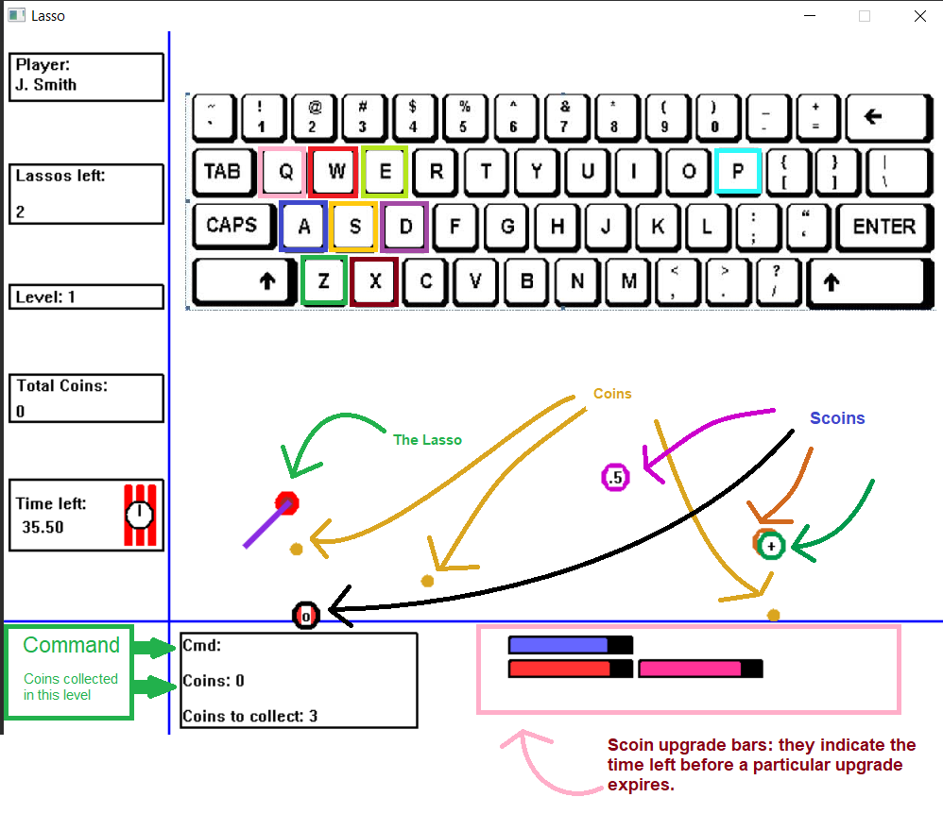In every level, there’s a time limit and a coin target; collect the required number of coins before the time runs out (the dynamite on the left blows up). Whenever the time runs out, you lose a lasso. If you have zero lassos, the game is over. Every level, two different scoins will be available for you to upgrade your lasso, or to avoid during the game.

You can save your progress by pausing the game (press ‘p’) and then hitting ‘s’. This does not store whatever happened in the current level but whatever you finished before it started is saved. You can load a saved a game by clicking on ‘Saved Game’ instead of ‘New Game’ when the homescreen appears. At any point during the game, you can pause it (‘p’) and abort it (‘a’) to save your highscore before you end it. Note that this does not save your progress.

Here’s the demo video:

https://drive.google.com/drive/folders/1YIBmD-gbVkvZkdjnXfSt5QOrNOp7XQVI?usp=sharing

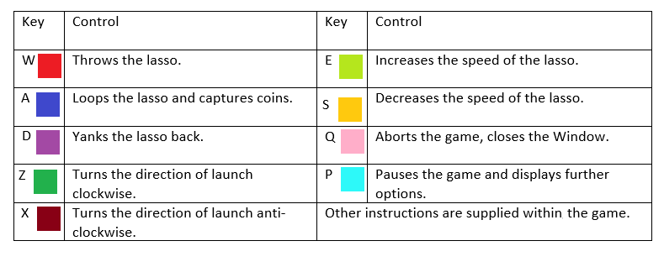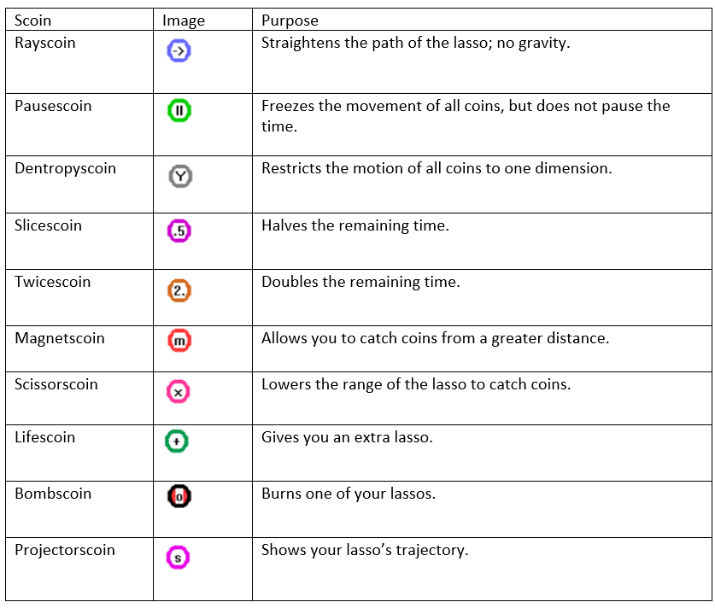

Please ignore the other two files titled “Instructions” in the submission; I submitted them before Sir specified how they were to be presented (and there’s no option to delete files from Bodhitree) and just repeat the same instructions as the ones in this README.pdf file.