**Assignment 6– Review**

***Assignment overview.*** This assignment is aimed at reviewing some concepts of the deep learning and reinforcement learning and to provide practice questions for the final exam.

***Submission.*** Please provide your answers to the written question (1-8) as a pdf file, and the last question (9) as Jupyder file through Brightspcae.

***Submission deadline.*** Thursday, April 5, 2:00 pm.

***Late submission policy.*** No late submission can be accepted.

***Academic Integrity.*** Dalhousie academic integrity policy applies to all submissions in this course. You are expected to submit your own work. Please refer to and understand the academic integrity policy, available at <https://www.dal.ca/academicintegrity>

***If you have a question:*** Teaching Assistants (TAs) will be present during the labs to help you with any questions you may have. If you still have questions, feel free to email me at [tt@cs.dal.ca](mailto:tt@cs.dal.ca).

**Questions:**

1. **[4 Marks] What** is the *vanishing gradient problem* in deep learning and how can it be mediated?
2. **[5 Marks] What** is the result when convolving the array A with the filter B without padding?

|  |  |
| --- | --- |
| A= array([[0, 0, 0, 2],  [2, 1, 0, 0],  [2, 1, 0, 2],  [2, 2, 2, 1]]) | B= array([[2, 0, 1],  [0, 0, 0],  [2, 0, 1]]) |

1. **[3 Marks] What** is a pooling operation in convolutional neural networks and why is this operation important?
2. **[4 Marks] What** is a gated recurrent network? Name an example of such a neural network.
3. **[4 Marks] In** reinforcement learning, what is a policy?
4. **[3 Marks] Explain** the difference between the SARSA and Q-Learning algorithm.
5. **[2 Marks] Briefly** explain `dropout’ and why it is used in deep networks.
6. **[5 marks] What** are the optimal Q values for the T-maze below, assuming that we value diminishing returns with y=0.5?

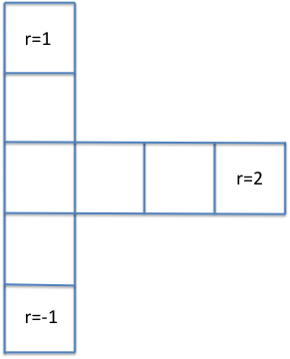

1. **[20 Marks]** Implement a neural network version of an RL to solve the linear maze example and submit your program as jupyter notebook.

