Quizify Project- Synopsis

Team Name: hardikarora483

Team Members:

Name:-

# Hardik Arora

# Amitabh Singh

# Shobhit Chaturvedi

Key Features and Functionalities:

Quizify is a dynamic quiz platform offering diverse categories like general knowledge, science, history, and more. It allows users to register, create profiles, track quiz history, and create their quizzes. Leaderboards, competitions, and social sharing enhance user engagement. Data visualization tools provide insights into user performance and quiz popularity.

Technologies:

Frontend development utilizes React.js, Redux for state management, Material-UI for design, and Chart.js for visualizations. The backend employs Node.js, Express.js, and MongoDB, with API integration for real-time quiz data.

# Design of the project:

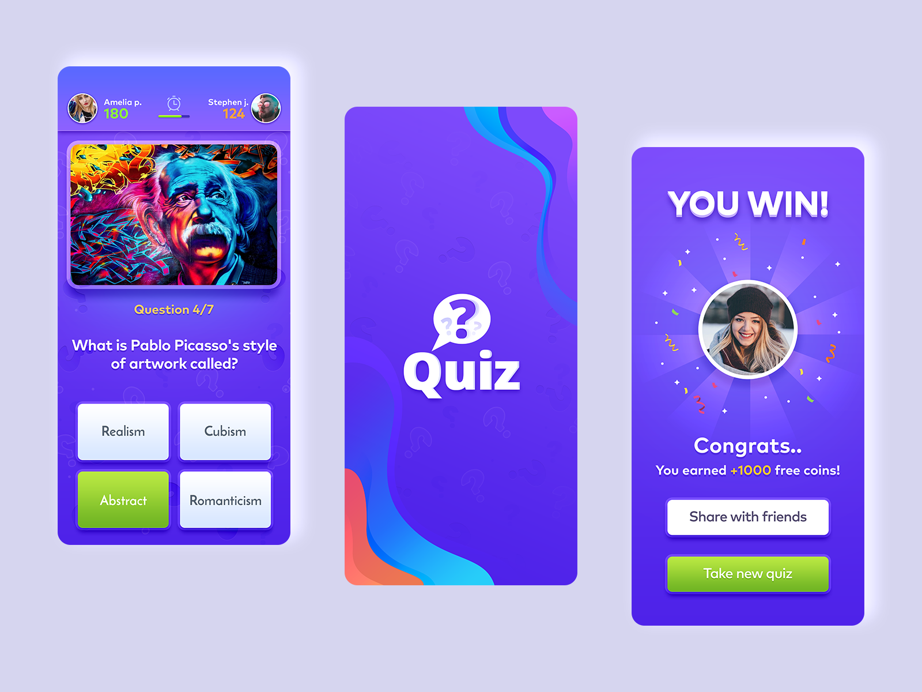

User Experience:

Quizify focuses on a clean, intuitive design with responsive layouts, interactive elements, and personalized user experiences. Responsive design ensures the platform adapts to various devices and screen sizes.

Solution Approach:

The solution includes robust backend development, secure user authentication, API integration, and real-time data handling. Leaderboards and competition management enhance user interaction, supported by thorough testing and cloud deployment for scalability.

Future Prospect of the Project

Current State of the Final Prototype:  
We have successfully completed the development of our project, achieving all the key functionalities outlined in our initial plan. The prototype is fully functional and provides users with an engaging quiz experience. However, we view this as a foundation and are committed to continuous improvement to make the product even more dynamic, user-friendly, and feature-rich.

## Next 5 Steps to Complete the Product:

1. **Enhancing Dynamic Functionality:**
   * Incorporate APIs to fetch questions dynamically based on difficulty levels (easy, medium, hard) to provide a tailored experience for each user.
   * Allow seamless integration of third-party quiz databases for diverse and updated question pools.
2. **Improving the UI/UX Design:**
   * Revamp the user interface to ensure a more intuitive, visually appealing, and responsive design across all devices.
   * Add animations, themes, and accessibility features to improve user engagement.
3. **Developing an Admin Portal:**
   * Build a secure and user-friendly admin portal to manage quiz content, monitor user progress, and oversee system operations.
   * Implement robust authentication mechanisms to ensure data security and restricted access.
4. **Adding Notes and Lectures Section:**
   * Integrate a dedicated section for educational content, including topic-specific notes, video lectures, and reference materials.
   * Provide a structured learning path that complements the quizzes, helping users build knowledge from scratch.
5. **Enhancing Documentation and Feedback Mechanisms:**
   * Document the product features, API details, and user workflows comprehensively for developers and users.
   * Implement user feedback collection systems to continually refine and expand features based on real-world usage.

# By implementing these strategies, Quizify will deliver a seamless and responsive user experience, ensuring that users can enjoy the platform on any device, whether they're using a smartphone, tablet, laptop, or desktop.