**InsurAI**

Application of Agentic AI and LLM in Insurance Product

"Revolutionizing Insurance with Intelligent Automation – InsurAI is an AI-powered solution designed to provide personalized policy recommendations, streamline claims processing, detect fraud, and enhance customer experiences through cutting-edge Agentic AI and Large Language Models."

Project Mentor : Dr. Ram Manohar Nisarg

Team Members:

Name:- University Roll No.:-

# Hardik Arora 2215500071

# Harsh Raj 2215500073

# Hemant Prajapati 2215500078

Key Features and Functionalities:

#### 1. ****Personalized Insurance Assistance****

* Customers can interact with an AI-powered chatbot to:
  + Explore policy options tailored to their needs.
  + Receive answers to FAQs in natural language.
  + Gain insights into premiums, coverage, and benefits.

#### 2. ****Dynamic Risk Assessment and Policy Recommendations****

* The system evaluates customer profiles (age, medical history, etc.) using Machine Learning models.
* Suggests the best policies based on real-time risk analysis.

#### 3. ****Automated Claims Management****

* Integrates OCR and NLP to extract and validate claims.
* Streamlines the claims process with automatic approvals/rejections.

#### 4. ****Fraud Detection****

* Employs anomaly detection algorithms to identify suspicious claim activities.
* Flags potential fraud cases for review.

#### 5. ****Policy Renewal and Retention****

* Proactively reminds customers about policy renewals.
* Suggests updates or upgrades based on user history and feedback.

Technologies:

#### ****Frontend****

* React.js, TailwindCSS for a responsive and dynamic user interface.

#### ****Backend****

* FastAPI for efficient API handling and asynchronous operations.

#### ****LLM Integration****

* OpenAI GPT-4 or Llama 2 for personalized customer interaction.

#### ****Agentic AI Framework****

* LangChain or AutoGPT for building autonomous decision-making agents.

#### ****Database****

* PostgreSQL for structured data storage.
* MongoDB for flexible, document-based storage.

#### ****Document Handling****

* Tesseract OCR for extracting information from images.

#### ****Hosting****

* AWS, Azure, or Google Cloud for scalability and high availability.

#### ****Security****

* JWT and OAuth2 for secure user authentication.

# Design of the Project :

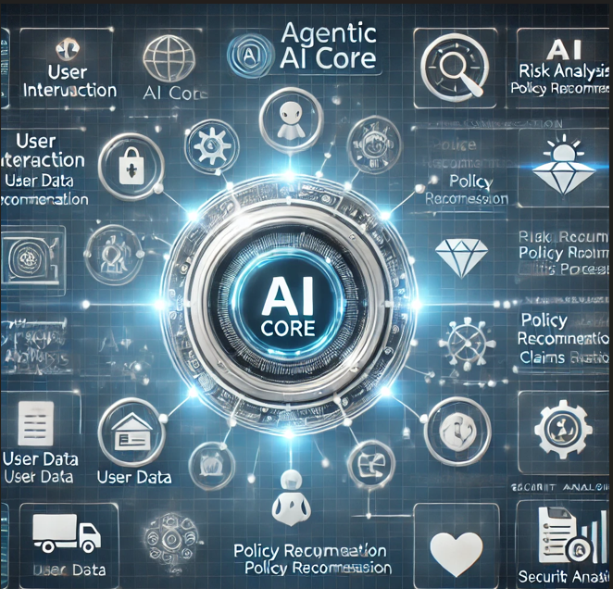

# Flowchart / Data Flow Diagram:

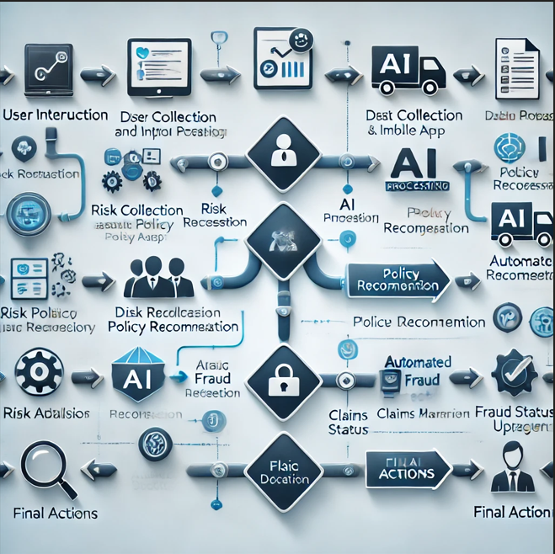

User Experience:

• **Intuitive Design**: A clean, responsive layout for easy navigation.

• **Accessibility**: Available across multiple devices and platforms.

• **Interactive Elements**: Real-time feedback and detailed visualizations enhance engagement.

Solution Approach:

• **AI-Powered Chatbot**

* Interacts with users to understand their requirements.
* Provides policy recommendations based on LLM-generated insights.

• **Autonomous Workflow**

* Leverages Agentic AI to manage multi-step processes like risk analysis, claims validation, and fraud detection.

• **Real-Time Adaptation**

* Continuously learns and updates suggestions based on user interactions and feedback.

• **Scalability**

* Cloud-hosted backend and distributed databases ensure high performance and scalability.

# "With these innovative strategies, InsurAI ensures a seamless, intelligent, and engaging experience, empowering users to effortlessly manage their insurance needs anytime, anywhere, across any device."

Approval Section

Project Title: InsurAI – Revolutionizing Insurance with Intelligent Automation

Project Mentor:

Dr. Ram Manohar Nisarg  
(Signature: ________________________________)

# Team Members:

| **Name** | **University Roll No.** | **Signature** |
| --- | --- | --- |
| Hardik Arora | 2215500071 | _____________________________ |
| Harsh Raj | 2215500073 | _____________________________ |
| Hemant Prajapati | 2215500078 | _____________________________ |