Quizify Project- Synopsis

Group Number: 14

Team Members:

Name:- University Roll No.:-

# Hardik Arora 2215500071

# Harsh Raj 2215500073

# Pradeep Pratap Singh 2215001247

# Mayank Dixit 2215001057

Key Features and Functionalities:

Quizify is a dynamic quiz platform offering diverse categories like general knowledge, science, history, and more. It allows users to register, create profiles, track quiz history, and create their quizzes. Leaderboards, competitions, and social sharing enhance user engagement. Data visualization tools provide insights into user performance and quiz popularity.

Technologies:

Frontend development utilizes React.js, Redux for state management, Material-UI for design, and Chart.js for visualizations. The backend employs Node.js, Express.js, and MongoDB, with API integration for real-time quiz data.

# Design of the project:

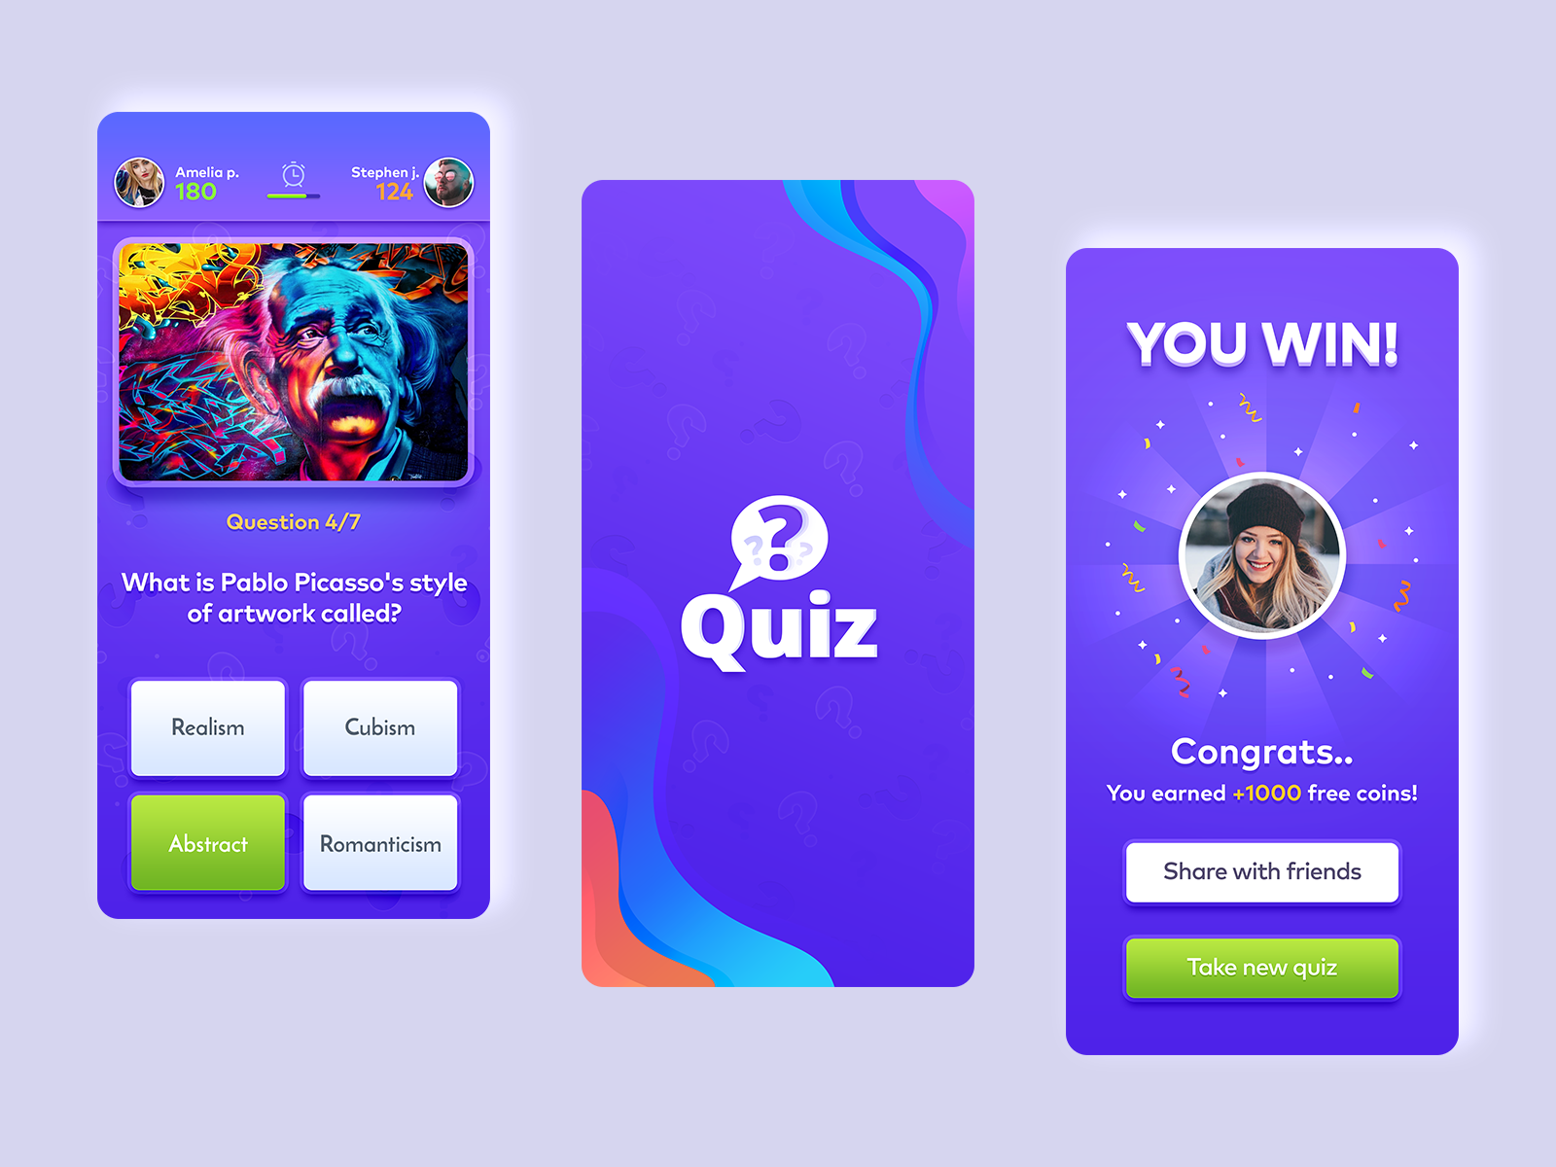

User Experience:

Quizify focuses on a clean, intuitive design with responsive layouts, interactive elements, and personalized user experiences. Responsive design ensures the platform adapts to various devices and screen sizes.

Solution Approach:

The solution includes robust backend development, secure user authentication, API integration, and real-time data handling. Leaderboards and competition management enhance user interaction, supported by thorough testing and cloud deployment for scalability.

# By implementing these strategies, Quizify will deliver a seamless and responsive user experience, ensuring that users can enjoy the platform on any device, whether they're using a smartphone, tablet, laptop, or desktop.