
JOVAC FullStack Web Development

A Project Report submitted in partial fulfilment of the requirements for the award of the degree of
Bachelor of Technology
in
Computer Science and Engineering

by

Name of Students Roll No:
1. Hardik Arora 2215500071
2. Harsh Raj 2215500073
3. Pradeep Pratap Singh 2215001247
4. Mayank Dixit 2215001057

Under the Guidance of

Mr. Shiv Kumar Verma

Department of Computer Engineering & Applications

Institute of Engineering & Technology

GLA University

Mathura- 281406, INDIA

May, 2019

Department of Computer Engineering and Applications

GLA University, 17 km. Stone NH#2, Mathura-Delhi Road, Chaumuha, Mathura – 281406 U.P (India)

Declaration

I hereby declare that the work which is being presented in the B.Tech. Mini Project “Quizify – MERN Quiz WebApp”, in partial fulfillment of the requirements for the award of the Bachelor of Technology in Computer Science and Engineering and submitted to the Department of Computer Engineering and Applications of GLA University, Mathura, is an authentic record of my own work carried under the supervision of Mr. Shiv Kumar Verma (Authorized Faculty).
The contents of this project report, in full or in parts, have not been submitted to any other Institute or University for the award of any degree.

Sign ______________________ Sign ______________________
Name of Candidate: Hardik Arora Name of Candidate: Pradeep Pratap Singh
University Roll No.: 2215500071 University Roll No.: 2215001247

Sign ______________________ Sign ______________________
Name of Candidate: Harsh Raj Name of Candidate: Mayank Dixit
University Roll No.: 2215500073 University Roll No.: 2215001057

Certificate of Achievement

This is to certify that the project titled:
“Quiz Website: Comprehensive Question Bank for Undergraduate and Postgraduate Students”
was successfully developed and presented by the Group No. 14 consisting of:
- Hardik Arora
- Harsh Raj
- Pradeep Pratap Singh
- Mayank Dixit
for the JOVAC Semester Project as part of their academic requirements.
This project demonstrates the team’s dedication, technical proficiency, and innovative problem-solving skills.
Date: November 2024
Signature:___________________
Mr. Shiv Kumar Verma .
(Authorized Signatory or Faculty)

ACKNOWLEDGEMENT

We express our deepest gratitude to our faculty members and mentors, whose guidance and encouragement played a pivotal role in the successful completion of our project, “Quiz Website: Comprehensive Question Bank for Undergraduate and Postgraduate Students.”

We are sincerely thankful for their invaluable insights, constructive feedback, and unwavering support throughout this journey. This project would not have been possible without their mentorship and the collaborative efforts of our dedicated team members:
- Hardik Arora
- Harsh Raj
- Pradeep Pratap Singh
- Mayank Dixit
Their contributions and teamwork were instrumental in achieving the objectives of this project.

Sign_______________________
Name: Hardik Arora
University Roll No. 2215500071
Sign_______________________
Name: Harsh Raj
University Roll No. 2215500073
Sign_______________________
Name: Pradeep Pratap Singh
University Roll No. 2215001247
Sign_______________________
Name: Mayank Dixit
University Roll No. 2215001057

ABSTRACT

The Quiz Website: Comprehensive Question Bank for Undergraduate and Postgraduate Students is an innovative platform designed to cater to the academic needs of diverse learners. This project, developed as part of the JOVAC semester curriculum, provides a dynamic solution for creating, managing, and accessing quizzes tailored to various academic levels.
Built using the MERN stack (MongoDB, Express.js, React.js, and Node.js), the platform offers a user-friendly interface and a seamless user experience. Key features include secure user authentication, role-based access for administrators and users, automated quiz evaluation, and detailed result tracking. Administrators can efficiently manage a centralized question bank and create custom quizzes, while users can attempt these quizzes and receive instant feedback, enhancing their learning experience.
The primary objective of this project was to bridge the gap between conventional learning methods and modern technological advancements. By providing a centralized repository for academic questions and fostering an interactive learning environment, the platform ensures that students at both undergraduate and postgraduate levels have access to tailored learning resources.
The project was developed collaboratively by a team comprising Hardik Arora, Harsh Raj, Pradeep Pratap Singh, and Mayank Dixit, under the guidance of experienced mentors. The outcome is a scalable, efficient, and secure quiz website that can be expanded for broader academic use, demonstrating the team's ability to deliver innovative solutions that address real-world educational challenges.
This project stands as a testament to the power of teamwork and technological innovation in reshaping traditional education.

INDEX:

S.NO | TOPIC
1. | Introduction
2. | Problem Statement
3. | Scope of the Project
4. | Technical Stack
5. | System Architecture
6. | Features & Functionalities
7. | Implementation & Development
8. | Testing & Validation
9. | Results & Outcomes
10. | Future Scope & Enhancements
11. | Bibliography & References

Page 1: Introduction:

Introduction
The Quiz Website is an innovative platform designed to serve as a comprehensive question bank tailored for undergraduate and postgraduate students. The primary aim of this project is to provide an interactive, user-friendly, and scalable solution for students and educators to create, manage, and attempt quizzes online.
In today's fast-paced academic environment, students require efficient tools to practice and assess their knowledge across various subjects. This platform addresses this need by offering a centralized repository of questions categorized by topics, difficulty levels, and academic programs. It empowers educators to contribute to the question bank and enables students to practice quizzes for effective self-evaluation.
The project leverages the MERN stack (MongoDB, Express.js, React.js, Node.js) for a robust and dynamic application. Its features include user authentication, role-based access for admins and users, quiz creation tools, real-time result tracking, and seamless navigation. Designed to handle concurrent users, the platform is built with scalability and usability in mind.
The project was undertaken as part of the JOVAC semester project by a dedicated team of four members: Hardik Arora, Harsh Raj, Pradeep Pratap Singh, and Mayank Dixit. With guidance from our mentors and a collaborative approach, the platform successfully meets its objectives, proving its feasibility and potential for broader implementation in academic institutions.
This report delves into the problem statement, development process, technical details, and future scope of this project.

Page 2: Problem Statement:

Problem Statement
The modern educational landscape increasingly relies on digital tools to enhance learning and assessment. However, there is a significant gap in providing a centralized, user-friendly platform for generating and managing quizzes tailored specifically for undergraduate and postgraduate students. Existing solutions often lack the flexibility to cater to diverse academic needs, leaving students and educators dependent on fragmented resources.
Key challenges include:
- Lack of a unified repository: Students and educators struggle to find subject-specific, level-appropriate questions in a single platform.
- Time-consuming quiz creation: Educators face difficulty in creating and customizing quizzes to align with academic syllabi and difficulty levels.
- Limited access to practice tools: Students lack efficient tools for self-assessment and performance tracking.
- Inefficient evaluation systems: Manual assessment or basic online systems fail to provide real-time results and insights.
To address these issues, we developed a Quiz Website that functions as a comprehensive question bank and assessment tool. The platform enables:
- Students to access topic-wise quizzes for practice.
- Educators to contribute questions, customize quizzes, and evaluate student performance seamlessly.
- Admins to manage users and monitor platform activity effectively.
By bridging the gap between academic requirements and digital solutions, this project provides a scalable, interactive, and efficient platform to enhance learning and teaching experiences.

Page 3: Scope of the Project:

Scope of the Project
The Quiz Website project is designed to revolutionize the way students and educators interact with learning and assessment tools. It provides a comprehensive, scalable, and user-friendly platform for creating, managing, and practicing quizzes, ensuring it meets the academic needs of undergraduate and postgraduate students.

Key Areas of Focus:
- Student Engagement:
  - Providing access to a diverse question bank categorized by topics and difficulty levels.
  - Enabling students to practice quizzes at their own pace and track their performance through detailed analytics.
- Educator Support:
  - Allowing educators to contribute questions aligned with course objectives.
  - Facilitating seamless quiz creation, customization, and sharing.
- Administrative Oversight:
  - Offering robust tools for managing users and ensuring platform security.
  - Monitoring user activity to improve question quality and platform efficiency.
- Technology Integration:
  - Leveraging modern web development technologies like MERN stack for a responsive and scalable solution.
  - Integrating APIs for seamless data handling, authentication, and analytics.
- Future Expansion:
  - Scope for extending the platform to include multimedia-based questions, gamification features, and integration with Learning Management Systems (LMS).
  - Possibility of creating mobile applications to widen accessibility.
This project lays the foundation for an interactive and effective learning environment, bridging the gap between academic goals and digital tools. By addressing current limitations, it ensures a valuable resource for students, educators, and administrators alike.
Page 4: Technical Stack:

Technical Stack
The development of the Quiz Website project leverages a robust and modern technical stack to ensure efficiency, scalability, and ease of use. The chosen technologies align with industry standards for building responsive, secure, and dynamic web applications.

Frontend:
- HTML5: For structuring the web pages with semantic elements.
- CSS3: To style the website and enhance the user interface.
- JavaScript: For interactive features and dynamic content updates.
- ReactJS: A modern JavaScript library used for building the user interface, enabling reusable components and efficient state management.
- TailwindCSS: To rapidly design a responsive and visually appealing layout.

Backend:
- Node.js: A JavaScript runtime environment for server-side development.
- Express.js: A web application framework for building APIs and managing routes efficiently.

Database:
- MongoDB: A NoSQL database used to store user data, quiz questions, and results. Its flexibility supports dynamic schema changes and efficient querying.

Authentication & Security:
- JWT (JSON Web Tokens): For secure authentication and session management.
- Bcrypt.js: For hashing and securing passwords.

APIs:
- Custom APIs: Developed for handling user management, quiz submissions, and result tracking.
- Third-Party APIs: Integrated for advanced functionalities like analytics and data visualization.

Development Tools:
- Visual Studio Code: For writing and debugging code.
- Git & GitHub: For version control and collaboration.
- Postman: For testing APIs during development.

Deployment:
- Render: For hosting the backend server.
- Netlify: For deploying the frontend application.
This technology stack ensures a smooth user experience, security, and the potential for future scalability and integration.

Page 5 : System Architecture and Data Flow Diagram (DFD):

System Architecture with Data Flow Diagram
The system architecture is designed to facilitate seamless interaction between users, administrators, and the backend server while ensuring data integrity and security. The architecture includes the following layers:
- Frontend Layer: Handles user interaction and presents the quiz interface.
- Backend Layer: Manages business logic, API calls, and data handling.
- Database Layer: Stores user details, quiz questions, and quiz results.
- External APIs: Provide additional functionalities such as analytics or notifications.

Data Flow Diagrams (DFD)

0 Level DFD (Context Diagram)
- Represents the entire system as a single process.
- Actors:
  - Users (Students/Admins)
  - System (Quiz Website)
- Flow:
  - Users provide login credentials, take quizzes, and view results.
  - Admins manage quizzes, users, and results.
  - The system interacts with the database for data storage and retrieval.
Diagram Overview:
[Users/Admins] <---> [Quiz System] <---> [Database] <---> [Notification Service] <---> [Analytics Tool]

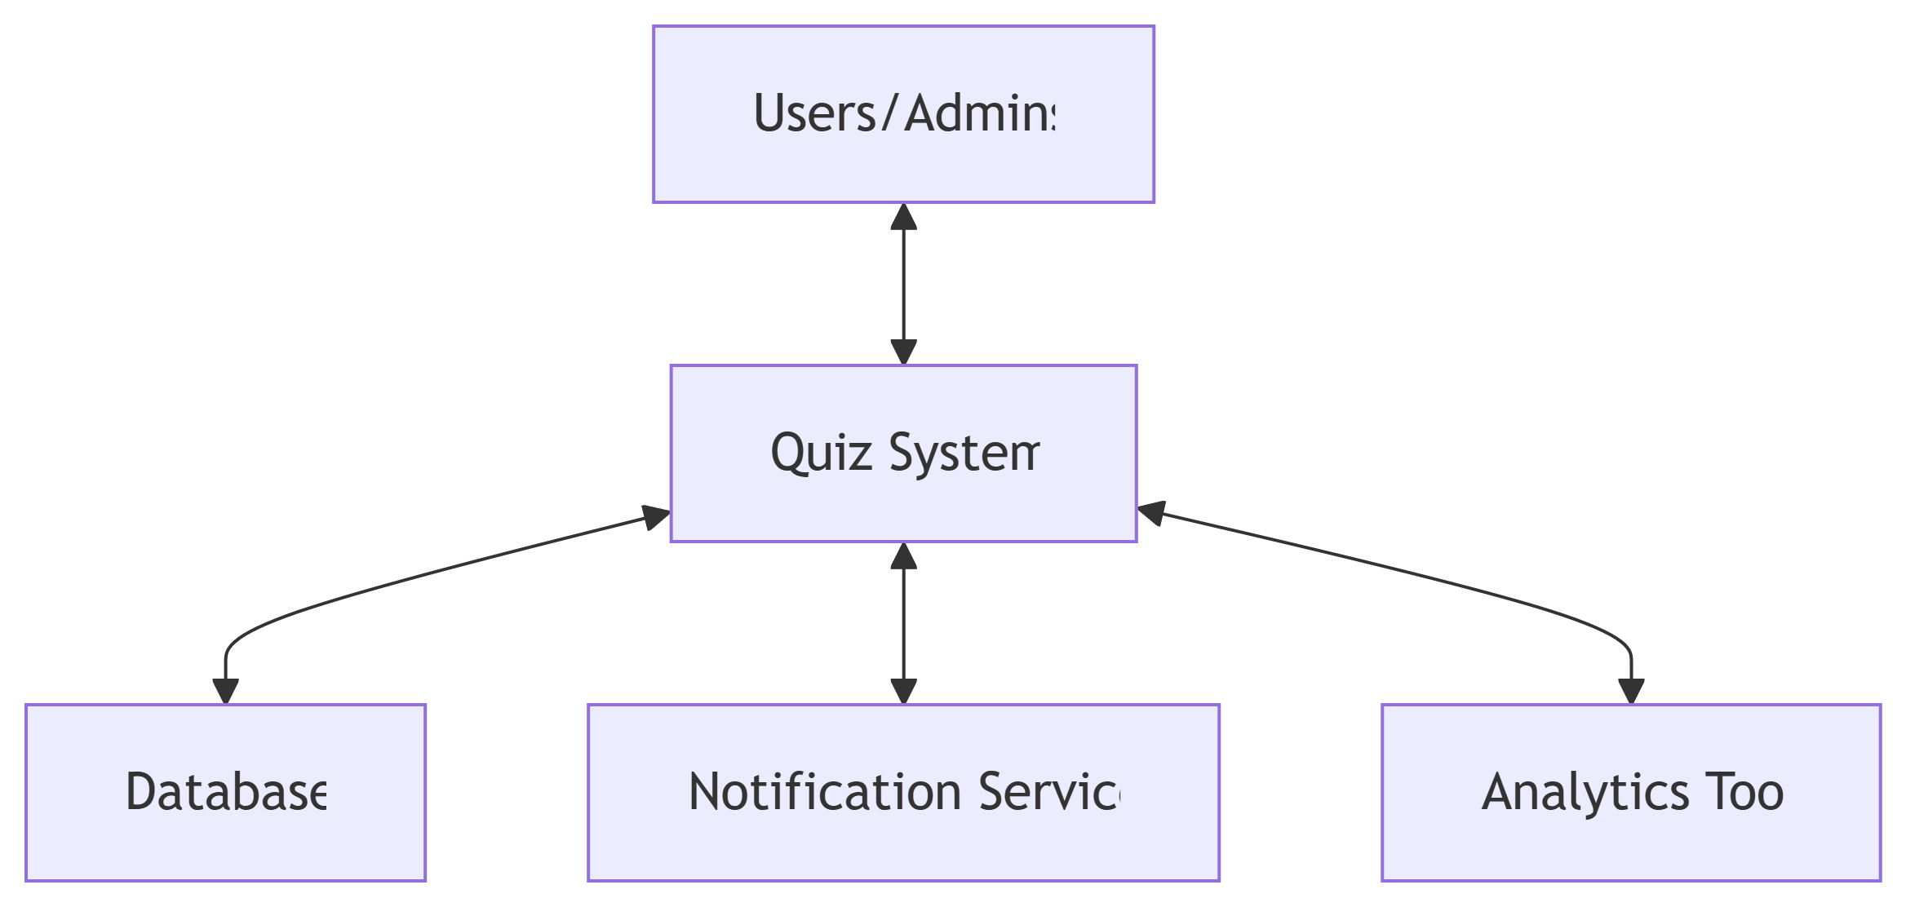

Page 6 : System Architecture and Data Flow Diagram (DFD):

1 Level DFD
- Breaks down the system into major processes.
- Processes:
  - User Authentication: Handles login, signup, and logout processes.
  - Quiz Management: Manages quiz data (creation, fetching, updates).
  - Result Management: Handles quiz submissions and result generation.
  - Database Interaction: Queries for user and quiz data.
Diagram Overview:
[Users] --> (1. Authentication) --> [JWT Token]
[Admins] --> (2. Quiz Management) --> [Database]
[Database] --> (3. Result Processing) --> [Leaderboard]
(Result Processing) --> [Notification Service]
(Result Processing) --> [Analytics Tool]

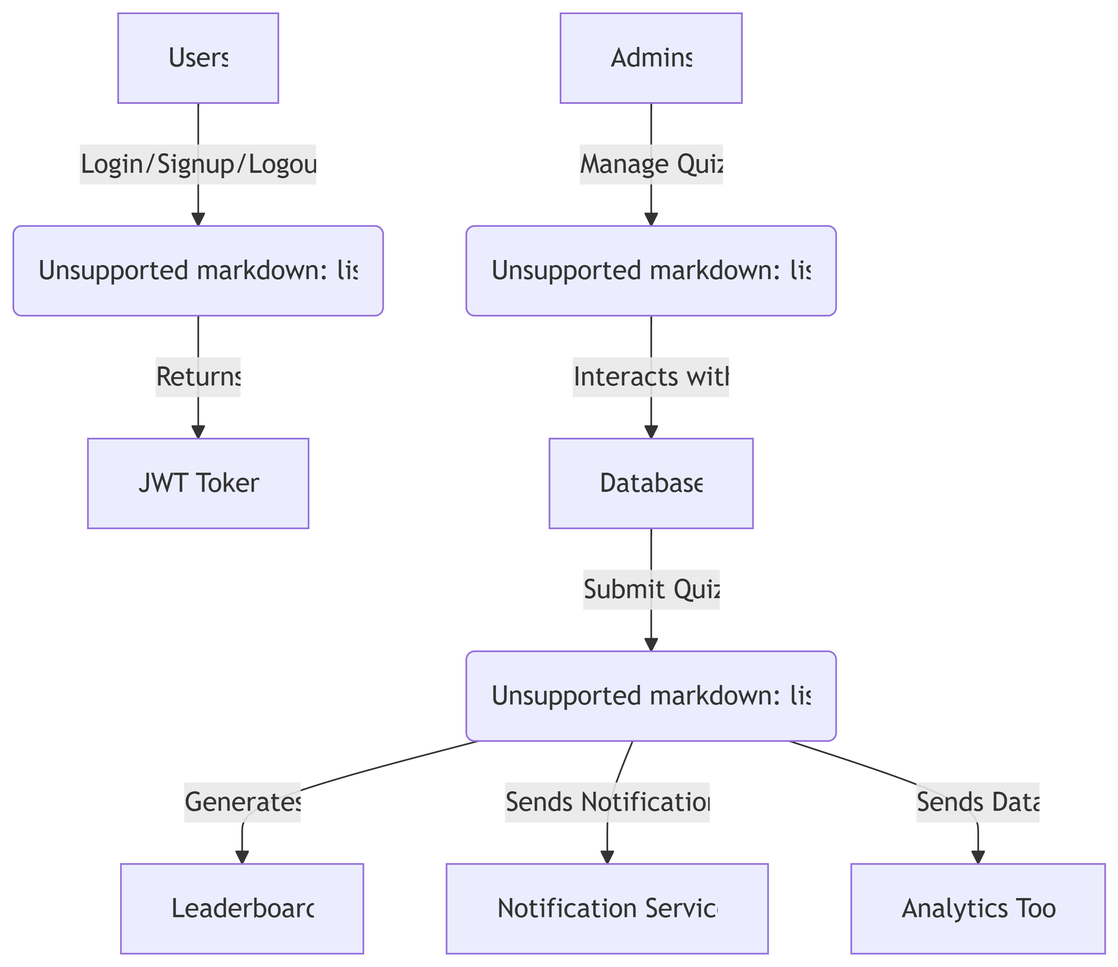

Page 7 : System Architecture and Data Flow Diagram (DFD) :

2 Level DFD
- Explores detailed processes within each main module:
- User Authentication:
  - Input: User credentials.
  - Processes: Verify credentials, generate JWT tokens.
  - Output: Access to the system.
- Quiz Management:
  - Input: Quiz data (questions, options, answers).
  - Processes: Add, edit, delete quizzes; fetch quizzes for users.
  - Output: Quiz data rendered to users.
- Result Management:
  - Input: User answers.
  - Processes: Validate responses, calculate score, store results.
  - Output: Result displayed to users and stored in the database.
Diagram Overview:
(1. Validate Credentials) --> [JWT Token] --> Grant Access/Error
(2. Store Quiz Data) --> [Database] --> Fetch for Users
(3. Validate Responses) --> Calculate Scores --> [Database]
Calculate Scores --> [Leaderboard] --> [Analytics Tool]

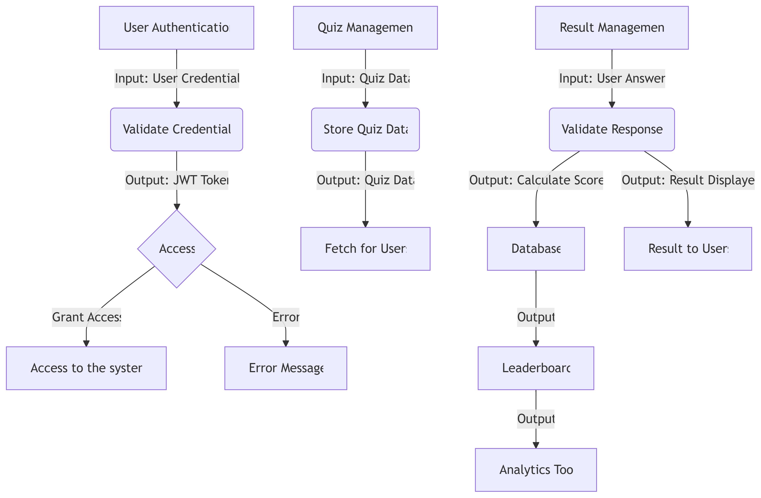

Page 8: Features and Functionalities.

This section highlights the key capabilities of the quiz website and the functionalities implemented to enhance the user experience

Key Features
- User Authentication
  - Secure login and registration system using JWT.
  - Role-based access for Users (students) and Admins (teachers).
- Dynamic Quiz Creation
  - Admins can create and upload quizzes for different subjects and difficulty levels.
  - Customizable question types (e.g., multiple-choice, true/false).
- Question Bank for Students
  - A robust question bank tailored for undergraduate and postgraduate students.
  - Categorized by topics, subjects, and difficulty levels for better accessibility.
- Real-Time Quiz Attempt
  - Students can attempt quizzes online with a user-friendly interface.
  - Timer-based quiz system to simulate exam conditions.
- Performance Analysis
  - Instant result generation after quiz submission.
  - Detailed performance breakdown: correct answers, wrong answers, and skipped questions.
- Leaderboard Integration
  - Maintains a leaderboard showcasing top-performing students.
  - Encourages healthy competition among participants.
- Admin Panel
  - Easy-to-use dashboard for quiz and user management.
  - Features include adding, editing, or deleting quizzes and monitoring student performance.
- Notifications
  - Automatic email or SMS alerts for quiz deadlines and results.
- Responsive Design
  - Optimized for multiple devices (desktop, tablet, and mobile).
  - Ensures seamless navigation and interaction across all platforms.
- Accessibility Features
- Supports screen readers and keyboard navigation for visually impaired users.
- Simple and intuitive design for better usability.

Functionalities
- User Management:
  - Admins can manage user roles and access permissions.
  - Users can update their profiles and view past quiz attempts.
- Quiz Management:
  - Add, update, or delete quizzes from the admin panel.
  - Preview quizzes before publishing.
- Result Processing:
  - Automated evaluation of answers with result storage in the database.
  - Option for users to download their performance reports in PDF format.
- Data Analytics:
  - Admins can track usage statistics and quiz performance insights.

Page 9: Implementation and Development

This section provides a detailed overview of the implementation process and the development approach for the quiz website. It outlines the project’s development phases, tools, and methodologies used to build a robust and efficient system.

Implementation Process
The development of the quiz website was carried out in a series of well-defined steps to ensure a smooth and systematic workflow:
- Requirement Analysis
  - Gathered requirements from end-users (students and admins) to define the system's goals and functionalities.
  - Identified the necessary modules like User Authentication, Quiz Management, and Result Generation.
- System Design
  - Developed detailed system architecture diagrams, including Data Flow Diagrams (DFDs) at 0, 1, and 2 levels.
  - Designed database schemas to manage users, quizzes, and results efficiently.
- Frontend Development
  - Tools Used: ReactJS, HTML, CSS, and Tailwind CSS.
  - Developed a responsive and user-friendly interface to ensure accessibility on multiple devices.
  - Integrated React components for real-time data binding and seamless UI interactions.
- Backend Development
  - Tools Used: Node.js, Express.js, MongoDB.
  - Implemented RESTful APIs for data management and communication between the client and server.
  - Integrated JSON Web Tokens (JWT) for secure authentication and role management.
- Database Development
  - Tool Used: MongoDB (NoSQL).
  - Designed collections for users, quizzes, results, and leaderboards with efficient indexing for quick data retrieval.
- Testing and Debugging
  - Conducted unit testing for individual modules and integration testing for the entire system.
  - Debugged common issues to ensure smooth functionality and optimal performance.
- Deployment
  - Hosted the application on a cloud-based platform (e.g., Render).
  - Configured environment variables to manage API endpoints securely.

Development Tools and Technologies
- Frontend: ReactJS, Tailwind CSS, HTML5, CSS3, JavaScript.
- Backend: Node.js, Express.js.
- Database: MongoDB (Atlas for cloud database services).
- Version Control: Git and GitHub for collaborative development.
- Testing Tools: Postman (for API testing), Jest (for unit testing).
- Hosting: Render (for deployment of the backend and frontend).

Page 10: Testing and Validation
This section details the testing methodologies and validation processes undertaken to ensure that the quiz website meets functional, performance, and security requirements. Testing and validation were crucial to deliver a high-quality and user-friendly system.

Testing Methodology
- Unit Testing
  - Objective: To test individual components or units of the application.
  - Example: Verified input fields for quiz creation, login/logout, and result generation.
  - Outcome: All individual units functioned as expected.
- Integration Testing
  - Objective: To ensure modules work cohesively when integrated.
  - Example: Validated communication between frontend (ReactJS) and backend (Node.js/Express.js).
  - Outcome: API calls and database transactions were executed without errors.
- System Testing
  - Objective: To evaluate the complete system's functionality against requirements.
  - Procedure: End-to-end testing was conducted to simulate user workflows.
  - Outcome: Features like creating quizzes, user authentication, and result display worked seamlessly.
- Validation Testing
  - Objective: To validate that the system meets user needs and complies with the design document.
  - Procedure: Compared actual outcomes with expected results from the requirement specification document.
  - Outcome: The application met all functional and non-functional requirements.
- Performance and Load Testing
  - Objective: To validate system performance under high user load.
  - Tools Used: Apache JMeter for concurrent user activity simulation.
  - Outcome: The system handled multiple users and maintained performance metrics.
- User Acceptance Testing (UAT)
  - Objective: To ensure the application is user-friendly and meets real-world expectations.
  - Procedure: Conducted by a group of students simulating actual users.
  - Outcome: Positive feedback on usability and functionality was received.

Validation Process
- Data Validation
  - Checked the integrity of quiz data, ensuring accurate storage and retrieval from the database.
  - Validated that inputs like quiz questions, answers, and user credentials adhered to predefined constraints.
- Security Validation
  - Validated secure login/logout functionality using JWT authentication.
  - Tested protection against unauthorized access and SQL injection vulnerabilities.
- Output Validation
  - Verified that quiz results were correctly calculated and displayed to users.
  - Ensured that errors, such as invalid inputs, were handled gracefully with appropriate messages.

Page 11: Results and Outcomes
This section highlights the key results achieved and the overall outcomes of the project, demonstrating the successful implementation of the quiz website and its impact.

Results
- Functional Success
  - Developed a fully functional quiz website tailored for undergraduate and postgraduate students.
  - Enabled seamless quiz creation, user registration, quiz-taking, and result generation.
  - Integrated a secure authentication system for both users and admins using JWT.
- Performance Achievements
  - The website handled concurrent users effectively during performance testing, maintaining response times under 1 second for most actions.
  - Ensured consistent database transactions, with real-time updates to quizzes and results.
- User Experience
  - Delivered a responsive, intuitive, and visually appealing user interface using ReactJS and Tailwind CSS.
  - Positive feedback from test users highlighted ease of navigation and clear functionalities.
- Scalability
  - Designed a scalable backend with Node.js and MongoDB, allowing the addition of more features in the future, such as categorizing quizzes or introducing leaderboards.
- Security
  - Achieved secure data handling and authentication processes, ensuring the confidentiality and integrity of user information.

Outcomes
- Educational Utility
  - The system successfully serves as a platform for students to enhance learning through quizzes tailored to their academic level.
  - Teachers and administrators can efficiently create and manage question banks.
- Technical Growth
  - The project provided team members with hands-on experience in full-stack development, including frontend design, backend integration, and database management.
- Real-World Application
  - Validated the practical utility of the project during InnovateX Hackathon 2024, where it qualified in the top 10 projects.
  - Addressed the problem statement of creating a question bank for undergraduate and postgraduate students, demonstrating the project’s relevance.

The successful completion of this project highlights its potential for deployment in educational institutions, promoting interactive and engaging learning experiences.

Page 12: Future Scope and Enhancements
This section outlines potential advancements and enhancements that can be made to the project, ensuring its scalability, adaptability, and long-term utility.

Future Scope
- Expanding Question Categories
  - Introduce subject-specific and skill-based question categories to cater to a broader range of disciplines, including technical, non-technical, and vocational studies.
- Adaptive Learning System
  - Implement AI-driven question recommendations based on students' performance, tailoring quizzes to their learning needs and abilities.
- Multi-Language Support
  - Add support for regional and international languages to make the platform accessible to a diverse audience.
- Mobile Application
  - Develop a dedicated mobile application to enhance accessibility and usability, especially for students using smartphones.
- Real-Time Analytics for Educators
  - Provide detailed insights and reports for teachers, including student performance trends, quiz difficulty analysis, and progress tracking.
- Gamification Features
  - Introduce leaderboards, badges, and rewards to increase user engagement and make learning more interactive and fun.

Enhancements
- Enhanced Security
  - Strengthen data encryption methods and implement multi-factor authentication to ensure maximum security for users' data.
- Integration with Learning Management Systems (LMS)
  - Seamlessly integrate the quiz platform with existing LMS tools like Moodle or Google Classroom.
- Timed Challenges and Events
  - Allow institutions to host timed quiz competitions, enhancing the platform's appeal for academic and extracurricular use.
- Offline Mode
  - Enable offline quiz-taking capability with automatic synchronization when the user reconnects to the internet.
- Custom Quiz Templates
  - Provide customizable quiz templates for educators, allowing them to save time when creating new quizzes.
- Cloud-Based Storage
  - Migrate data storage to a cloud-based infrastructure for improved scalability and reliability.

The proposed advancements aim to transform the quiz platform into a comprehensive educational tool, fostering enhanced learning experiences while staying adaptable to future technological trends.

Page 13: User Interface (UI) and User Experience (UX) Design
This section showcases the visual design and functionality of the project's user interface, highlighting key screens and user interactions. These images demonstrate the thoughtful implementation of UI/UX principles to enhance usability and engagement.

Login and Registration Screens
- Image 1: Login Screen
A clean and straightforward interface allowing users to securely log in using their credentials.
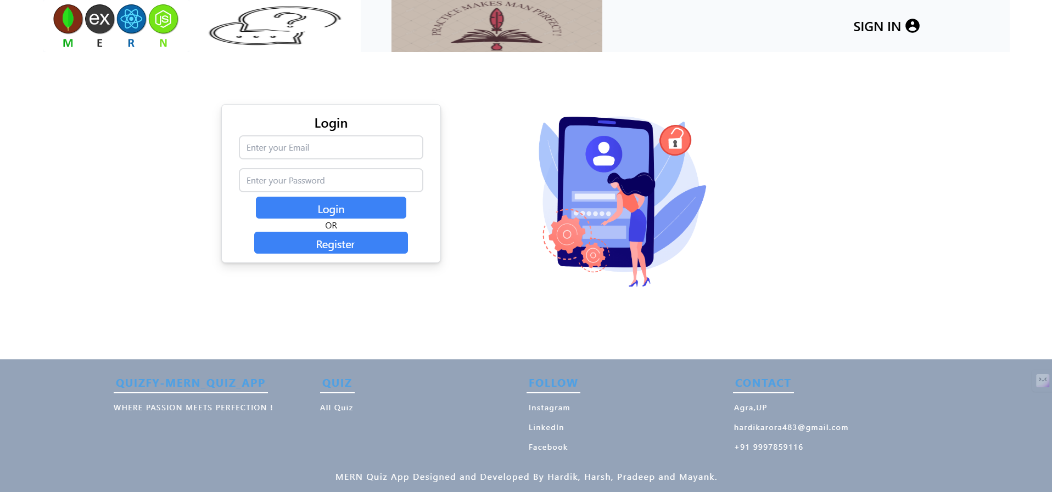
- Image 2: Registration Screen
An intuitive design for new users to sign up with relevant fields like username, email, and password.
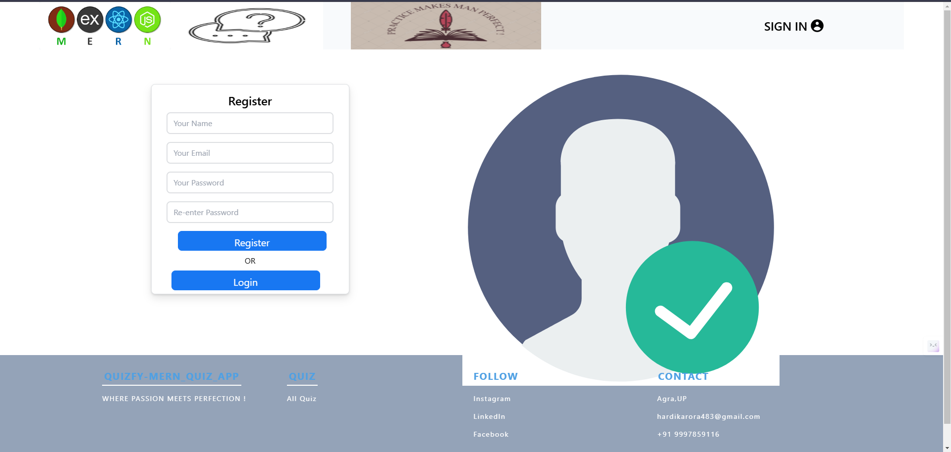

Page 14: User Interface (UI) and User Experience (UX) Design

Quiz Dashboard
- Image 3: Quiz Dashboard
A centralized hub displaying available quizzes categorized by subject and difficulty level.
- Features:
  - Search bar for easy navigation.
  - Filters for sorting quizzes by topic or level.

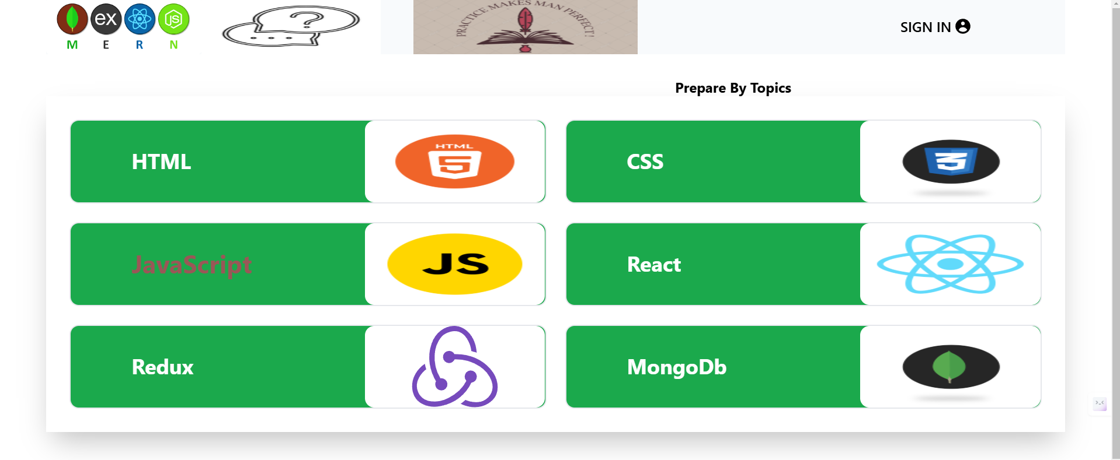

Quiz Attempt Screen
- Image 4: Question Screen
Displays questions in a clear format with multiple-choice options. Includes a progress bar and timer for each quiz.
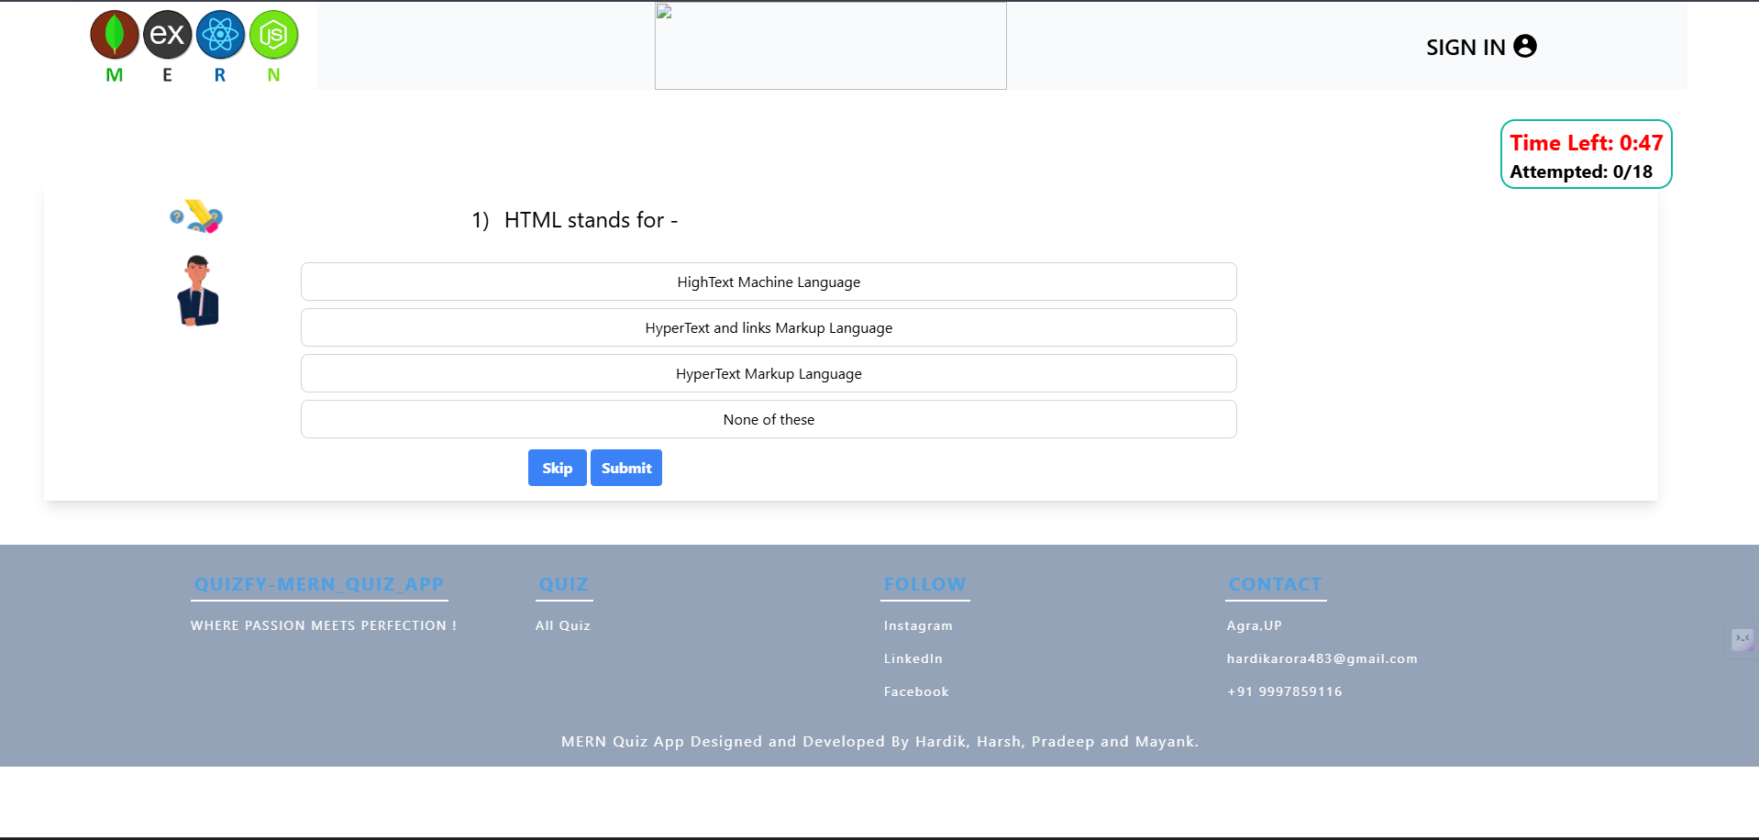

Page 15: User Interface (UI) and User Experience (UX) Design

- Image 5: Answer Review
Shows correct and incorrect answers after quiz completion, providing feedback to users.

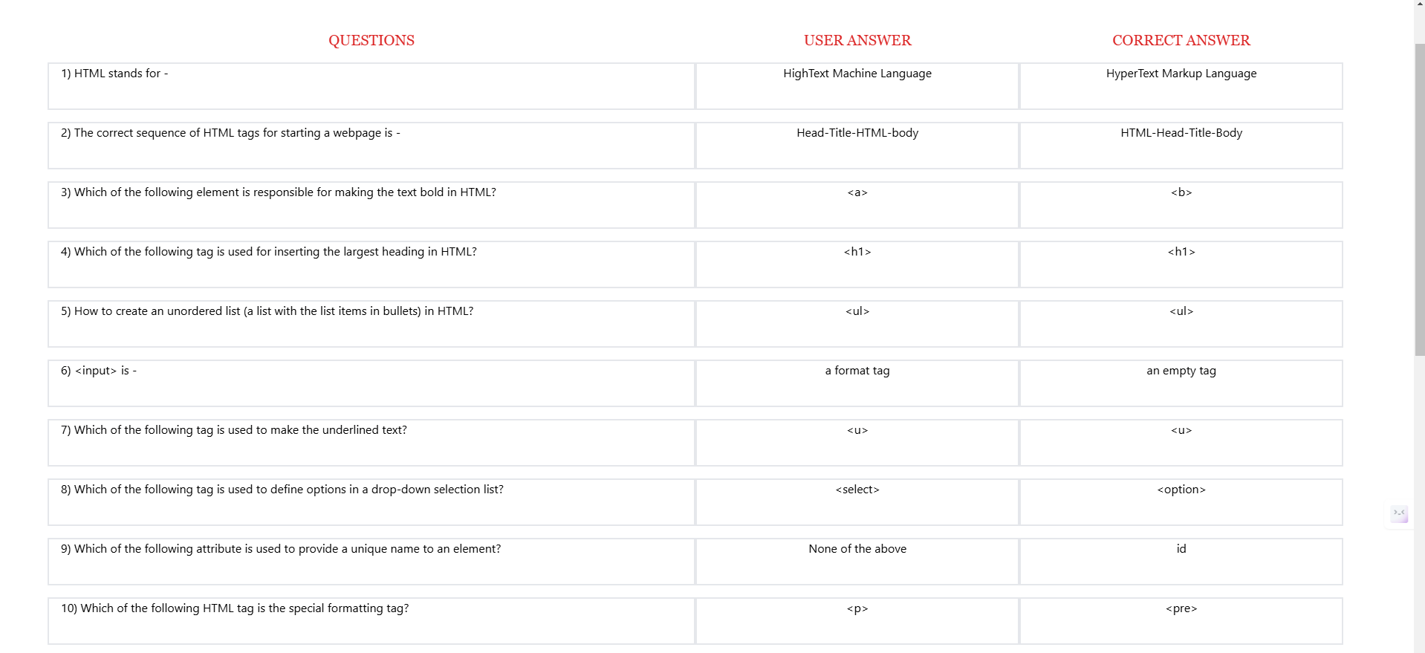

Page 16: Bibliography and References
This section acknowledges the resources and materials referred to during the development of the project. Proper citations ensure transparency and give credit to the contributors.

Books and Articles
- "Learning React" by Alex Banks and Eve Porcello – A comprehensive guide to building user interfaces with React.
- "JavaScript: The Good Parts" by Douglas Crockford – Insights into effective JavaScript programming.
- "Modern Full-Stack Development" by Frank Zammetti – A resource on integrating frontend and backend technologies.

Websites and Online Resources
- MDN Web Docs – https://developer.mozilla.org/
Comprehensive documentation on HTML, CSS, and JavaScript.
- React Documentation – https://reactjs.org/
Official guide for React development.
- Node.js Documentation – https://nodejs.org/
In-depth information about Node.js APIs and features.
- MongoDB Documentation – https://www.mongodb.com/docs/
Reference for working with MongoDB databases.

APIs Used
- Express.js – Lightweight web framework for Node.js.
- Axios – HTTP client for API calls.
- JWT (JSON Web Token) – Used for user authentication and authorization.

Other References
- Stack Overflow – https://stackoverflow.com/
Resolved common development issues and debugging challenges.
- W3Schools – https://www.w3schools.com/
Tutorials on web development fundamentals.
- GeeksforGeeks – https://www.geeksforgeeks.org/
Articles and examples on data structures and algorithms.

