Breadboard:

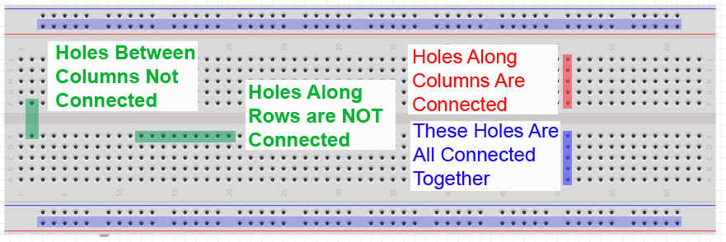

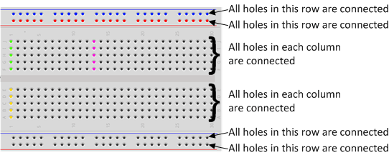

Arduino:

Microcontroller: ATmega328P

14 digital i/o pins; 6 analogue input pins

Input voltage: 7-20V Operating voltage: 5V

Microcontroller: it’s a small computer on a integrated circuit chip. It has one or more CPUs along with memory and programmable i/o peripherals.

JK Flip Flop:

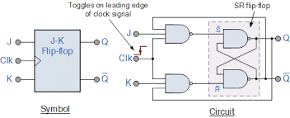

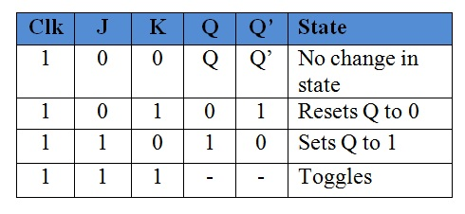

IC 74HC73 (Tinkercad):

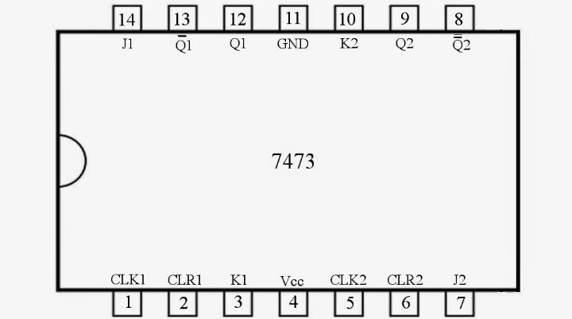 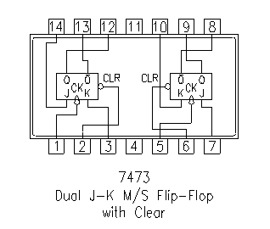

IC CD4027 (Lab):

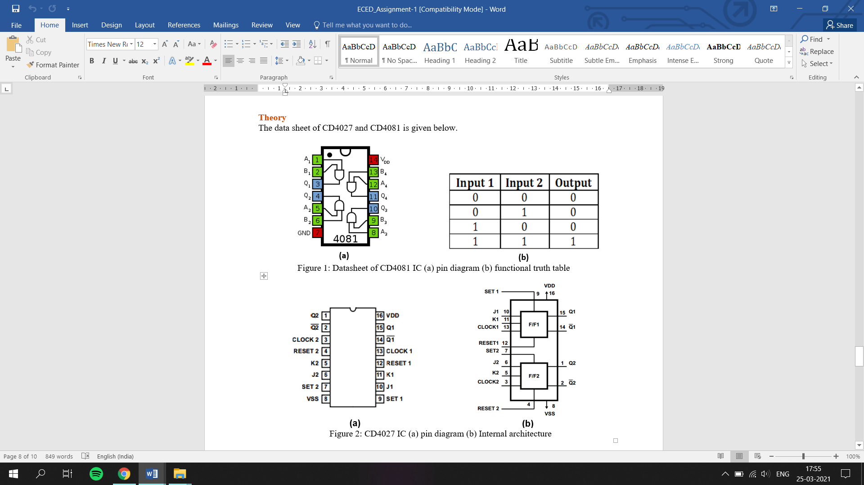

A Latch is a basic memory device to store one bit of information. It is a sequential electronic circuit that has no CLOCK input and changes output state only in response to data input.

A Flip-flop is a clock-controlled memory device. It differs from a Latch in that it has a control signal (CLOCK) input. It stores the input state and outputs the stored state only in response to the CLOCK signal. If a Flip-flop accepts its inputs at L to H (H to L) transition, it is Positive-Edge (Negative-Edge) Triggered.

Clock can be applied in Arduino using delay(___) function.

Set and Preset are same

Reset and Clear are same

Set = 0 🡪 Qn=1

Reset = 0 🡪 Qn=0 because Qn’=1

|  |  |  |
| --- | --- | --- |
| Preset | Clear | Qn |
| 0 | 0 | Not used |
| 0 | 1 | 1 |
| 1 | 0 | 0 |
| 1 | 1 | No effect on flip flop |

CD 4081(Lab): AND Gate



A,B-inputs Q-output

IC 7408(Tinkercad):

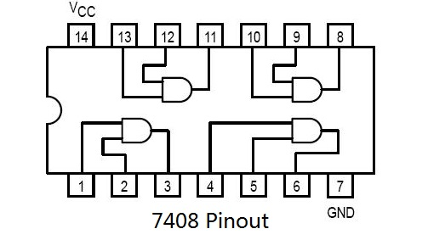

CD4543 (Lab): BCD to 7 segment decoder

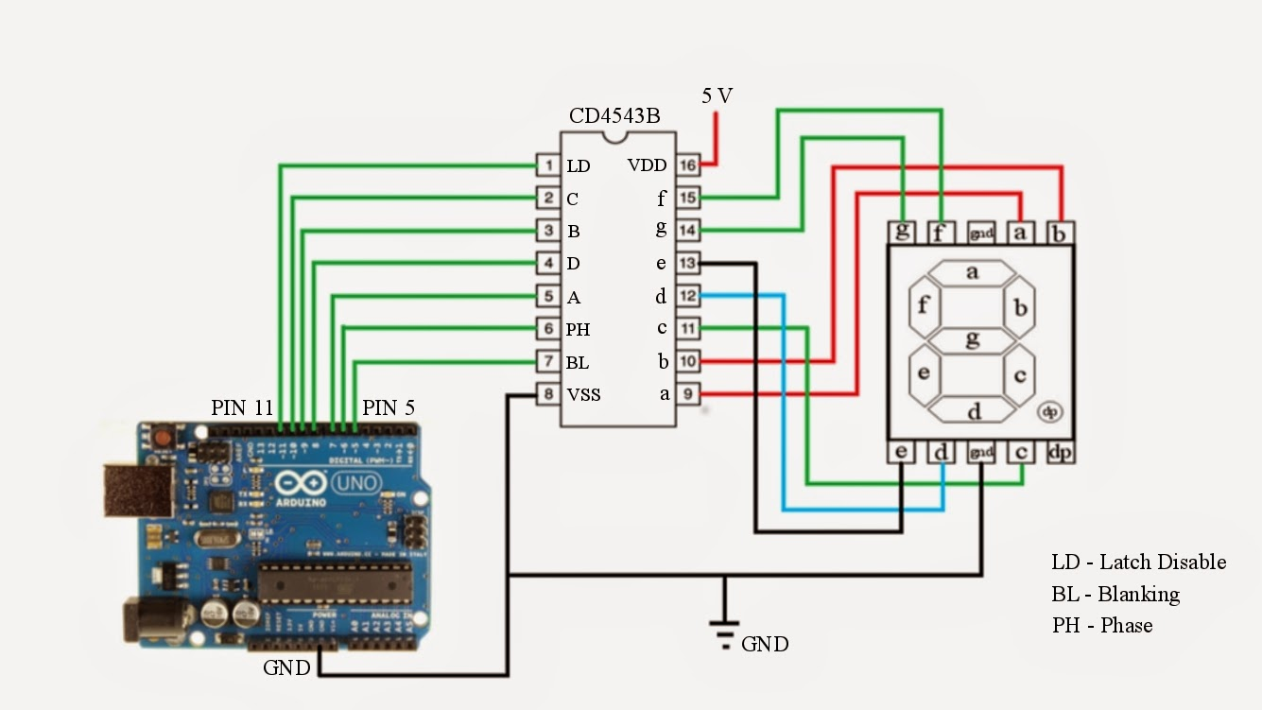

CD 4511 (Tinkercad):

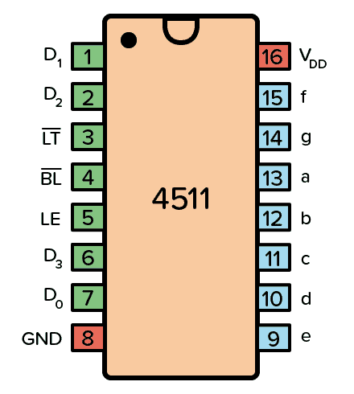

LE- Latch Enable BL- Blanking Test LT- Lamp Test

IR sensor:

The emitter is simply an IR LED [(Light Emitting Diode](https://robu.in/product-category/display-boards/led/)) and the detector is simply an IR photodiode. Photodiode is sensitive to IR light of the same wavelength which is emitted by the IR LED. When IR light falls on the photodiode, the resistances and the output voltages will change in proportion to the magnitude of the IR light received.

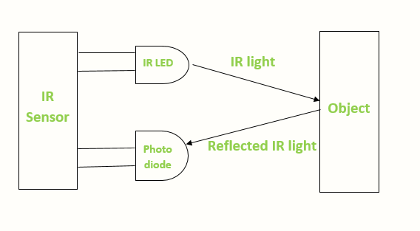

When the IR transmitter emits radiation, it reaches the object and some of the radiation reflects back to the IR receiver. Based on the intensity of the reception by the IR receiver, the output of the [sensor](https://robu.in/product-category/sensor/) defines.

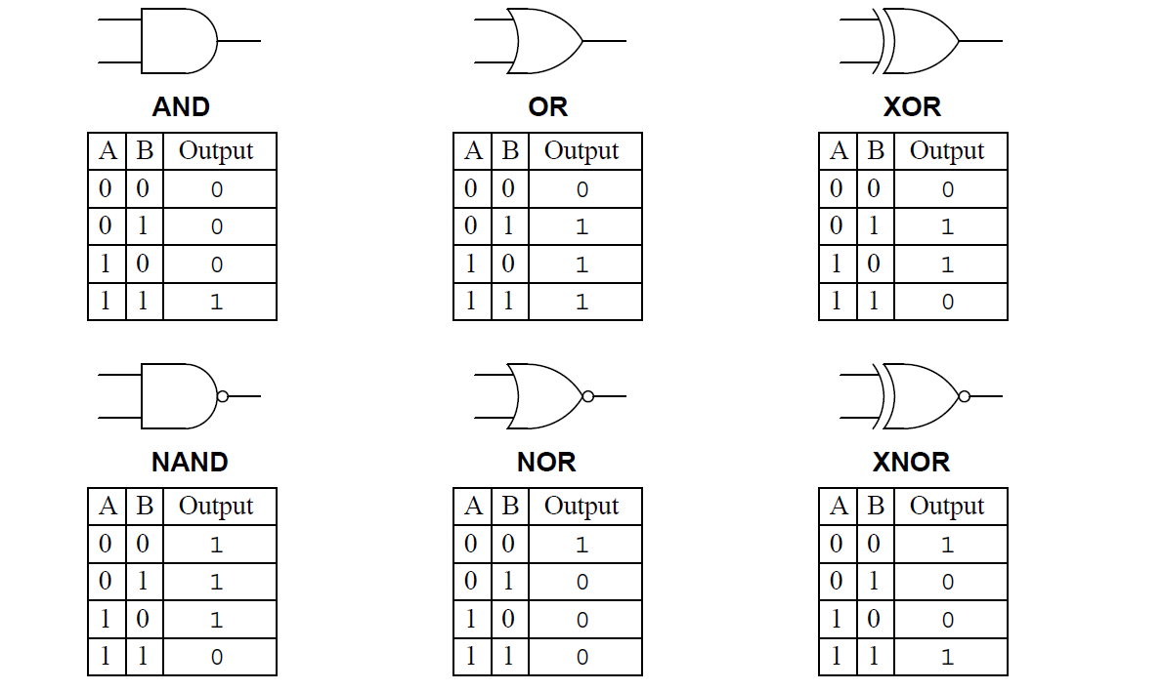

For combination of logic gates: <https://www.electronics-tutorials.ws/logic/universal-gates.html>