P2
package com.example.hello;
import androidx.appcompat.app.AppCompatActivity;
import android.os.Bundle;
public class MainActivity extends AppCompatActivity {
@Override
protected void onCreate(Bundle savedInstanceState) {
super.onCreate(savedInstanceState);
setContentView(R.layout.activity_main);
}
}
<?xml version="1.0" encoding="utf-8"?>
<androidx.constraintlayout.widget.ConstraintLayout xmlns:android="http://schemas.android.com/apk/res/android"
xmlns:app="http://schemas.android.com/apk/res-auto"
xmlns:tools="http://schemas.android.com/tools"
android:layout_width="match_parent"
android:layout_height="match_parent"
tools:context=".MainActivity">
<TextView
android:layout_width="wrap_content"
android:layout_height="wrap_content"
android:text="Hello World!"
app:layout_constraintBottom_toBottomOf="parent"
app:layout_constraintEnd_toEndOf="parent"
app:layout_constraintStart_toStartOf="parent"
app:layout_constraintTop_toTopOf="parent" />
</androidx.constraintlayout.widget.ConstraintLayout>

package com.example.hello;
import androidx.appcompat.app.AppCompatActivity;
import android.os.Bundle;
public class MainActivity extends AppCompatActivity {
@Override
protected void onCreate(Bundle savedInstanceState) {
super.onCreate(savedInstanceState);
setContentView(R.layout.activity_main);
}
}
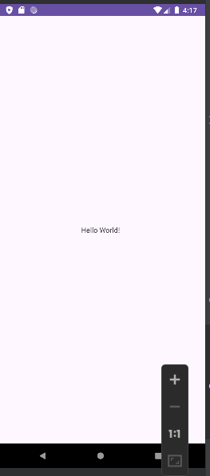
P4
<?xml version="1.0" encoding="utf-8"?>
<LinearLayout xmlns:android="http://schemas.android.com/apk/res/android"
android:layout_width="match_parent"
android:layout_height="match_parent"
android:orientation="vertical"
android:padding="16dp">

<EditText
android:id="@+id/editTextInput"
android:layout_width="match_parent"
android:layout_height="wrap_content"
android:textSize="24sp"
android:textColor="#FF5733"

android:hint="Enter your text" />

<Button
android:id="@+id/buttonDisplay"
android:layout_width="wrap_content"
android:layout_height="wrap_content"
android:text="Display Text" />

<TextView
android:id="@+id/textViewOutput"
android:layout_width="match_parent"
android:layout_height="wrap_content"
android:textSize="18sp"
android:textColor="#FF5733"
android:paddingTop="16dp" />
</LinearLayout>
package com.example.hardiks_1st_practical;

import android.os.Bundle;
import android.view.View;
import android.widget.Button;
import android.widget.EditText;
import android.widget.TextView;
import android.widget.Toast;

import androidx.appcompat.app.AppCompatActivity;

public class MainActivity extends AppCompatActivity {

private EditText editTextInput;
private TextView textViewOutput;

@Override
protected void onCreate(Bundle savedInstanceState) {
super.onCreate(savedInstanceState);
setContentView(R.layout.activity_main);
editTextInput = findViewById(R.id.editTextInput);
textViewOutput = findViewById(R.id.textViewOutput);
Button buttonDisplay = findViewById(R.id.buttonDisplay);

buttonDisplay.setOnClickListener(new View.OnClickListener() {
@Override
public void onClick(View v) {
String userInput = editTextInput.getText().toString();
textViewOutput.setText("hello "+userInput);
Toast.makeText(getApplicationContext(), "tostmessage", Toast.LENGTH_SHORT).show();
}
});
}
}
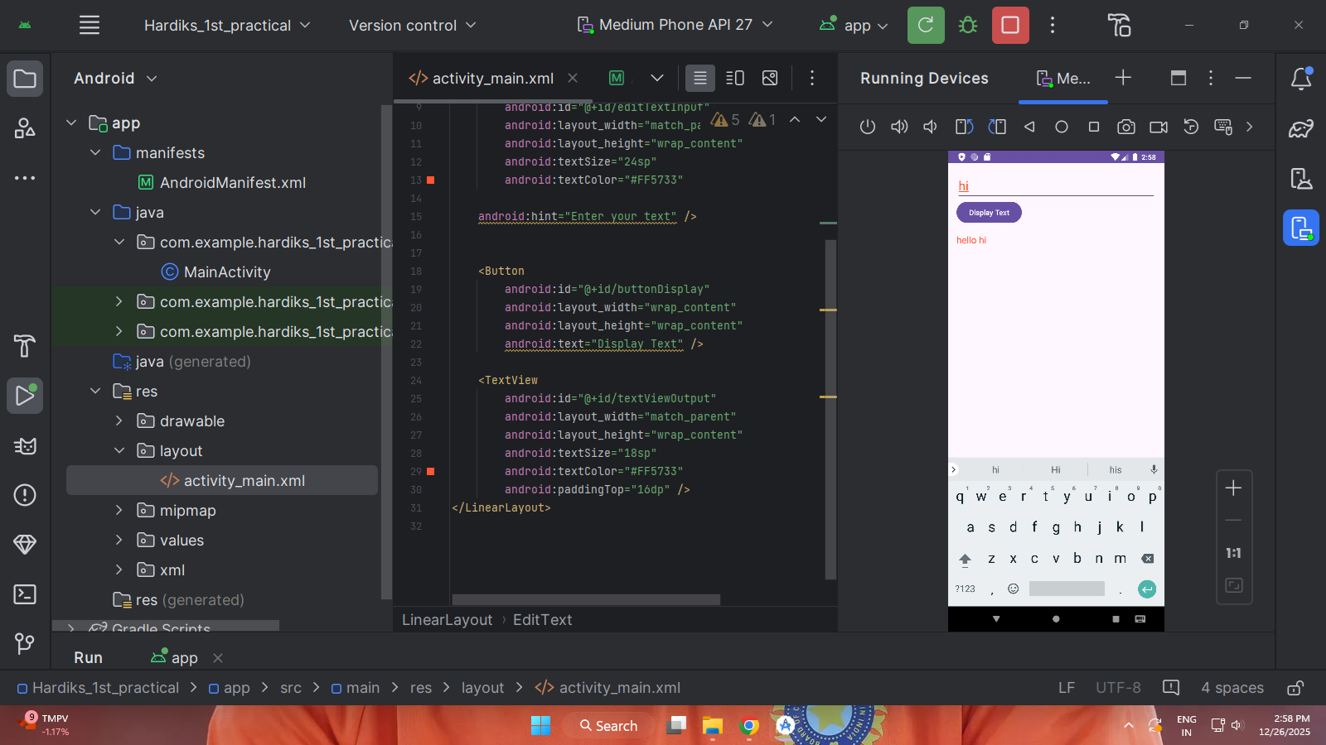
P5
package com.example.myapplication;

import androidx.appcompat.app.AppCompatActivity;

import android.os.Bundle;
import android.view.View;
import android.widget.Button;
import android.widget.ImageButton;
import android.widget.Toast;
import android.widget.ToggleButton;

public class MainActivity extends AppCompatActivity {

@Override
protected void onCreate(Bundle savedInstanceState) {
super.onCreate(savedInstanceState);

setContentView(R.layout.activity_main);

// Initialize the buttons
Button standardButton = findViewById(R.id.standardButton);
ImageButton imageButton = findViewById(R.id.imageButton);
ToggleButton toggleButton = findViewById(R.id.toggleButton);

// Set up click listener for standard button
standardButton.setOnClickListener(new View.OnClickListener() {
@Override
public void onClick(View v) {
Toast.makeText(MainActivity.this, "Standard Button Clicked", Toast.LENGTH_SHORT).show();
}
});

// Set up click listener for image button
imageButton.setOnClickListener(new View.OnClickListener() {
@Override
public void onClick(View v) {
Toast.makeText(MainActivity.this, "Image Button Clicked", Toast.LENGTH_SHORT).show();
}
});

// Set up toggle listener for toggle button
toggleButton.setOnCheckedChangeListener((buttonView, isChecked) -> {
if (isChecked) {
Toast.makeText(MainActivity.this, "Toggle ON", Toast.LENGTH_SHORT).show();
} else {
Toast.makeText(MainActivity.this, "Toggle OFF", Toast.LENGTH_SHORT).show();
}
});
}
}
<!--add image in res>drawable>past the image with img name-->
<?xml version="1.0" encoding="utf-8"?>
<LinearLayout
xmlns:android="http://schemas.android.com/apk/res/android"
android:layout_width="match_parent"
android:layout_height="match_parent"
android:orientation="vertical"
android:padding="16dp">

<ImageButton
android:id="@+id/imageButton"
android:layout_width="wrap_content"
android:layout_height="wrap_content"
android:src="@drawable/img"
android:contentDescription="Sample Image Button" />

<Button
android:id="@+id/standardButton"
android:layout_width="wrap_content"
android:layout_height="wrap_content"
android:text="Click Me" />

<ToggleButton
android:id="@+id/toggleButton"
android:layout_width="wrap_content"
android:layout_height="wrap_content"
android:textOff="OFF"
android:textOn="ON" />

</LinearLayout>
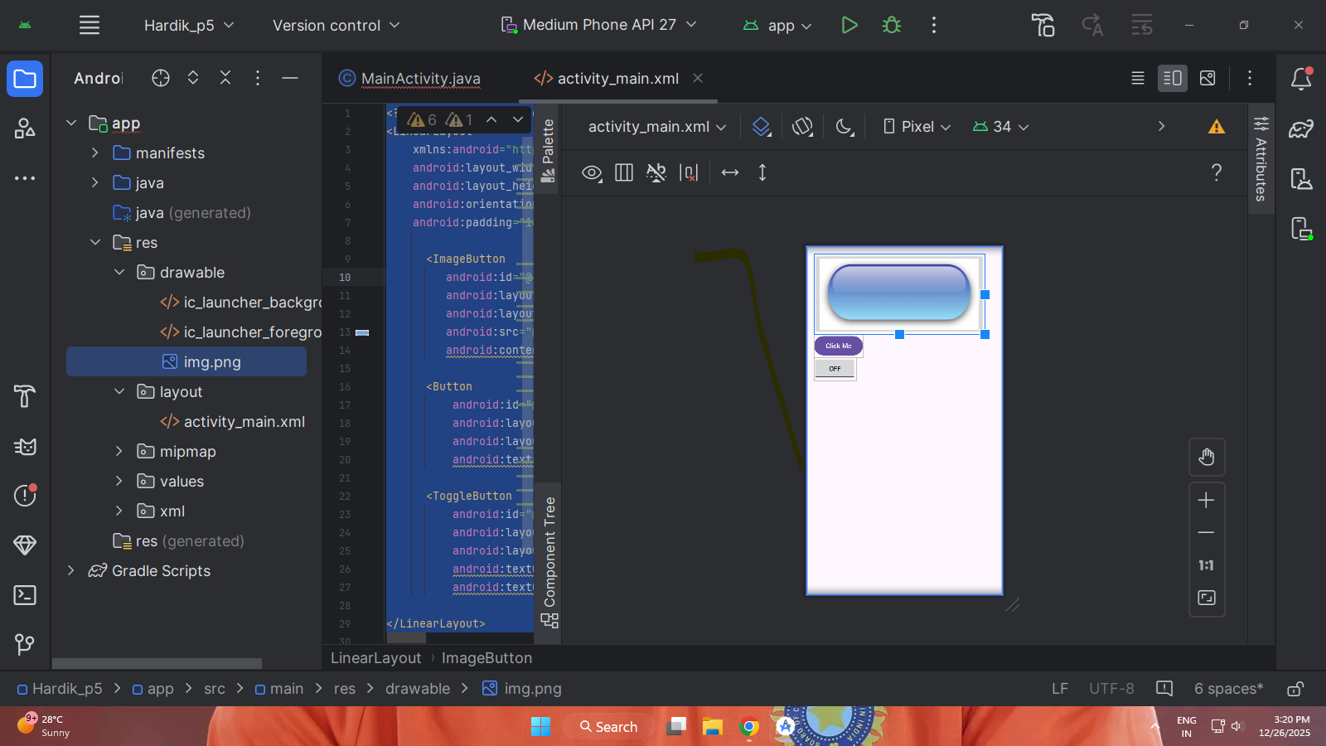
P6
package com.example.p6_1;

import androidx.appcompat.app.AppCompatActivity;

import android.graphics.Color;
import android.os.Bundle;
import android.view.View;
import android.widget.Button;
import android.widget.CheckBox;
import android.widget.EditText;
import android.widget.RadioButton;
import android.widget.RadioGroup;
import android.widget.TextView;
import android.widget.ToggleButton;
import android.widget.Toast;

public class MainActivity extends AppCompatActivity {

TextView t1, tvCheckCount;
EditText e1, e2;
RadioButton r1, r2;
RadioGroup rg;
ToggleButton tb1;
Button b1, bDetails;
CheckBox cb1, cb2;

@Override
protected void onCreate(Bundle savedInstanceState) {
super.onCreate(savedInstanceState);
setContentView(R.layout.activity_main);

t1 = findViewById(R.id.t_1);
e1 = findViewById(R.id.editTextText);
e2 = findViewById(R.id.editTextTextPassword);
rg = findViewById(R.id.radioGroup);
r1 = findViewById(R.id.radioButton);
r2 = findViewById(R.id.radioButton2);
tb1 = findViewById(R.id.toggleButton);
b1 = findViewById(R.id.button);
bDetails = findViewById(R.id.buttonDetails);
cb1 = findViewById(R.id.checkBox);
cb2 = findViewById(R.id.checkBox2);
tvCheckCount = findViewById(R.id.tvCheckCount);

// Change RadioButton color when selected
rg.setOnCheckedChangeListener((group, checkedId) -> {
r1.setTextColor(Color.BLACK);
r2.setTextColor(Color.BLACK);

if (checkedId == R.id.radioButton)
r1.setTextColor(Color.BLUE);
else if (checkedId == R.id.radioButton2)
r2.setTextColor(Color.BLUE);
});

// Submit Button (count + clear)
b1.setOnClickListener(view -> {

int count = 0;
if (cb1.isChecked()) count++;
if (cb2.isChecked()) count++;

tvCheckCount.setText("Selected CheckBoxes: " + count);

cb1.setChecked(false);
cb2.setChecked(false);
rg.clearCheck();

r1.setTextColor(Color.BLACK);
r2.setTextColor(Color.BLACK);
});

// Login Details Button
bDetails.setOnClickListener(view -> {

String name = e1.getText().toString();
String pass = e2.getText().toString();

String gender = "Not Selected";
if (r1.isChecked()) gender = "Male";
else if (r2.isChecked()) gender = "Female";

String toggleStatus = tb1.isChecked() ? "ON" : "OFF";

Toast.makeText(MainActivity.this,
"Name: " + name +
"\nPassword: " + pass +
"\nGender: " + gender +
"\nToggle: " + toggleStatus,
Toast.LENGTH_LONG).show();
});
}
}
<?xml version="1.0" encoding="utf-8"?>
<androidx.constraintlayout.widget.ConstraintLayout
xmlns:android="http://schemas.android.com/apk/res/android"
xmlns:app="http://schemas.android.com/apk/res-auto"
xmlns:tools="http://schemas.android.com/tools"
android:layout_width="match_parent"
android:layout_height="match_parent">

<TextView
android:id="@+id/t_1"
android:layout_width="wrap_content"
android:layout_height="wrap_content"
android:text="Input Form"
android:textSize="22sp"
android:textStyle="bold"
android:layout_margin="16dp"
app:layout_constraintTop_toTopOf="parent"
app:layout_constraintStart_toStartOf="parent"/>

<EditText
android:id="@+id/editTextText"
android:layout_width="0dp"
android:layout_height="wrap_content"
android:hint="Enter Name"
android:layout_margin="16dp"
app:layout_constraintTop_toBottomOf="@id/t_1"
app:layout_constraintStart_toStartOf="parent"
app:layout_constraintEnd_toEndOf="parent"/>

<EditText
android:id="@+id/editTextTextPassword"
android:layout_width="0dp"
android:layout_height="wrap_content"
android:hint="Enter Password"
android:inputType="textPassword"
android:layout_margin="16dp"
app:layout_constraintTop_toBottomOf="@id/editTextText"
app:layout_constraintStart_toStartOf="parent"
app:layout_constraintEnd_toEndOf="parent"/>

<RadioGroup
android:id="@+id/radioGroup"
android:layout_width="wrap_content"
android:layout_height="wrap_content"
android:layout_margin="16dp"
app:layout_constraintTop_toBottomOf="@id/editTextTextPassword"
app:layout_constraintStart_toStartOf="parent">

<RadioButton
android:id="@+id/radioButton"
android:text="Male"
android:layout_width="wrap_content"
android:layout_height="wrap_content"/>

<RadioButton
android:id="@+id/radioButton2"
android:text="Female"
android:layout_width="wrap_content"
android:layout_height="wrap_content"/>
</RadioGroup>

<ToggleButton
android:id="@+id/toggleButton"
android:layout_width="wrap_content"
android:layout_height="wrap_content"
android:textOn="ON"
android:textOff="OFF"
android:layout_margin="16dp"
app:layout_constraintTop_toBottomOf="@id/radioGroup"
app:layout_constraintStart_toStartOf="parent"/>

<CheckBox
android:id="@+id/checkBox"
android:text="Option 1"
android:layout_width="wrap_content"
android:layout_height="wrap_content"
android:layout_margin="16dp"
app:layout_constraintTop_toBottomOf="@id/toggleButton"
app:layout_constraintStart_toStartOf="parent"/>

<CheckBox
android:id="@+id/checkBox2"
android:text="Option 2"
android:layout_width="wrap_content"
android:layout_height="wrap_content"
android:layout_margin="16dp"
app:layout_constraintTop_toBottomOf="@id/checkBox"
app:layout_constraintStart_toStartOf="parent"/>

<!-- Submit Button -->
<Button
android:id="@+id/button"
android:text="Submit"
android:layout_width="wrap_content"
android:layout_height="wrap_content"
android:layout_margin="16dp"
app:layout_constraintTop_toBottomOf="@id/checkBox2"
app:layout_constraintStart_toStartOf="parent"/>

<!-- New Login Details Button -->
<Button
android:id="@+id/buttonDetails"
android:text="Login Details"
android:layout_width="wrap_content"
android:layout_height="wrap_content"
android:layout_margin="16dp"
app:layout_constraintTop_toBottomOf="@id/button"
app:layout_constraintStart_toStartOf="parent"/>

<TextView
android:id="@+id/tvCheckCount"
android:text="Selected CheckBoxes: 0"
android:textSize="16sp"
android:layout_width="wrap_content"
android:layout_height="wrap_content"
android:layout_margin="16dp"
app:layout_constraintTop_toBottomOf="@id/buttonDetails"
app:layout_constraintStart_toStartOf="parent"/>

</androidx.constraintlayout.widget.ConstraintLayout>
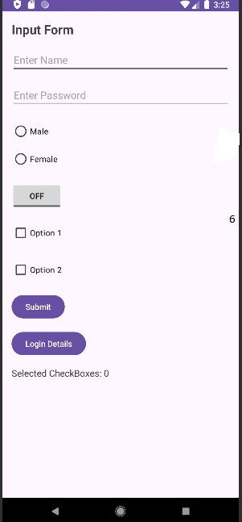
P7_1
<?xml version="1.0" encoding="utf-8"?>
<LinearLayout xmlns:android="http://schemas.android.com/apk/res/android"
android:layout_width="match_parent"
android:layout_height="match_parent"
android:orientation="vertical"
android:gravity="center"
android:padding="20dp">

<TextView
android:id="@+id/tvProgress"
android:layout_width="wrap_content"
android:layout_height="wrap_content"
android:text="Progress: 0%"
android:textSize="18sp"
android:layout_marginBottom="20dp"/>

<ProgressBar
android:id="@+id/progressBar"
style="?android:attr/progressBarStyleHorizontal"
android:layout_width="match_parent"
android:layout_height="wrap_content"
android:max="100"
android:progress="0"/>

</LinearLayout>
package com.example.p7_1;

import android.os.Bundle;
import android.os.Handler;
import android.widget.ProgressBar;
import android.widget.TextView;

import androidx.appcompat.app.AppCompatActivity;

public class MainActivity extends AppCompatActivity {

ProgressBar progressBar;
TextView tvProgress;
int progressStatus = 0;
Handler handler = new Handler();

@Override
protected void onCreate(Bundle savedInstanceState) {
super.onCreate(savedInstanceState);
setContentView(R.layout.activity_main);

progressBar = findViewById(R.id.progressBar);
tvProgress = findViewById(R.id.tvProgress);

// Background thread
new Thread(new Runnable() {
@Override
public void run() {
while (progressStatus < 100) {
progressStatus += 10;

// Update UI using handler
handler.post(new Runnable() {
@Override
public void run() {
progressBar.setProgress(progressStatus);
tvProgress.setText("Progress: " + progressStatus + "%");
}
});

try {
Thread.sleep(1000); // 1 second delay
} catch (InterruptedException e) {
e.printStackTrace();
}
}
}
}).start();
}
}
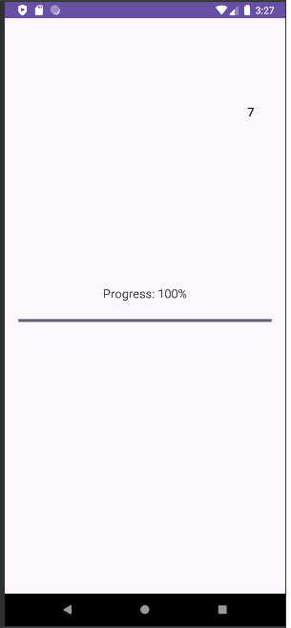
P7_2
package com.example.p7_2;

import android.os.Bundle;
import android.os.Handler;
import android.view.View;
import android.widget.Button;
import android.widget.ProgressBar;
import android.widget.TextView;

import androidx.appcompat.app.AppCompatActivity;

public class MainActivity extends AppCompatActivity {

ProgressBar progressBar;
TextView tvStatus;
Button btnDownload;

int progress = 0;
Handler handler = new Handler();

@Override
protected void onCreate(Bundle savedInstanceState) {
super.onCreate(savedInstanceState);
setContentView(R.layout.activity_main);

progressBar = findViewById(R.id.progressBar);
tvStatus = findViewById(R.id.tvStatus);
btnDownload = findViewById(R.id.btnDownload);

btnDownload.setOnClickListener(new View.OnClickListener() {
@Override
public void onClick(View view) {
progress = 0;
progressBar.setProgress(0);
tvStatus.setText("Downloading...");
startDownload();
}
});
}

private void startDownload() {
new Thread(new Runnable() {
@Override
public void run() {
while (progress < 100) {
progress += 10;

handler.post(new Runnable() {
@Override
public void run() {
progressBar.setProgress(progress);
tvStatus.setText("Downloading: " + progress + "%");
}
});

try {
Thread.sleep(1000); // Simulate download time
} catch (InterruptedException e) {
e.printStackTrace();
}
}

handler.post(new Runnable() {
@Override
public void run() {
tvStatus.setText("Download Complete");
}
});
}
}).start();
}
}
<?xml version="1.0" encoding="utf-8"?>
<LinearLayout xmlns:android="http://schemas.android.com/apk/res/android"
android:layout_width="match_parent"
android:layout_height="match_parent"
android:orientation="vertical"
android:gravity="center"
android:padding="20dp">

<TextView
android:id="@+id/tvStatus"
android:layout_width="wrap_content"
android:layout_height="wrap_content"
android:text="Download not started"
android:textSize="18sp"
android:layout_marginBottom="20dp"/>

<ProgressBar
android:id="@+id/progressBar"
style="?android:attr/progressBarStyleHorizontal"
android:layout_width="match_parent"
android:layout_height="wrap_content"
android:max="100"
android:progress="0"/>

<Button
android:id="@+id/btnDownload"
android:layout_width="wrap_content"
android:layout_height="wrap_content"
android:text="Start Download"
android:layout_marginTop="20dp"/>

</LinearLayout>
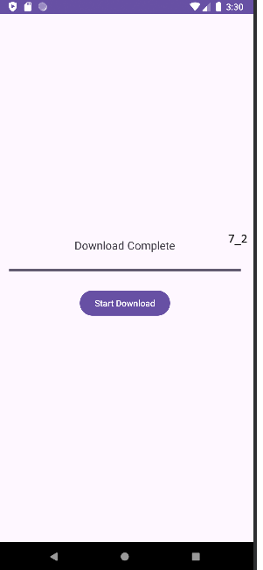
P7_3
package com.example.p7_3;

import android.os.AsyncTask;
import android.os.Bundle;
import android.os.Handler;
import android.widget.Button;
import android.widget.ProgressBar;
import android.widget.SeekBar;
import android.widget.TextView;

import androidx.appcompat.app.AppCompatActivity;

public class MainActivity extends AppCompatActivity {

ProgressBar progressBar;
TextView tvProgress;
SeekBar seekBar;
Button btnStart;

int delay = 50; // default delay (speed)
Handler handler = new Handler();

@Override
protected void onCreate(Bundle savedInstanceState) {
super.onCreate(savedInstanceState);
setContentView(R.layout.activity_main);

progressBar = findViewById(R.id.progressBar);
tvProgress = findViewById(R.id.tvProgress);
seekBar = findViewById(R.id.seekBar);
btnStart = findViewById(R.id.btnStart);

// Change download speed using SeekBar
seekBar.setOnSeekBarChangeListener(new SeekBar.OnSeekBarChangeListener() {
@Override
public void onProgressChanged(SeekBar seekBar, int progress, boolean fromUser) {
delay = 100 - progress; // higher progress = faster download
if (delay < 10) delay = 10;
}

@Override
public void onStartTrackingTouch(SeekBar seekBar) {}

@Override
public void onStopTrackingTouch(SeekBar seekBar) {}
});

btnStart.setOnClickListener(v -> {
progressBar.setProgress(0);
new DownloadTask().execute();
});
}

// AsyncTask for background processing
private class DownloadTask extends AsyncTask<Void, Integer, Void> {

@Override
protected Void doInBackground(Void... voids) {
for (int i = 1; i <= 100; i++) {
try {
Thread.sleep(delay);
} catch (InterruptedException e) {
e.printStackTrace();
}
publishProgress(i);
}
return null;
}

@Override
protected void onProgressUpdate(Integer... values) {
int progress = values[0];
progressBar.setProgress(progress);
tvProgress.setText("Progress: " + progress + "%");
}

@Override
protected void onPostExecute(Void aVoid) {
tvProgress.setText("Download Completed!");
}
}
}
<?xml version="1.0" encoding="utf-8"?>
<LinearLayout xmlns:android="http://schemas.android.com/apk/res/android"
android:layout_width="match_parent"
android:layout_height="match_parent"
android:orientation="vertical"
android:padding="20dp">

<TextView
android:id="@+id/tvTitle"
android:layout_width="wrap_content"
android:layout_height="wrap_content"
android:text="File Download Simulation"
android:textSize="20sp"
android:textStyle="bold"
android:layout_gravity="center" />

<ProgressBar
android:id="@+id/progressBar"
style="?android:attr/progressBarStyleHorizontal"
android:layout_width="match_parent"
android:layout_height="wrap_content"
android:max="100"
android:progress="0"
android:layout_marginTop="30dp"/>

<TextView
android:id="@+id/tvProgress"
android:layout_width="wrap_content"
android:layout_height="wrap_content"
android:text="Progress: 0%"
android:layout_marginTop="10dp"/>

<TextView
android:layout_width="wrap_content"
android:layout_height="wrap_content"
android:text="Download Speed"
android:layout_marginTop="20dp"/>

<SeekBar
android:id="@+id/seekBar"
android:layout_width="match_parent"
android:layout_height="wrap_content"
android:max="100"
android:progress="50"/>

<Button
android:id="@+id/btnStart"
android:layout_width="match_parent"
android:layout_height="wrap_content"
android:text="Start Download"
android:layout_marginTop="20dp"/>
</LinearLayout>
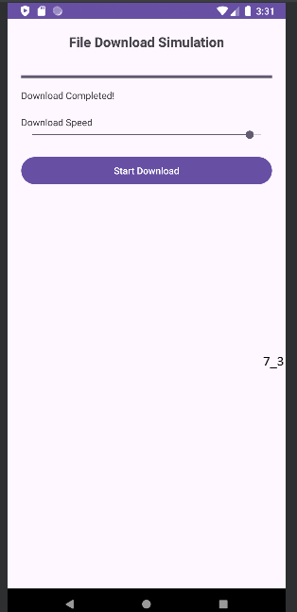
P8
package com.example.p8_1;

import android.os.Bundle;
import android.os.Handler;
import android.text.Editable;
import android.text.TextWatcher;
import android.view.View;
import android.widget.*;

import androidx.appcompat.app.AppCompatActivity;

public class MainActivity extends AppCompatActivity {

EditText etUsername, etPassword;
RadioGroup radioGroupGender;
CheckBox checkRemember;
Button btnLogin;
ProgressBar progressBar;

@Override
protected void onCreate(Bundle savedInstanceState) {
super.onCreate(savedInstanceState);
setContentView(R.layout.activity_main);

etUsername = findViewById(R.id.etUsername);
etPassword = findViewById(R.id.etPassword);
radioGroupGender = findViewById(R.id.radioGroupGender);
checkRemember = findViewById(R.id.checkRemember);
btnLogin = findViewById(R.id.btnLogin);
progressBar = findViewById(R.id.progressBar);

TextWatcher textWatcher = new TextWatcher() {
@Override
public void beforeTextChanged(CharSequence s, int start, int count, int after) {}

@Override
public void onTextChanged(CharSequence s, int start, int before, int count) {
btnLogin.setEnabled(
!etUsername.getText().toString().trim().isEmpty() &&
!etPassword.getText().toString().trim().isEmpty() &&
radioGroupGender.getCheckedRadioButtonId() != -1
);
}

@Override
public void afterTextChanged(Editable s) {}
};

etUsername.addTextChangedListener(textWatcher);
etPassword.addTextChangedListener(textWatcher);

radioGroupGender.setOnCheckedChangeListener((group, checkedId) -> btnLogin.setEnabled(
!etUsername.getText().toString().trim().isEmpty() &&
!etPassword.getText().toString().trim().isEmpty()
));

btnLogin.setOnClickListener(v -> {
progressBar.setVisibility(View.VISIBLE);

new Handler().postDelayed(() -> {
progressBar.setVisibility(View.GONE);

int selectedGenderId = radioGroupGender.getCheckedRadioButtonId();
RadioButton selectedGender = findViewById(selectedGenderId);
String gender = selectedGender.getText().toString();

if (checkRemember.isChecked()) {
Toast.makeText(this, "Login Successful. Remember Me enabled", Toast.LENGTH_SHORT).show();
} else {
Toast.makeText(this, "Login Successful. Remember Me disabled", Toast.LENGTH_SHORT).show();
}

Toast.makeText(this, "Gender: " + gender, Toast.LENGTH_SHORT).show();

}, 2000); });
}
}
<?xml version="1.0" encoding="utf-8"?>
<LinearLayout xmlns:android="http://schemas.android.com/apk/res/android"
android:layout_width="match_parent"
android:layout_height="match_parent"
android:orientation="vertical"
android:padding="20dp">

<TextView
android:layout_width="wrap_content"
android:layout_height="wrap_content"
android:text="Login Form"
android:textSize="22sp"
android:textStyle="bold"
android:layout_gravity="center_horizontal"
android:paddingBottom="20dp" />

<EditText
android:id="@+id/etUsername"
android:layout_width="match_parent"
android:layout_height="wrap_content"
android:hint="Username" />

<EditText
android:id="@+id/etPassword"
android:layout_width="match_parent"
android:layout_height="wrap_content"
android:hint="Password"
android:inputType="textPassword"
android:layout_marginTop="10dp" />

<TextView
android:layout_width="wrap_content"
android:layout_height="wrap_content"
android:text="Gender"
android:layout_marginTop="15dp" />

<RadioGroup
android:id="@+id/radioGroupGender"
android:layout_width="wrap_content"
android:layout_height="wrap_content">

<RadioButton
android:id="@+id/radioMale"
android:layout_width="wrap_content"
android:layout_height="wrap_content"
android:text="Male" />

<RadioButton
android:id="@+id/radioFemale"
android:layout_width="wrap_content"
android:layout_height="wrap_content"
android:text="Female" />
</RadioGroup>

<CheckBox
android:id="@+id/checkRemember"
android:layout_width="wrap_content"
android:layout_height="wrap_content"
android:text="Remember Me"
android:layout_marginTop="10dp" />

<Button
android:id="@+id/btnLogin"
android:layout_width="match_parent"
android:layout_height="wrap_content"
android:text="Login"
android:enabled="false"
android:layout_marginTop="15dp" />

<ProgressBar
android:id="@+id/progressBar"
android:layout_width="wrap_content"
android:layout_height="wrap_content"
android:visibility="gone"
android:layout_gravity="center"
android:layout_marginTop="15dp" />

</LinearLayout>
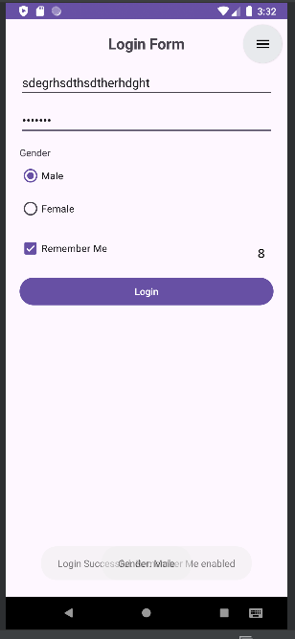
P9
package com.example.p9_1;

import android.graphics.Color;
import android.os.Bundle;
import android.view.Gravity;
import android.view.View;
import android.widget.*;
import androidx.appcompat.app.AppCompatActivity;

public class MainActivity extends AppCompatActivity {

EditText etName, etEmail, etPhone;
RadioGroup radioGender;
CheckBox cbTerms;
Button btnRegister;

@Override
protected void onCreate(Bundle savedInstanceState) {
super.onCreate(savedInstanceState);
setContentView(R.layout.activity_main);

etName = findViewById(R.id.etName);
etEmail = findViewById(R.id.etEmail);
etPhone = findViewById(R.id.etPhone);
radioGender = findViewById(R.id.radioGender);
cbTerms = findViewById(R.id.cbTerms);
btnRegister = findViewById(R.id.btnRegister);

btnRegister.setOnClickListener(v -> validateAndRegister());
}

private void validateAndRegister() {

String name = etName.getText().toString().trim();
String email = etEmail.getText().toString().trim();
String phone = etPhone.getText().toString().trim();

if (name.isEmpty() || email.isEmpty() || phone.isEmpty()) {
showCustomToast("All fields are required", false);
return;
}

if (phone.length() != 10) {
showCustomToast("Phone must be 10 digits", false);
return;
}

if (!cbTerms.isChecked()) {
showCustomToast("Accept Terms & Conditions", false);
return;
}

int selectedId = radioGender.getCheckedRadioButtonId();
if (selectedId == -1) {
showCustomToast("Select Gender", false);
return;
}

RadioButton rb = findViewById(selectedId);
String gender = rb.getText().toString();

showCustomToast("Welcome " + name + "\nEmail: " + email + "\nGender: " + gender, true);
}

// Custom Toast created programmatically
private void showCustomToast(String message, boolean success) {

LinearLayout layout = new LinearLayout(this);
layout.setOrientation(LinearLayout.HORIZONTAL);
layout.setPadding(30, 20, 30, 20);
layout.setGravity(Gravity.CENTER_VERTICAL);

layout.setBackgroundColor(success ? Color.parseColor("#4CAF50")
: Color.parseColor("#F44336"));

ImageView icon = new ImageView(this);
icon.setImageResource(success ?
android.R.drawable.checkbox_on_background :
android.R.drawable.ic_delete);

TextView text = new TextView(this);
text.setText(message);
text.setTextColor(Color.WHITE);
text.setPadding(20, 0, 0, 0);

layout.addView(icon);
layout.addView(text);

Toast toast = new Toast(this);
toast.setView(layout);
toast.setDuration(Toast.LENGTH_SHORT);
toast.show();
}
}
<?xml version="1.0" encoding="utf-8"?>
<androidx.constraintlayout.widget.ConstraintLayout
xmlns:android="http://schemas.android.com/apk/res/android"
xmlns:app="http://schemas.android.com/apk/res-auto"
android:layout_width="match_parent"
android:layout_height="match_parent"
android:padding="16dp">

<!-- Title -->
<TextView
android:id="@+id/tvTitle"
android:layout_width="wrap_content"
android:layout_height="wrap_content"
android:text="Registration Form"
android:textSize="22sp"
android:textStyle="bold"
app:layout_constraintTop_toTopOf="parent"
app:layout_constraintStart_toStartOf="parent"
app:layout_constraintEnd_toEndOf="parent"/>

<!-- LinearLayout Registration Form -->
<LinearLayout
android:id="@+id/linearForm"
android:layout_width="0dp"
android:layout_height="wrap_content"
android:orientation="vertical"
android:layout_marginTop="16dp"
app:layout_constraintTop_toBottomOf="@id/tvTitle"
app:layout_constraintStart_toStartOf="parent"
app:layout_constraintEnd_toEndOf="parent">

<EditText
android:id="@+id/etName"
android:layout_width="match_parent"
android:layout_height="wrap_content"
android:hint="Name"/>

<EditText
android:id="@+id/etEmail"
android:layout_width="match_parent"
android:layout_height="wrap_content"
android:hint="Email"
android:inputType="textEmailAddress"/>

<EditText
android:id="@+id/etPhone"
android:layout_width="match_parent"
android:layout_height="wrap_content"
android:hint="Phone Number"
android:inputType="phone"/>

<!-- Gender Selection -->
<RadioGroup
android:id="@+id/radioGender"
android:layout_width="wrap_content"
android:layout_height="wrap_content"
android:orientation="horizontal">

<RadioButton
android:id="@+id/rbMale"
android:layout_width="wrap_content"
android:layout_height="wrap_content"
android:text="Male"/>

<RadioButton
android:id="@+id/rbFemale"
android:layout_width="wrap_content"
android:layout_height="wrap_content"
android:text="Female"/>
</RadioGroup>

<!-- Terms -->
<CheckBox
android:id="@+id/cbTerms"
android:layout_width="wrap_content"
android:layout_height="wrap_content"
android:text="I agree to Terms and Conditions"/>

<Button
android:id="@+id/btnRegister"
android:layout_width="match_parent"
android:layout_height="wrap_content"
android:text="Register"/>

</LinearLayout>

</androidx.constraintlayout.widget.ConstraintLayout>
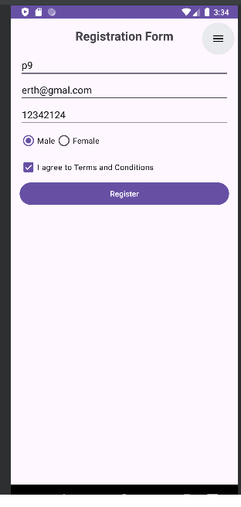
P10
package com.example.p10_1;

import android.os.Bundle;
import android.view.View;
import android.widget.Button;
import android.widget.Toast;

import androidx.appcompat.app.AppCompatActivity;

public class MainActivity extends AppCompatActivity {

Button btnAddCart, btnBuyNow;

@Override
protected void onCreate(Bundle savedInstanceState) {
super.onCreate(savedInstanceState);
setContentView(R.layout.activity_main);

btnAddCart = findViewById(R.id.btnAddCart);
btnBuyNow = findViewById(R.id.btnBuyNow);

btnAddCart.setOnClickListener(new View.OnClickListener() {
@Override
public void onClick(View view) {
Toast.makeText(MainActivity.this,
"Product added to cart",
Toast.LENGTH_SHORT).show();
}
});

btnBuyNow.setOnClickListener(new View.OnClickListener() {
@Override
public void onClick(View view) {
Toast.makeText(MainActivity.this,
"Proceeding to checkout",
Toast.LENGTH_SHORT).show();
}
});
}
}
<?xml version="1.0" encoding="utf-8"?>
<ScrollView xmlns:android="http://schemas.android.com/apk/res/android"
android:layout_width="match_parent"
android:layout_height="match_parent">

<LinearLayout
android:layout_width="match_parent"
android:layout_height="wrap_content"
android:orientation="vertical"
android:padding="16dp">

<FrameLayout
android:layout_width="match_parent"
android:layout_height="200dp">

<ImageView
android:layout_width="match_parent"
android:layout_height="match_parent"
android:scaleType="centerCrop"
android:src="@drawable/img" />

<TextView
android:layout_width="wrap_content"
android:layout_height="wrap_content"
android:text="20% OFF"
android:textColor="#FFFFFF"
android:background="#E91E63"
android:padding="8dp"
android:layout_gravity="top|end"
android:layout_margin="8dp" />
</FrameLayout>

<TextView
android:layout_width="wrap_content"
android:layout_height="wrap_content"
android:text="stroberry"
android:textSize="20sp"
android:textStyle="bold"
android:layout_marginTop="12dp" />

<TableLayout
android:layout_width="match_parent"
android:layout_height="wrap_content"
android:layout_marginTop="12dp"
android:stretchColumns="1">

<TableRow>
<TextView android:text="Item Price" />
<TextView android:text="₹2000" />
</TableRow>

<TableRow>
<TextView android:text="Tax" />
<TextView android:text="₹200" />
</TableRow>

<TableRow>
<TextView android:text="Shipping" />
<TextView android:text="₹100" />
</TableRow>

<TableRow>
<TextView
android:text="Total"
android:textStyle="bold" />
<TextView
android:text="₹2300"
android:textStyle="bold" />
</TableRow>
</TableLayout>

<RelativeLayout
android:layout_width="match_parent"
android:layout_height="wrap_content"
android:layout_marginTop="20dp">

<Button
android:id="@+id/btnAddCart"
android:layout_width="wrap_content"
android:layout_height="wrap_content"
android:text="Add to Cart"
android:layout_alignParentStart="true" />

<Button
android:id="@+id/btnBuyNow"
android:layout_width="wrap_content"
android:layout_height="wrap_content"
android:text="Buy Now"
android:layout_alignParentEnd="true" />

<TextView
android:layout_width="wrap_content"
android:layout_height="wrap_content"
android:text="Delivery by: 3–5 Business Days"
android:layout_below="@id/btnAddCart"
android:layout_marginTop="10dp"
android:textColor="#388E3C" />
</RelativeLayout>

</LinearLayout>
</ScrollView>
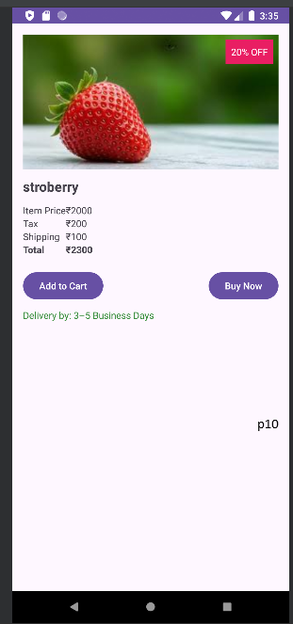
P11
package com.example.p11_1;

import android.os.Bundle;
import android.view.View;
import android.view.ViewGroup;
import android.widget.*;
import androidx.appcompat.app.AppCompatActivity;

public class MainActivity extends AppCompatActivity {

GridView gridView;
ListView listView;

String[] bookTitles = {"Android", "Java", "Python", "DSA"};
int[] bookImages = {
R.drawable.img_1,
R.drawable.img_1,
R.drawable.img_1,
R.drawable.img_1
};

String[] borrowers = {
"Amit - 01 Aug",
"Neha - 03 Aug",
"Rahul - 05 Aug",
"Sneha - 07 Aug"
};

@Override
protected void onCreate(Bundle savedInstanceState) {
super.onCreate(savedInstanceState);
setContentView(R.layout.activity_main);

gridView = findViewById(R.id.gridViewBooks);
listView = findViewById(R.id.listViewBorrowers);

gridView.setAdapter(new BookAdapter());

ArrayAdapter<String> adapter =
new ArrayAdapter<>(this,
android.R.layout.simple_list_item_1,
borrowers);

listView.setAdapter(adapter);

listView.setOnItemClickListener((parent, view, position, id) ->
Toast.makeText(this,
"Borrower: " + borrowers[position],
Toast.LENGTH_SHORT).show()
);
}

class BookAdapter extends BaseAdapter {

@Override
public int getCount() {
return bookTitles.length;
}

@Override
public Object getItem(int position) {
return bookTitles[position];
}

@Override
public long getItemId(int position) {
return position;
}

@Override
public View getView(int position, View convertView, ViewGroup parent) {

if (convertView == null) {
convertView = getLayoutInflater()
.inflate(R.layout.grid_item, parent, false);
}

ImageView imageView = convertView.findViewById(R.id.bookImage);
TextView textView = convertView.findViewById(R.id.bookTitle);

imageView.setImageResource(bookImages[position]);
textView.setText(bookTitles[position]);

return convertView;
}
}
}<?xml version="1.0" encoding="utf-8"?>
<ScrollView xmlns:android="http://schemas.android.com/apk/res/android"
android:layout_width="match_parent"
android:layout_height="match_parent">

<LinearLayout
android:orientation="vertical"
android:layout_width="match_parent"
android:layout_height="wrap_content"
android:padding="10dp">

<!-- 1. ImageView - Banner -->
<ImageView
android:id="@+id/bannerImage"
android:layout_width="match_parent"
android:layout_height="180dp"
android:src="@drawable/img"
android:scaleType="centerCrop" />

<!-- Title -->
<TextView
android:layout_width="wrap_content"
android:layout_height="wrap_content"
android:text="Library Book Catalog"
android:textSize="20sp"
android:textStyle="bold"
android:layout_marginTop="10dp" />

<!-- 2. GridView - Book Covers -->
<GridView
android:id="@+id/gridViewBooks"
android:layout_width="match_parent"
android:layout_height="wrap_content"
android:numColumns="2"
android:verticalSpacing="10dp"
android:horizontalSpacing="10dp"
android:stretchMode="columnWidth" />

<!-- Title -->
<TextView
android:layout_width="wrap_content"
android:layout_height="wrap_content"
android:text="Recent Borrowers"
android:textSize="20sp"
android:textStyle="bold"
android:layout_marginTop="10dp" />

<!-- 3. ListView - Borrowers -->
<ListView
android:id="@+id/listViewBorrowers"
android:layout_width="match_parent"
android:layout_height="wrap_content"
android:dividerHeight="1dp"/>

</LinearLayout>
</ScrollView>

<!-- Below is a single complete Android example (Library) that answers all 7 questions together, using:-->

<!-- GridView → Book covers-->

<!-- ImageView → Banner-->

<!-- ScrollView → Entire layout scrollable-->

<!-- ListView → Recent borrowers / guests-->

<!-- Custom Adapter → Book title + image-->

<!-- Click Listener → Toast on ListView click-->

<!-- Dashboard → GridView + ListView on same screen-->
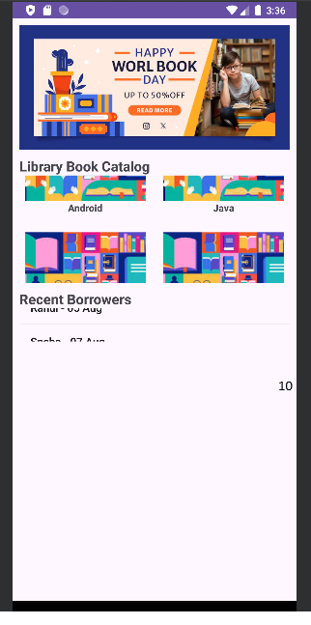
p12
package com.example.p12;

import androidx.appcompat.app.AppCompatActivity;
import android.os.Bundle;
import android.view.View;
import android.widget.Button;
import android.widget.TextView;
import android.widget.Toast;

public class MainActivity extends AppCompatActivity {

TextView txtDisplay;
double firstValue = 0, secondValue = 0;
String operator = "";
boolean isNewInput = true;

@Override
protected void onCreate(Bundle savedInstanceState) {
super.onCreate(savedInstanceState);
setContentView(R.layout.activity_main);

txtDisplay = findViewById(R.id.txtDisplay);

int[] numberButtons = {
R.id.btn0, R.id.btn1, R.id.btn2, R.id.btn3,
R.id.btn4, R.id.btn5, R.id.btn6,
R.id.btn7, R.id.btn8, R.id.btn9, R.id.btnDot
};

View.OnClickListener numberListener = view -> {
Button btn = (Button) view;
if (isNewInput) {
txtDisplay.setText("");
isNewInput = false;
}
txtDisplay.append(btn.getText().toString());
};

for (int id : numberButtons) {
findViewById(id).setOnClickListener(numberListener);
}

findViewById(R.id.btnAdd).setOnClickListener(v -> setOperator("+"));
findViewById(R.id.btnSub).setOnClickListener(v -> setOperator("-"));
findViewById(R.id.btnMul).setOnClickListener(v -> setOperator("*"));
findViewById(R.id.btnDiv).setOnClickListener(v -> setOperator("/"));

findViewById(R.id.btnEqual).setOnClickListener(v -> calculateResult());

findViewById(R.id.btnClear).setOnClickListener(v -> {
txtDisplay.setText("0");
firstValue = secondValue = 0;
operator = "";
isNewInput = true;
});
}

private void setOperator(String op) {
try {
firstValue = Double.parseDouble(txtDisplay.getText().toString());
operator = op;
isNewInput = true;
} catch (Exception e) {
Toast.makeText(this, "Invalid Input", Toast.LENGTH_SHORT).show();
}
}

private void calculateResult() {
try {
secondValue = Double.parseDouble(txtDisplay.getText().toString());
double result = 0;

switch (operator) {
case "+":
result = firstValue + secondValue;
break;
case "-":
result = firstValue - secondValue;
break;
case "*":
result = firstValue * secondValue;
break;
case "/":
if (secondValue == 0) {
Toast.makeText(this, "Cannot divide by zero", Toast.LENGTH_SHORT).show();
return;
}
result = firstValue / secondValue;
break;
}

txtDisplay.setText(String.valueOf(result));
isNewInput = true;

} catch (Exception e) {
Toast.makeText(this, "Error in Calculation", Toast.LENGTH_SHORT).show();
}
}
}<?xml version="1.0" encoding="utf-8"?>
<LinearLayout xmlns:android="http://schemas.android.com/apk/res/android"
android:layout_width="match_parent"
android:layout_height="match_parent"
android:orientation="vertical"
android:padding="10dp">

<!-- Display -->
<TextView
android:id="@+id/txtDisplay"
android:layout_width="match_parent"
android:layout_height="80dp"
android:text="0"
android:textSize="30sp"
android:gravity="end|center_vertical"
android:background="#EEEEEE"
android:padding="10dp" />

<!-- GridLayout for Calculator Buttons -->
<GridLayout
android:layout_width="match_parent"
android:layout_height="wrap_content"
android:columnCount="4"
android:rowCount="5"
android:layout_marginTop="10dp">

<!-- Row 1 -->
<Button android:id="@+id/btn7" android:text="7"/>
<Button android:id="@+id/btn8" android:text="8"/>
<Button android:id="@+id/btn9" android:text="9"/>
<Button android:id="@+id/btnDiv" android:text="/"/>

<!-- Row 2 -->
<Button android:id="@+id/btn4" android:text="4"/>
<Button android:id="@+id/btn5" android:text="5"/>
<Button android:id="@+id/btn6" android:text="6"/>
<Button android:id="@+id/btnMul" android:text="*"/>

<!-- Row 3 -->
<Button android:id="@+id/btn1" android:text="1"/>
<Button android:id="@+id/btn2" android:text="2"/>
<Button android:id="@+id/btn3" android:text="3"/>
<Button android:id="@+id/btnSub" android:text="-"/>

<!-- Row 4 -->
<Button android:id="@+id/btn0" android:text="0"/>
<Button android:id="@+id/btnDot" android:text="."/>
<Button android:id="@+id/btnEqual" android:text="="/>
<Button android:id="@+id/btnAdd" android:text="+"/>

<!-- Row 5 -->
<Button
android:id="@+id/btnClear"
android:text="C"
android:layout_columnSpan="4"
android:layout_width="match_parent"/>
</GridLayout>

</LinearLayout>
