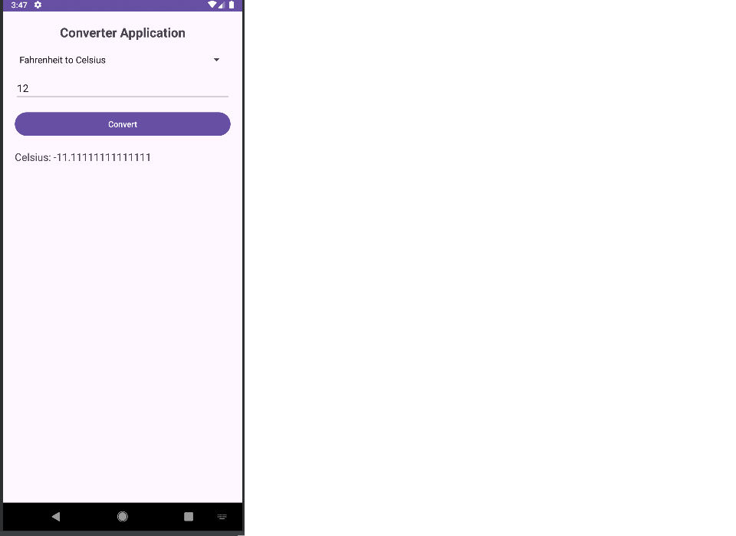package com.example.p14_1;

import android.os.Bundle;
import android.view.View;
import android.widget.*;
import androidx.appcompat.app.AppCompatActivity;

public class MainActivity extends AppCompatActivity {

Spinner spinner;
EditText editInput;
Button btnConvert;
TextView textResult;

@Override
protected void onCreate(Bundle savedInstanceState) {
super.onCreate(savedInstanceState);
setContentView(R.layout.activity_main);

spinner = findViewById(R.id.spinnerConversion);
editInput = findViewById(R.id.editInput);
btnConvert = findViewById(R.id.btnConvert);
textResult = findViewById(R.id.textResult);

String[] conversions = {
"Celsius to Fahrenheit",
"Fahrenheit to Celsius",
"INR to USD",
"USD to INR",
"Liters to Gallons",
"Gallons to Liters"
};

ArrayAdapter<String> adapter = new ArrayAdapter<>(
this, android.R.layout.simple_spinner_item, conversions);
adapter.setDropDownViewResource(android.R.layout.simple_spinner_dropdown_item);
spinner.setAdapter(adapter);

btnConvert.setOnClickListener(new View.OnClickListener() {
@Override
public void onClick(View v) {

if (editInput.getText().toString().isEmpty()) {
editInput.setError("Please enter a value");
return;
}

double input = Double.parseDouble(editInput.getText().toString());
double result = 0;
String selected = spinner.getSelectedItem().toString();

switch (selected) {

case "Celsius to Fahrenheit":
result = (input * 9 / 5) + 32;
textResult.setText("Fahrenheit: " + result);
break;

case "Fahrenheit to Celsius":
result = (input - 32) * 5 / 9;
textResult.setText("Celsius: " + result);
break;

case "INR to USD":
result = input / 83; // Fixed rate
textResult.setText("USD: " + result);
break;

case "USD to INR":
result = input * 83;
textResult.setText("INR: " + result);
break;

case "Liters to Gallons":
result = input * 0.264;
textResult.setText("Gallons: " + result);
break;

case "Gallons to Liters":
result = input / 0.264;
textResult.setText("Liters: " + result); break;
}
}
});
}
}

Xml code

<?xml version="1.0" encoding="utf-8"?>
<LinearLayout xmlns:android="http://schemas.android.com/apk/res/android"
android:layout_width="match_parent"
android:layout_height="match_parent"
android:orientation="vertical"
android:padding="20dp">

<TextView
android:layout_width="wrap_content"
android:layout_height="wrap_content"
android:text="Converter Application"
android:textSize="22sp"
android:textStyle="bold"
android:layout_gravity="center" />

<Spinner
android:id="@+id/spinnerConversion"
android:layout_width="match_parent"
android:layout_height="wrap_content"
android:layout_marginTop="20dp" />

<EditText
android:id="@+id/editInput"
android:layout_width="match_parent"
android:layout_height="wrap_content"
android:hint="Enter value"
android:inputType="numberDecimal"
android:layout_marginTop="15dp" />

<Button
android:id="@+id/btnConvert"
android:layout_width="match_parent"
android:layout_height="wrap_content"
android:text="Convert"
android:layout_marginTop="15dp" />

<TextView
android:id="@+id/textResult"
android:layout_width="wrap_content"
android:layout_height="wrap_content"
android:text="Result will appear here"
android:textSize="18sp"
android:layout_marginTop="20dp" />

</LinearLayout>

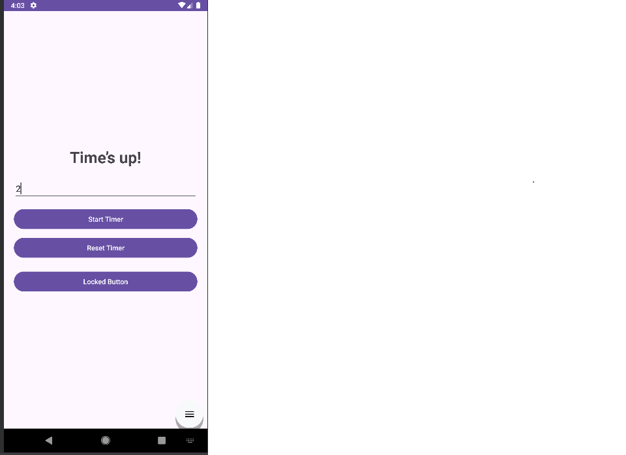
package com.example.p15_1;

import android.media.MediaPlayer;
import android.os.Build;
import android.os.Bundle;
import android.os.CountDownTimer;
import android.os.VibrationEffect;
import android.os.Vibrator;
import android.os.VibratorManager;
import android.widget.Button;
import android.widget.EditText;
import android.widget.TextView;

import androidx.appcompat.app.AppCompatActivity;

public class MainActivity extends AppCompatActivity {

TextView timerText;
EditText inputTime;
Button startBtn, resetBtn, lockedBtn;

CountDownTimer countDownTimer;
long timeInMillis = 10000; // default 10 seconds

MediaPlayer mediaPlayer;
Vibrator vibrator;

@Override
protected void onCreate(Bundle savedInstanceState) {
super.onCreate(savedInstanceState);
setContentView(R.layout.activity_main);

timerText = findViewById(R.id.timerText);
inputTime = findViewById(R.id.inputTime);
startBtn = findViewById(R.id.startBtn);
resetBtn = findViewById(R.id.resetBtn);
lockedBtn = findViewById(R.id.lockedBtn);

mediaPlayer = MediaPlayer.create(this, R.raw.beep);

if (Build.VERSION.SDK_INT >= Build.VERSION_CODES.S) {
VibratorManager vibratorManager =
(VibratorManager) getSystemService(VIBRATOR_MANAGER_SERVICE);
vibrator = vibratorManager.getDefaultVibrator();
} else {
vibrator = (Vibrator) getSystemService(VIBRATOR_SERVICE);
}

lockedBtn.setEnabled(false);

startBtn.setOnClickListener(v -> startTimer());
resetBtn.setOnClickListener(v -> resetTimer());
}

private void startTimer() {

if (!inputTime.getText().toString().isEmpty()) {
int seconds = Integer.parseInt(inputTime.getText().toString());
timeInMillis = seconds * 1000L;
}

lockedBtn.setEnabled(false);

countDownTimer = new CountDownTimer(timeInMillis, 1000) {

@Override
public void onTick(long millisUntilFinished) {
timerText.setText("Time Left: " + millisUntilFinished / 1000 + " sec");
}

@Override
public void onFinish() {
timerText.setText("Time’s up!");
lockedBtn.setEnabled(true);

// Play sound
if (mediaPlayer != null) {
mediaPlayer.start();
}

// Vibrate (fixed & safe)
if (vibrator != null && vibrator.hasVibrator()) {
if (Build.VERSION.SDK_INT >= Build.VERSION_CODES.O) {
vibrator.vibrate(
VibrationEffect.createOneShot(
500,
VibrationEffect.DEFAULT_AMPLITUDE
)
);
} else {
vibrator.vibrate(500);
}
}
}
}.start();
}

private void resetTimer() {
if (countDownTimer != null) {
countDownTimer.cancel();
}
timerText.setText("10");
inputTime.setText("");
lockedBtn.setEnabled(false);
}

@Override
protected void onDestroy() {
super.onDestroy();
if (mediaPlayer != null) {
mediaPlayer.release();
mediaPlayer = null;
}
}
}
Xml code
<?xml version="1.0" encoding="utf-8"?>
<LinearLayout xmlns:android="http://schemas.android.com/apk/res/android"
android:layout_width="match_parent"
android:layout_height="match_parent"
android:orientation="vertical"
android:gravity="center"
android:padding="20dp">

<TextView
android:id="@+id/timerText"
android:layout_width="wrap_content"
android:layout_height="wrap_content"
android:text="10"
android:textSize="32sp"
android:textStyle="bold"
android:layout_marginBottom="20dp" />

<EditText
android:id="@+id/inputTime"
android:layout_width="match_parent"
android:layout_height="wrap_content"
android:hint="Enter time in seconds"
android:inputType="number"
android:layout_marginBottom="15dp" />

<Button
android:id="@+id/startBtn"
android:layout_width="match_parent"
android:layout_height="wrap_content"
android:text="Start Timer" />

<Button
android:id="@+id/resetBtn"
android:layout_width="match_parent"
android:layout_height="wrap_content"
android:text="Reset Timer"
android:layout_marginTop="10dp" />

<Button
android:id="@+id/lockedBtn"
android:layout_width="match_parent"
android:layout_height="wrap_content"
android:text="Locked Button"
android:layout_marginTop="20dp" />

</LinearLayout>

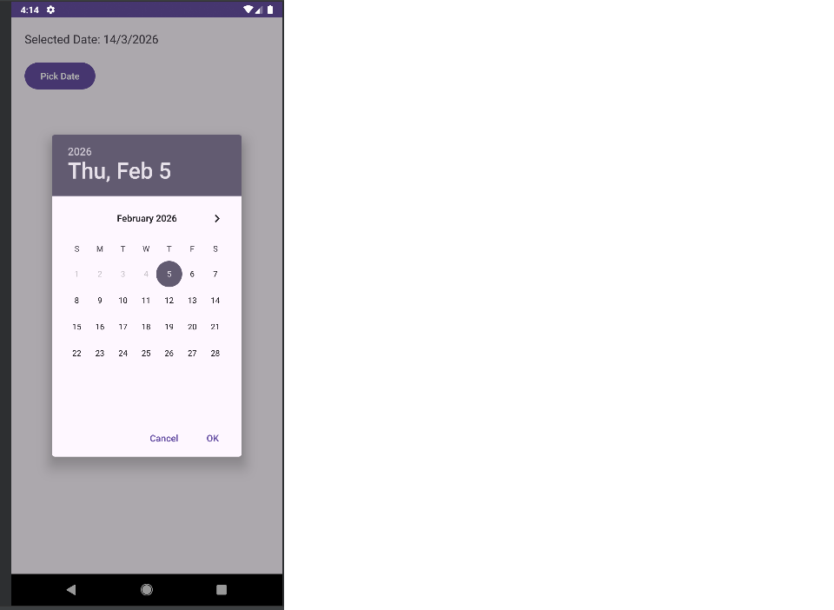
package com.example.p16;

import android.app.DatePickerDialog;
import android.os.Bundle;
import android.widget.Button;
import android.widget.DatePicker;
import android.widget.TextView;

import androidx.appcompat.app.AppCompatActivity;

import java.util.Calendar;

public class MainActivity extends AppCompatActivity {

TextView tvDate;
Button btnPickDate;

@Override
protected void onCreate(Bundle savedInstanceState) {
super.onCreate(savedInstanceState);
setContentView(R.layout.activity_main);

tvDate = findViewById(R.id.tvDate);
btnPickDate = findViewById(R.id.btnPickDate);

btnPickDate.setOnClickListener(v -> showDatePicker());
}

private void showDatePicker() {

// 4. Get current system date
Calendar calendar = Calendar.getInstance();
int year = calendar.get(Calendar.YEAR);
int month = calendar.get(Calendar.MONTH);
int day = calendar.get(Calendar.DAY_OF_MONTH);

DatePickerDialog datePickerDialog = new DatePickerDialog(
MainActivity.this,
(DatePicker view, int selectedYear, int selectedMonth, int selectedDay) -> {

// 2. Display selected date in TextView
String date = selectedDay + "/" + (selectedMonth + 1) + "/" + selectedYear;
tvDate.setText("Selected Date: " + date);
},
year, month, day
);

// 3. Restrict past dates
datePickerDialog.getDatePicker().setMinDate(System.currentTimeMillis());

datePickerDialog.show();
}
}
Xml code
<?xml version="1.0" encoding="utf-8"?>
<LinearLayout xmlns:android="http://schemas.android.com/apk/res/android"
android:layout_width="match_parent"
android:layout_height="match_parent"
android:orientation="vertical"
android:padding="20dp">

<TextView
android:id="@+id/tvDate"
android:layout_width="wrap_content"
android:layout_height="wrap_content"
android:text="Selected Date"
android:textSize="18sp"
android:layout_marginBottom="20dp"/>

<Button
android:id="@+id/btnPickDate"
android:layout_width="wrap_content"
android:layout_height="wrap_content"
android:text="Pick Date"/>
</LinearLayout>

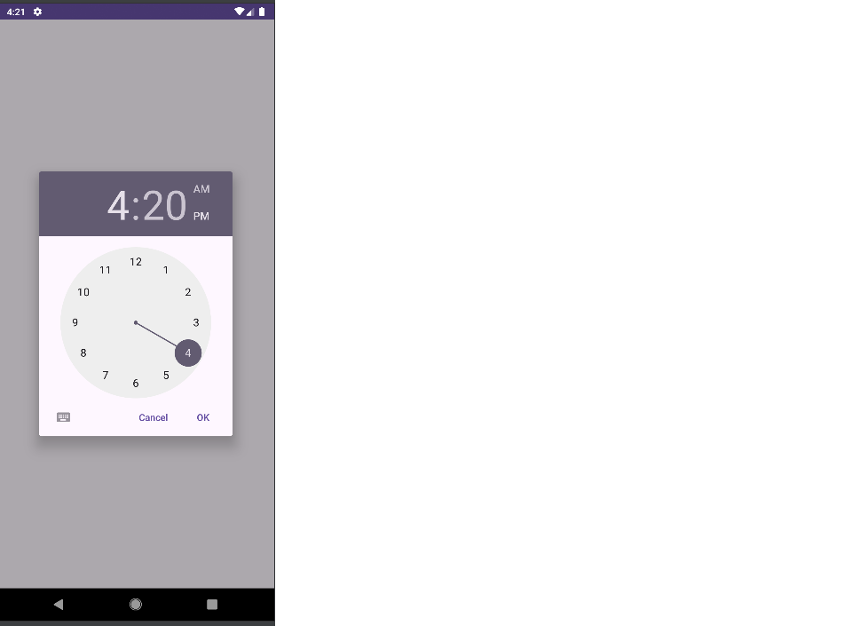

package com.example.p17;

import androidx.appcompat.app.AppCompatActivity;

import android.app.TimePickerDialog;
import android.os.Bundle;
import android.view.View;
import android.widget.Button;
import android.widget.TextView;
import android.widget.TimePicker;

import java.util.Calendar;

public class MainActivity extends AppCompatActivity {

Button btnPickTime;
TextView txtTime;

@Override
protected void onCreate(Bundle savedInstanceState) {
super.onCreate(savedInstanceState);
setContentView(R.layout.activity_main);

btnPickTime = findViewById(R.id.btnPickTime);
txtTime = findViewById(R.id.txtTime);

btnPickTime.setOnClickListener(new View.OnClickListener() {
@Override
public void onClick(View view) {

// Get current system time
Calendar calendar = Calendar.getInstance();
int hour = calendar.get(Calendar.HOUR_OF_DAY);
int minute = calendar.get(Calendar.MINUTE);

// Create TimePickerDialog
TimePickerDialog timePickerDialog = new TimePickerDialog(
MainActivity.this,
new TimePickerDialog.OnTimeSetListener() {
@Override
public void onTimeSet(TimePicker timePicker, int hourOfDay, int minute) {
// Display selected time
txtTime.setText("Selected Time: " + hourOfDay + ":" + minute);
}
},
hour,
minute,
false // false = 12 hour format (AM/PM)
);

timePickerDialog.show();
}
});
}
}
Xml code
<?xml version="1.0" encoding="utf-8"?>
<LinearLayout xmlns:android="http://schemas.android.com/apk/res/android"
android:layout_width="match_parent"
android:layout_height="match_parent"
android:orientation="vertical"
android:gravity="center"
android:padding="20dp">

<TextView
android:id="@+id/txtTime"
android:layout_width="wrap_content"
android:layout_height="wrap_content"
android:text="Selected Time"
android:textSize="20sp"
android:layout_marginBottom="20dp" />

<Button
android:id="@+id/btnPickTime"
android:layout_width="wrap_content"
android:layout_height="wrap_content"
android:text="Pick Time" />

</LinearLayout>

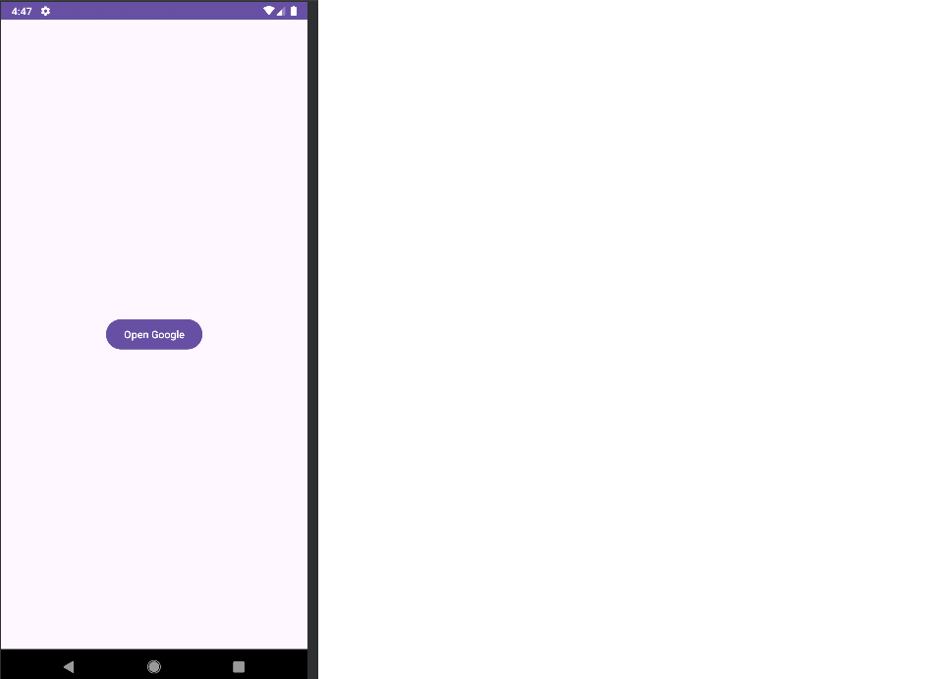
package com.example.p18_1;

import android.content.Intent;
import android.net.Uri;
import android.os.Bundle;
import android.view.View;
import android.widget.Button;
import androidx.appcompat.app.AppCompatActivity;

public class MainActivity extends AppCompatActivity {

Button btnOpenWebsite;

@Override
protected void onCreate(Bundle savedInstanceState) {
super.onCreate(savedInstanceState);
setContentView(R.layout.activity_main);

btnOpenWebsite = findViewById(R.id.btnOpenWebsite);

btnOpenWebsite.setOnClickListener(new View.OnClickListener() {
@Override
public void onClick(View v) {
// Implicit Intent to open a website
Intent intent = new Intent(Intent.ACTION_VIEW);
intent.setData(Uri.parse("https://www.google.com"));
startActivity(intent);
}
});
}
}
Xml code
<?xml version="1.0" encoding="utf-8"?>
<LinearLayout xmlns:android="http://schemas.android.com/apk/res/android"
android:orientation="vertical"
android:gravity="center"
android:layout_width="match_parent"
android:layout_height="match_parent"
android:padding="20dp">

<Button
android:id="@+id/btnOpenWebsite"
android:layout_width="wrap_content"
android:layout_height="wrap_content"
android:text="Open Google" />
</LinearLayout>
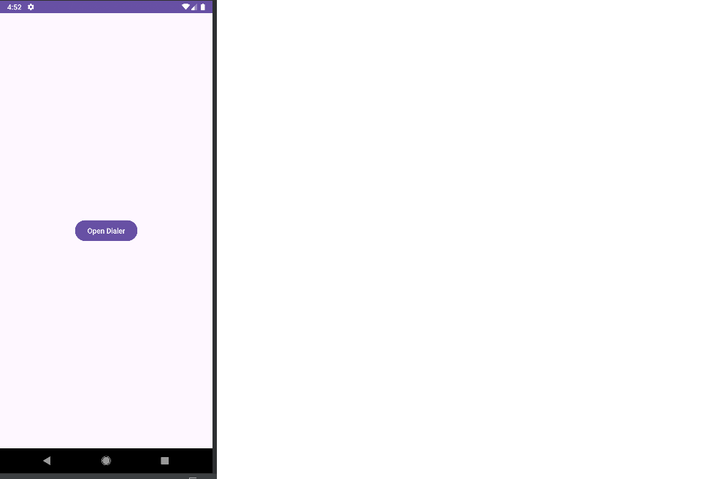
package com.example.p18_2;

import android.content.Intent;
import android.net.Uri;
import android.os.Bundle;
import android.view.View;
import android.widget.Button;
import androidx.appcompat.app.AppCompatActivity;

public class MainActivity extends AppCompatActivity {

Button btnDialer;

@Override
protected void onCreate(Bundle savedInstanceState) {
super.onCreate(savedInstanceState);
setContentView(R.layout.activity_main);

btnDialer = findViewById(R.id.btnDialer);

btnDialer.setOnClickListener(new View.OnClickListener() {
@Override
public void onClick(View v) {
// Implicit Intent to open dialer
Intent intent = new Intent(Intent.ACTION_DIAL);
intent.setData(Uri.parse("tel:1234567890"));
startActivity(intent);
}
});
}
}
<?xml version="1.0" encoding="utf-8"?>
<LinearLayout xmlns:android="http://schemas.android.com/apk/res/android"
android:orientation="vertical"
android:gravity="center"
android:layout_width="match_parent"
android:layout_height="match_parent"
android:padding="20dp">

<Button
android:id="@+id/btnDialer"
android:layout_width="wrap_content"
android:layout_height="wrap_content"
android:text="Open Dialer" />
</LinearLayout>

