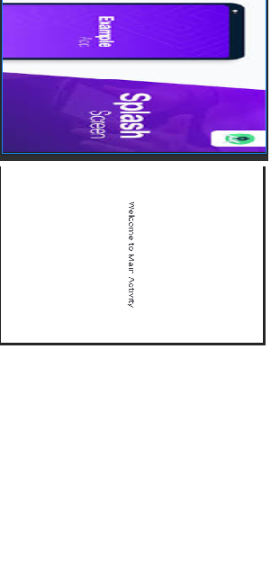

P30 activity_main.xml
<?xml version="1.0" encoding="utf-8"?>
<AbsoluteLayout xmlns:android="http://schemas.android.com/apk/res/android" xmlns:app="http://schemas.android.com/apk/res-auto" xmlns:tools="http://schemas.android.com/tools"
android:id="@+id/main" android:layout_width="match_parent" android:layout_height="match_parent" tools:context=".MainActivity">
<!-- This is the simple divider between above TextView and ToggleButton -->
<TextView android:layout_width="match_parent" android:layout_height="wrap_content" android:gravity="center" android:layout_x="-0dp" android:layout_y="50dp" android:text="Flashlight" android:textSize="30sp" />
<ToggleButton android:id="@+id/toggle_flashlight" android:layout_width="match_parent" android:layout_height="wrap_content" android:layout_x="0dp" android:layout_y="150dp" android:backgroundTint="#FF9800" android:gravity="center" android:onClick="toggleFlashLight" android:textOff="ON" android:textOn="OFF" />
</AbsoluteLayout>
MainActivity.java
package com.example.practicalno30; import android.content.Context;
import android.hardware.camera2.CameraAccessException; import android.hardware.camera2.CameraManager;
import android.os.Build; import android.os.Bundle; import android.view.View; import android.widget.Toast;
import android.widget.ToggleButton; import androidx.annotation.RequiresApi;
import androidx.appcompat.app.AppCompatActivity; public class MainActivity extends AppCompatActivity {
private ToggleButton toggleFlashLightOnOff; private CameraManager cameraManager; private String getCameraID;

@Override
protected void onCreate(Bundle savedInstanceState) { super.onCreate(savedInstanceState); setContentView(R.layout.activity_main);

toggleFlashLightOnOff = findViewById(R.id.toggle_flashlight);
cameraManager = (CameraManager) getSystemService(Context.CAMERA_SERVICE); try {
getCameraID = cameraManager.getCameraIdList()[0]; // 0 means back camera unit, 1 means front camera unit
} catch (CameraAccessException e) { e.printStackTrace();}}

// RequiresApi is set because devices below API level 23 (Marshmallow) don't have the flash unit with the camera
@RequiresApi(api = Build.VERSION_CODES.M) public void toggleFlashLight(View view) {
if (toggleFlashLightOnOff.isChecked()) { try
cameraManager.setTorchMode(getCameraID, true); Toast.makeText(MainActivity.this, "Flashlight is turned ON",
Toast.LENGTH_SHORT).show();
} catch (CameraAccessException e) { e.printStackTrace();
}} else { try {
cameraManager.setTorchMode(getCameraID, false); Toast.makeText(MainActivity.this, "Flashlight is turned OFF",
Toast.LENGTH_SHORT).show();
} catch (CameraAccessException e) { e.printStackTrace();}}} }
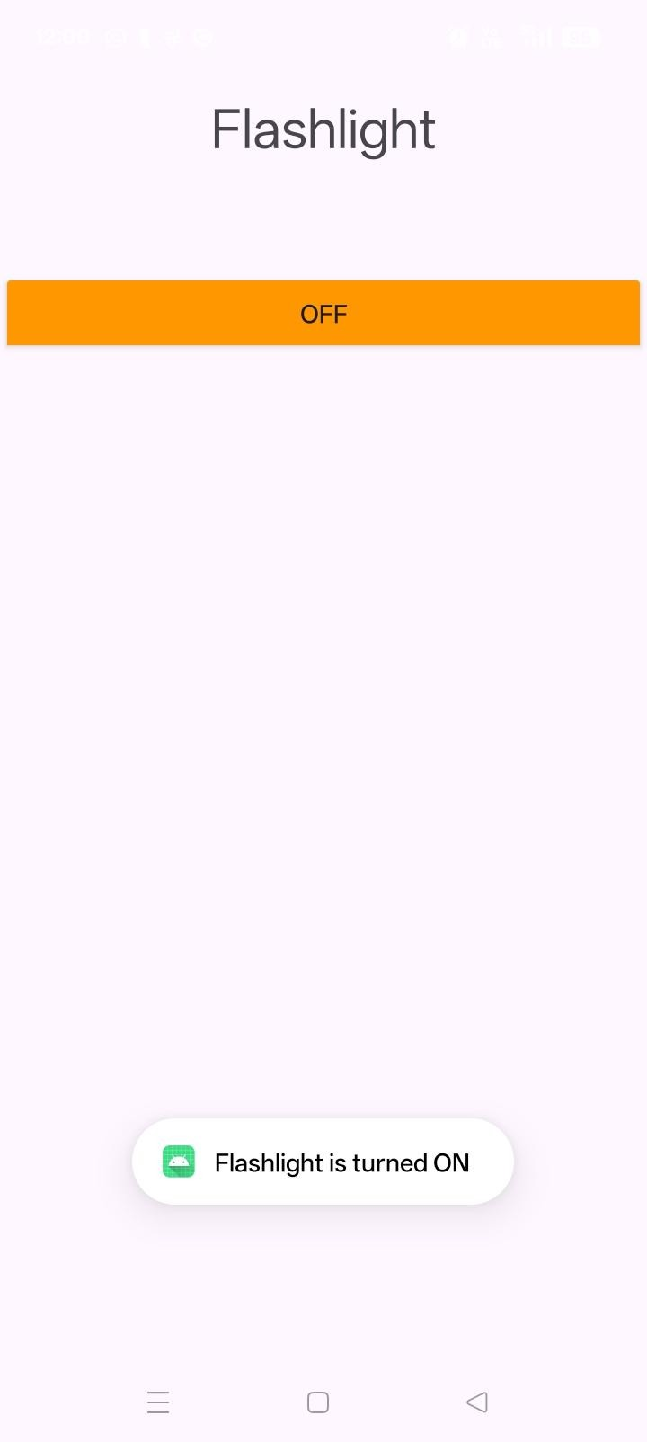

P21
package com.example.p21;

import androidx.appcompat.app.AppCompatActivity;

import android.content.Intent;
import android.content.IntentFilter;
import android.os.Bundle;
import android.view.View;
import android.widget.Button;

public class MainActivity extends AppCompatActivity {
ModeReceiver receiver;
Button silentBtn, loudBtn;
@Override
protected void onCreate(Bundle savedInstanceState) {
super.onCreate(savedInstanceState); setContentView(R.layout.activity_main);
silentBtn = findViewById(R.id.btnSilent);
loudBtn = findViewById(R.id.btnLoud);
receiver = new ModeReceiver();
// Dynamic Registration
IntentFilter filter =
new IntentFilter(Intent.ACTION_AIRPLANE_MODE_CHANGED);
registerReceiver(receiver, filter);
silentBtn.setOnClickListener(new View.OnClickListener() {
@Override
public void onClick(View v) {
ModeReceiver.setSilent(MainActivity.this);
} });

loudBtn.setOnClickListener(new View.OnClickListener() {
@Override
public void onClick(View v) { ModeReceiver.setLoud(MainActivity.this);
} }); }
@Override
protected void onDestroy() {
super.onDestroy();
unregisterReceiver(receiver); }}
package com.example.p21;
import android.content.BroadcastReceiver;
import android.content.Context;
import android.content.Intent;
import android.media.AudioManager;
import android.widget.Toast;
public class ModeReceiver extends BroadcastReceiver {
@Override
public void onReceive(Context context, Intent intent) { if (Intent.ACTION_AIRPLANE_MODE_CHANGED.equals(intent.getAction())) {
boolean isOn = intent.getBooleanExtra("state", false);
if (isOn) {
Toast.makeText(context, "Airplane Mode ON", Toast.LENGTH_LONG).show();
} else {
Toast.makeText(context, "Airplane Mode OFF", Toast.LENGTH_LONG).show(); } } }
// Function to set Silent Mode
public static void setSilent(Context context) {
AudioManager audioManager =
(AudioManager) context.getSystemService(Context.AUDIO_SERVICE);
if (audioManager != null) { audioManager.setRingerMode(AudioManager.RINGER_MODE_SILENT);
Toast.makeText(context, "Silent Mode Activated", Toast.LENGTH_SHORT).show(); } }
// Function to set Loud Mode
public static void setLoud(Context context) {
AudioManager audioManager =
(AudioManager) context.getSystemService(Context.AUDIO_SERVICE);
if (audioManager != null) { audioManager.setRingerMode(AudioManager.RINGER_MODE_NORMAL);
Toast.makeText(context, "Loud Mode Activated", Toast.LENGTH_SHORT).show();
} }}
<?xml version="1.0" encoding="utf-8"?>
<LinearLayout xmlns:android="http://schemas.android.com/apk/res/android"
android:orientation="vertical"
android:layout_width="match_parent"
android:layout_height="match_parent"
android:gravity="center"
android:padding="20dp">

<Button
android:id="@+id/btnSilent"
android:layout_width="wrap_content"
android:layout_height="wrap_content"
android:text="Silent Mode"
android:layout_margin="10dp"/>

<Button
android:id="@+id/btnLoud"
android:layout_width="wrap_content"
android:layout_height="wrap_content"
android:text="Loud Mode"
android:layout_margin="10dp"/>

</LinearLayout>
<?xml version="1.0" encoding="utf-8"?>
<manifest xmlns:android="http://schemas.android.com/apk/res/android"
xmlns:tools="http://schemas.android.com/tools">

<!-- Permission to modify audio settings -->
<uses-permission android:name="android.permission.MODIFY_AUDIO_SETTINGS"/>

<application
android:allowBackup="true"
android:dataExtractionRules="@xml/data_extraction_rules"
android:fullBackupContent="@xml/backup_rules"
android:icon="@mipmap/ic_launcher"
android:label="@string/app_name"
android:roundIcon="@mipmap/ic_launcher_round"
android:supportsRtl="true"
android:theme="@style/Theme.P21"
tools:targetApi="31">

<activity
android:name=".MainActivity"
android:exported="true">
<intent-filter>
<action android:name="android.intent.action.MAIN" />
<category android:name="android.intent.category.LAUNCHER" />
</intent-filter>
</activity>

<!-- Broadcast Receiver for Airplane Mode -->
<receiver
android:name=".ModeReceiver"
android:exported="true">
<intent-filter>
<action android:name="android.intent.action.AIRPLANE_MODE_CHANGED"/>
</intent-filter> </receiver>
</application></manifest>
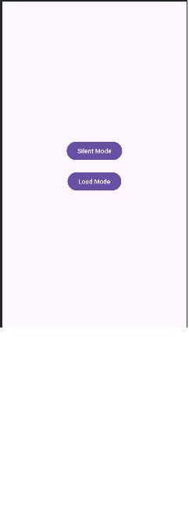
P22

package com.example.p22;

import androidx.appcompat.app.AppCompatActivity;

import android.database.Cursor;
import android.os.Bundle;
import android.view.View;
import android.widget.*;
import android.app.AlertDialog;

public class MainActivity extends AppCompatActivity {

EditText name, email, phone, password;
Button insert, view, update, delete;

DBHelper db;

@Override
protected void onCreate(Bundle savedInstanceState) {
super.onCreate(savedInstanceState);
setContentView(R.layout.activity_main);

name = findViewById(R.id.etName);
email = findViewById(R.id.etEmail);
phone = findViewById(R.id.etPhone);
password = findViewById(R.id.etPassword);

insert = findViewById(R.id.btnInsert);
view = findViewById(R.id.btnView);
update = findViewById(R.id.btnUpdate);
delete = findViewById(R.id.btnDelete);

db = new DBHelper(this);

// INSERT BUTTON CLICK LISTENER
insert.setOnClickListener(v -> {
String nameStr = name.getText().toString().trim();
String emailStr = email.getText().toString().trim();
String phoneStr = phone.getText().toString().trim();
String passwordStr = password.getText().toString().trim();

if (nameStr.isEmpty() || emailStr.isEmpty() || phoneStr.isEmpty() || passwordStr.isEmpty()) {
Toast.makeText(MainActivity.this, "All fields are required", Toast.LENGTH_SHORT).show();
return;
}

try {
boolean result = db.insertData(nameStr, emailStr, phoneStr, passwordStr);

if (result) {
Toast.makeText(MainActivity.this, "Data Inserted Successfully", Toast.LENGTH_SHORT).show();
name.setText("");
email.setText("");
phone.setText("");
password.setText("");
} else {
Toast.makeText(MainActivity.this, "Insert Failed", Toast.LENGTH_SHORT).show();
}
} catch (Exception e) {
Toast.makeText(MainActivity.this, "Error: " + e.getMessage(), Toast.LENGTH_SHORT).show();
}
});

// VIEW BUTTON CLICK LISTENER
view.setOnClickListener(v -> {
Cursor res = db.getData();

if (res.getCount() == 0) {
showMessage("Error", "No Data Found");
res.close();
return;
}

StringBuffer buffer = new StringBuffer();

while (res.moveToNext()) {
buffer.append("ID: " + res.getString(0) + "\n");
buffer.append("Name: " + res.getString(1) + "\n");
buffer.append("Email: " + res.getString(2) + "\n");
buffer.append("Phone: " + res.getString(3) + "\n\n");
}

res.close();
showMessage("All Records", buffer.toString());
});

// UPDATE BUTTON CLICK LISTENER
update.setOnClickListener(v -> {
AlertDialog.Builder builder = new AlertDialog.Builder(MainActivity.this);
builder.setTitle("Update Record");
builder.setCancelable(true);

LinearLayout layout = new LinearLayout(MainActivity.this);
layout.setOrientation(LinearLayout.VERTICAL);
layout.setPadding(50, 40, 50, 40);

EditText idInput = new EditText(MainActivity.this);
idInput.setHint("Enter ID to Update");
layout.addView(idInput);

builder.setView(layout);

builder.setPositiveButton("Update", (dialog, which) -> {
String id = idInput.getText().toString().trim();
String nameStr = name.getText().toString().trim();
String emailStr = email.getText().toString().trim();
String phoneStr = phone.getText().toString().trim();
String passwordStr = password.getText().toString().trim();

if (id.isEmpty()) {
Toast.makeText(MainActivity.this, "Please enter ID", Toast.LENGTH_SHORT).show();
return;
}

if (nameStr.isEmpty() || emailStr.isEmpty() || phoneStr.isEmpty() || passwordStr.isEmpty()) {
Toast.makeText(MainActivity.this, "All fields are required", Toast.LENGTH_SHORT).show();
return;
}

try {
boolean result = db.updateData(id, nameStr, emailStr, phoneStr, passwordStr);

if (result) {
Toast.makeText(MainActivity.this, "Data Updated Successfully", Toast.LENGTH_SHORT).show();
name.setText("");
email.setText("");
phone.setText("");
password.setText("");
} else {
Toast.makeText(MainActivity.this, "Update Failed", Toast.LENGTH_SHORT).show();
}
} catch (Exception e) {
Toast.makeText(MainActivity.this, "Error: " + e.getMessage(), Toast.LENGTH_SHORT).show();
}
});

builder.setNegativeButton("Cancel", (dialog, which) -> dialog.dismiss());
builder.show();
});

// DELETE BUTTON CLICK LISTENER
delete.setOnClickListener(v -> {
AlertDialog.Builder builder = new AlertDialog.Builder(MainActivity.this);
builder.setTitle("Delete Record");
builder.setCancelable(true);

LinearLayout layout = new LinearLayout(MainActivity.this);
layout.setOrientation(LinearLayout.VERTICAL);
layout.setPadding(50, 40, 50, 40);

EditText idInput = new EditText(MainActivity.this);
idInput.setHint("Enter ID to Delete");
layout.addView(idInput);

builder.setView(layout);

builder.setPositiveButton("Delete", (dialog, which) -> {
String id = idInput.getText().toString().trim();

if (id.isEmpty()) {
Toast.makeText(MainActivity.this, "Please enter ID", Toast.LENGTH_SHORT).show();
return;
}

try {
int result = db.deleteData(id);

if (result > 0) {
Toast.makeText(MainActivity.this, "Data Deleted Successfully", Toast.LENGTH_SHORT).show();
} else {
Toast.makeText(MainActivity.this, "Delete Failed - ID not found", Toast.LENGTH_SHORT).show();
}
} catch (Exception e) {
Toast.makeText(MainActivity.this, "Error: " + e.getMessage(), Toast.LENGTH_SHORT).show();
}
});

builder.setNegativeButton("Cancel", (dialog, which) -> dialog.dismiss());
builder.show();
});
}

public void showMessage(String title, String message) {
AlertDialog.Builder builder = new AlertDialog.Builder(this);
builder.setCancelable(true);
builder.setTitle(title);
builder.setMessage(message);
builder.setPositiveButton("OK", (dialog, which) -> dialog.dismiss());
builder.show();
}
}
package com.example.p22;

import android.content.ContentValues;
import android.content.Context;
import android.database.Cursor;
import android.database.sqlite.SQLiteDatabase;
import android.database.sqlite.SQLiteOpenHelper;

public class DBHelper extends SQLiteOpenHelper {

public static final String DB_NAME = "RegistrationDB";
public static final String TABLE_NAME = "Registration";

public DBHelper(Context context) {
super(context, DB_NAME, null, 1);
}

@Override
public void onCreate(SQLiteDatabase db) {
db.execSQL("CREATE TABLE Registration(id INTEGER PRIMARY KEY AUTOINCREMENT, name TEXT, email TEXT, phone TEXT, password TEXT)");
}

@Override
public void onUpgrade(SQLiteDatabase db, int oldVersion, int newVersion) {
db.execSQL("DROP TABLE IF EXISTS Registration");
onCreate(db);
}

public boolean insertData(String name, String email, String phone, String password) {
SQLiteDatabase db = this.getWritableDatabase();
ContentValues cv = new ContentValues();

cv.put("name", name);
cv.put("email", email);
cv.put("phone", phone);
cv.put("password", password);

long result = db.insert(TABLE_NAME, null, cv);
db.close();

if (result == -1)
return false;
else
return true;
}

public Cursor getData() {
SQLiteDatabase db = this.getReadableDatabase();
Cursor cursor = db.query(TABLE_NAME, null, null, null, null, null, null);
return cursor;
}

public boolean updateData(String id, String name, String email, String phone, String password) {
SQLiteDatabase db = this.getWritableDatabase();
ContentValues cv = new ContentValues();

cv.put("name", name);
cv.put("email", email);
cv.put("phone", phone);
cv.put("password", password);

long result = db.update(TABLE_NAME, cv, "id=?", new String[]{id});
db.close();

if (result == -1)
return false;
else
return true;
}

public Integer deleteData(String id) {
SQLiteDatabase db = this.getWritableDatabase();
int result = db.delete(TABLE_NAME, "id=?", new String[]{id});
db.close();
return result;
}
}<?xml version="1.0" encoding="utf-8"?>
<LinearLayout xmlns:android="http://schemas.android.com/apk/res/android"
android:orientation="vertical"
android:padding="20dp"
android:layout_width="match_parent"
android:layout_height="match_parent">

<EditText
android:id="@+id/etName"
android:hint="Enter Name"
android:layout_width="match_parent"
android:layout_height="wrap_content"
android:layout_margin="10dp"
android:padding="12dp"
android:inputType="text" />

<EditText
android:id="@+id/etEmail"
android:hint="Enter Email"
android:layout_width="match_parent"
android:layout_height="wrap_content"
android:layout_margin="10dp"
android:padding="12dp"
android:inputType="textEmailAddress" />

<EditText
android:id="@+id/etPhone"
android:hint="Enter Phone"
android:layout_width="match_parent"
android:layout_height="wrap_content"
android:layout_margin="10dp"
android:padding="12dp"
android:inputType="phone" />

<EditText
android:id="@+id/etPassword"
android:hint="Enter Password"
android:layout_width="match_parent"
android:layout_height="wrap_content"
android:layout_margin="10dp"
android:padding="12dp"
android:inputType="textPassword" />

<Button
android:id="@+id/btnInsert"
android:text="Register"
android:layout_width="match_parent"
android:layout_height="wrap_content"
android:layout_margin="10dp"
android:backgroundTint="#4CAF50"
android:textColor="@color/white" />

<Button
android:id="@+id/btnView"
android:text="View Data"
android:layout_width="match_parent"
android:layout_height="wrap_content"
android:layout_margin="10dp"
android:backgroundTint="#2196F3"
android:textColor="@color/white" />

<Button
android:id="@+id/btnUpdate"
android:text="Update"
android:layout_width="match_parent"
android:layout_height="wrap_content"
android:layout_margin="10dp"
android:backgroundTint="#FF9800"
android:textColor="@color/white" />

<Button
android:id="@+id/btnDelete"
android:text="Delete"
android:layout_width="match_parent"
android:layout_height="wrap_content"
android:layout_margin="10dp"
android:backgroundTint="#F44336"
android:textColor="@color/white" />

</LinearLayout>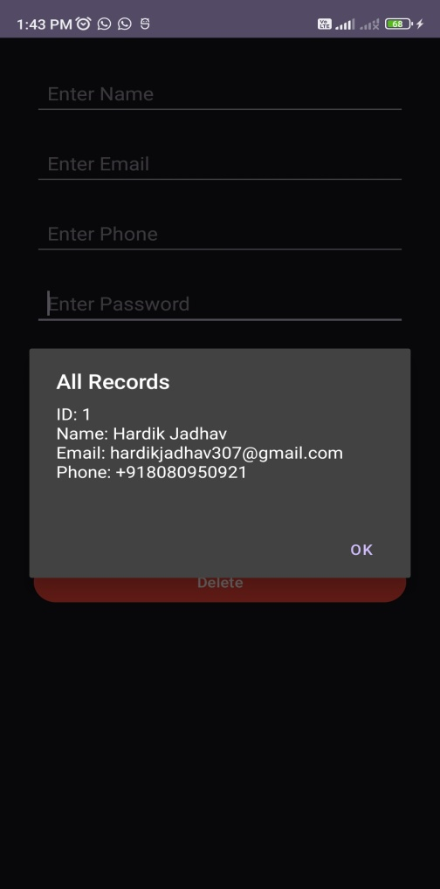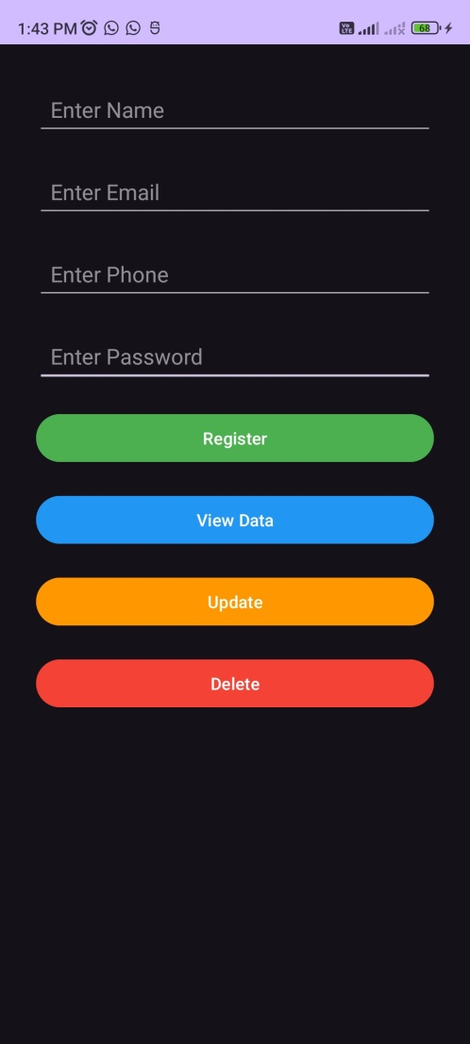

P25
<?xml version="1.0" encoding="utf-8"?>

<LinearLayout xmlns:android="http://schemas.android.com/apk/res/android"
android:layout_width="match_parent"
android:layout_height="match_parent"
android:orientation="vertical"
android:gravity="center"
android:padding="20dp">

<Button
android:id="@+id/btnCamera"
android:layout_width="wrap_content"
android:layout_height="wrap_content"
android:text="Capture Image"/>

<ImageView
android:id="@+id/imageView"
android:layout_width="250dp"
android:layout_height="250dp"
android:layout_marginTop="20dp"
android:background="#cccccc"/>

</LinearLayout>
<?xml version="1.0" encoding="utf-8"?>
<manifest xmlns:android="http://schemas.android.com/apk/res/android"
xmlns:tools="http://schemas.android.com/tools">

<!-- Permissions -->
<uses-permission android:name="android.permission.CAMERA"/>
<uses-permission android:name="android.permission.WRITE_EXTERNAL_STORAGE"/>

<application
android:allowBackup="true"
android:dataExtractionRules="@xml/data_extraction_rules"
android:fullBackupContent="@xml/backup_rules"
android:icon="@mipmap/ic_launcher"
android:label="@string/app_name"
android:roundIcon="@mipmap/ic_launcher_round"
android:supportsRtl="true"
android:theme="@style/Theme.P25"
tools:targetApi="31">

<activity
android:name=".MainActivity"
android:exported="true">

<intent-filter>
<action android:name="android.intent.action.MAIN" />
<category android:name="android.intent.category.LAUNCHER" />
</intent-filter>

</activity>

</application>

</manifest> package com.example.p25;

import androidx.appcompat.app.AppCompatActivity;
import androidx.activity.result.ActivityResultLauncher;
import androidx.activity.result.contract.ActivityResultContracts;

import android.content.Intent;
import android.graphics.Bitmap;
import android.os.Bundle;
import android.provider.MediaStore;
import android.view.View;
import android.widget.Button;
import android.widget.ImageView;

public class MainActivity extends AppCompatActivity {

Button btnCamera;
ImageView imageView;
ActivityResultLauncher<Intent> cameraLauncher;

@Override
protected void onCreate(Bundle savedInstanceState) {
super.onCreate(savedInstanceState);
setContentView(R.layout.activity_main);

btnCamera = findViewById(R.id.btnCamera);
imageView = findViewById(R.id.imageView);

// Register the camera launcher
cameraLauncher = registerForActivityResult(
new ActivityResultContracts.StartActivityForResult(),
result -> {
if (result.getResultCode() == RESULT_OK) {
Intent data = result.getData();
if (data != null) {
Bundle extras = data.getExtras();
if (extras != null) {
Bitmap imageBitmap = (Bitmap) extras.get("data");
imageView.setImageBitmap(imageBitmap);
}
}
}
}
);

btnCamera.setOnClickListener(v -> {
Intent intent = new Intent(MediaStore.ACTION_IMAGE_CAPTURE);
cameraLauncher.launch(intent);
});
}
} 