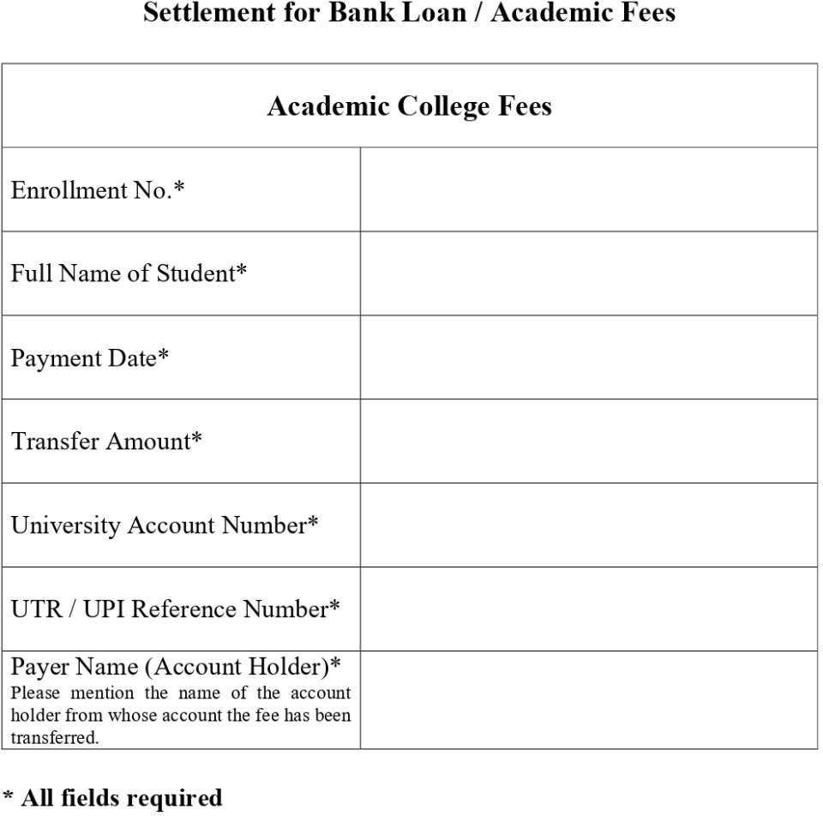
5544556291
46000 only
chaudhari shreyanshikumari vineshbhai
620832521945
27/7/2006
chaudhari shreyashi vinesh bhai
2219361020018

