|  |  |  |
| --- | --- | --- |
| **No.** | **Method** | **Description** |
| 1 | public boolean add(E e) | It is used to insert an element in this collection. |
| 2 | public boolean addAll(Collection<? extends E> c) | It is used to insert the specified collection elements in the invoking collection. |
| 3 | public boolean remove(Object element) | It is used to delete an element from the collection. |
| 4 | public boolean removeAll(Collection<?> c) | It is used to delete all the elements of the specified collection from the invoking collection. |
| 5 | default boolean removeIf(Predicate<? super E> filter) | It is used to delete all the elements of the collection that satisfy the specified predicate. |
| 6 | public boolean retainAll(Collection<?> c) | It is used to delete all the elements of invoking collection except the specified collection. |
| 7 | public int size() | It returns the total number of elements in the collection. |
| 8 | public void clear() | It removes the total number of elements from the collection. |
| 9 | public boolean contains(Object element) | It is used to search an element. |
| 10 | public boolean containsAll(Collection<?> c) | It is used to search the specified collection in the collection. |
| 11 | public Iterator iterator() | It returns an iterator. |
| 12 | public Object[] toArray() | It converts collection into array. |
| 13 | public <T> T[] toArray(T[] a) | It converts collection into array. Here, the runtime type of the returned array is that of the specified array. |
| 14 | public boolean isEmpty() | It checks if collection is empty. |
| 18 | public boolean equals(Object element) | It matches two collections. |
| 19 | public int hashCode() | It returns the hash code number of the collection. |

collections framework:

----------------------

collection is interface.

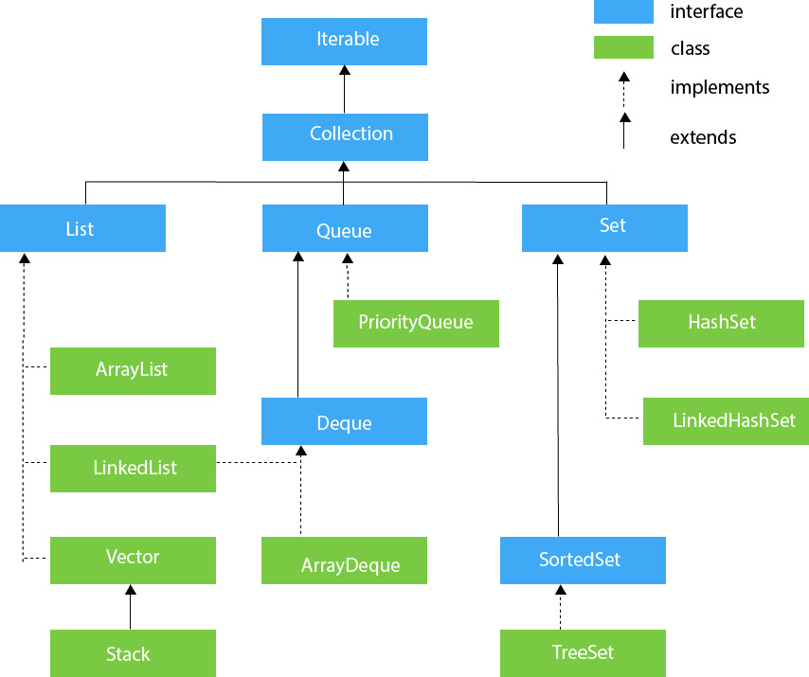

Difference between arraylist and linked list.

|  |  |
| --- | --- |
| **ArrayList** | **LinkedList** |
| 1) ArrayList internally uses a **dynamic array** to store the elements. | LinkedList internally uses a **doubly linked list** to store the elements. |
| 2) Manipulation with ArrayList is **slow** because it internally uses an array. If any element is removed from the array, all the bits are shifted in memory. | Manipulation with LinkedList is **faster** than ArrayList because it uses a doubly linked list, so no bit shifting is required in memory. |
| 3) An ArrayList class can **act as a list** only because it implements List only. | LinkedList class can **act as a list and queue** both because it implements List and Deque interfaces. |
| 4) ArrayList is **better for storing and accessing** data. | LinkedList is **better for manipulating** data. |

Useful methods of Map interface

|  |  |
| --- | --- |
| **Method** | **Description** |
| V put(Object key, Object value) | It is used to insert an entry in the map. |
| void putAll(Map map) | It is used to insert the specified map in the map. |
| V remove(Object key) | It is used to delete an entry for the specified key. |
| boolean remove(Object key, Object value) | It removes the specified values with the associated specified keys from the map. |
| void clear() | It is used to reset the map. |
| boolean containsValue(Object value) | This method returns true if some value equal to the value exists within the map, else return false. |
| boolean containsKey(Object key) | This method returns true if some key equal to the key exists within the map, else return false. |
| boolean equals(Object o) | It is used to compare the specified Object with the Map. |
| boolean isEmpty() | This method returns true if the map is empty; returns false if it contains at least one key. |
|  |  |
|  |  |
|  |  |
|  |  |
|  |  |
|  |  |