**Extra Credit Activity**

1. Download the twitter script from the following link

<https://drive.google.com/open?id=0B3n4oQctrRw6cFJIM3N4Q3ZMZFE>

Look into the script and learn how does the program work. Make sure to include at least a paragraph about how does this code work. Do you think you can use this code for different purposes ? Explain different scenarios that you think you can use this code for twitter data collection.

1. Add your twitter API key in the script. You can generate one using <https://apps.twitter.com/> .
2. Run the twitter.py script.
3. Give a **search string**, the **from and to date** and **the number of records to be retrieved** as input from the console. The output file is generated. The file contains user name, time, tweet, retweet count, and the followers for the user.
4. Now write a program to read the file generated. Your program should get the value of n (the number of records to be displayed) from the user, and generate the following output and write them into separate files
5. The top n users who have tweeted the most related to the search string for the entire timeline
6. The top n users who have tweeted the most for every hour
7. The top n users who have the maximum followers
8. The top n tweets which have the maximum retweet count

**Guidelines:**

* A zip file containing text document, source code as well as the output generated for the above scenarios for top 10 users and include how to run your program in the word document
* Also check in your code in github and specify the github repository link in the word document. You can refer the steps below to create a repository in github.

**Creating a repository in GitHub**

Go to <https://github.com/>

Select Start a project

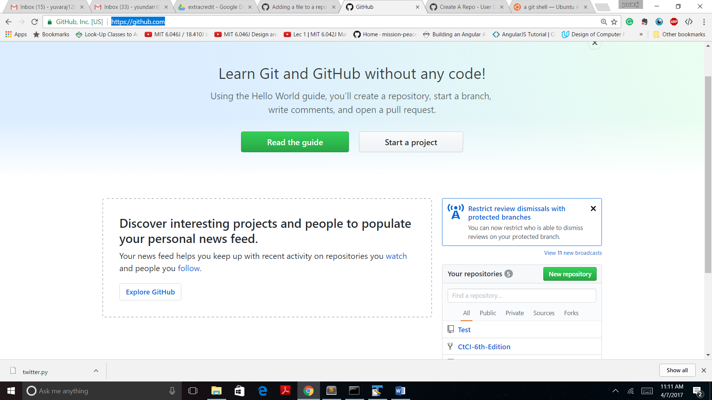

Specify a repository name in the text box. Click create repository.

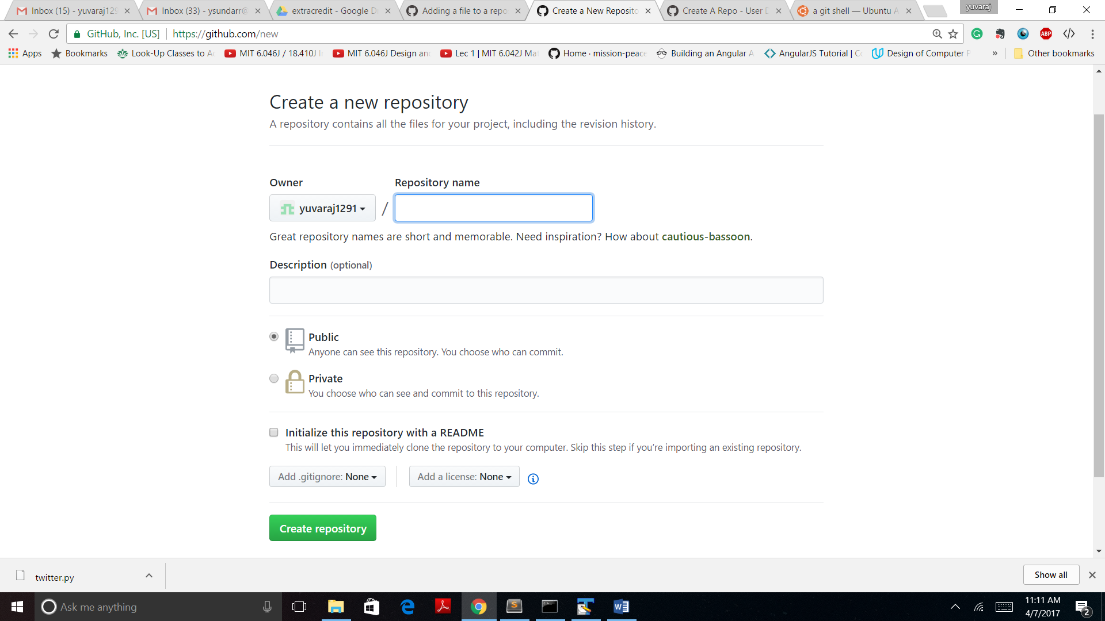

Now open the terminal in ubuntu and do the following steps

Tell Git your name so your commits will be properly labeled. Type everything after the $ here:

git config --global user.name "*YOUR NAME*"

Tell Git the email address that will be associated with your Git commits. The email you specify should be the same one found in your [email settings](https://help.github.com/articles/adding-an-email-address-to-your-github-account/).

git config --global user.email "EMAIL ADDRESS"

**To initialize git :**

git init

**To add the files to git:**

git add README.md

**Committing the files to repository**

git commit -m "first commit"

**Add it to your git hub repository**

git remote add origin <https://github.com/yuvaraj1291/Test.git>

**Now Push it to the repository:-**

git push -u origin master