A

PROJECT REPORT ON

Automate Making and Uploading Videos to Social Media

( RedditReels )

# By

**HARDIK THANTH (CE144) (19CEUBS082)**

# B.Tech CE Semester-VI Subject: System Design Practice

**Guided by:**

Prof. Chintan Chatterjee Assistant Professor Dept. of Comp. Engg.



# Faculty of Technology Department of Computer Engineering

**Dharmsinh Desai University**



**Faculty of Technology Department of Computer Engineering**

**Dharmsinh Desai University**

**CERTIFICATE**

This is to certify that the practical / term work carried out in the subject of **SYSTEM DESIGN PRACTICE** and recorded in this journal is the bonafide work of

**HARDIK THANTH (CE144) (19CEUBS082)**

of B.Tech Semester **VI** in the branch of **COMPUTER ENGINEERING**

during the academic year **2022 - 2023**

Prof. Chintan Chatterjee Dr. C. K. Bhensdadia,

Assistant Professor, Head,

Dept. of Computer Engg., Dept. of Computer Engg.,

Faculty of Technology, Faculty of Technology,

Dharmnsinh Desai University, Nadiad Dharmsinh Desai University, Nadiad

# Acknowledgement

It is indeed a great pleasure to express my thanks and gratitude to all those who helped me during this project. This project would not have been materialized without the help from many who asked me good questions and rescued from various crisis.

Theoretical knowledge is of no importance if one doesn’t know the way of its implementation. I am thankful to our institute that provided me an opportunity to apply my theoretical knowledge through the project. I feel obliged in submitting this project as part of our curriculum.

I would like to take the opportunity to express our humble gratitude to my guide **Prof. Chintan R. Chatterjee**, under whom I undertook this project. His constant guidance and willingness to share his vast knowledge made me enhance my knowledge and helped me to complete the assigned tasks to perfection.

Without his effort, support and an astonishing testing ability this project may not have succeeded.

With Sincere Regards, Hardik Thanth

# CONTENTS

|  |  |  |
| --- | --- | --- |
| Index | Content | Page No |
| 1 | Abstract | 4 |
| 2 | Introduction | 5 |
| 3 | Software Requirement Specification | 6 |
| 4 | Database Design | 9 |
| 5 | Implementation Detail | 13 |
| 6 | Testing | 14 |
| 7 | Screen-shots | 16 |
| 8 | Conclusion | 21 |
| 9 | Limitation and Future Extension | 22 |
| 10 | Bibliography | 23 |

**List of Figures**

|  |  |  |
| --- | --- | --- |
| Figure Number | Details | Page No |
| 4.1 | Use Case Diagram | 9 |
| 4.2 | Sequence Diagram for SignUp | 10 |
| 4.3 | Sequence Diagram for Login | 10 |
| 4.4 | Seq. Diagram: Making & uploading A Video | 11 |
| 4.5 | Activity Diagram | 12 |
| 7.1 | Login for User | 16 |
| 7.2 | Home page for User | 16 |
| 7.3 | Create Video Page | 17 |
| 7.4 | Video in Progress | 17 |
| 7.5 | API keys | 18 |
| 7.6 | All Videos | 18 |
| 7.7 | View/Edit/Delete Video | 19 |
| 7.8 | Video Deleted | 19 |
| 7.9 | Video Uploaded to YouTube | 20 |
| 7.10 | YouTube Page | 20 |

# ABSTRACT

RedditReels is a powerful and user-friendly web application that simplifies the process of creating engaging social media videos. With RedditReels, users can easily source memes and top comments from Reddit to create videos for Instagram reels and YouTube shorts.

The application is built using uses Reddit and to get memes from subreddit that is specified, then combine memes and add background music to videos. With its intuitive user interface and direct upload feature to YouTube, RedditReels makes it easy for anyone to create professional-looking videos and share them with the world.

Whether you're an influencer, content creator, or just looking to make fun videos to share with friends, RedditReels is the perfect tool for you. Try it out today and take your social media content to the next level!

# INTRODUCTION

The RedditReels web application is a tool that allows users to create engaging videos for social media platforms such as Instagram and YouTube by sourcing memes and comments from Reddit and combining them with background music.

This document outlines the functional and non-functional requirements of the application, as well as the assumptions and constraints that must be taken into account during the development process.

System will ensure Integrity of data for all User.

# Scope:

# With its easy-to-use interface and direct upload feature to YouTube, RedditReels is the perfect tool for anyone looking to quickly create videos to share on social media.

# Technologies used:

* Flask (Python)
* Bootstrap
* HTML
* CSS

# Tools used:

* GitHub
* GitPod
* Visual Studio Code

# Python Libraries Used:

* *MoviePy* : to edit and manipulate video files
* *Preaw* : to access Reddit's API.
* *google-api-core* : used to access Google's YouTube APIs
* *PIL-Py. Imaging Lib* : used to add support for opening,

manipulating, and saving many

different image file formats

# SOFTWARE REQUIREMENT SPECIFICATIONS

**Users of the system:**

* User

**Functional Requirements:**

1. **Manage User**

Users will be able to register themselves.

R1.1 SignUp

Description: Users will be able to sign up.

Input: User credentials

Output: Redirected to homepage

R1.2 Login

Description: User can login into the system using username & password.

Input: Username & Password

Output: Successfully logged in.

R1.3 Logout

Description : Logout user from the application

Input : Press LogOut

Button Next : Redirected to Login

# Manage API Credentials

Users will be able to Add-Edit therir API keys.

R2.1 Enter API Credentials/Keys

Description: Enter the Keys for APIs of Reddit and YouTube.

Input: User input on *addkeys* Page

Output: Keys added, redirected to *Secrets* Page

R2.2 View API Credentials

Description: View Keys for APIs

Input: Go to The Secrets page.

# Get Images

Description : To extract top and new memes from given subreddit. It will also get

generate title for new video from downloaded memes.

Input : Enter name of Subreddit and press Create Video Button on make new

video page.

Next : Make Video will be called to make video from downloaded images

# Make Video

Description : Make video from the images taken from Reddit and random audio

file.Video Should be made in background without any problem with use of web app.

Input : Enter Subreddit Name

Output : Video generated and saved in User’s folderTheater-admins can request

system admin for registration of their cinemas.

# Get All Video

Description : List of all videos made and their details including title, keywords,

description, privacy Status and if the video is uploaded or not.

Input : Go to All Videos page.Registered users will be able to update their profile.

# Get Video

Description : Play, Edit, Upload or delete given video.

Previous : click on button in allvideos page to go to particular video.

# Edit Video Details

Description : User can Edit Details of a video like Title, keywords, privacy Status

and Description.

Input : Press Edit Button in video page for that video.

# Upload Video

R8.1 Upload Video to YouTube

Description : Upload the video to YouTube via YouTube Data API v3 key

using Video Details.

Input : Choose to upload after Creation Or Press upload Button

Output : Upload on YouTube shown in video details with link to YouTube

R8.2 Update Status

Description : Update status of video in video data.

Input : Automatic update of status of video that is uploaded

Output : button on videos list page links to video uploaded on youtube.

# Delete Video

Description : Delete the Given Video

Input : Press Delete button on the video page.

Output : Remove Video data from database.

# Non-Functional Requirements:

* 1. **Performance**: The website will be interactive and it may take a delay of less than 5-6 seconds to respond to users’ actions.
  2. **Security:** Users’ Integrity must be maintained..
  3. **Compatibility:** This website is highly compatible with the All the Web-Browser.
  4. **Scalability:** The system will still perform as expected under high workloads too. Can serve multiple user at the same time.
  5. **Usability:** The interface should be easy to learn without a tutorial and allow users to accomplish their goals without errors.

# User Interfaces/ User Experience:

1. **Front-end software:** BootStrap/JavaScript/Flask
2. **Back-end software:** REST API in python (Flask)
3. **Guid** given on home page to help.

# DATABASE DESIGN

* **Use Case Diagram:**

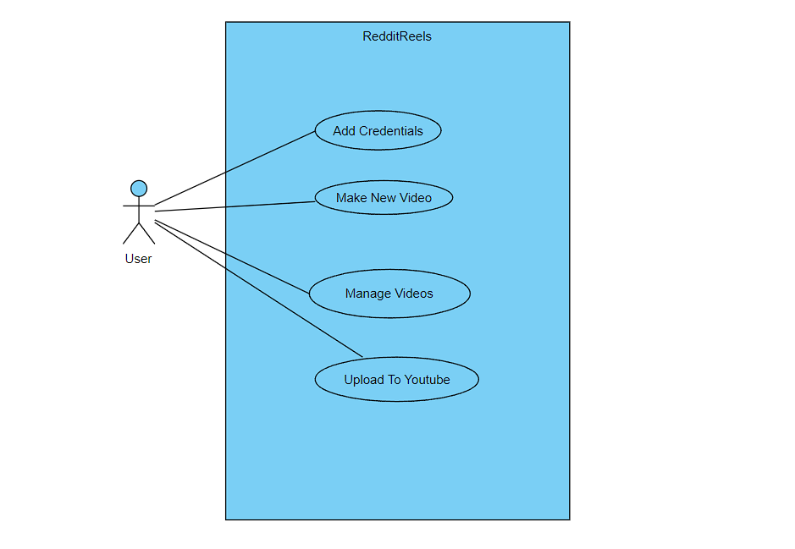

Figure 4.1 (Use Case Diagram)

# Sequence Diagrams:

→ **Registration:**

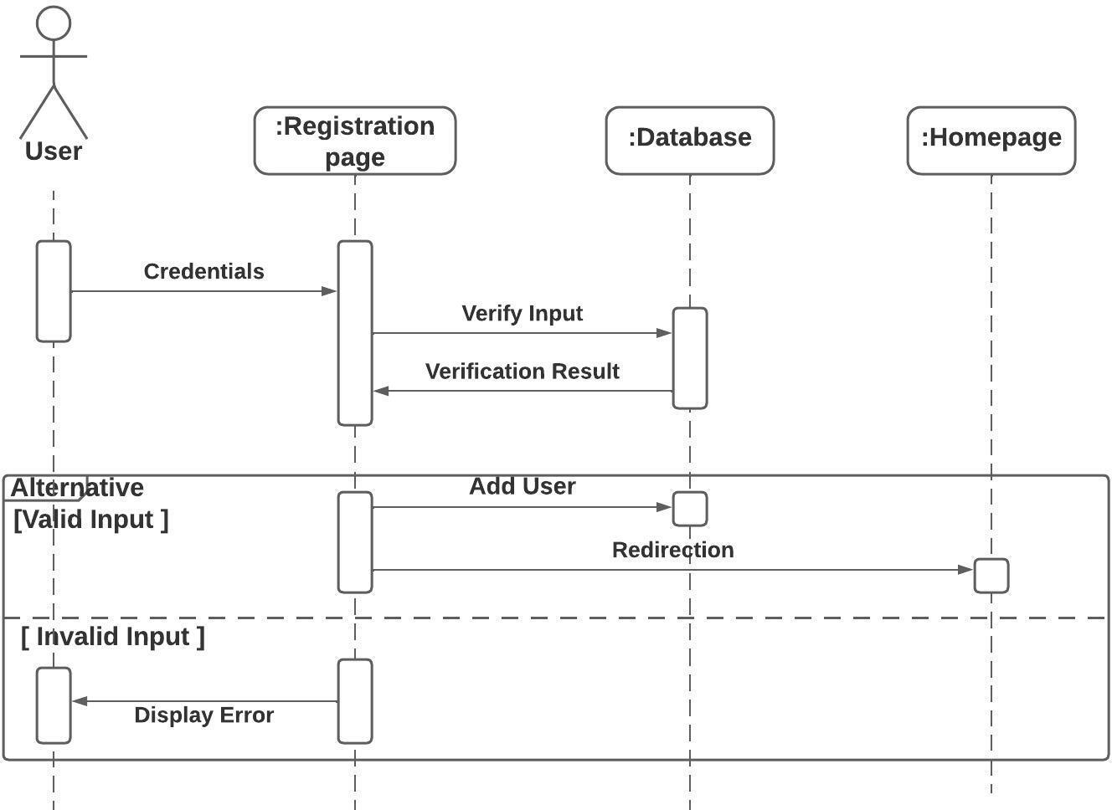

Figure 4.2 (Sequence diagram for SignUp)

→ **Login:**

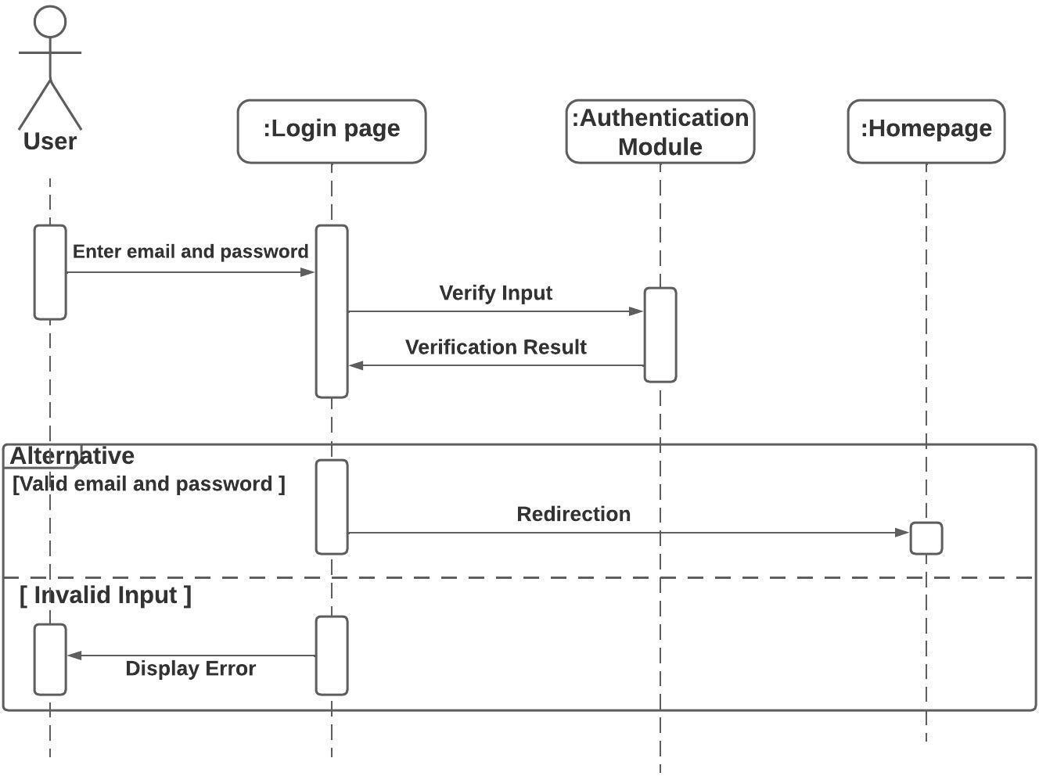

Figure 4.3 (Sequence diagram for Login)

#  Make Video:

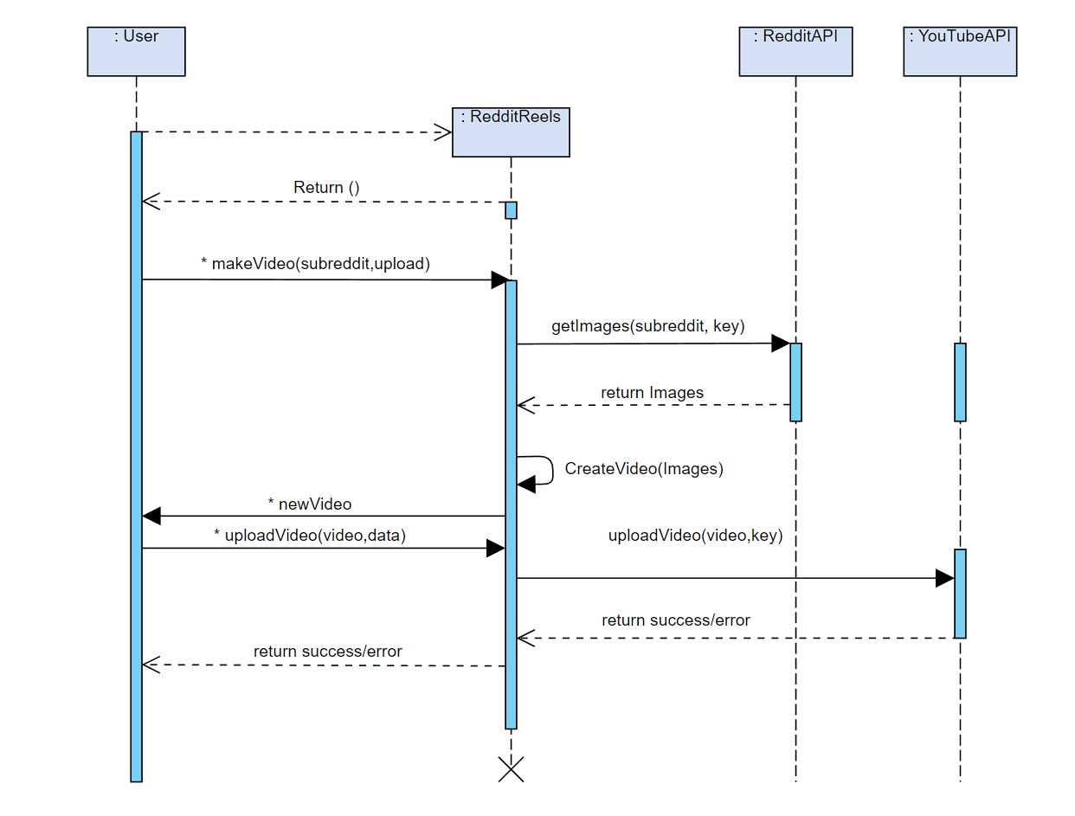

Figure 4.4 (Sequence diagram for Make Video & Upload Video)

# Activity Diagram:

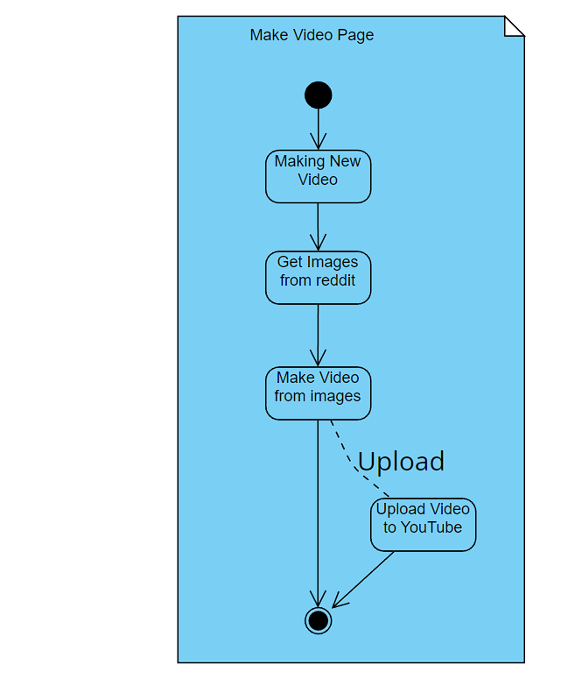

Figure 4.5 (Activity Diagram)

# IMPLEMENTATION DETAILS

**Modules:**

**User Module:**

In this system, Everything Depends mainly on User Module. As all the operations performed are called through User Module to run them concurrently with operations of other Users.

User module have all the methods required to Manage user, Manage Videos, Manage Creation of the video and uploading of video.

# Video Module:

To Stores, Process and access all the data on video, video module is used. It have all the necessary data and methods required to upload the video to YouTube via YouTube Data API v3.

Like save video, upload video and update video from given videoed.

**Reddit and YouTube Credentials:**

# To Stores API keys of Reddit and YouTube.

# TESTING

Manual testing was performed in order to find and fix the bugs in the development process.

|  |  |  |  |  |  |
| --- | --- | --- | --- | --- | --- |
| **Test Case ID** | **SRS ID** | **Test Case Objective** | **Expected Output** | **Actual Output** | **Status** |
| 01 | R1.1 | Registration with empty or invalid field | User should not be able to register | Error message is shown | PASS |
| 02 | R1.1 | Registration with valid fields | User’s is successfully registered and data is stored in the database | User is redirected to login page | PASS |
| 03 | R1.2 | Login with incorrect credentials | User should not be able to log into the system | Error message is shown | PASS |
| 04 | R1.2 | Login with correct details | User is logged in successfully | User is redirected to homepage | PASS |
| 05 | R1.3 | Logout Button press | Logout & Session terminated | Logged out & redirected to login page | PASS |
| 06 | R2.1 | Enter Credentials | Show credentials that entered | Shown Credentials in secrets page | PASS |
| 07 | R4 | Making new video | New video made from given subreddit | New video in videos page | PASS |
| 08 | R5 | Show all videos | List alĺ videos for the user | All videos listed | PASS |
| 09 | R6 | View video | Play video form video list page | Video played | PASS |
| 10 | R7 | Edit video data | Video data edited in video list page | Data edited | PASS |
| 11 | R8.1 | Upload Video To YouTube | Video uploaded | Video shown on YouTube | PASS |
| 12 | R8.2 | Update Status of video after upload | Videos will have button to the uploaded video on YouTube | Button shows up | FAIL |
| 13 | R9 | Delete Video | Video data and video will be deleted from data | Video deleted with data | PASS |

# SCREENSHOTS

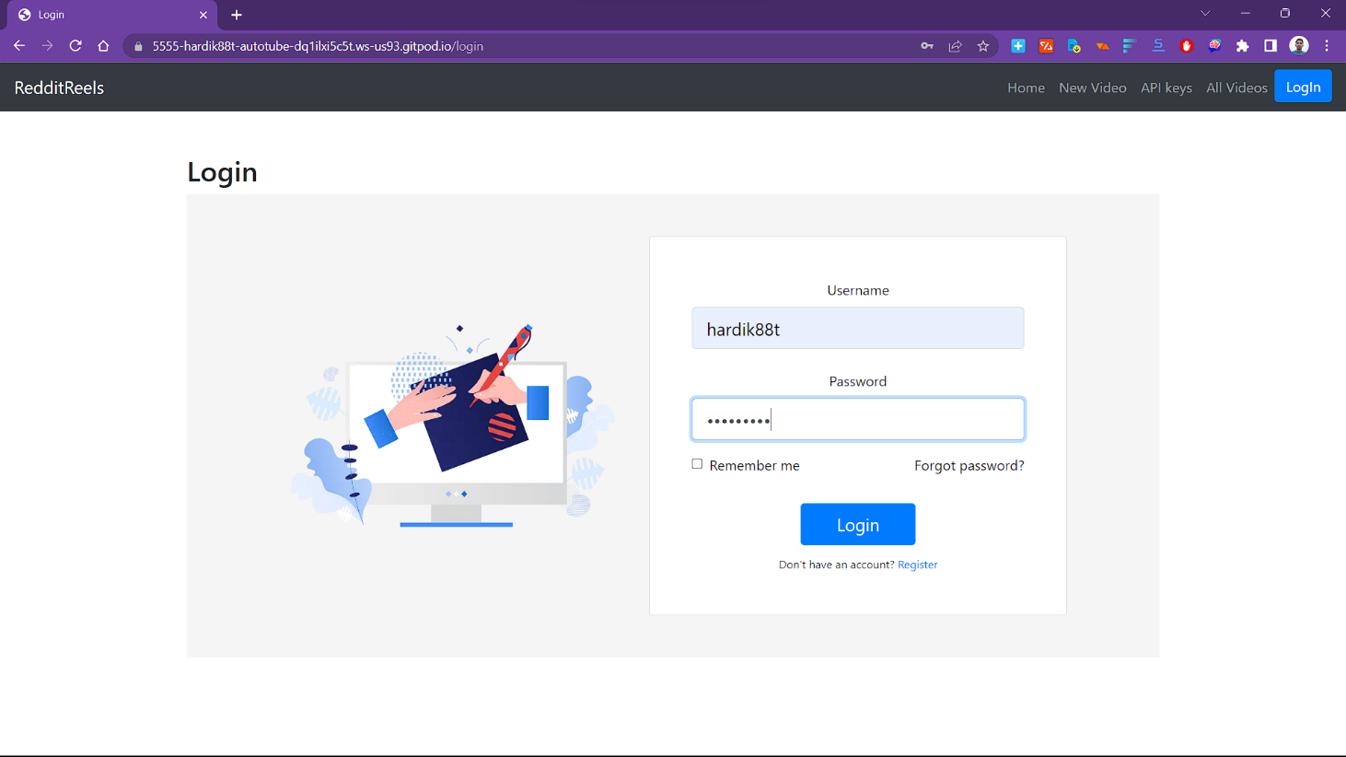

Figure 7.1 (Login for user)

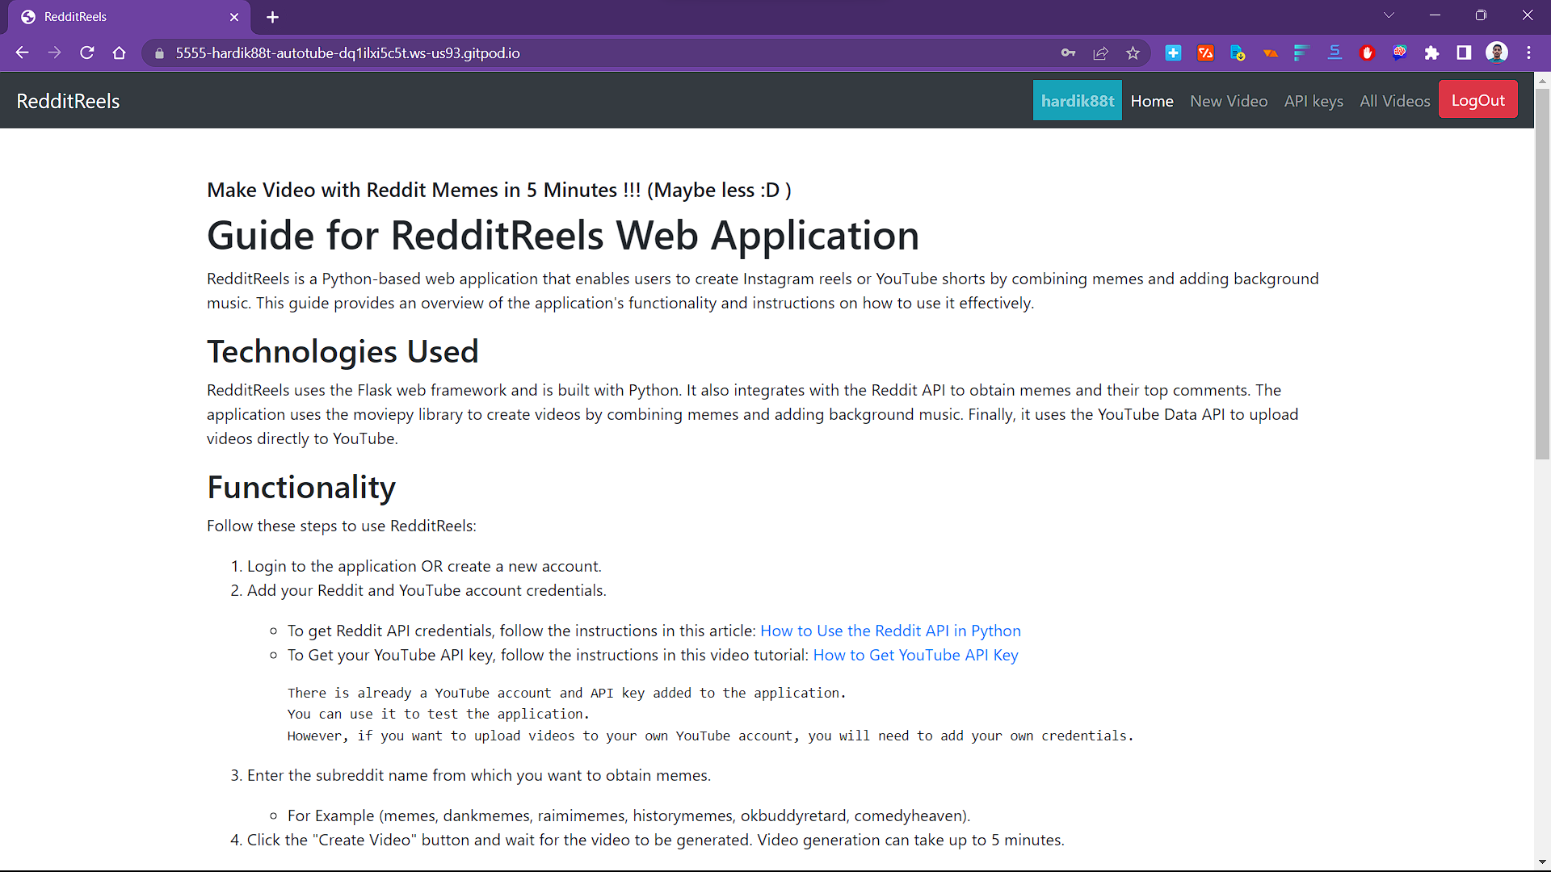

Figure 7.2 (Home page for User)

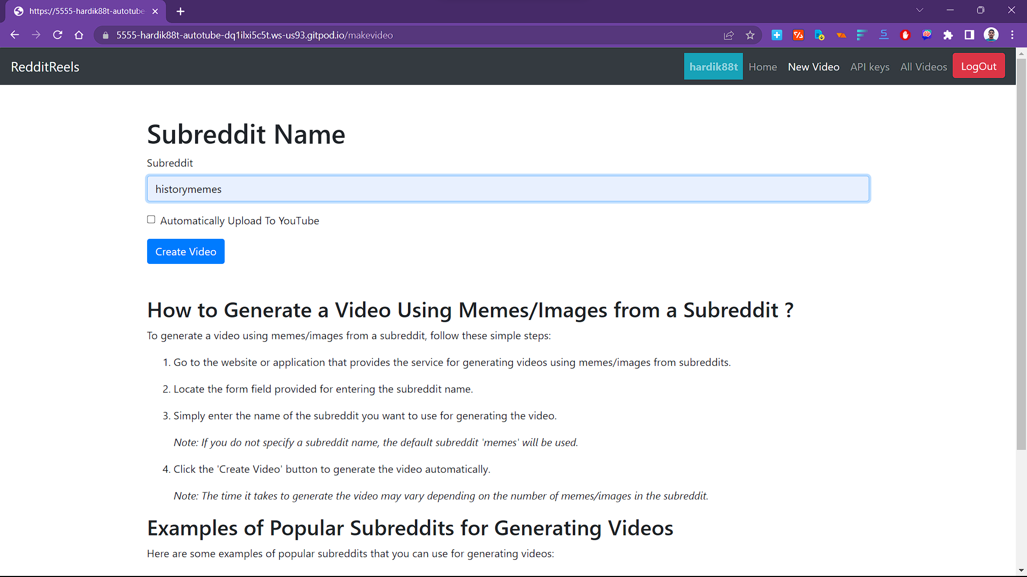

Figure 7.3 (Create Video Page)

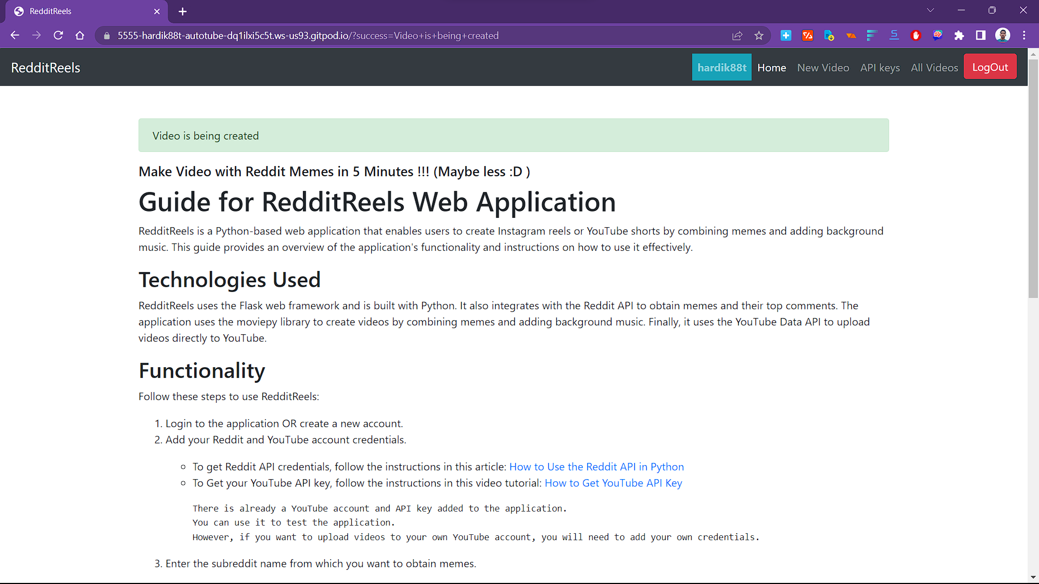

Figure 7.4 (Video in Progress)

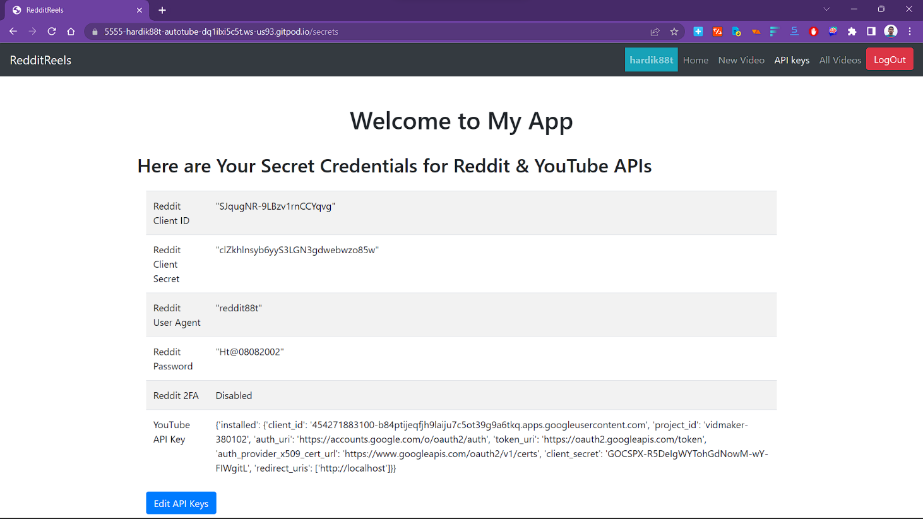

Figure 7.5 (API keys)

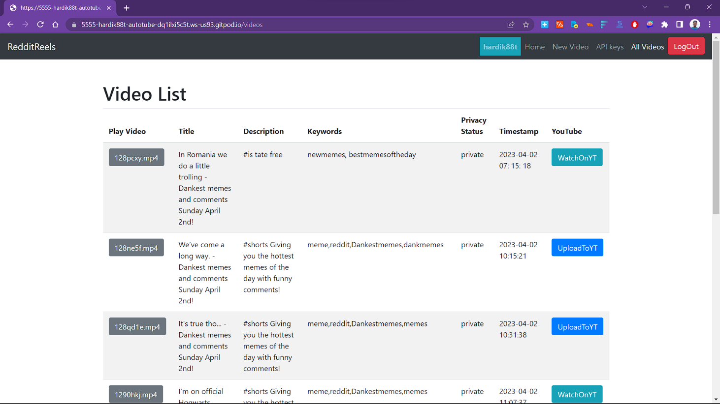

Figure 7.6 (All Videos)

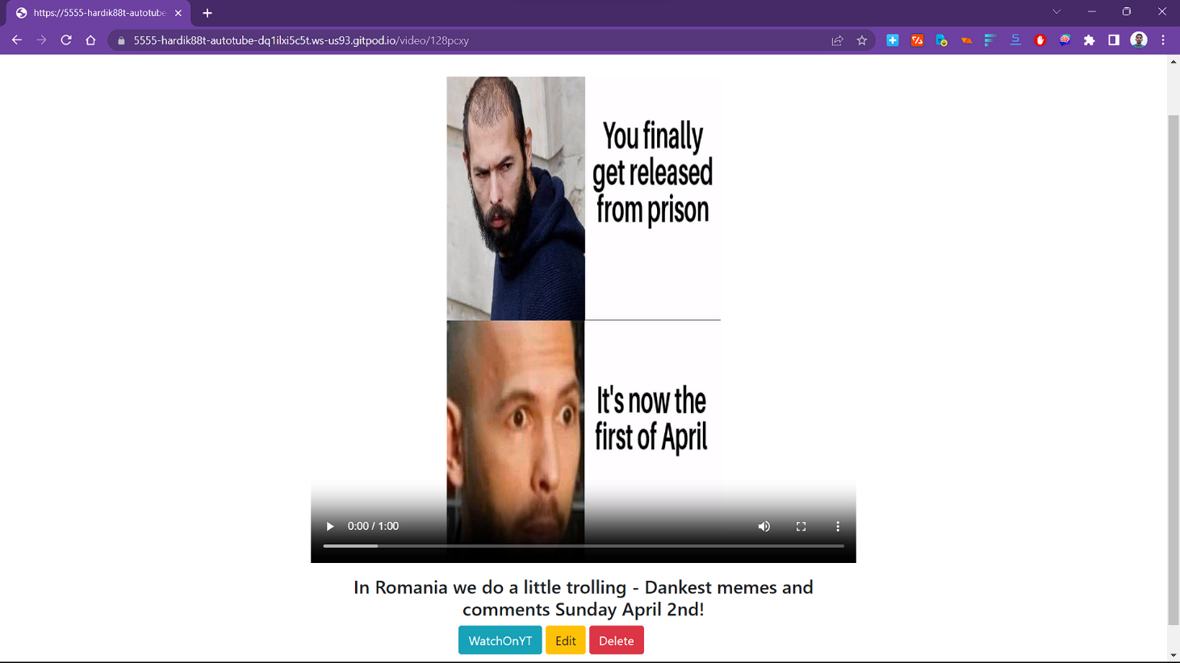

Figure 7.7 (View/Edit/Delete Video)

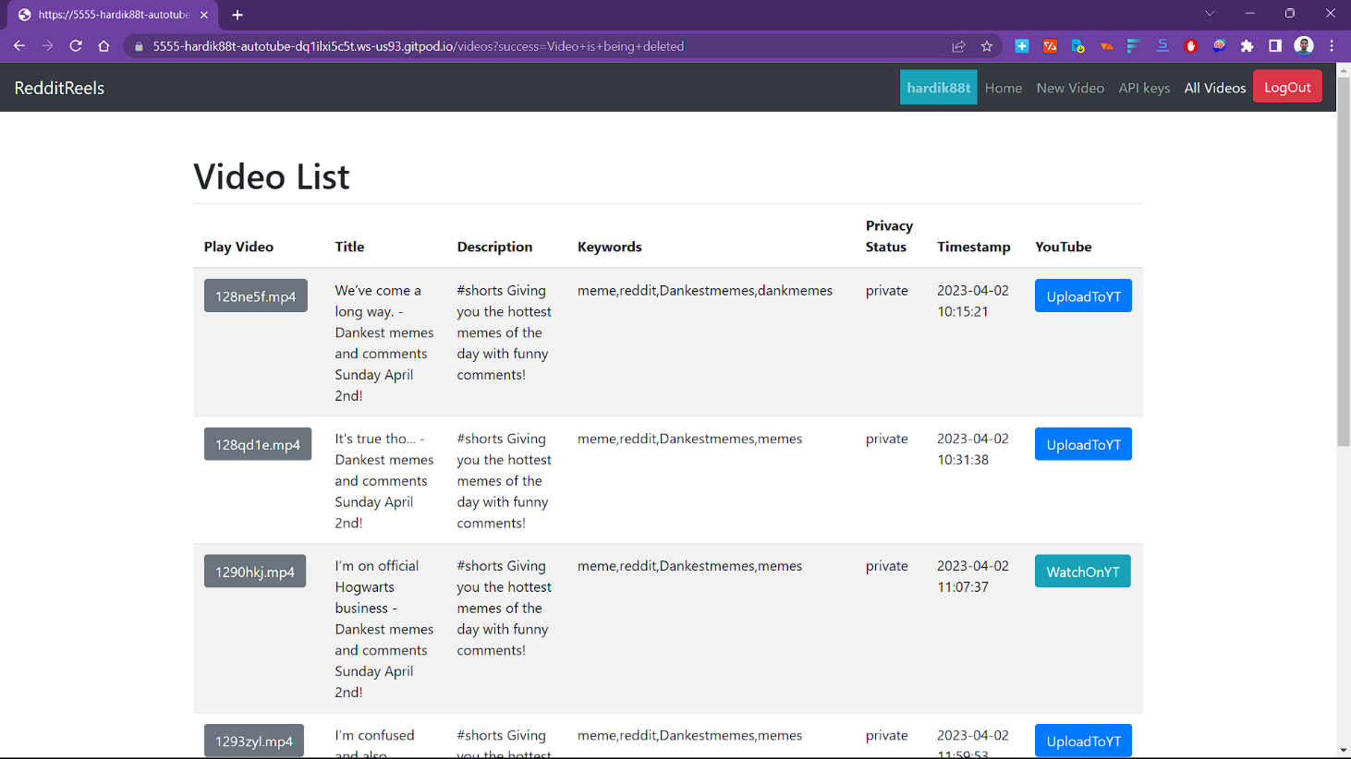

Figure 7.8 (Video Deleted)

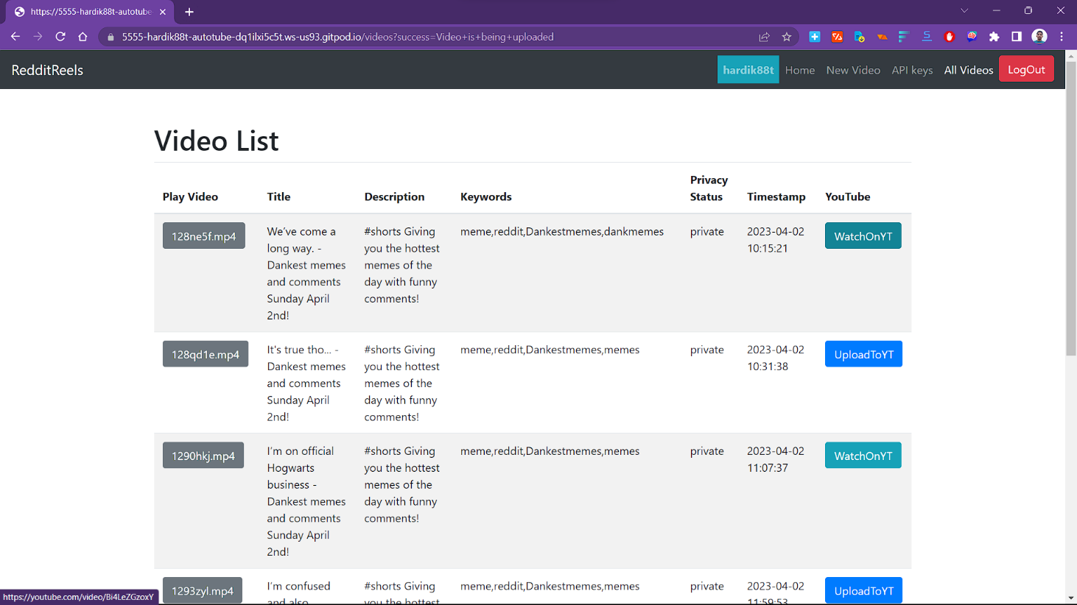

Figure 7.9 (Video Uploaded To YouTube)

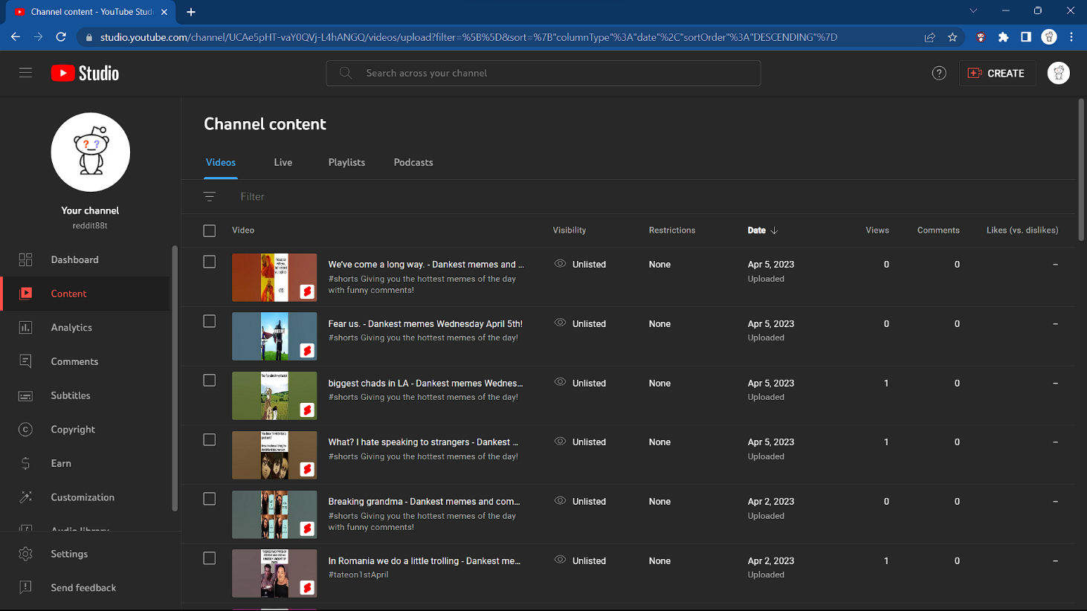

Figure 7.10 (YouTube Page)

# CONCLUSION

In conclusion, RedditReels is an innovative web application that empowers users to create captivating social media videos with ease. By leveraging the vast library of memes and comments from Reddit, RedditReels streamlines the video creation process while delivering professional-quality results. Its intuitive interface and direct upload feature make it an ideal tool for content creators, influencers, and anyone looking to share fun videos with their friends and followers. With RedditReels, users can take their social media content to the next level and stand out in the crowded world of social media.

# 9. LIMITATIONS AND FUTURE EXTENSIONS

**Limitations:**

While RedditReels offers a great solution for creating social media videos, there are some limitations to be aware of. Firstly, the application currently only sources content from Reddit, which limits the range of content available to users. Additionally, the application may face performance issues if the user tries to create long videos or use a large number of memes. Finally, the application currently lacks support for other social media platforms such as Instagram, Facebook or Snapchat.

**Future Extensions:**

To address these limitations and expand its capabilities, RedditReels could be extended in several ways. Firstly, the application could be enhanced to source content from other social media platforms in addition to Reddit, allowing for a broader range of content options. Secondly, the application could be optimized to handle longer videos and support more advanced video editing features. Thirdly, RedditReels could incorporate machine learning algorithms to suggest memes and comments that are most likely to resonate with the user's target audience. Finally, RedditReels could incorporate analytics features to provide users with insights into the performance of their videos and help them optimize their content for maximum engagement.

Another potential future extension for RedditReels could be the ability to directly upload videos to other social media platforms besides YouTube. As social media continues to evolve, users are increasingly using a variety of platforms to share their content. By adding support for platforms such as TikTok, Snapchat, and Instagram, RedditReels could become an even more versatile and valuable tool for content creators. This would enable users to easily share their videos on a variety of social media platforms, without having to manually upload them to each platform separately. With this extension, RedditReels could become a one-stop-shop for creating and sharing social media videos across multiple platforms.

# 10. BIBLIOGRAPHY

* ClarityCoders/AutoTube. GitHub, <https://github.com/ClarityCoders/AutoTube>.
* Stack Overflow. Where Developers Learn, Share, & Build Careers. <https://stackoverflow.com/>
* GitHub. Version Control with Git. GitHub, <https://github.com/>
* Flask. Welcome to Flask — Flask Documentation (2.0.x). PalletsProjects, <https://flask.palletsprojects.com/en/2.0.x/>
* Microsoft. Visual Studio Code - Code Editing. Redefined. Microsoft, <https://code.visualstudio.com/>
* Gitpod, <https://gitpod.com/>