DEVELOPMENT TASK

The task below has been created to give candidates the opportunity to demonstrate both their front-end
and back-end development skills as well as their general understanding of web-development best
practices.

REQUIREMENT

Build a module which a customer can use to view information stored by Ruroc. This information should
be visible on a new page accessible within their account area and should display:
• Any orders and corresponding order information.
• Any personal details we store against that customer.
• A link which allows customers to request this information is deleted.

The last point complies with a GDPR right to erasure request. It should send an email to a system
configured email address to notify us the customer wants us to remove their personal information.
The page should be styled as closely as possible to the Ruroc.com styling.

------------------------------------------------------------------------------------------------------------------------

This module created as standard module related to customer changes and added in default ‘Customer Configuration’ tab in admin system configuration area.

- Added enable/disable config on module level.
- Added enable/disable config for allowing customer for requesting to remove information.
- Email template config added for setting email subject, email template, receiver name and receiver email.
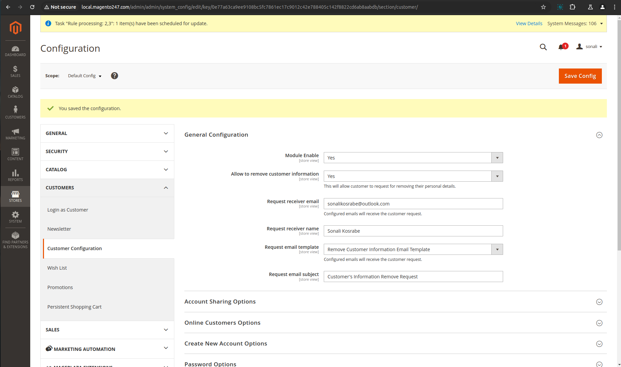

I have developed this module on magento default theme but tried to copy Ruroc theme on this tab. I didn’t have font so font is not applied.

I have added remove information icon on ‘Personal Information’ level and ‘Order Level’. I have added on ‘Order Level’, if customer want to remove information related to specific order or if you want to extend on order level.

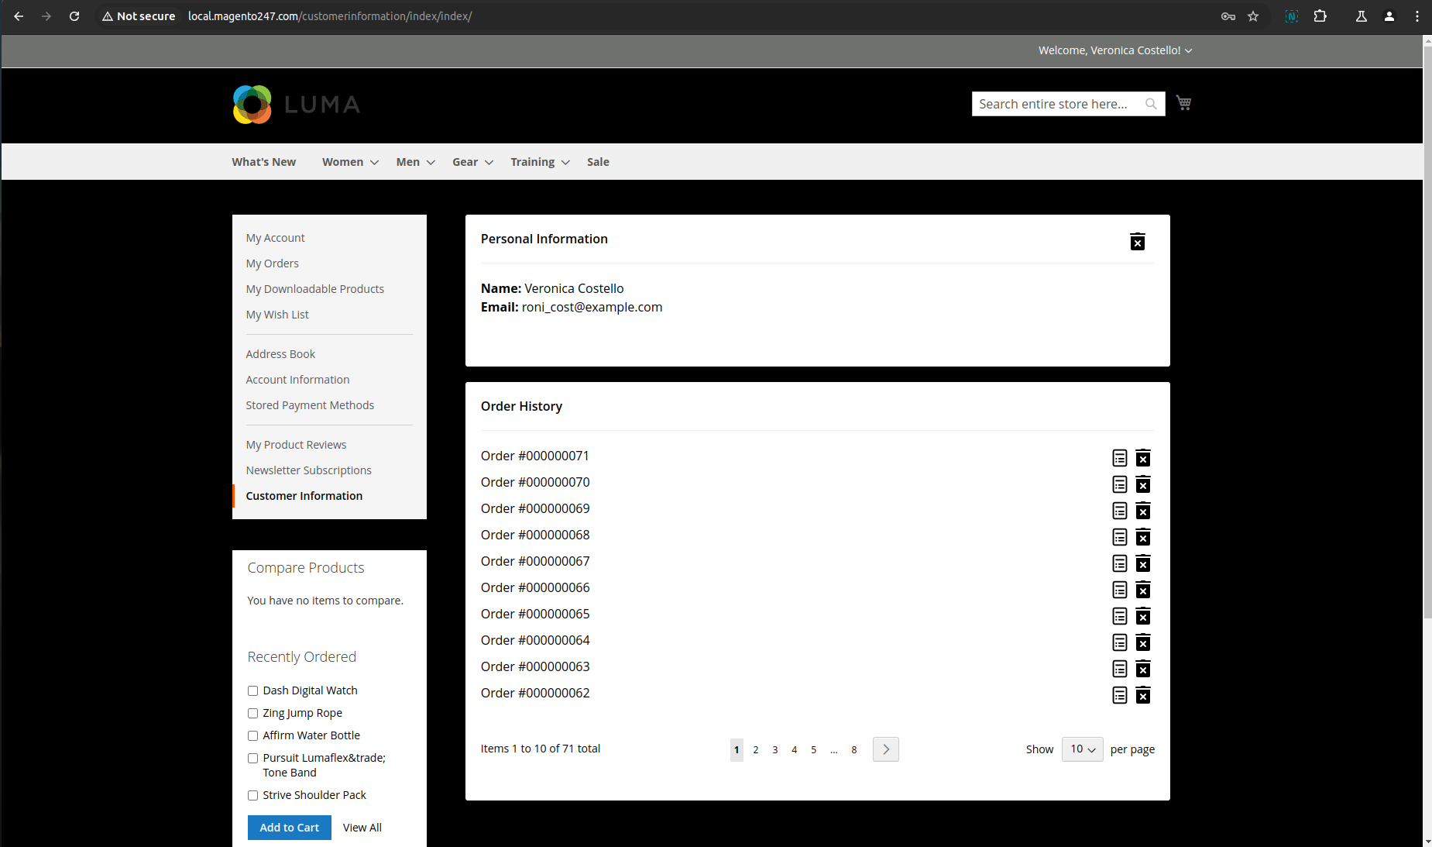

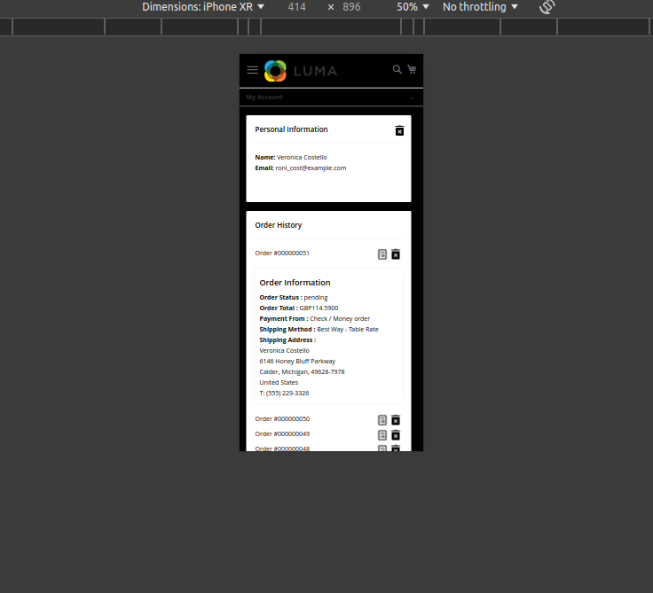

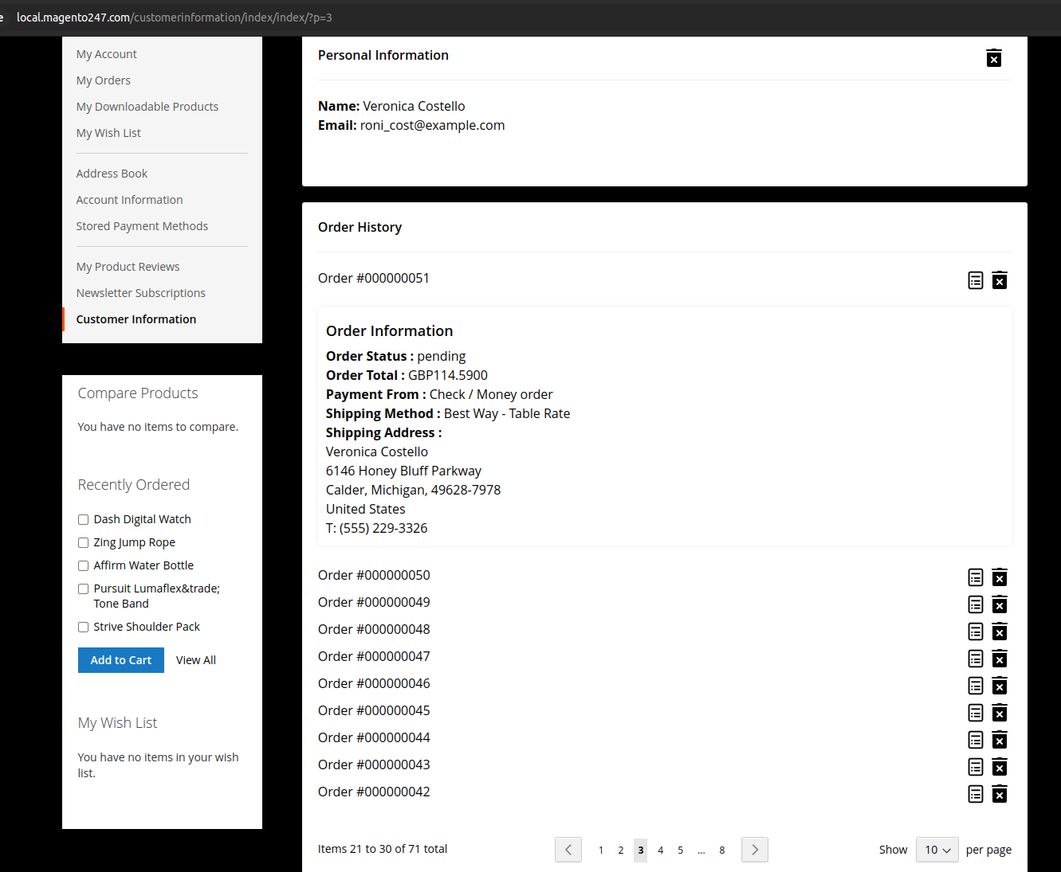

After requesting, success message will display.

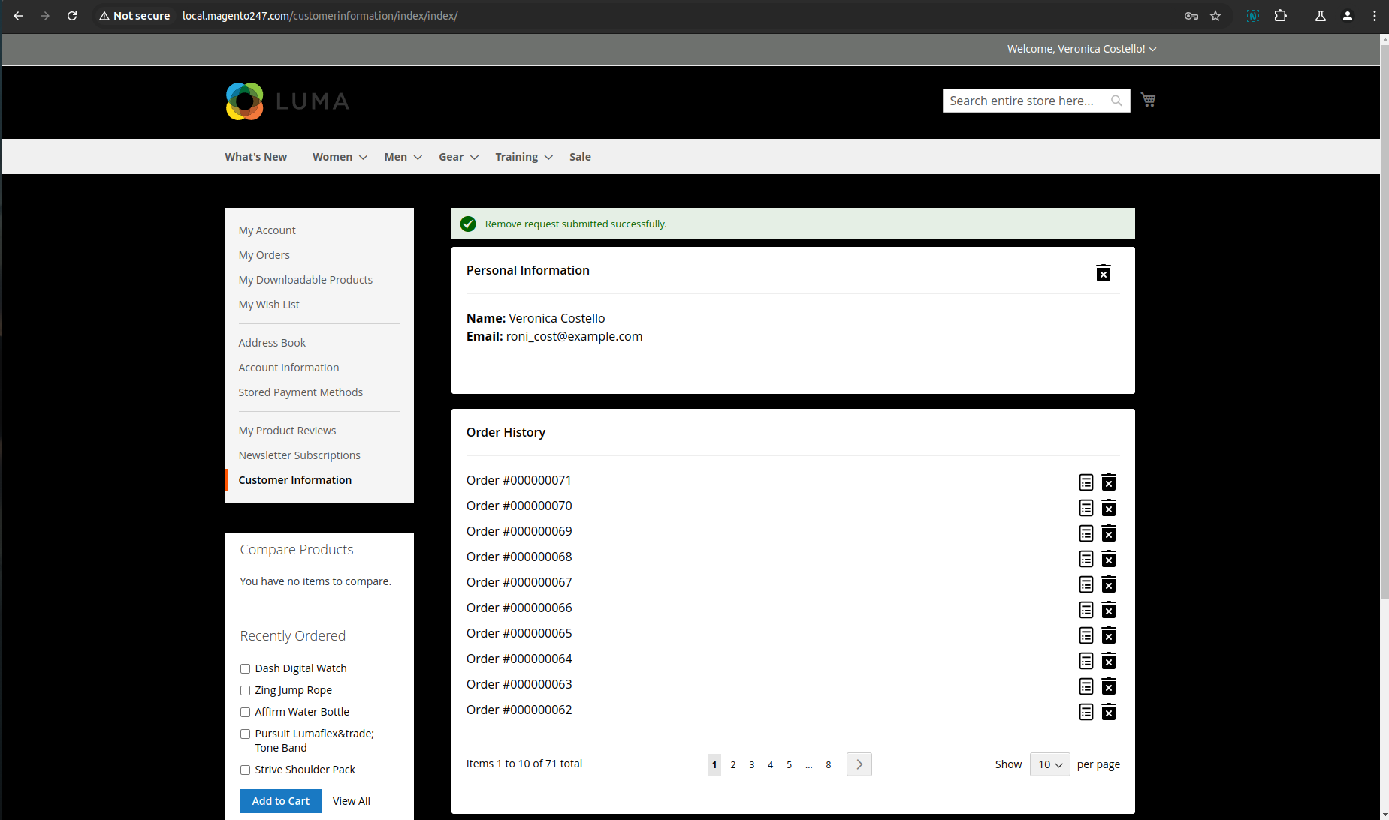

Receiver will receive an email as below:

If request generated from ‘Personal Information’ area,

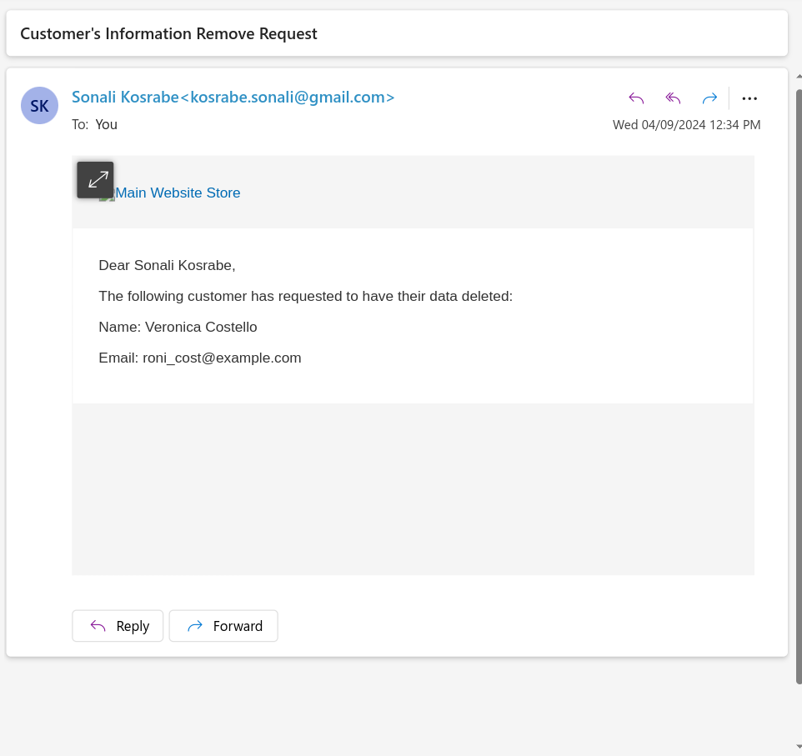
If request generated from ‘Order Details’ area,

