Github:- https://github.com/smarthardik10/FoodBox

Objective:-

Create a dynamic and responsive online food delivery web application for ordering food items of different cuisines from a restaurant.

**Background of the problem statement:**  
Foodbox is a restaurant chain that delivers food items of different cuisines at affordable prices. It was established in 2014 in Bengaluru, India. It had been serving fine all these years, however, the business analysts noticed a decline in sales since 2016. They found out that the online ordering of food items with companies, such as Swiggy and Foodpanda were gaining more profit by eliminating middlemen from the equation. As a result, the team decided to hire a Full Stack developer to develop an online food delivery web application with a rich and user-friendly interface.  
You are hired as the Full Stack Java developer and are asked to develop the web application. The management team has provided you with the requirements and their business model so that you can easily arrange different components of the application.

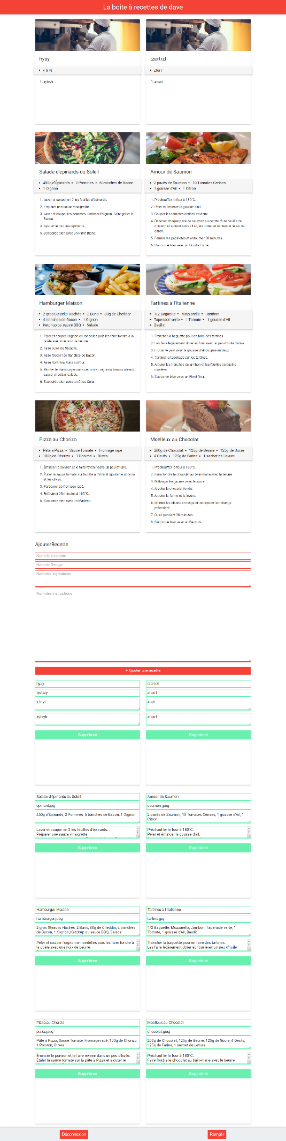Screen Shot: