Theory

1. JSP - JSP allows Java code and certain predefined actions to be interleaved with static web markup content, such as HTML. Architecturally, JSP may be viewed as a high-level abstraction of Java servlets. Each JSP servlet is cached and re-used until the original JSP is modified. The compiled pages, as well as any dependent Java libraries, contain Java bytecode rather than machine code.
2. MySQL - MyAdmin is an open-source relational database management system (RDBMS). Its name is a combination of "My", the name of co-founder Michael Widenius's daughter, and "SQL", the abbreviation for Structured Query Language. A relational database organizes data into one or more data tables in which data types may be related to each other; these relations help structure the data.
3. HTML - HyperText Markup Language or HTML is the standard markup language for documents designed to be displayed in a web browser. It can be assisted by technologies such as Cascading Style Sheets (CSS) and scripting languages such as JavaScript. HTML describes the structure of a web page semantically and originally included cues for the appearance of the document. Images and other objects such as interactive forms may be embedded into the rendered page.
4. CSS - Cascading Style Sheets (CSS) is a style sheet language used for describing the presentation of a document written in a markup language such as HTML. CSS is designed to enable the separation of presentation and content, including layout, colors, and fonts. This separation can improve content accessibility, provide more flexibility and control in the specification of presentation characteristics, and enable multiple web pages to share formatting.

Screenshots

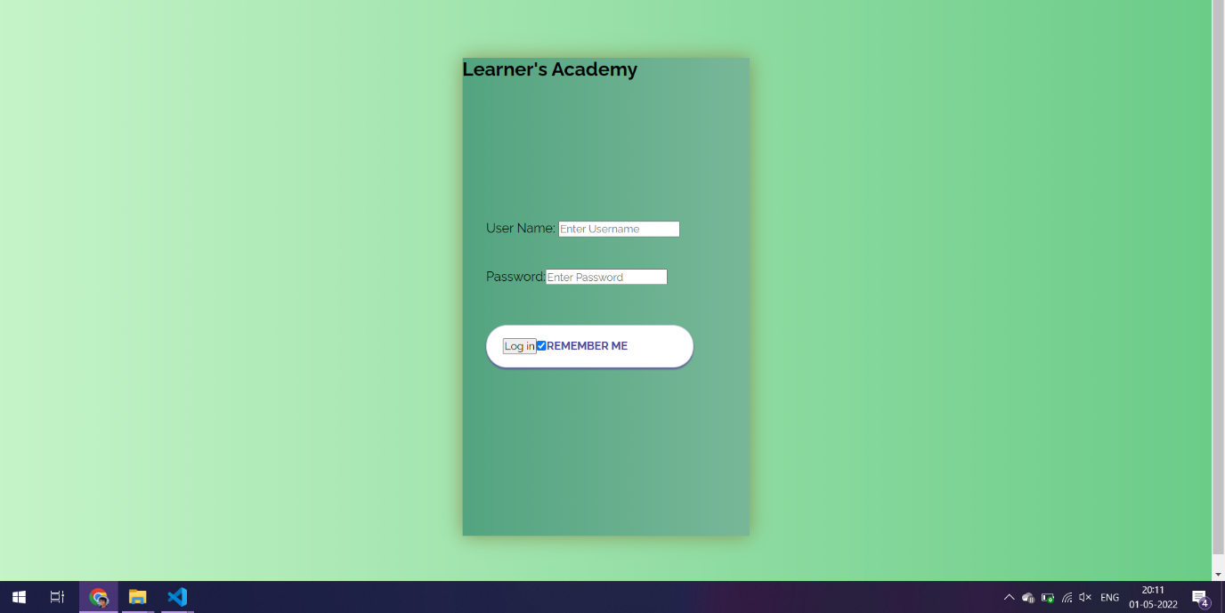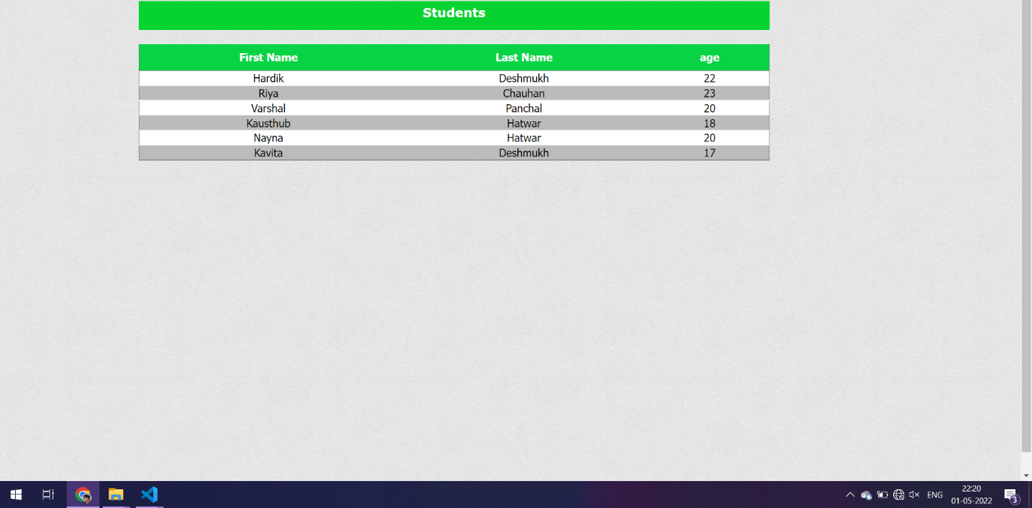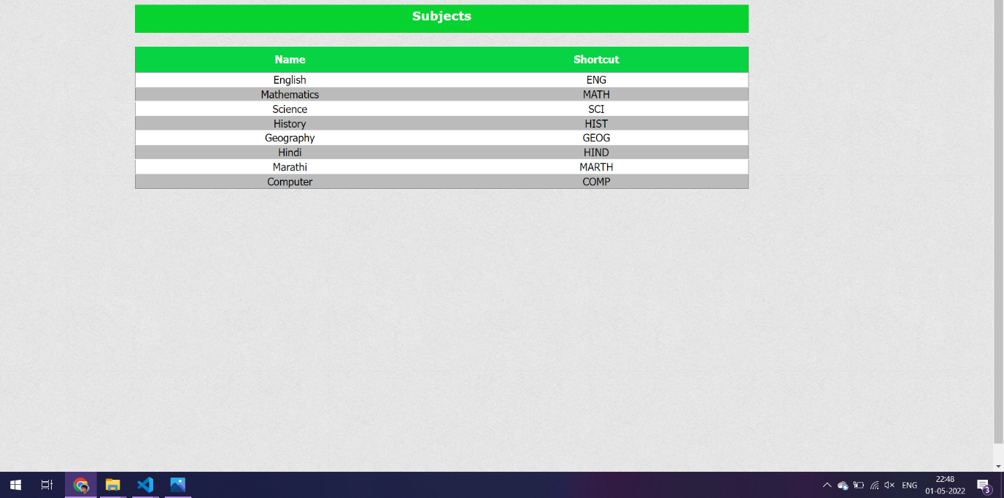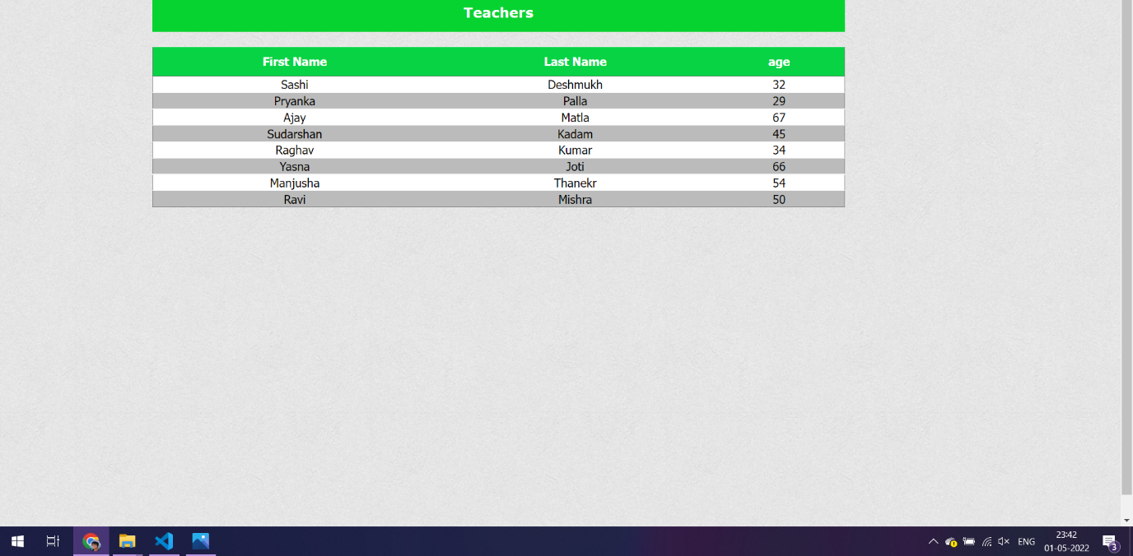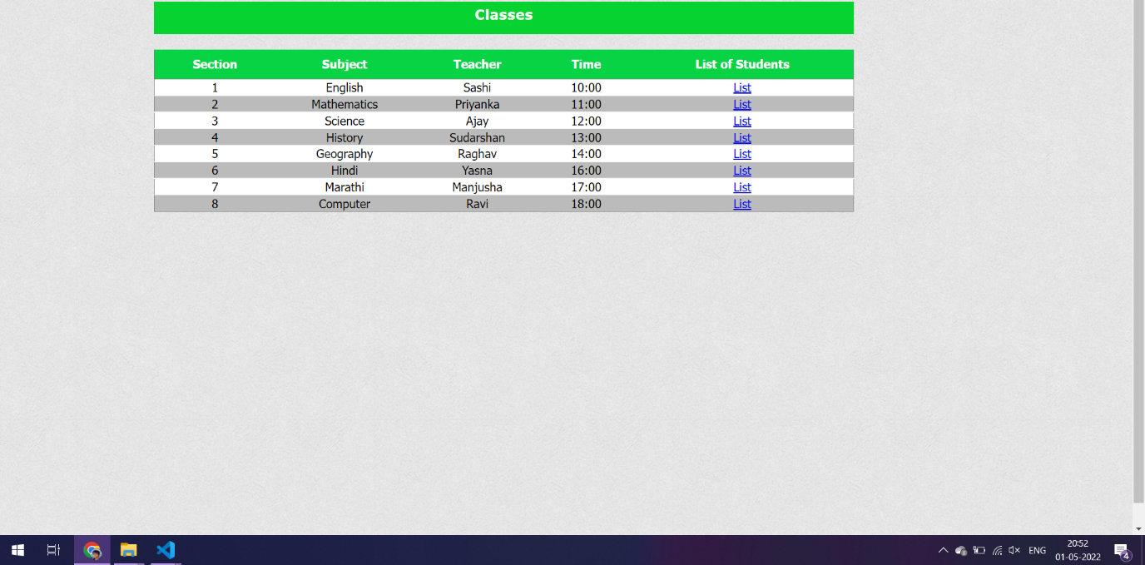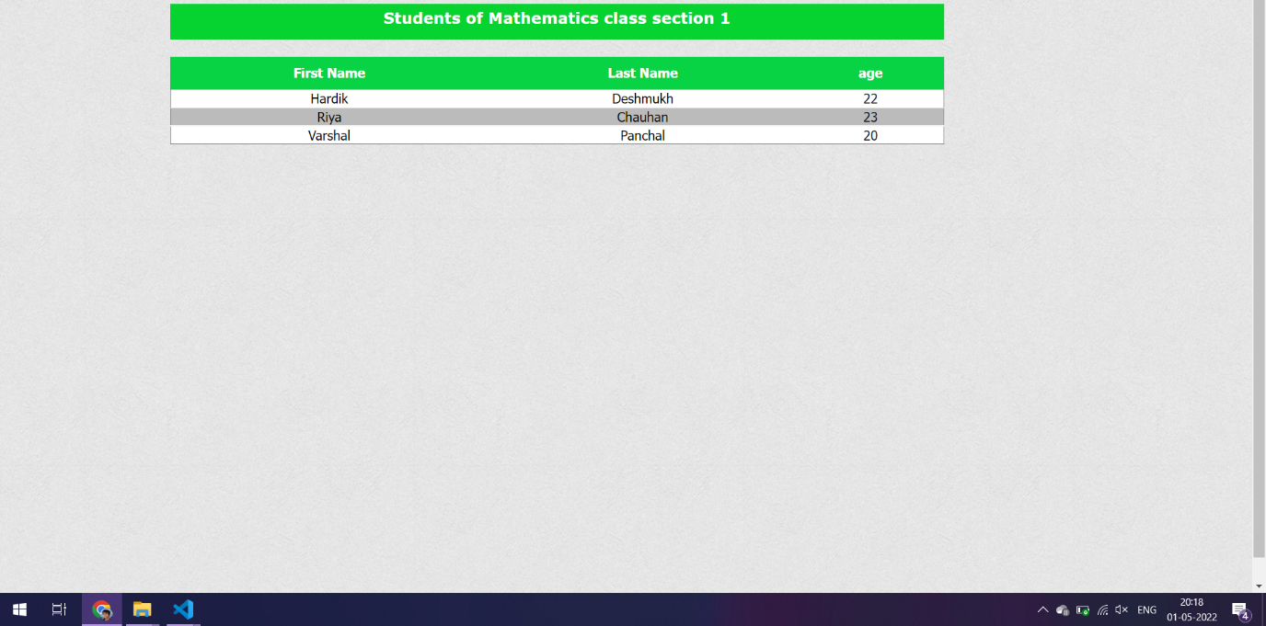

DataBase Scheme

CREATE DATABASE IF NOT EXISTS `administrative_portal` /*!40100 DEFAULT CHARACTER SET utf8mb4 COLLATE utf8mb4_0900_ai_ci */ /*!80016 DEFAULT ENCRYPTION='N' */;

USE `administrative_portal`;

-- MySQL dump 10.13 Distrib 8.0.27, for Win64 (x86_64)

--

-- Host: 127.0.0.1 Database: administrative_portal

-- ------------------------------------------------------

-- Server version 8.0.27

/*!40101 SET @OLD_CHARACTER_SET_CLIENT=@@CHARACTER_SET_CLIENT */;

/*!40101 SET @OLD_CHARACTER_SET_RESULTS=@@CHARACTER_SET_RESULTS */;

/*!40101 SET @OLD_COLLATION_CONNECTION=@@COLLATION_CONNECTION */;

/*!50503 SET NAMES utf8 */;

/*!40103 SET @OLD_TIME_ZONE=@@TIME_ZONE */;

/*!40103 SET TIME_ZONE='+00:00' */;

/*!40014 SET @OLD_UNIQUE_CHECKS=@@UNIQUE_CHECKS, UNIQUE_CHECKS=0 */;

/*!40014 SET @OLD_FOREIGN_KEY_CHECKS=@@FOREIGN_KEY_CHECKS, FOREIGN_KEY_CHECKS=0 */;

/*!40101 SET @OLD_SQL_MODE=@@SQL_MODE, SQL_MODE='NO_AUTO_VALUE_ON_ZERO' */;

/*!40111 SET @OLD_SQL_NOTES=@@SQL_NOTES, SQL_NOTES=0 */;

--

-- Table structure for table `classes`

--

DROP TABLE IF EXISTS `classes`;

/*!40101 SET @saved_cs_client = @@character_set_client */;

/*!50503 SET character_set_client = utf8mb4 */;

CREATE TABLE `classes` (

`id` int NOT NULL AUTO_INCREMENT,

`section` int NOT NULL,

`teacher` int NOT NULL,

`subject` int NOT NULL,

`time` varchar(55) NOT NULL,

PRIMARY KEY (`id`),

KEY `subject_id` (`subject`),

KEY `teacher_id` (`teacher`),

CONSTRAINT `subject_id` FOREIGN KEY (`subject`) REFERENCES `subjects` (`id`),

CONSTRAINT `teacher_id` FOREIGN KEY (`teacher`) REFERENCES `teachers` (`id`)

) ENGINE=InnoDB AUTO_INCREMENT=12 DEFAULT CHARSET=utf8mb4 COLLATE=utf8mb4_0900_ai_ci;

/*!40101 SET character_set_client = @saved_cs_client */;

--

-- Dumping data for table `classes`

--

LOCK TABLES `classes` WRITE;

/*!40000 ALTER TABLE `classes` DISABLE KEYS */;

INSERT INTO `classes` VALUES (1,1,1,1,'9:00'),(2,3,2,2,'11:30'),(3,2,3,3,'12:30'),(4,4,4,4,'1:45'),(5,2,3,5,'2:59'),(6,6,4,2,'5:00'),(7,7,5,6,'2:00'),(8,5,6,7,'3:00'),(9,8,7,8,'2:30'),(10,9,8,9,'5:30');

/*!40000 ALTER TABLE `classes` ENABLE KEYS */;

UNLOCK TABLES;

/*!40103 SET TIME_ZONE=@OLD_TIME_ZONE */;

/*!40101 SET SQL_MODE=@OLD_SQL_MODE */;

/*!40014 SET FOREIGN_KEY_CHECKS=@OLD_FOREIGN_KEY_CHECKS */;

/*!40014 SET UNIQUE_CHECKS=@OLD_UNIQUE_CHECKS */;

/*!40101 SET CHARACTER_SET_CLIENT=@OLD_CHARACTER_SET_CLIENT */;

/*!40101 SET CHARACTER_SET_RESULTS=@OLD_CHARACTER_SET_RESULTS */;

/*!40101 SET COLLATION_CONNECTION=@OLD_COLLATION_CONNECTION */;

/*!40111 SET SQL_NOTES=@OLD_SQL_NOTES */;

CREATE DATABASE IF NOT EXISTS `administrative_portal` /*!40100 DEFAULT CHARACTER SET utf8mb4 COLLATE utf8mb4_0900_ai_ci */ /*!80016 DEFAULT ENCRYPTION='N' */;

USE `administrative_portal`;

-- MySQL dump 10.13 Distrib 8.0.27, for Win64 (x86_64)

--

-- Host: 127.0.0.1 Database: administrative_portal

-- ------------------------------------------------------

-- Server version 8.0.27

/*!40101 SET @OLD_CHARACTER_SET_CLIENT=@@CHARACTER_SET_CLIENT */;

/*!40101 SET @OLD_CHARACTER_SET_RESULTS=@@CHARACTER_SET_RESULTS */;

/*!40101 SET @OLD_COLLATION_CONNECTION=@@COLLATION_CONNECTION */;

/*!50503 SET NAMES utf8 */;

/*!40103 SET @OLD_TIME_ZONE=@@TIME_ZONE */;

/*!40103 SET TIME_ZONE='+00:00' */;

/*!40014 SET @OLD_UNIQUE_CHECKS=@@UNIQUE_CHECKS, UNIQUE_CHECKS=0 */;

/*!40014 SET @OLD_FOREIGN_KEY_CHECKS=@@FOREIGN_KEY_CHECKS, FOREIGN_KEY_CHECKS=0 */;

/*!40101 SET @OLD_SQL_MODE=@@SQL_MODE, SQL_MODE='NO_AUTO_VALUE_ON_ZERO' */;

/*!40111 SET @OLD_SQL_NOTES=@@SQL_NOTES, SQL_NOTES=0 */;

--

-- Dumping events for database 'administrative_portal'

--

--

-- Dumping routines for database 'administrative_portal'

--

/*!40103 SET TIME_ZONE=@OLD_TIME_ZONE */;

/*!40101 SET SQL_MODE=@OLD_SQL_MODE */;

/*!40014 SET FOREIGN_KEY_CHECKS=@OLD_FOREIGN_KEY_CHECKS */;

/*!40014 SET UNIQUE_CHECKS=@OLD_UNIQUE_CHECKS */;

/*!40101 SET CHARACTER_SET_CLIENT=@OLD_CHARACTER_SET_CLIENT */;

/*!40101 SET CHARACTER_SET_RESULTS=@OLD_CHARACTER_SET_RESULTS */;

/*!40101 SET COLLATION_CONNECTION=@OLD_COLLATION_CONNECTION */;

/*!40111 SET SQL_NOTES=@OLD_SQL_NOTES */;

CREATE DATABASE IF NOT EXISTS `administrative_portal` /*!40100 DEFAULT CHARACTER SET utf8mb4 COLLATE utf8mb4_0900_ai_ci */ /*!80016 DEFAULT ENCRYPTION='N' */;

USE `administrative_portal`;

-- MySQL dump 10.13 Distrib 8.0.27, for Win64 (x86_64)

--

-- Host: 127.0.0.1 Database: administrative_portal

-- ------------------------------------------------------

-- Server version 8.0.27

/*!40101 SET @OLD_CHARACTER_SET_CLIENT=@@CHARACTER_SET_CLIENT */;

/*!40101 SET @OLD_CHARACTER_SET_RESULTS=@@CHARACTER_SET_RESULTS */;

/*!40101 SET @OLD_COLLATION_CONNECTION=@@COLLATION_CONNECTION */;

/*!50503 SET NAMES utf8 */;

/*!40103 SET @OLD_TIME_ZONE=@@TIME_ZONE */;

/*!40103 SET TIME_ZONE='+00:00' */;

/*!40014 SET @OLD_UNIQUE_CHECKS=@@UNIQUE_CHECKS, UNIQUE_CHECKS=0 */;

/*!40014 SET @OLD_FOREIGN_KEY_CHECKS=@@FOREIGN_KEY_CHECKS, FOREIGN_KEY_CHECKS=0 */;

/*!40101 SET @OLD_SQL_MODE=@@SQL_MODE, SQL_MODE='NO_AUTO_VALUE_ON_ZERO' */;

/*!40111 SET @OLD_SQL_NOTES=@@SQL_NOTES, SQL_NOTES=0 */;

--

-- Table structure for table `students`

--

DROP TABLE IF EXISTS `students`;

/*!40101 SET @saved_cs_client = @@character_set_client */;

/*!50503 SET character_set_client = utf8mb4 */;

CREATE TABLE `students` (

`id` int NOT NULL AUTO_INCREMENT,

`fname` varchar(55) NOT NULL,

`lname` varchar(55) NOT NULL,

`age` int DEFAULT NULL,

`class` int NOT NULL,

PRIMARY KEY (`id`),

KEY `class_id` (`class`),

CONSTRAINT `class_id` FOREIGN KEY (`class`) REFERENCES `classes` (`id`)

) ENGINE=InnoDB AUTO_INCREMENT=16 DEFAULT CHARSET=utf8mb4 COLLATE=utf8mb4_0900_ai_ci;

/*!40101 SET character_set_client = @saved_cs_client */;

--

-- Dumping data for table `students`

--

LOCK TABLES `students` WRITE;

/*!40000 ALTER TABLE `students` DISABLE KEYS */;

INSERT INTO `students` VALUES (1,'Devesh','Singh',21,1),(2,'Diwakar','G',23,2),(4,'Arun','Srivastava',21,1),(5,'Gill','Jeet',18,2),(6,'Kishore','Kumar',24,1),(7,'Aditya','Gupta',24,2),(8,'Sumirta','Nandan',26,3),(9,'Aditi','Raghav',21,4),(10,'Sunaina','Singh',24,5),(11,'Danish ','Khan',27,6),(12,'Chitra','Kumari',23,7),(13,'Haider','Abbas',26,8),(14,'Swaroop','Sri',20,9),(15,'Devika','Di',27,10);

/*!40000 ALTER TABLE `students` ENABLE KEYS */;

UNLOCK TABLES;

/*!40103 SET TIME_ZONE=@OLD_TIME_ZONE */;

/*!40101 SET SQL_MODE=@OLD_SQL_MODE */;

/*!40014 SET FOREIGN_KEY_CHECKS=@OLD_FOREIGN_KEY_CHECKS */;

/*!40014 SET UNIQUE_CHECKS=@OLD_UNIQUE_CHECKS */;

/*!40101 SET CHARACTER_SET_CLIENT=@OLD_CHARACTER_SET_CLIENT */;

/*!40101 SET CHARACTER_SET_RESULTS=@OLD_CHARACTER_SET_RESULTS */;

/*!40101 SET COLLATION_CONNECTION=@OLD_COLLATION_CONNECTION */;

/*!40111 SET SQL_NOTES=@OLD_SQL_NOTES */;

CREATE DATABASE IF NOT EXISTS `administrative_portal` /*!40100 DEFAULT CHARACTER SET utf8mb4 COLLATE utf8mb4_0900_ai_ci */ /*!80016 DEFAULT ENCRYPTION='N' */;

USE `administrative_portal`;

-- MySQL dump 10.13 Distrib 8.0.27, for Win64 (x86_64)

--

-- Host: 127.0.0.1 Database: administrative_portal

-- ------------------------------------------------------

-- Server version 8.0.27

/*!40101 SET @OLD_CHARACTER_SET_CLIENT=@@CHARACTER_SET_CLIENT */;

/*!40101 SET @OLD_CHARACTER_SET_RESULTS=@@CHARACTER_SET_RESULTS */;

/*!40101 SET @OLD_COLLATION_CONNECTION=@@COLLATION_CONNECTION */;

/*!50503 SET NAMES utf8 */;

/*!40103 SET @OLD_TIME_ZONE=@@TIME_ZONE */;

/*!40103 SET TIME_ZONE='+00:00' */;

/*!40014 SET @OLD_UNIQUE_CHECKS=@@UNIQUE_CHECKS, UNIQUE_CHECKS=0 */;

/*!40014 SET @OLD_FOREIGN_KEY_CHECKS=@@FOREIGN_KEY_CHECKS, FOREIGN_KEY_CHECKS=0 */;

/*!40101 SET @OLD_SQL_MODE=@@SQL_MODE, SQL_MODE='NO_AUTO_VALUE_ON_ZERO' */;

/*!40111 SET @OLD_SQL_NOTES=@@SQL_NOTES, SQL_NOTES=0 */;

--

-- Table structure for table `subjects`

--

DROP TABLE IF EXISTS `subjects`;

/*!40101 SET @saved_cs_client = @@character_set_client */;

/*!50503 SET character_set_client = utf8mb4 */;

CREATE TABLE `subjects` (

`id` int NOT NULL AUTO_INCREMENT,

`name` varchar(55) NOT NULL,

`shortcut` varchar(50) NOT NULL,

PRIMARY KEY (`id`)

) ENGINE=InnoDB AUTO_INCREMENT=10 DEFAULT CHARSET=utf8mb4 COLLATE=utf8mb4_0900_ai_ci;

/*!40101 SET character_set_client = @saved_cs_client */;

--

-- Dumping data for table `subjects`

--

LOCK TABLES `subjects` WRITE;

/*!40000 ALTER TABLE `subjects` DISABLE KEYS */;

INSERT INTO `subjects` VALUES (1,'English','ENG'),(2,'Mathematics','MATH'),(3,'Socialology','SCO'),(4,'Computer Science','CS'),(5,'History','HS'),(6,'Art','ART'),(7,'Hindi','HND'),(8,'Chemistry','CHM'),(9,'Physics','PHY');

/*!40000 ALTER TABLE `subjects` ENABLE KEYS */;

UNLOCK TABLES;

/*!40103 SET TIME_ZONE=@OLD_TIME_ZONE */;

/*!40101 SET SQL_MODE=@OLD_SQL_MODE */;

/*!40014 SET FOREIGN_KEY_CHECKS=@OLD_FOREIGN_KEY_CHECKS */;

/*!40014 SET UNIQUE_CHECKS=@OLD_UNIQUE_CHECKS */;

/*!40101 SET CHARACTER_SET_CLIENT=@OLD_CHARACTER_SET_CLIENT */;

/*!40101 SET CHARACTER_SET_RESULTS=@OLD_CHARACTER_SET_RESULTS */;

/*!40101 SET COLLATION_CONNECTION=@OLD_COLLATION_CONNECTION */;

/*!40111 SET SQL_NOTES=@OLD_SQL_NOTES */;

CREATE DATABASE IF NOT EXISTS `administrative_portal` /*!40100 DEFAULT CHARACTER SET utf8mb4 COLLATE utf8mb4_0900_ai_ci */ /*!80016 DEFAULT ENCRYPTION='N' */;

USE `administrative_portal`;

-- MySQL dump 10.13 Distrib 8.0.27, for Win64 (x86_64)

--

-- Host: 127.0.0.1 Database: administrative_portal

-- ------------------------------------------------------

-- Server version 8.0.27

/*!40101 SET @OLD_CHARACTER_SET_CLIENT=@@CHARACTER_SET_CLIENT */;

/*!40101 SET @OLD_CHARACTER_SET_RESULTS=@@CHARACTER_SET_RESULTS */;

/*!40101 SET @OLD_COLLATION_CONNECTION=@@COLLATION_CONNECTION */;

/*!50503 SET NAMES utf8 */;

/*!40103 SET @OLD_TIME_ZONE=@@TIME_ZONE */;

/*!40103 SET TIME_ZONE='+00:00' */;

/*!40014 SET @OLD_UNIQUE_CHECKS=@@UNIQUE_CHECKS, UNIQUE_CHECKS=0 */;

/*!40014 SET @OLD_FOREIGN_KEY_CHECKS=@@FOREIGN_KEY_CHECKS, FOREIGN_KEY_CHECKS=0 */;

/*!40101 SET @OLD_SQL_MODE=@@SQL_MODE, SQL_MODE='NO_AUTO_VALUE_ON_ZERO' */;

/*!40111 SET @OLD_SQL_NOTES=@@SQL_NOTES, SQL_NOTES=0 */;

--

-- Table structure for table `teachers`

--

DROP TABLE IF EXISTS `teachers`;

/*!40101 SET @saved_cs_client = @@character_set_client */;

/*!50503 SET character_set_client = utf8mb4 */;

CREATE TABLE `teachers` (

`id` int NOT NULL AUTO_INCREMENT,

`fname` varchar(55) NOT NULL,

`lname` varchar(55) NOT NULL,

`age` varchar(11) DEFAULT NULL,

PRIMARY KEY (`id`)

) ENGINE=InnoDB AUTO_INCREMENT=10 DEFAULT CHARSET=utf8mb4 COLLATE=utf8mb4_0900_ai_ci;

/*!40101 SET character_set_client = @saved_cs_client */;

--

-- Dumping data for table `teachers`

--

LOCK TABLES `teachers` WRITE;

/*!40000 ALTER TABLE `teachers` DISABLE KEYS */;

INSERT INTO `teachers` VALUES (1,'Swatantra','Dwivedi','55'),(2,'Raghu','Nath','66'),(3,'Alvin','Desauza','58'),(4,'Pushpankar','Singh','47'),(5,'Niyati ','chawala','38'),(6,'Gaurav','Shukla','47'),(7,'Nadeem','Quersi','50'),(8,'Akshat','Dev','49'),(9,'Divya ','jyoti','28');

/*!40000 ALTER TABLE `teachers` ENABLE KEYS */;

UNLOCK TABLES;

/*!40103 SET TIME_ZONE=@OLD_TIME_ZONE */;

/*!40101 SET SQL_MODE=@OLD_SQL_MODE */;

/*!40014 SET FOREIGN_KEY_CHECKS=@OLD_FOREIGN_KEY_CHECKS */;

/*!40014 SET UNIQUE_CHECKS=@OLD_UNIQUE_CHECKS */;

/*!40101 SET CHARACTER_SET_CLIENT=@OLD_CHARACTER_SET_CLIENT */;

/*!40101 SET CHARACTER_SET_RESULTS=@OLD_CHARACTER_SET_RESULTS */;

/*!40101 SET COLLATION_CONNECTION=@OLD_COLLATION_CONNECTION */;

/*!40111 SET SQL_NOTES=@OLD_SQL_NOTES */;