Assignment 5.2
Problem Statement 1:-
Find out the top 5 most visited destinations
Solution:-
delayedflights = load '/home/acadgild/hadoop/DelayedFlights.csv' USING org.apache.pig.piggybank.storage.CSVExcelStorage(',','NO_MULTILINE','UNIX','SKIP_INPUT_HEADER');
list_year_flightnum_origin_dest = foreach delayedflights generate (int)$1 as year, (int)$10 as flight_num, (chararray)$17 as origin,(chararray) $18 as dest;
filtered_dest = filter list_year_flightnum_origin_dest by dest is not null;
grouped_by_dest = group filtered_dest by dest;
count_dest = foreach grouped_by_dest generate group, COUNT(filtered_dest.dest);
order_dest = order count_dest by $1 DESC;
top_5_most_visted_destinations = LIMIT order_dest 5;
DUMP top_5_most_visted_destinations;

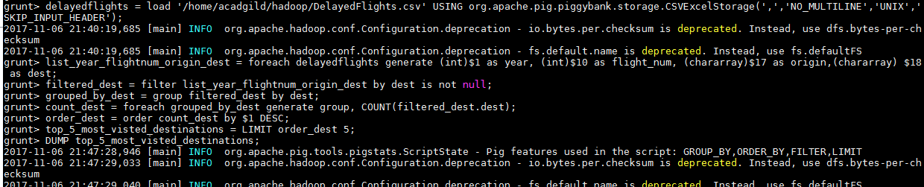
airports = load '/home/acadgild/hadoop/airports.csv' USING org.apache.pig.piggybank.storage.CSVExcelStorage(',','NO_MULTILINE','UNIX','SKIP_INPUT_HEADER');
airports_dest = foreach airports generate (chararray)$0 as dest, (chararray)$2 as city, (chararray)$4 as country;
joined_table = join top_5_most_visted_destinations by $0, airports_dest by dest;
DUMP joined_table;

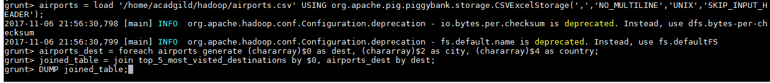

Problem Statement 2:-
Which month has seen the most number of cancellations due to bad weather
Solution:-
list_flights_cancel = foreach delayedflights generate (int)$2 as month,(int)$10 as flight_num,(int)$22 as cancelled,(chararray)$23 as cancel_code;
filtered_cancel = filter list_flights_cancel by cancelled == 1 AND cancel_code =='B';
order_month = group filtered_cancel by month;
cancel_count = foreach order_month generate group, COUNT(filtered_cancel.cancelled);
list_cancel= order cancel_count by $1 DESC;
cancellations_bad = limit list_cancel 1;
dump cancellations_bad;
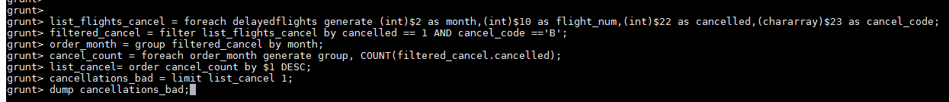

Problem Statement 3:-
Top ten origins with the highest AVG departure delay
Solution:-
list_dep_delay = foreach delayedflights generate (int)$16 as dep_delay, (chararray)$17 as origin;
filtered_dep_delay = filter list_dep_delay by (dep_delay is not null) AND (origin is not null);
group_by_origin = group filtered_dep_delay by origin;
average_dep_delay = foreach group_by_origin generate group, AVG(filtered_dep_delay.dep_delay);
origins_highest_avg_dep_delay = order average_dep_delay by $1 DESC;
Top_ten_origins = limit origins_highest_avg_dep_delay 10;
airports_origin = foreach airports generate (chararray)$0 as origin, (chararray)$2 as city, (chararray)$4 as country;
joined_top_10_origins = join airports_origin by origin, Top_ten_origins by $0;
final = foreach joined_top_10_origins generate $0,$1,$2,$4;
Top_10_origins_highest_AVG_departure_delay = ORDER final by $3 DESC;
dump Top_10_origins_highest_AVG_departure_delay;
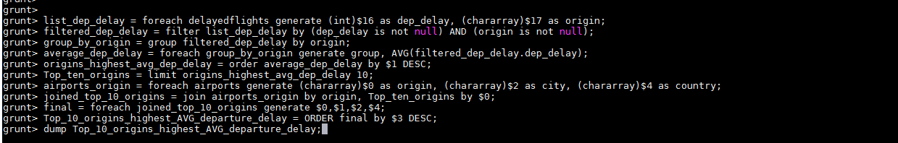
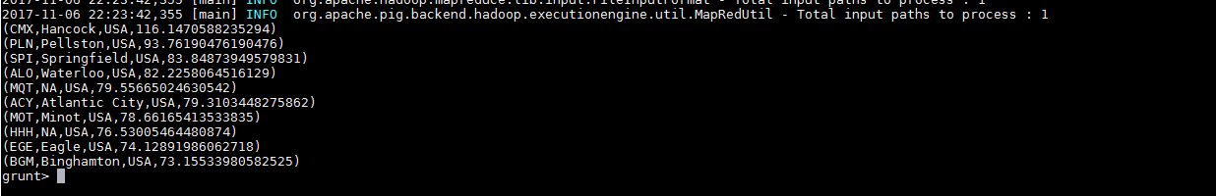

Problem Statement 4:-
Which route (origin & destination) has seen the maximum diversion
Solution:-
list_diversion = FOREACH delayedflights GENERATE (chararray)$17 as origin, (chararray)$18 as dest, (int)$24 as diversion;
filtered_diversion = FILTER list_diversion BY (origin is not null) AND (dest is not null) AND (diversion == 1);
group_origin = GROUP filtered_diversion by (origin,dest);
list_origin_diversion = FOREACH group_origin generate group, COUNT(filtered_diversion.diversion);
order_diversion = ORDER list_origin_diversion BY $1 DESC;
top_diversion = limit order_diversion 10;
dump top_diversion;

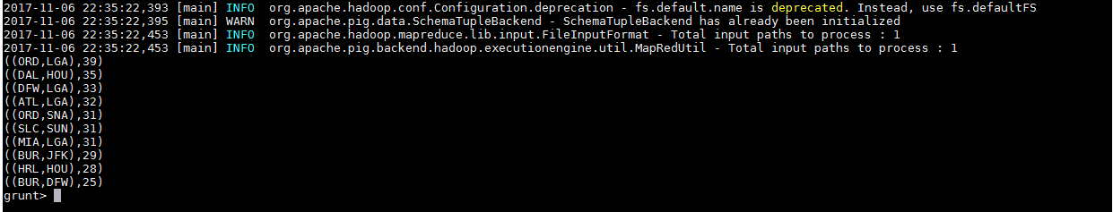

Submitted By:-
Hardik Kaushik

