Assignment 6.1
Problem Statement 1:-
Create a database named 'custom'.
Create a table named temperature_data inside custom having below fields:
1. date (mm-dd-yyyy) format
2. zip code
3. temperature
The table will be loaded from comma-delimited file.
Load the dataset.txt (which is ',' delimited) in the table.

Solution:-
CREATE DATABASE custom;
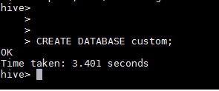
use custom;
CREATE TABLE temperature_table
(
full_date STRING,
zip INT,
temperature INT
)
ROW FORMAT DELIMITED
FIELDS TERMINATED BY ',';
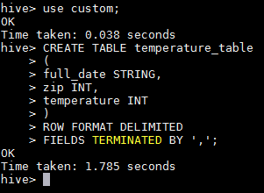
LOAD DATA LOCAL INPATH '/home/acadgild/hadoop/ dataset_Session_14.txt ' INTO TABLE custom.temperature_table;

Submitted by:-
Hardik Kaushik

