Assignment 6.2
Problem Statement 1:-
Fetch date and temperature from temperature_data where zip code is greater than 300000 and less than 399999.

Solution:-
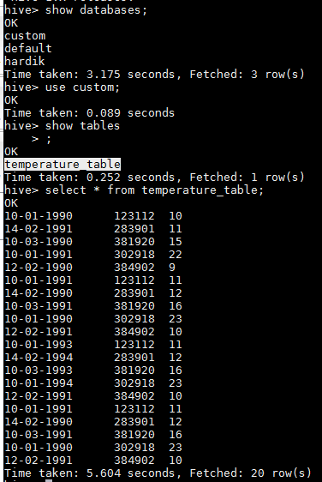

SELECT full_date, temperature FROM temperature_table WHERE zip>300000 AND zip<399999;
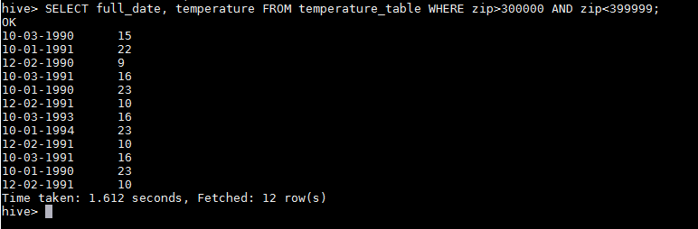

Problem Statement 2:-
Calculate maximum temperature corresponding to every year from temperature_data table.

Solution:-
SELECT SUBSTR(full_date, 7, 10), MAX(temperature) FROM temperature_table GROUP BY SUBSTR(full_date, 7, 10);
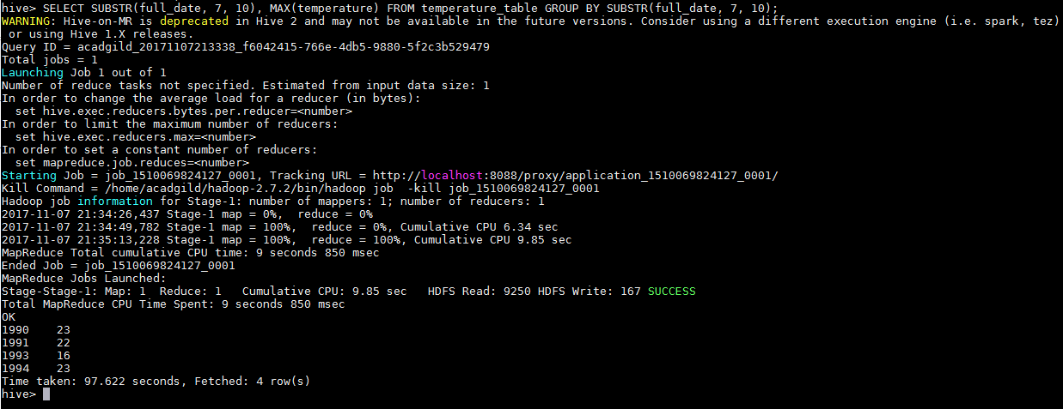
Problem Statement 3:-
Calculate maximum temperature from temperature_data table corresponding to those years which have at least 2 entries in the table.

Solution:-
SELECT SUBSTR(full_date, 7, 10), MAX(temperature) FROM temperature_table GROUP BY SUBSTR(full_date, 7, 10);

Problem Statement 4:-
Create a view on the top of last query, name it temperature_data_vw.

Solution:-
CREATE VIEW temperature_data_vw (YEAR,TEMPERATURE) AS SELECT SUBSTR(full_date, 7, 10), MAX(temperature) FROM temperature_table GROUP BY SUBSTR(full_date, 7, 10);
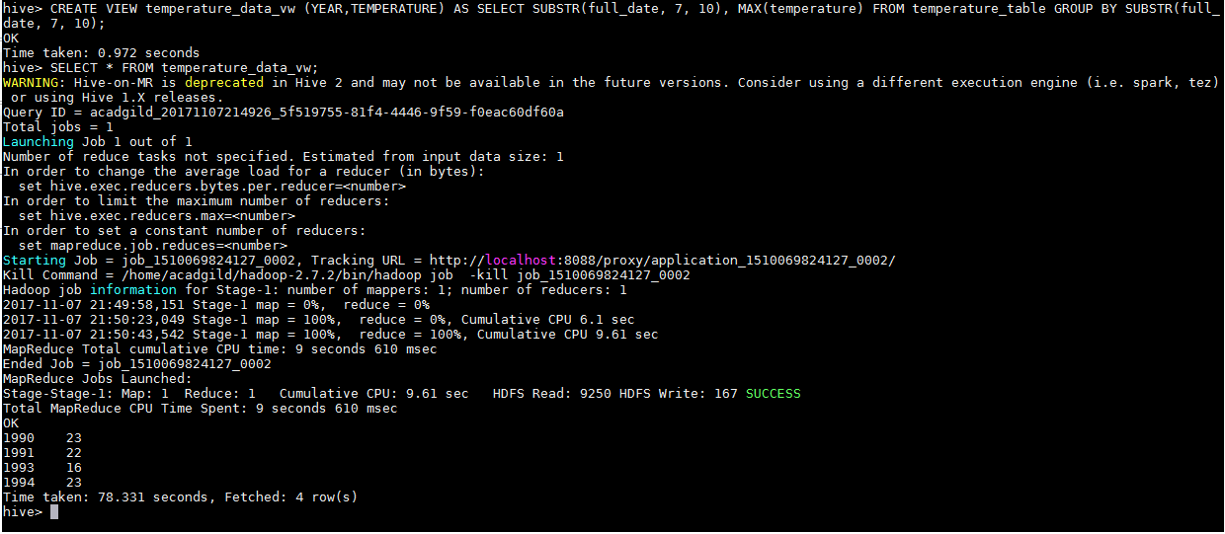

Problem Statement 5:-
Export contents from temperature_data_vw to a file in local file system, such that each file is '|' delimited.

Solution:-
INSERT OVERWRITE LOCAL DIRECTORY '/home/acadgild/hadoop/temperature_data_vw.txt' ROW FORMAT DELIMITED FIELDS TERMINATED BY '|' SELECT * FROM temperature_data_vw;
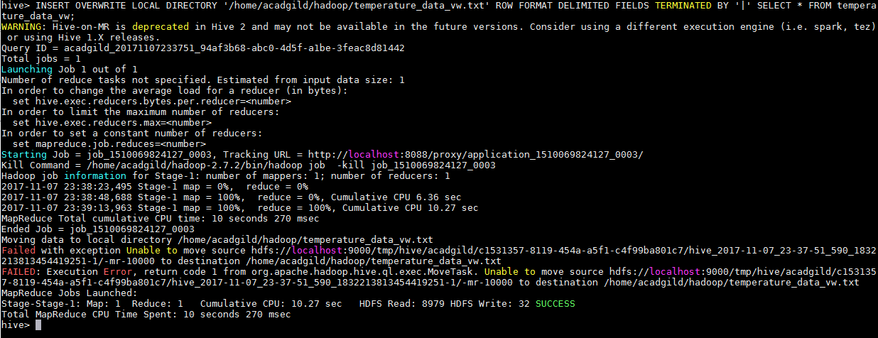

Submitted By
Hardik Kaushik

