Assignment 7.1
Problem Statement :-
Calculate the number of employees corresponding to each skill from the table 'employee' which is loaded in the Demo.

Solution:-
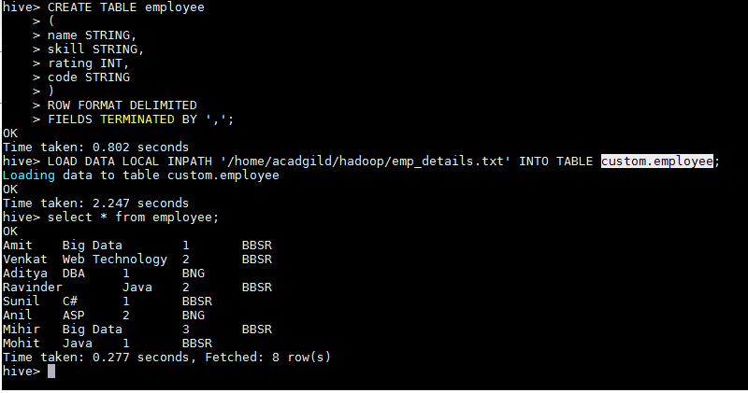
SELECT skill,count(*) FROM employee GROUP BY skill;
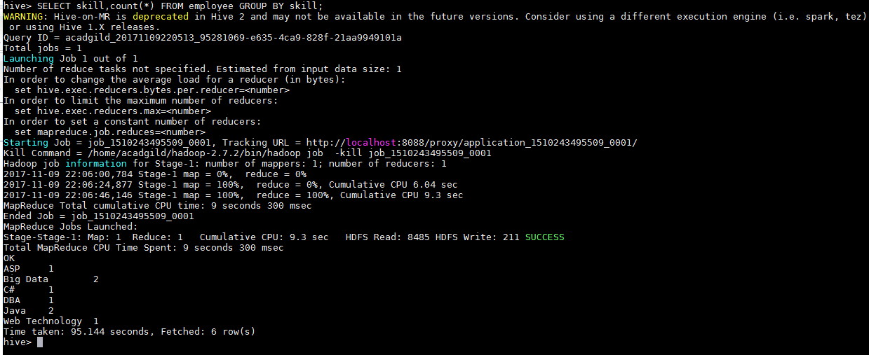
Submitted By:-
Hardik Kaushik

