Assignment 7.2
Problem Statement 1 :-
Write a Hive program to find the number of medals won by each country in swimming.

Solution:-
use custom;
CREATE TABLE olympix_data
(
Aname STRING,
Age INT,
Country STRING,
Year INT,
Closing_Datre STRING,
Sport STRING,
Gold INT,
Silver INT,
Bronze INT,
Total_medals INT
)
ROW FORMAT DELIMITED
FIELDS TERMINATED BY '\t';

LOAD DATA LOCAL INPATH '/home/acadgild/hadoop/olympix_data.csv' INTO TABLE custom.olympix_data;
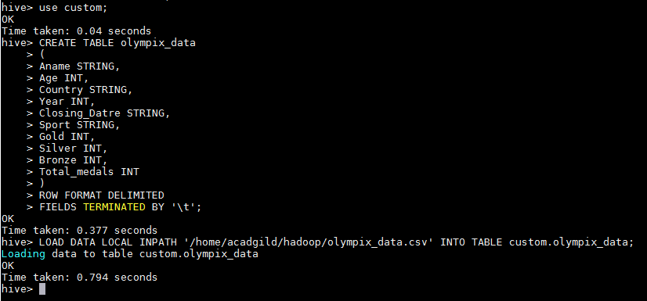
SELECT Country,COUNT(Total_medals) FROM olympix_data WHERE Sport = "Swimming" GROUP BY Country;
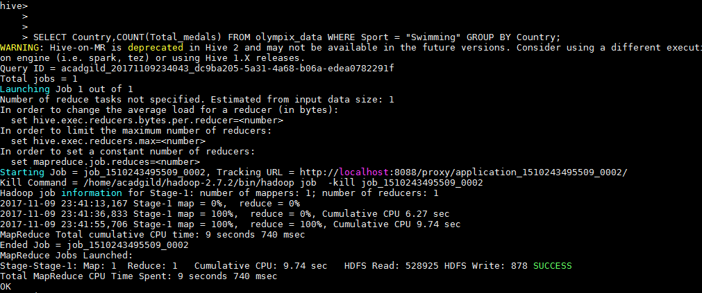
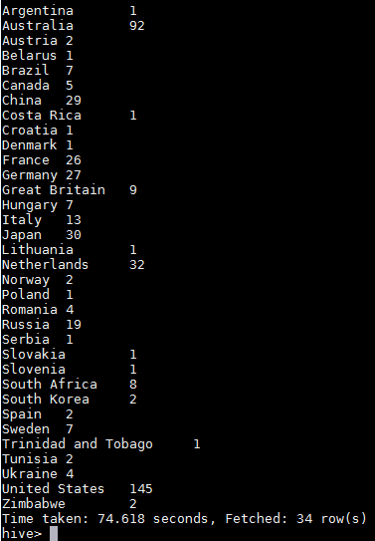

Problem Statement 2 :-
Write a Hive program to find the number of medals that India won year wise.

Solution:-
SELECT Year,COUNT(Total_medals) FROM olympix_data WHERE Country="India" GROUP BY Year;
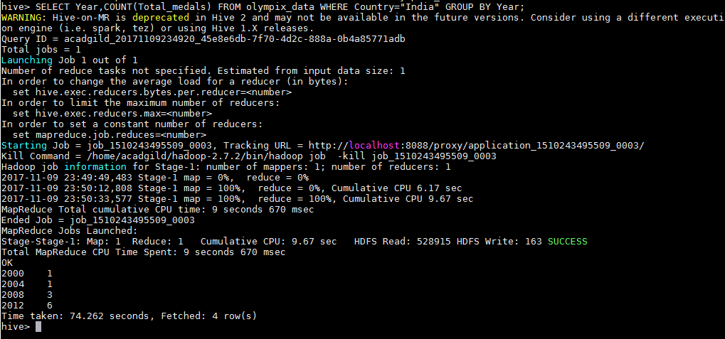

Problem Statement 3 :-
Write a Hive Program to find the total number of medals each country won.

Solution:-
SELECT Country,COUNT(Total_medals) FROM olympix_data GROUP BY Country;
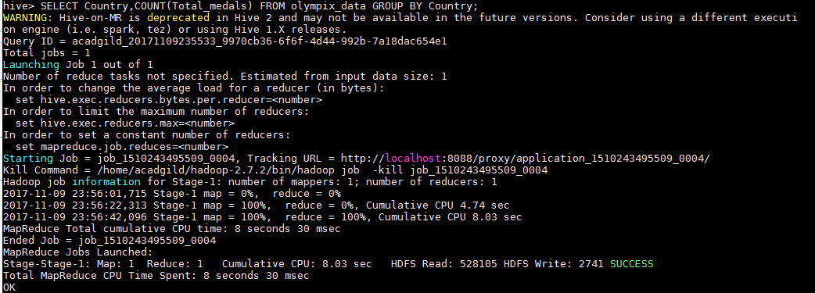
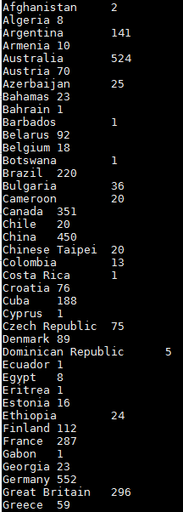
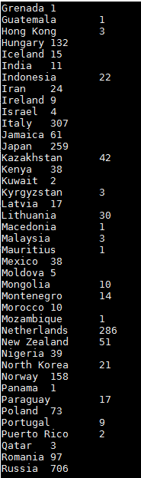
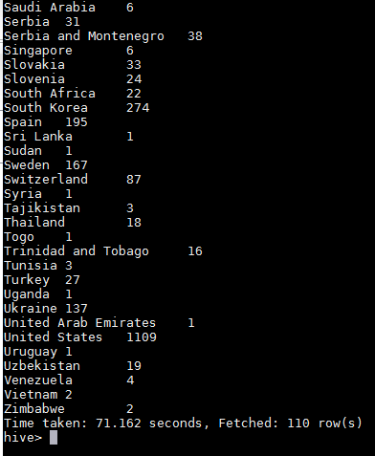

Problem Statement 4 :-
Write a Hive program to find the number of gold medals each country won.

Solution:-
SELECT Country,COUNT(Gold) FROM olympix_data GROUP BY Country;
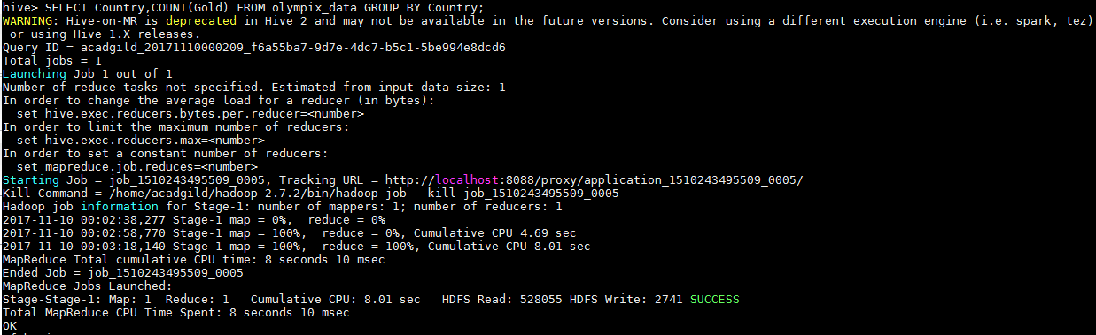
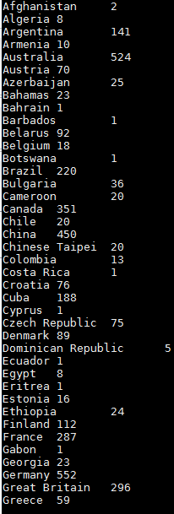
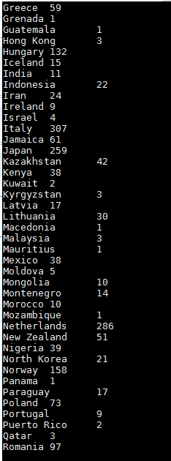
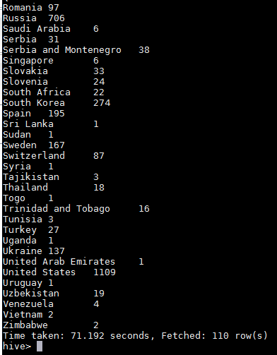

Submitted By:-
Hardik Kaushik

