Assignment 8.1
Problem Statement 1 :-
Get a list of employees who receive a salary less than 100, compared to their immediate employee with higher salary in the same unit

Solution:-
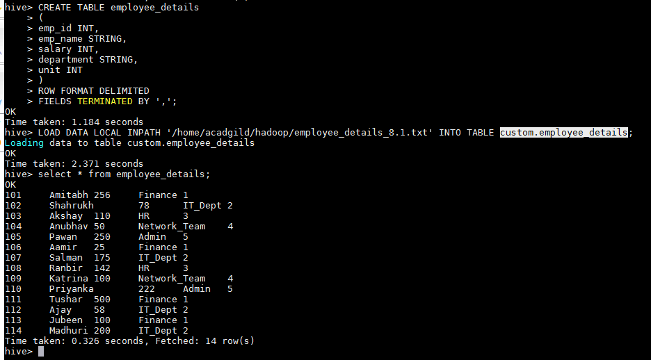
SELECT emp_name,department,salary FROM employee_details where salary < 100 GROUP BY emp_name,department,salary;
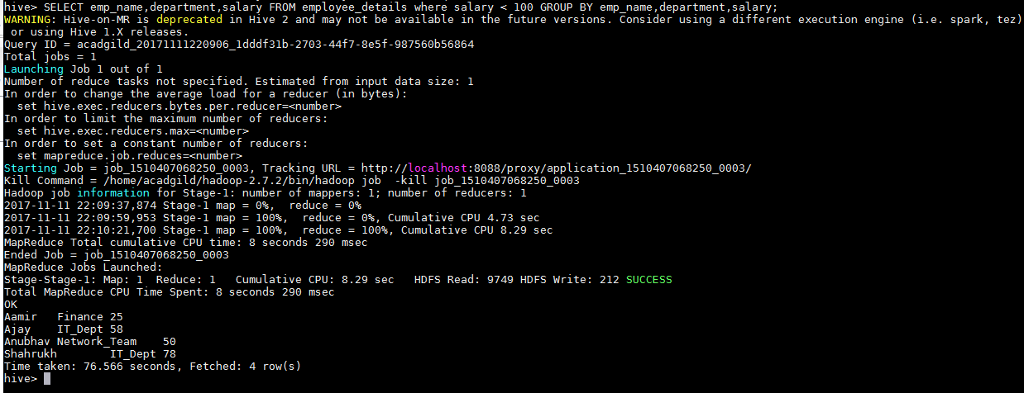
Problem Statement 2 :-
List of all employees who draw higher salary than the average salary of that department

Solution:-
Suppose we want list of all employees who draw higher salary than average salary of Finance department than we ran below command :-
select avg(salary) from employee_details where department = 'Finance';
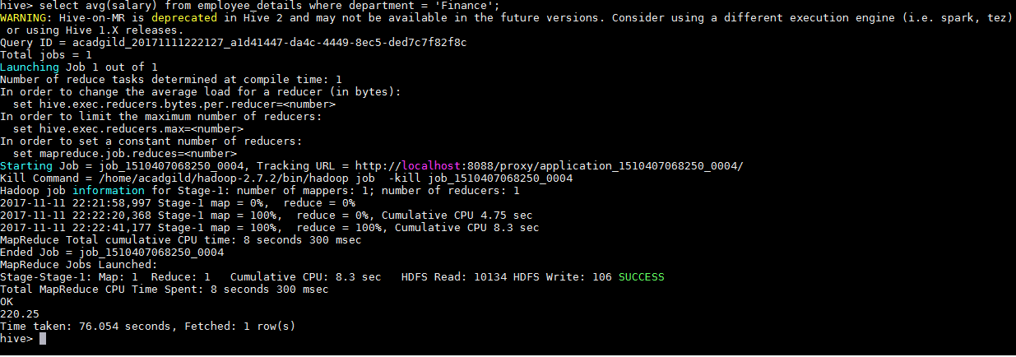
select * from employee_details where department = 'Finance' AND salary > 220.25;
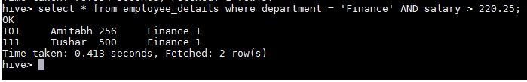
Submitted By:-
Hardik Kaushik

