Assignment 8.3
Problem Statement :-
Link: https://acadgild.com/blog/transactions-in-hive/
Refer the above given link for transactions in Hive and implement the operations given in the blog using your own sample data set and send us the screenshot.

Solution:-
Transactions in Hive:-
Transactions are provided at the row-level in Hive 0.14. The different row-level transactions available in Hive 0.14 are as follows:
- Insert
- Delete
- Update
There are numerous limitations with the present transactions available in Hive 0.14. ORC is the file format supported by Hive transaction. It is now essential to have ORC file format for performing transactions in Hive. The table needs to be bucketed in order to support transactions.
Row-level Transactions:-
The below properties needs to be set appropriately in hive shell , order-wise to work with transactions in Hive:-
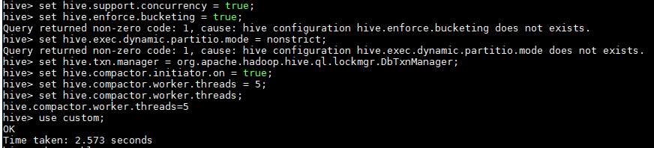
Creating a Table That Supports Hive Transactions:-
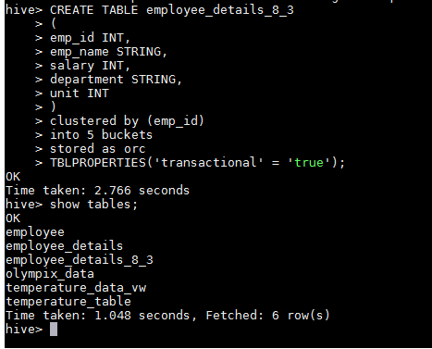
Inserting Data into a Hive Table
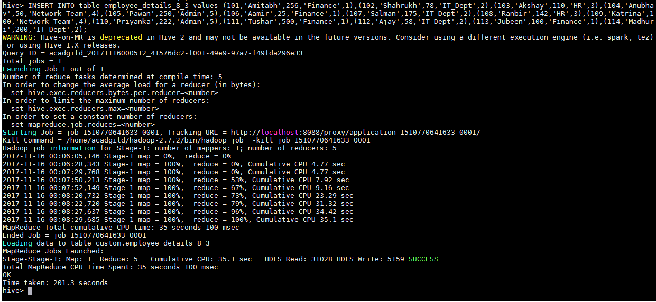
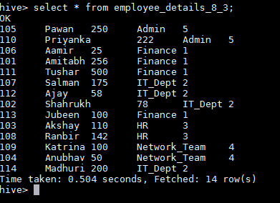
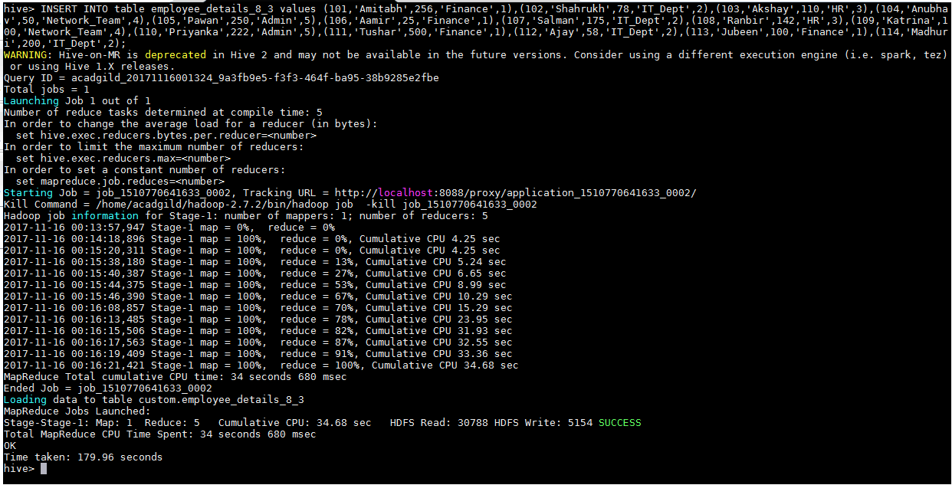
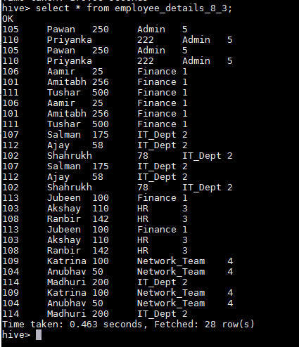
Updating the Data in Hive Table
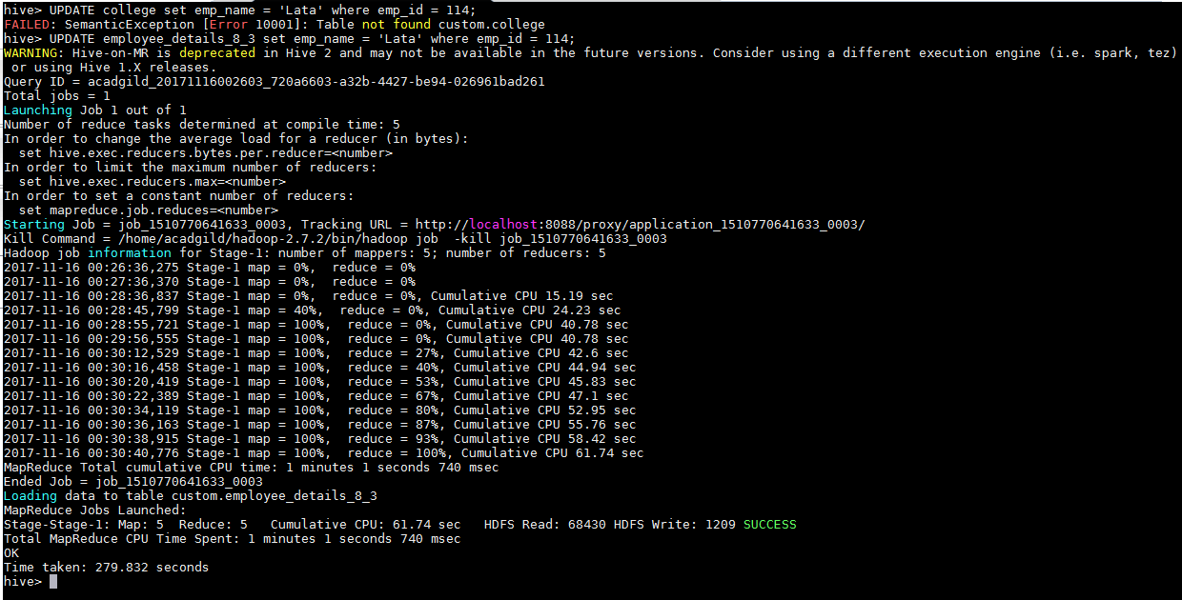
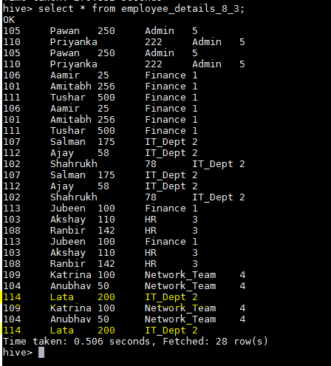
Deleting a Row from Hive Table
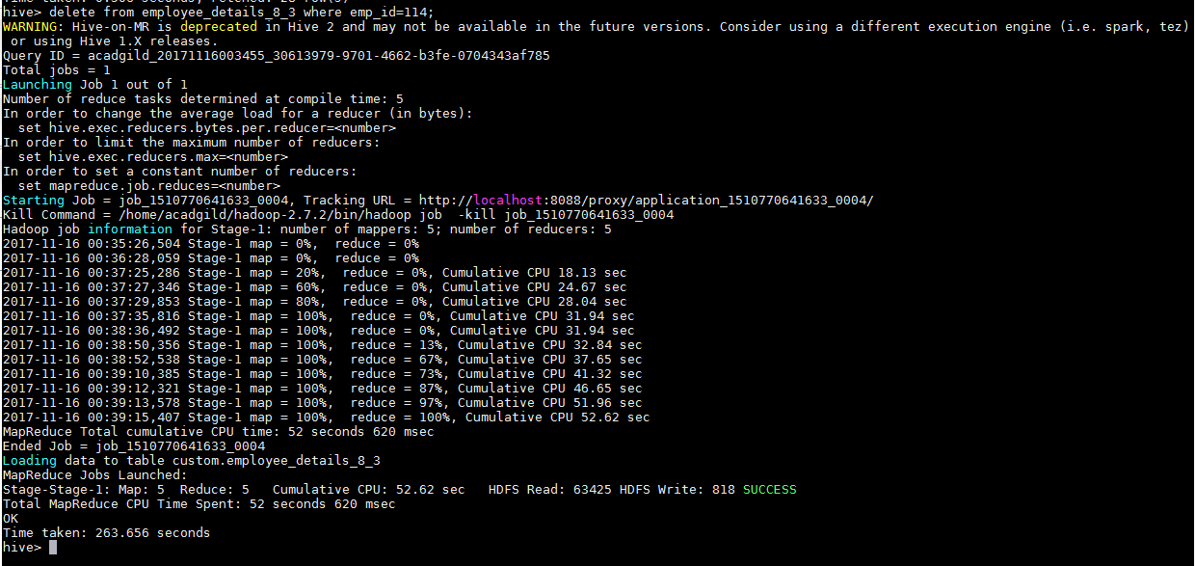
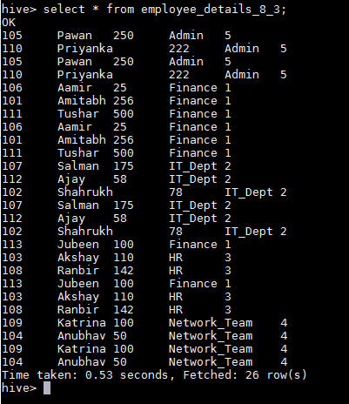
As we see that records related to emp_id=114 is deleted from the table.

This is how the transactions or row-wise operations are performed in Hive.

Submitted By:-
Hardik Kaushik

