Assignment 9.2
Problem Statement 1 :-
Create an HBase table named 'clicks' with a column family 'hits' such that it should be able to store last 5 values of qualifiers inside 'hits' column family

Solution:-
create 'clicks', {NAME=>'hits', VERSIONS=>5}
put 'clicks','10.249.176.78','hits:user1','1st'
put 'clicks','10.249.176.78','hits:user1','2nd'
put 'clicks','10.249.176.78','hits:user1','3rd'
put 'clicks','10.249.176.78','hits:user1','4th'
put 'clicks','10.249.176.78','hits:user1','5th'
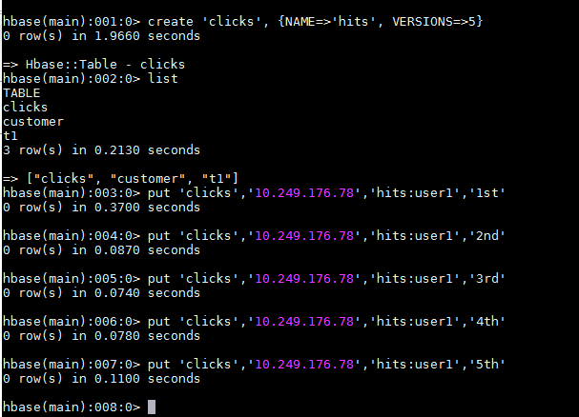
scan 'clicks',{COLUMN=>'hits:user1',VERSIONS=>5}
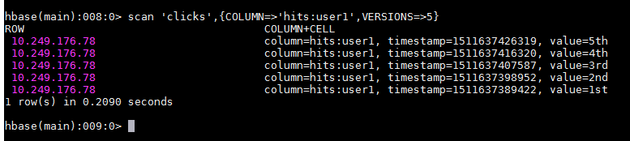

Problem Statement 2 :-
Add few records in the table and update some of them. Use IP Address as row-key. Scan the table to view if all the previous versions are getting displayed.

Solution:-
alter 'clicks', {NAME=>'hits', VERSIONS=>10}
put 'clicks','10.249.176.78','hits:user2','1st'
put 'clicks','10.249.176.78','hits:user2','2nd'
put 'clicks','10.249.176.78','hits:user2','3rd'
put 'clicks','10.249.176.78','hits:user3','4th'
put 'clicks','10.249.176.78','hits:user4','5th'
put 'clicks','10.249.176.78','hits:user1','6th'
put 'clicks','10.249.176.78','hits:user1','7th'
put 'clicks','10.249.176.78','hits:user1','8th'
put 'clicks','10.249.176.78','hits:user1','9th'
put 'clicks','10.249.176.78','hits:user1','10th'
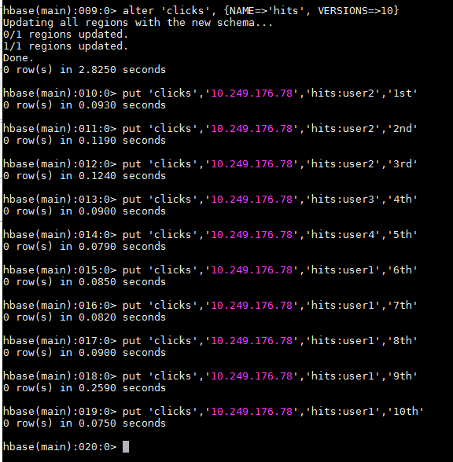

scan 'clicks',VERSIONS=>10
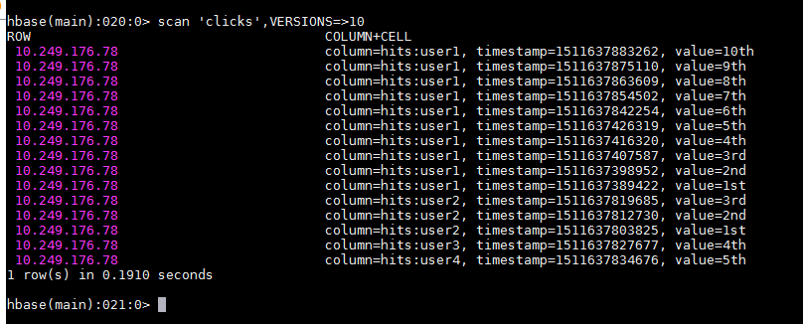

Submitted By:-
Hardik Kaushik

