A REPORT

Submitted by

Hinal Upadhyay (21619SBECE30238)
Hardik Panchal (1519BECE30030)

In fulfillment for the award of the degree
of
BACHELOR OF ENGINEERING
in
Computer Engineering



LDRP Institute of Technology and Research, Gandhinagar
Kadi Sarva Vishwavidyalaya
September, 2017

LDRP Institute of Technology and Research
Gandhinagar

CE Department


CERTIFICATE
This is to certify that the website entitled “Confesstico” has been prepared by Hardik Panchal (#1519BECE30030) and Hinal Upadhyay (#21619SBECE30238) as a part of term work for the subject Web Technology (CE-506) in fulfilment of the degree of Bachelor of Engineering in Computer Engineering Department of LDRP – Institute of Technology and Research, Kadi Sarva Vishwavidyalaya during the academic year 2017-18.

Prof. Vishal Barot
Lecturer
LDRP ITR
Introduction
Confesstico is an online social website that lets you to anonymously post a status in a group. The post within a group can be viewed only by its group members. The groups are subjected to be publicly open or completely private or in a restricted protected mode.
Users are allowed to create groups, add contacts in a group and post a confession within selected set of groups by attaching various tags with it.

- Confesstico lets you post your confessions anonymously.
- We will let you form and join groups, confess anything and nobody will be able to track you.
- Here you can post what you wish to deliver to the people anonymously.

Features
- Features of Website
The website opens with a Header and Footer and in between a little description of what confesstico is on the left side and a Log In and Sign Up utilities on a right hand side.
New users must create an account by Signing Up and the data is stored in backend supported with php and mysql. Already Signed Up users may simply login where there entered values are compared to be valid by backend.
On the bottom left corner, there is a link for Admin Panel that allows administrators of the website to access the backend of the website.
After having a valid Sign Up or Log In, user is directed to website’s social interface.
In this interface user may access various facilities provided by confesstico which are modularly described in the next topic.
The main motto of our website is to be anonymous so that the social profile of the users is never fetched by any other user. However, accessibility of confessions is restricted by implementation of various modes at the time of creating a group.
The project is still in its beta phase and some modules require higher implementations to be fully functional. However, we have a complete prototype and explanation. The project has a wide scope to be further extended by addition of various other advanced features.

- Comparison
The idea of project was not at all taken from any existing website but still it can be loosely compared with some of the existing ones which share some sort of similar functionality.
Whisper
It is a is a form of anonymous social media, allowing users to post and share photo and video messages anonymously, although this claim has been challenged with privacy concerns over Whisper's handling of user data. The postings, called "whispers", consist of text superimposed over an image, and the background imagery is either automatically retrieved from Whisper's own search engine or uploaded by the user.
Sarahah
Sarahah is a social networking service for providing anonymous feedback. In Arabic sarahah means "frankness" or "honesty". It was created by Zain al-Abidin Tawfiq in the end of 2016 and reached a sudden worldwide success by mid–2017. This growth is considered to be deeply related with the release of a Snapchat update that allowed people to share URLs on their snaps.

The idea of our website is not at all related to above projects, infact the Sarahah came to our notice much after we started the development of our project.

Modules
1.Welcome Page.
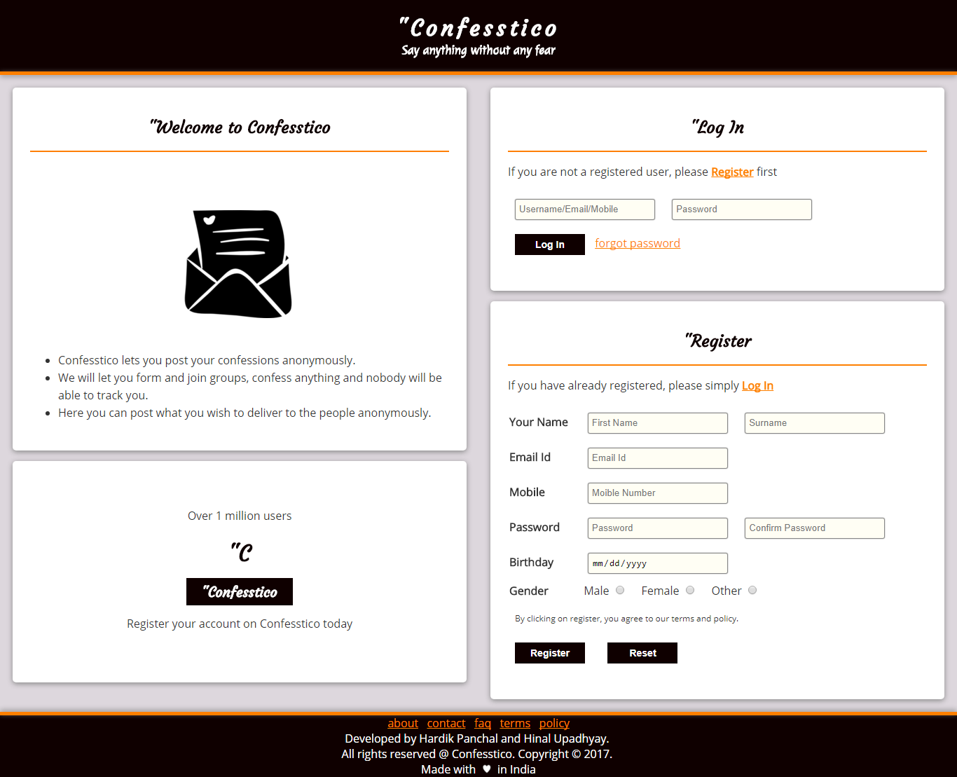

When a user loads website, this is the first page that gets loaded. This Page allows user to Login to his/her confesstico account if already registered. If a user has not already registered then user may create a new account and register on confesstico.
2.Timeline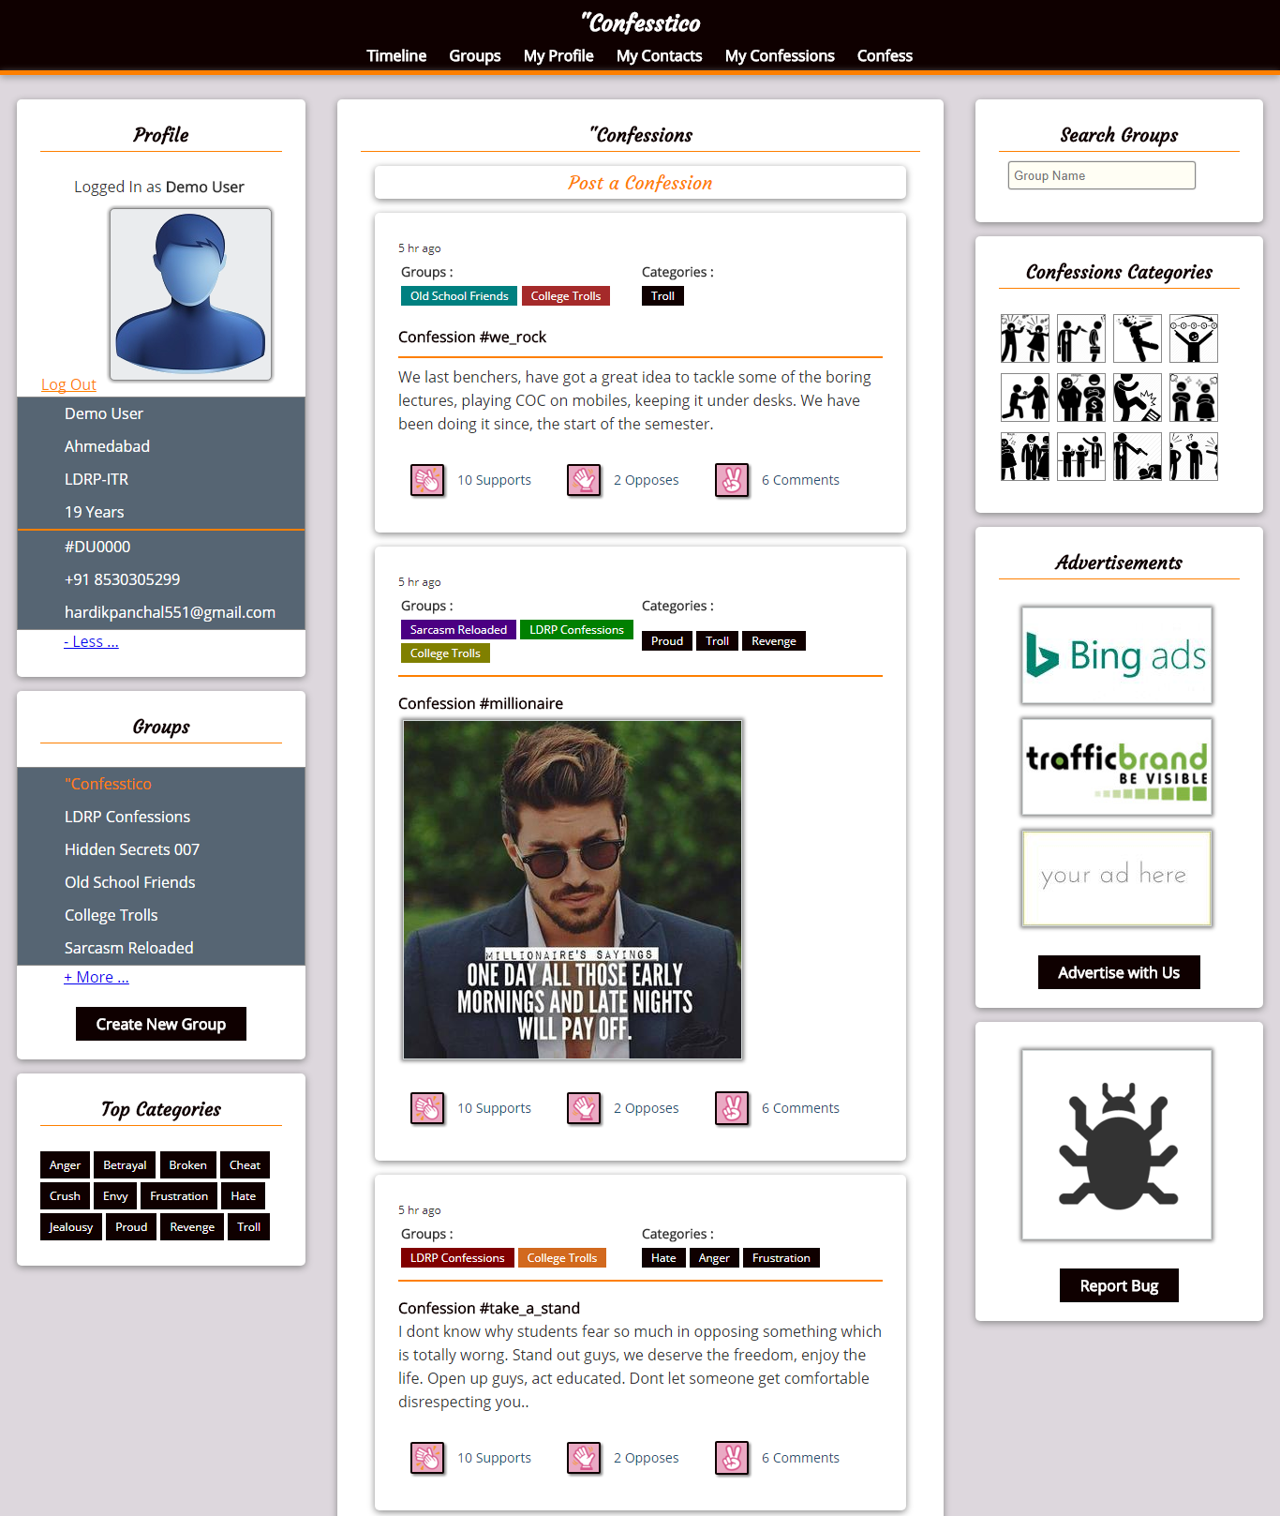

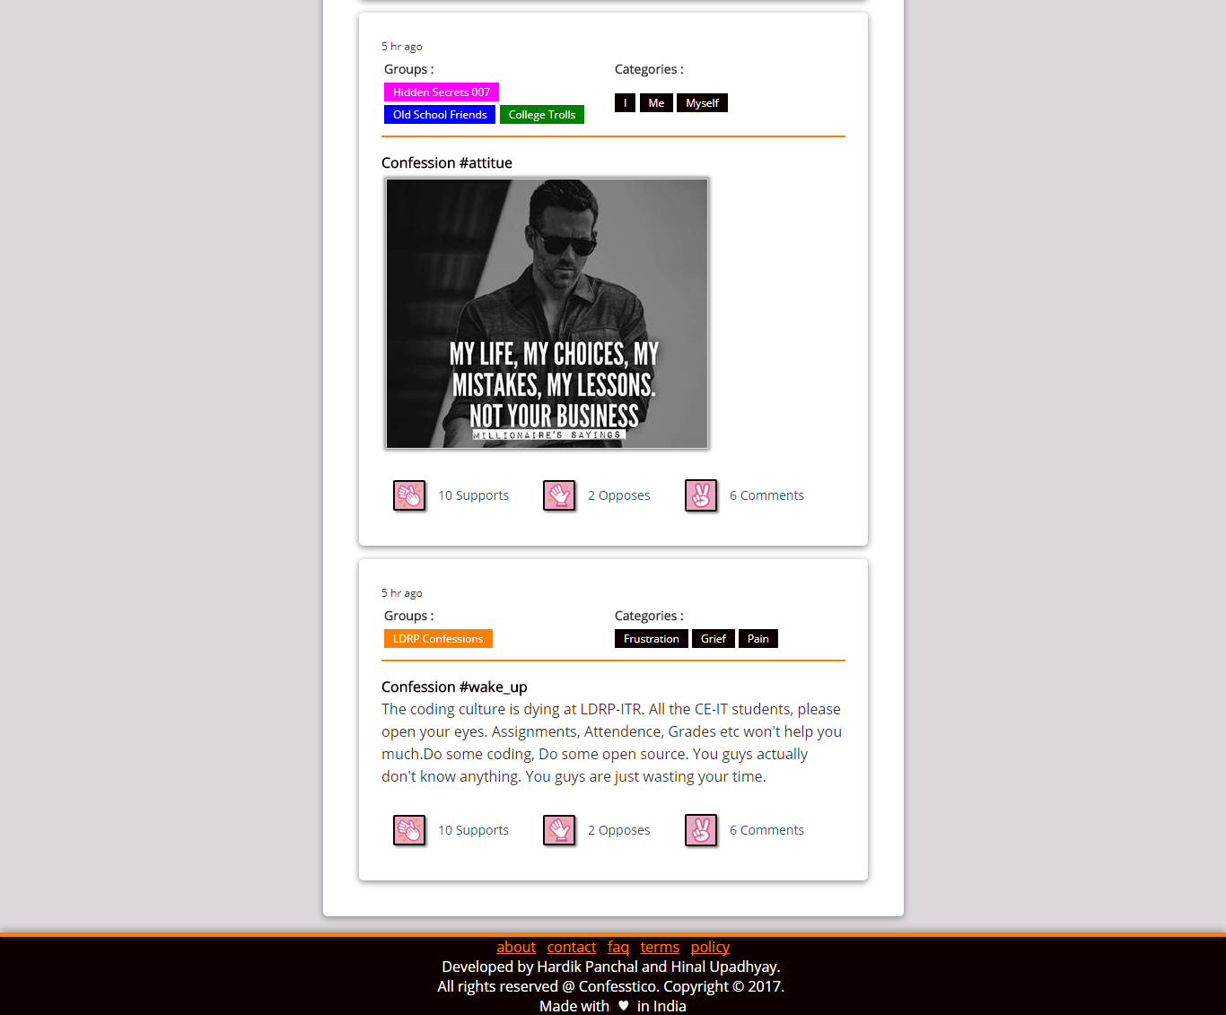

A user is able to view confesstico timeline on this page. Here confessions posts from various groups that the user is a part of are displayed. User can support, oppose or comment on the posts.

3. Group
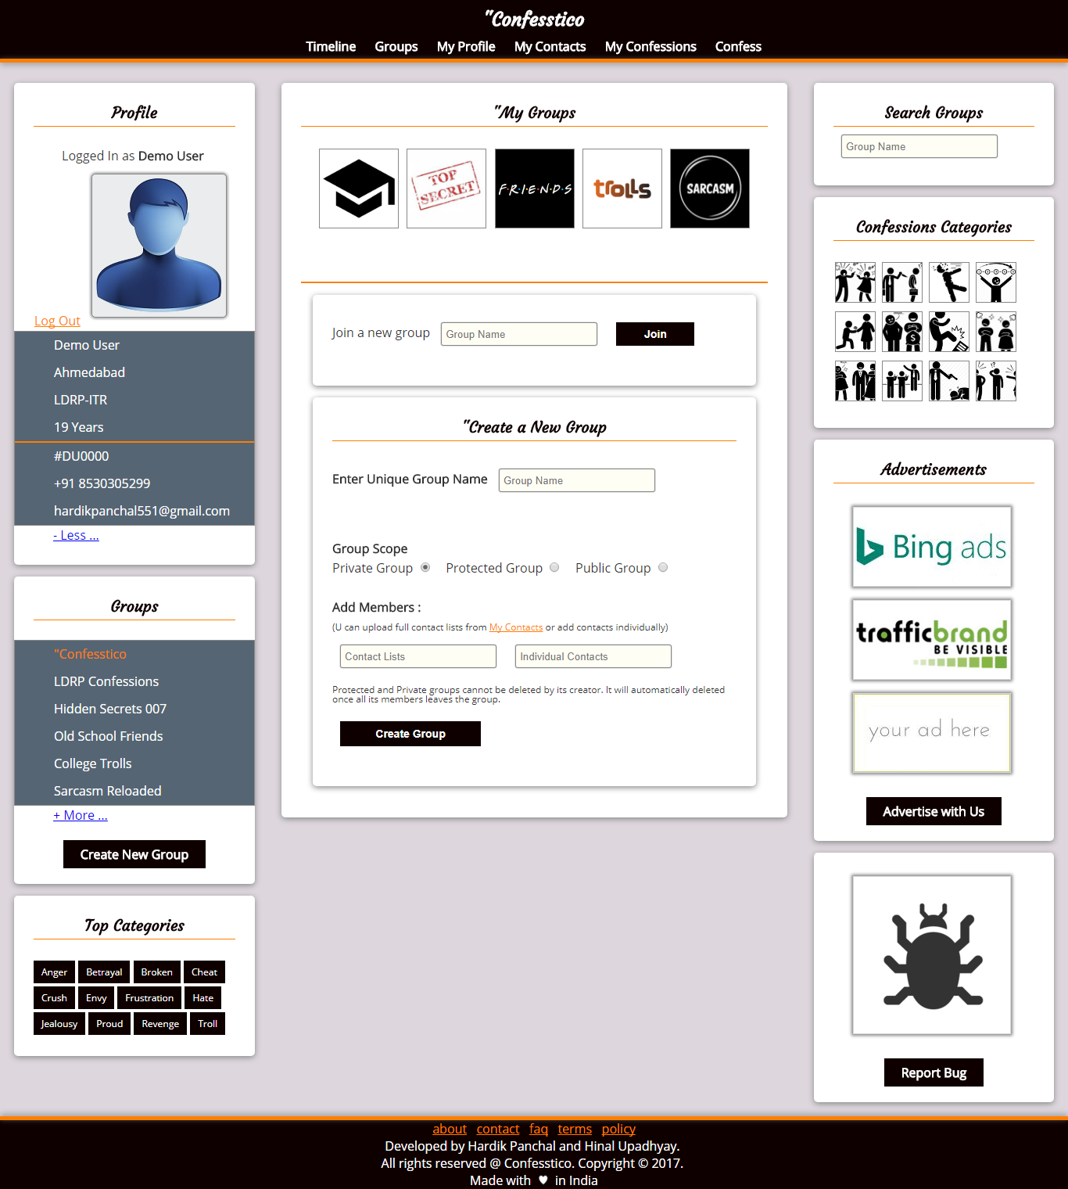
This module let user to create a new group and add a predefined contact lists or contacts individually. All the users mentioned in contacts becomes part of this group. The group can be of public, private or protected mode.
4. Profile
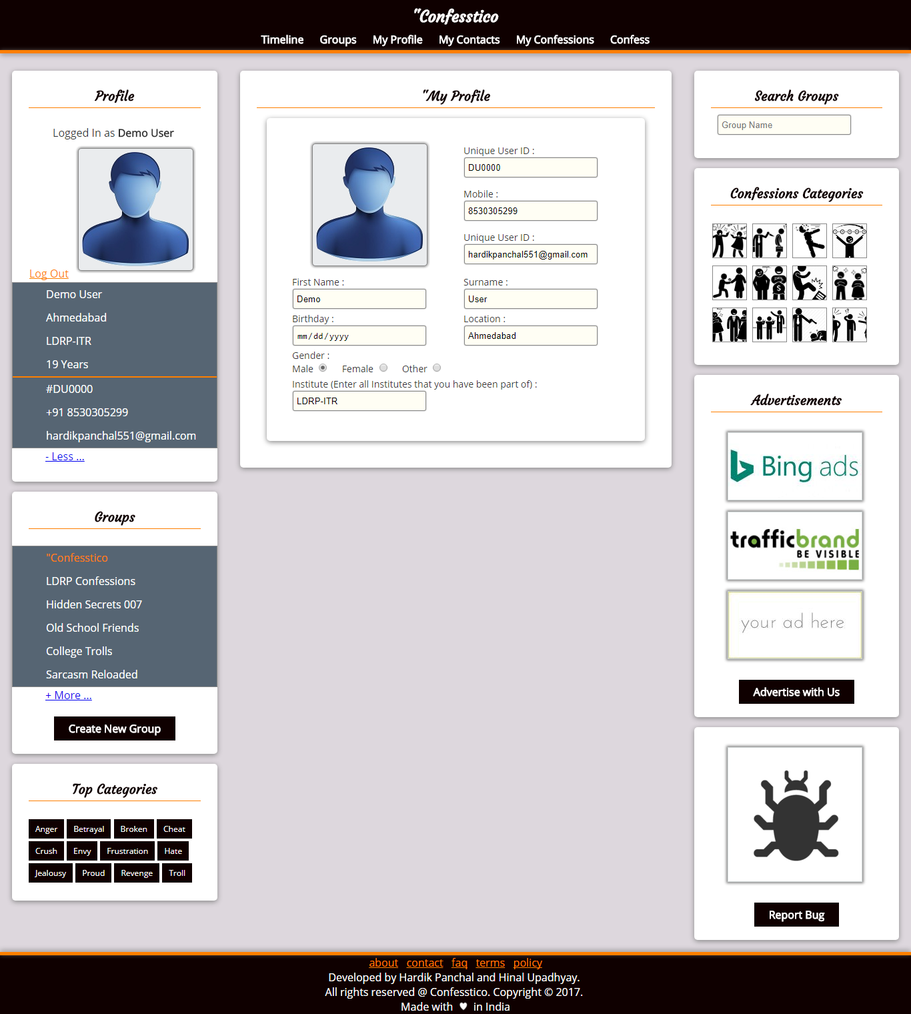
This module allows user to view his/her profile. User may also edit profile from this page.
5. My Contacts
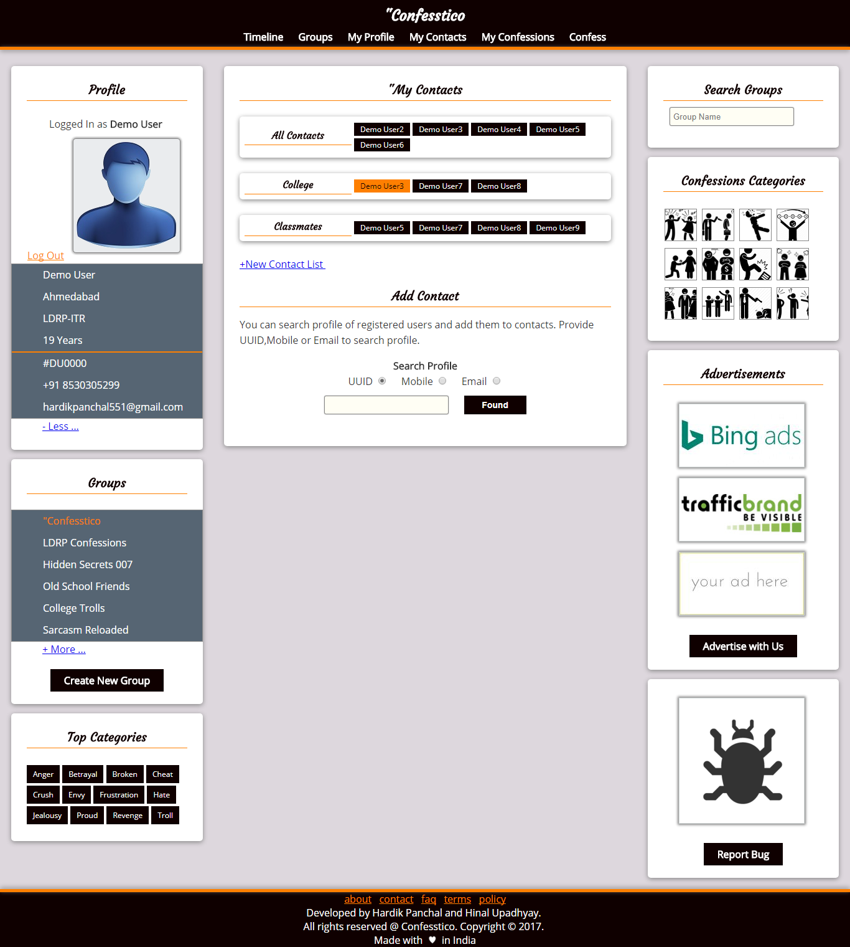
In this module a user can find other registered users on confesstico and add them to his/her contact list. User may also create new contact lists or add contacts to the existing ones.
6. My Confessions
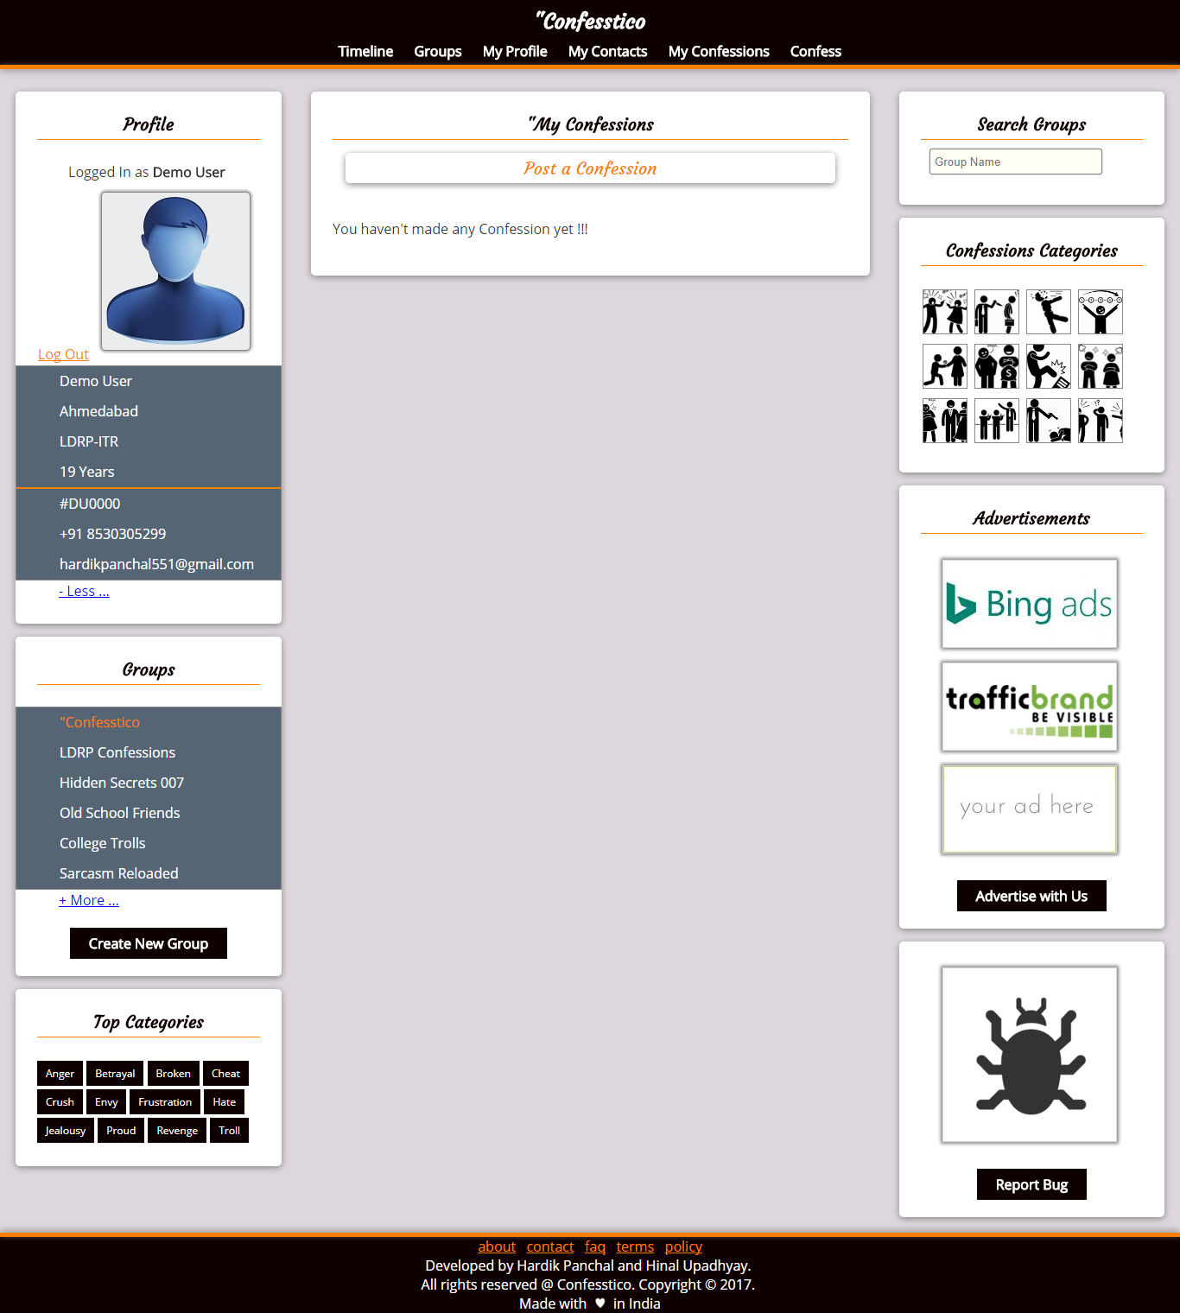
This module shows all the confessions posted by the user. User may edit or delete the confessions.
7. Confess
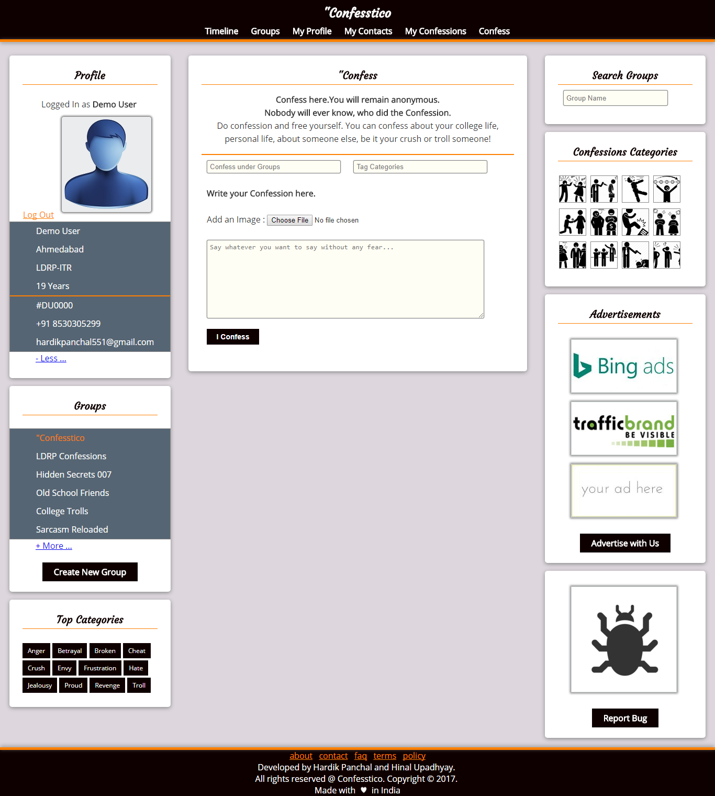
This module allows users to post a new confession, by specifying target groups of which user is a part of and tag various categories to the confession. The confession is restricted by mode of the specified group.

