

Name :- Hardik Parmar & Ashutosh kaul
Roll no. :- 24BCE198 &24BCE207
Div. :- C
Subject code & name :- 3CS524CC26 & Full Stack Development
Academic Year:- 2026–27
PROJECT NAME:-
REAL-TIME NETWORK TRAFFIC ANALYSIS AND ANOMALY DETECTION SYSTEM

1. INTRODUCTION
1.1 Background
Modern computer networks continuously generate network traffic. Monitoring this traffic is important for understanding network behavior and identifying unusual patterns.
Manual monitoring of a large amount of traffic can be difficult because network data is continuously generated and can contain many records. Machine learning can help automate the identification of traffic patterns that differ from expected behavior.
This project combines machine learning with full-stack web development to create a simple web-based network traffic monitoring system.
The application receives simulated network traffic, processes the traffic through a machine learning model, and displays the results through an interactive dashboard.

1.2 Problem Statement
Network traffic contains multiple parameters that can change depending on the type and behavior of communication. Identifying abnormal traffic manually from a large number of records can be difficult.
Therefore, there is a need for a simple system that can:
- Process network traffic data.
- Classify traffic as normal or anomalous.
- Display traffic information in an easy-to-understand dashboard.
- Provide basic information about detected anomalies.
- Display traffic continuously using real-time communication.
The proposed system addresses these requirements through a full-stack web application integrated with a machine learning model.

2. OBJECTIVES
The main objectives of the project are:
- To develop a web-based network traffic monitoring dashboard.
- To integrate machine learning with a full-stack web application.
- To classify network traffic into normal and anomalous categories.
- To display traffic statistics in a visual and understandable format.
- To provide real-time traffic updates using WebSocket communication.
- To display protocol distribution of the observed traffic.
- To provide basic anomaly reason and severity information.
- To provide Start and Pause controls for the traffic stream.
- To develop a responsive dashboard that can be viewed on different screen sizes.

3. SCOPE OF THE PROJECT
The scope of this project is limited to a simulated network traffic environment.
The system focuses on:
- Network traffic data processing.
- Machine learning-based classification.
- Real-time visualization.
- Basic anomaly analysis.
- Full-stack integration.
The project does not perform actual packet capture from a physical network. Instead, traffic records are simulated using CSV data.
The system is intended as an academic demonstration of how machine learning and full-stack technologies can be combined for network traffic analysis.

4. TECHNOLOGIES USED
Technology | Purpose
Python | Backend and machine learning
FastAPI | Backend API development
React.js | Frontend development
Vite | Frontend development environment
JavaScript | Frontend logic
HTML | Web page structure
CSS | Styling and responsive design
Scikit-learn | Machine learning
Random Forest | Traffic classification
Pandas | Data processing
Joblib | Saving and loading the trained model
WebSocket | Real-time traffic communication
CSV | Traffic dataset storage
The project uses React for component-based frontend development. React is suitable for creating reusable UI components and dynamic interfaces. UNIT-2 Frontend Frameworks

5. SYSTEM ARCHITECTURE
The overall system follows the following flow:
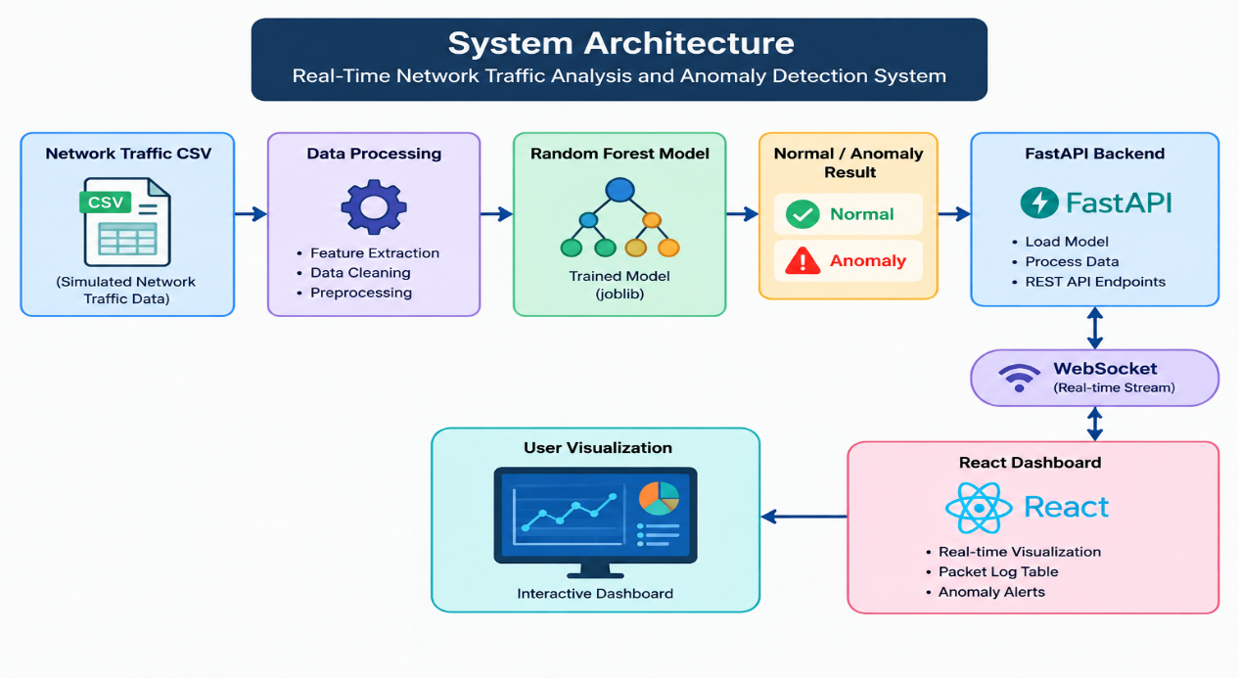
The frontend and backend are maintained separately. The backend handles application logic and machine learning processing, while the frontend is responsible for presenting the results to the user.
This separation follows the basic full-stack principle of separating presentation and backend responsibilities. The course material describes full-stack development as involving both frontend and backend workflows.

6. DATASET AND FEATURES
The project uses simulated network traffic records stored in CSV format.
The traffic data contains the following important features:
Feature | Description
Stl | Source-to-destination TTL-related traffic feature
Proto | Network protocol value
Sload | Source-side load
Dload | Destination-side load
Spkts | Number of source packets
Dpkts | Number of destination packets
The project generates 1000 synthetic traffic records for model training and evaluation.
A separate set of traffic records is used for simulating continuous network traffic on the dashboard.

7. ANOMALY DETECTION METHOD
7.1 Random Forest Classifier
The project uses a Random Forest Classifier for anomaly detection.
Random Forest is a supervised machine learning algorithm that combines multiple decision trees to make a classification decision.
In this project, the model classifies traffic into two categories:
- 0 – Normal Traffic
- 1 – Anomalous Traffic
The model is trained using the selected network traffic features.
The project uses:
- Number of estimators: 100
- Random state: 42
- Training/testing split: 80/20

7.2 Traffic Labelling
For the synthetic dataset, traffic is labelled as anomalous when any of the selected conditions is satisfied:
Sload > 80000
OR
Sttl > 240
OR
Proto == 1
Otherwise, the traffic is labelled as normal.
This approach provides a simple and understandable way to generate labelled data for the academic project.

8. MACHINE LEARNING WORKFLOW
The machine learning workflow consists of the following steps:
Step 1: Data Generation
Synthetic network traffic records are generated.
Step 2: Feature Selection
The selected features are: Sttl , Proto , Sload , Dload , Spkts , Dpkts
Step 3: Data Labelling
The traffic records are classified into normal and anomalous categories using the defined conditions.
Step 4: Train-Test Split
The dataset is divided into:
- 80% training data
- 20% testing data
Step 5: Model Training
A Random Forest Classifier containing 100 estimators is trained.
Step 6: Model Evaluation
The trained model is evaluated using classification metrics.
Step 7: Model Saving
The trained model is stored using Joblib so that it can be loaded by the backend application.

9. BACKEND DEVELOPMENT
The backend of the system is developed using Python and FastAPI.
FastAPI is responsible for:
- Loading the trained machine learning model.
- Processing traffic data.
- Generating predictions.
- Providing API endpoints.
- Sending traffic information through WebSocket communication.
The backend exposes a metrics endpoint: /api/metrics
This endpoint provides information such as:
- Accuracy
- Precision
- Recall
- F1-score
- Model type
The backend also provides a WebSocket endpoint: /ws/traffic
which is used to send traffic records continuously to the frontend.

10. FRONTEND DEVELOPMENT
The frontend is developed using React.js and Vite.
React allows the dashboard to be divided into reusable UI components. React is a component-based frontend library intended for building user interfaces.
The dashboard provides the following sections:
- System header
- Traffic statistics
- Normal traffic count
- Threat rate
- Protocol distribution
- Traffic visualization
- Recent traffic records
- Anomaly reason
- Severity indicator
- Start/Pause controls
The frontend receives traffic information from the backend and updates the dashboard dynamically.
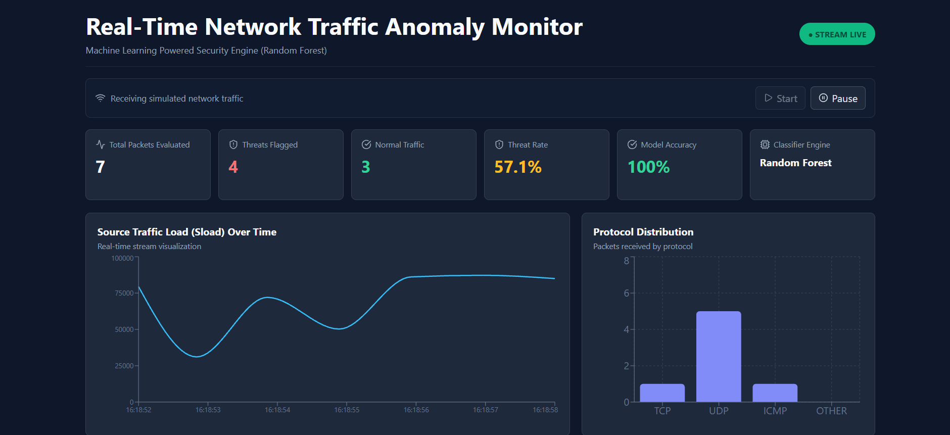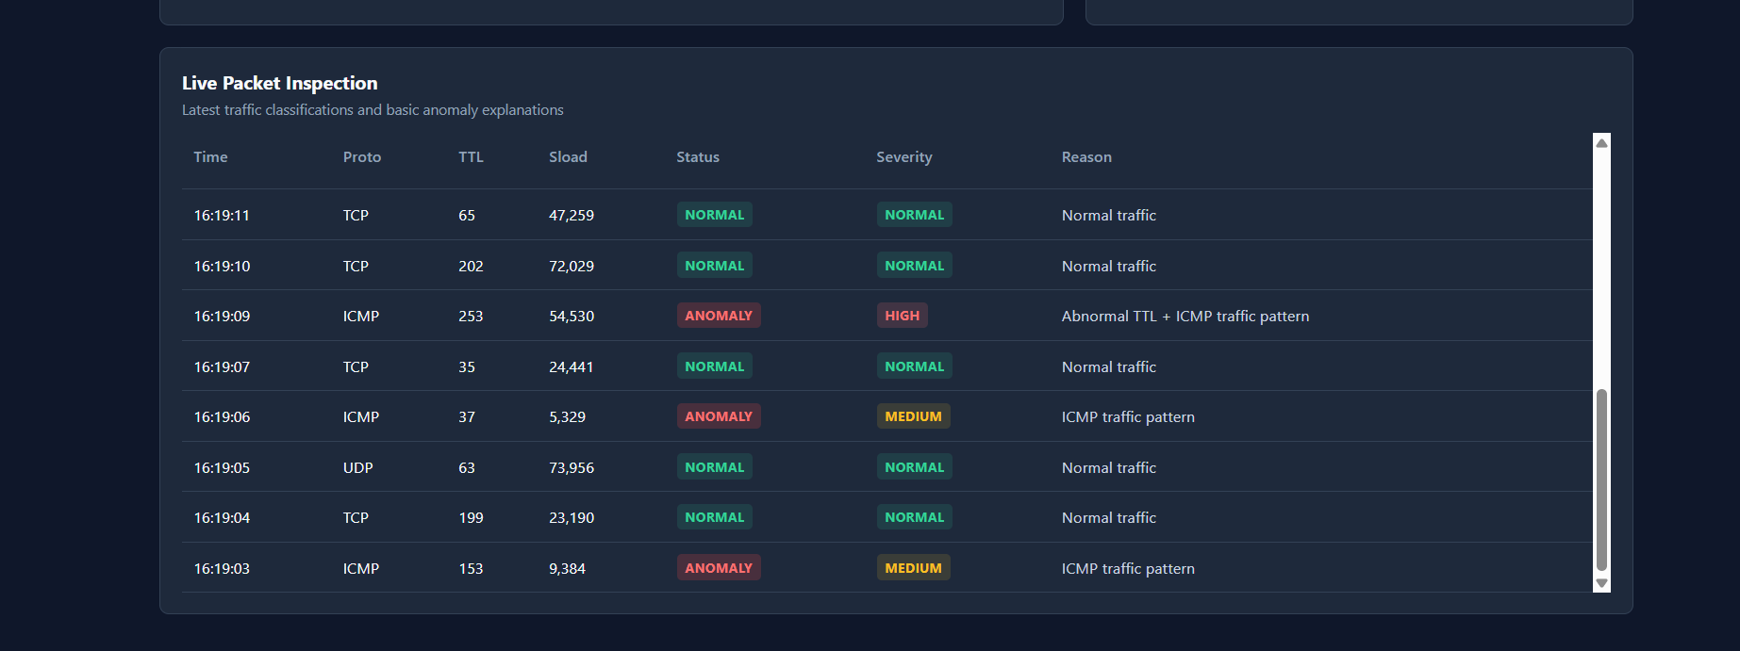
11. REAL-TIME TRAFFIC MONITORING
One of the main features of the system is real-time traffic simulation.
The backend sends traffic records through a WebSocket connection at regular intervals.
The frontend receives these records and updates the dashboard.
The simplified workflow is:
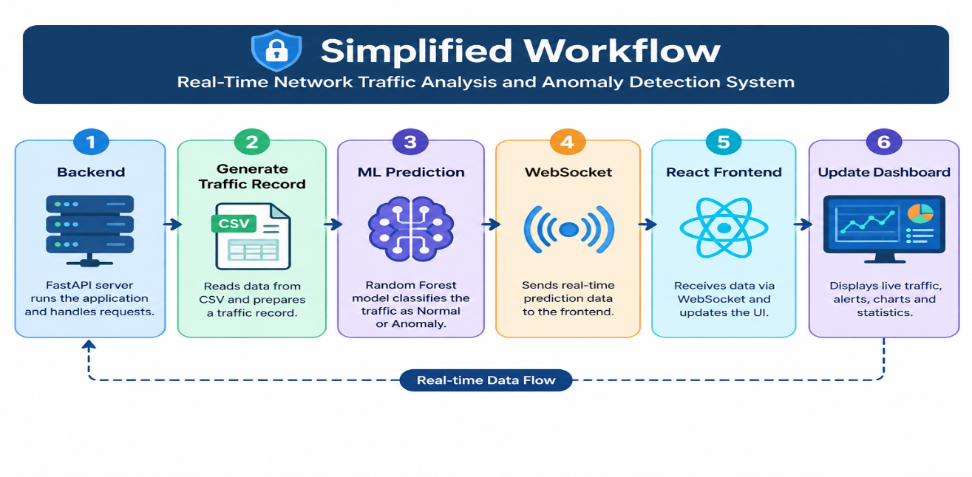
This allows the user to observe traffic records without manually refreshing the webpage.
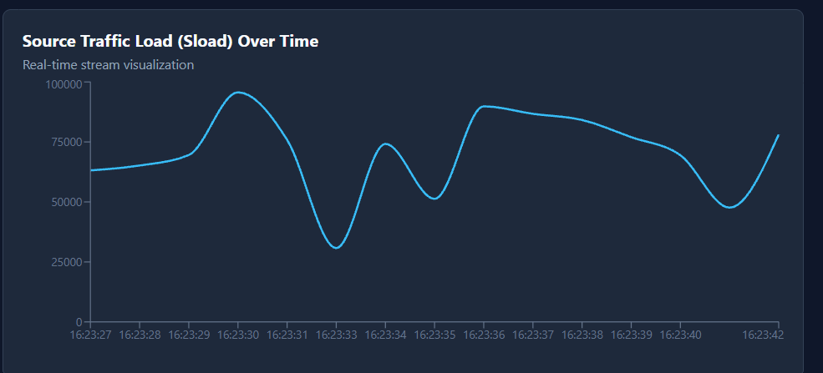
12. DASHBOARD FEATURES
12.1 Traffic Statistics
The dashboard provides summary information about the current traffic stream.
Important statistics include:
- Total traffic
- Normal traffic
- Anomalous traffic
- Threat rate
These statistics provide a quick overview of the current traffic condition.

12.2 Protocol Distribution
The dashboard displays the distribution of network protocols.
The system provides a visual representation of:
- TCP
- UDP
- ICMP
This makes it easier for the user to understand the composition of the observed traffic.
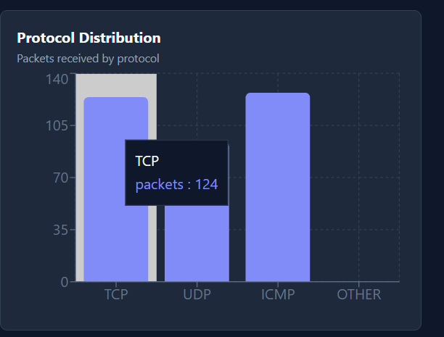
13. ANOMALY EXPLANATION AND SEVERITY
To make the dashboard easier to understand, the system provides basic information about detected anomalies.
When anomalous traffic is detected, the system can provide an explanation based on the traffic values.
For example, an anomaly may be associated with:
- High source load.
- High TTL value.
- Specific protocol value.
The system also provides a simple severity classification: NORMAL , MEDIUM , HIGH
This does not replace the Random Forest prediction. It is an additional presentation feature that helps users interpret the prediction.
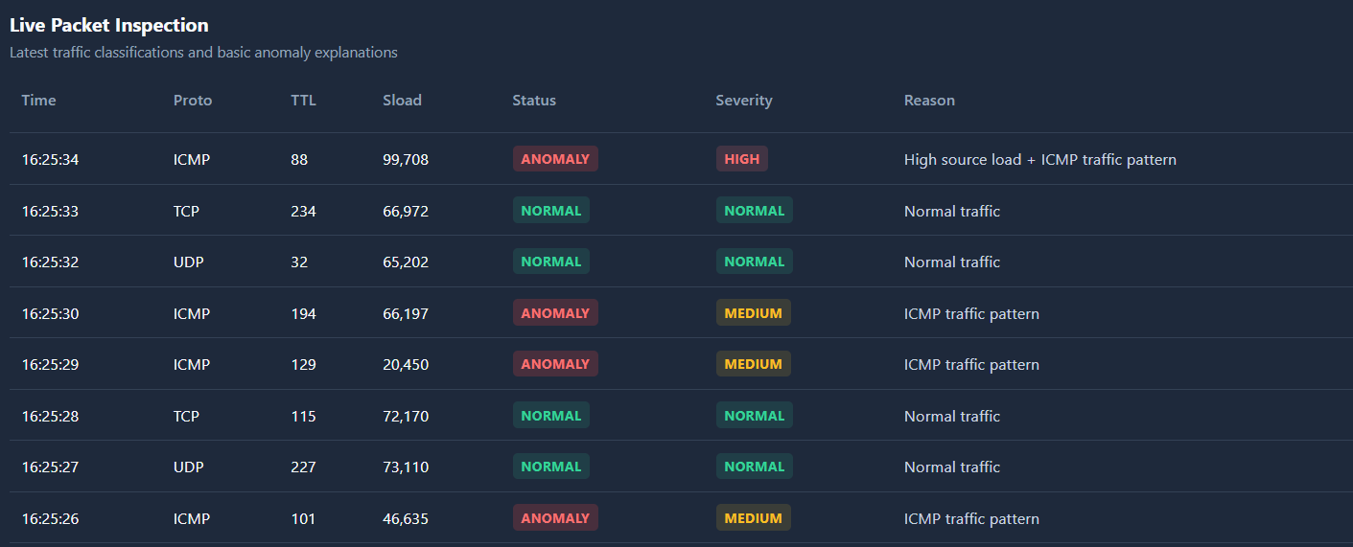
14. START AND PAUSE FUNCTIONALITY
The dashboard provides controls to manage the simulated traffic stream.
Start
The START button begins the continuous traffic stream.
Pause
The PAUSE button temporarily stops the stream.
This provides the user with basic control over the real-time simulation and makes it easier to examine individual traffic records.
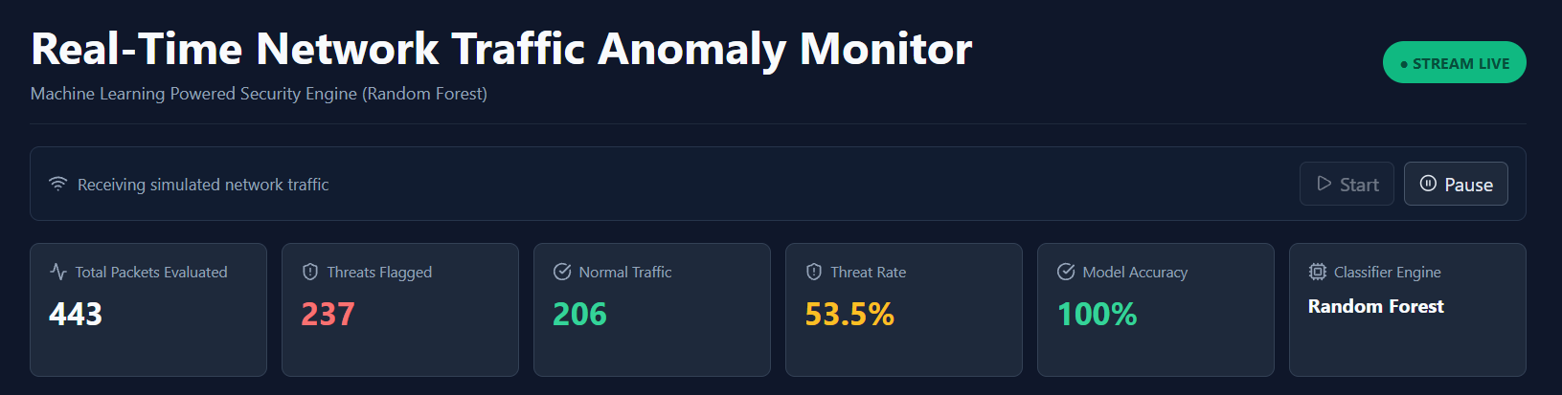
15. RESPONSIVE DESIGN
The frontend is designed to provide a usable interface across different screen sizes.
Responsive design allows the dashboard components to adjust according to the available screen width.
The frontend framework concepts used in the project include component-based UI development and responsive web design. The course material discusses responsive layouts and media-query breakpoints for adapting interfaces to different screen sizes.
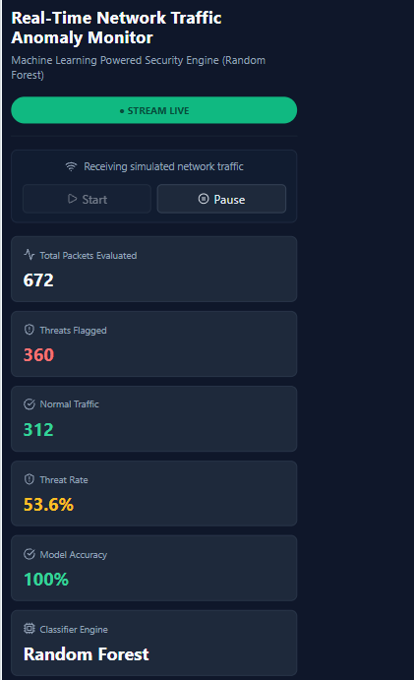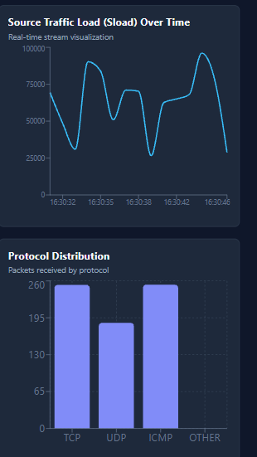
16. API AND BACKEND TESTING
The backend can be tested independently using the browser.
The metrics endpoint is: http://127.0.0.1:8000/api/metrics
It returns information about the trained model and its evaluation metrics.
The frontend communicates with the backend to obtain traffic information and display it to the user.
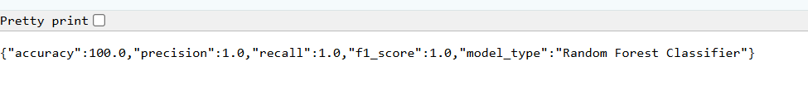
17. MODEL PERFORMANCE
The model is evaluated using standard classification metrics:
- Accuracy
- Precision
- Recall
- F1-score
These metrics provide different views of the classification performance.
For this academic implementation, the generated evaluation dataset produces very high performance because the synthetic labels are created using rules closely related to the selected features.
Therefore, the reported result should be described as:
“Model performance on the generated evaluation dataset.”
It should not be interpreted as real-world network intrusion detection accuracy.
18. RESULTS
The developed system successfully integrates the frontend, backend, machine learning model and real-time communication.
The final dashboard allows users to:
- Monitor simulated network traffic.
- View traffic statistics.
- Observe normal and anomalous traffic.
- View protocol distribution.
- Identify anomaly severity.
- Understand basic anomaly reasons.
- Start and pause the traffic stream.
- Observe traffic updates without manually refreshing the page.
The project demonstrates how a machine learning model can be integrated into a full-stack web application.
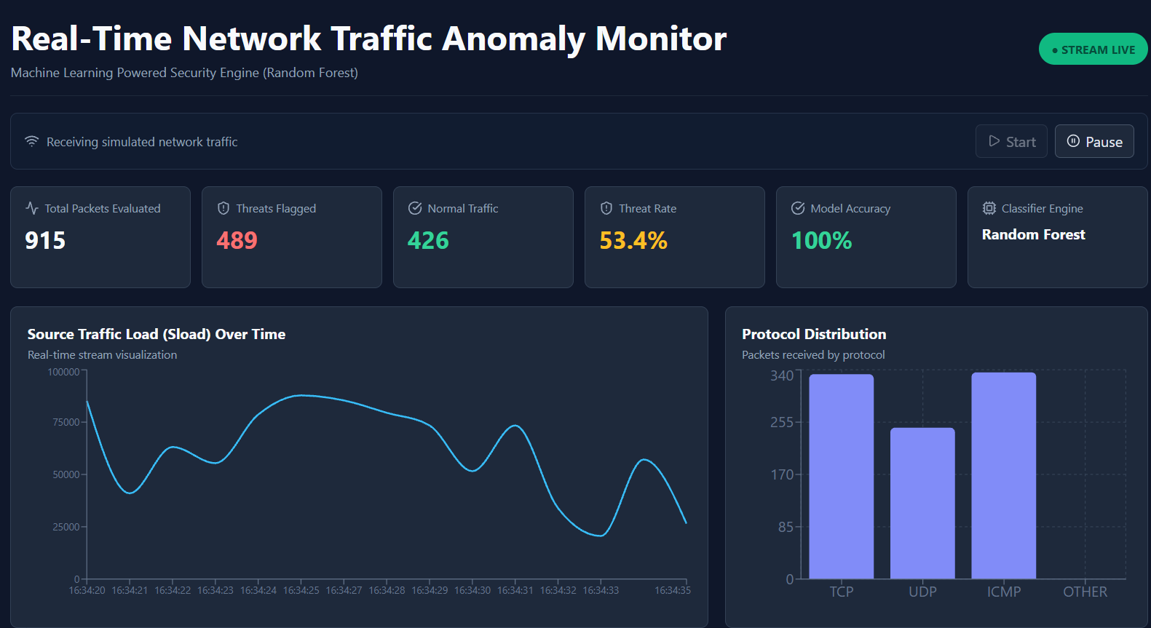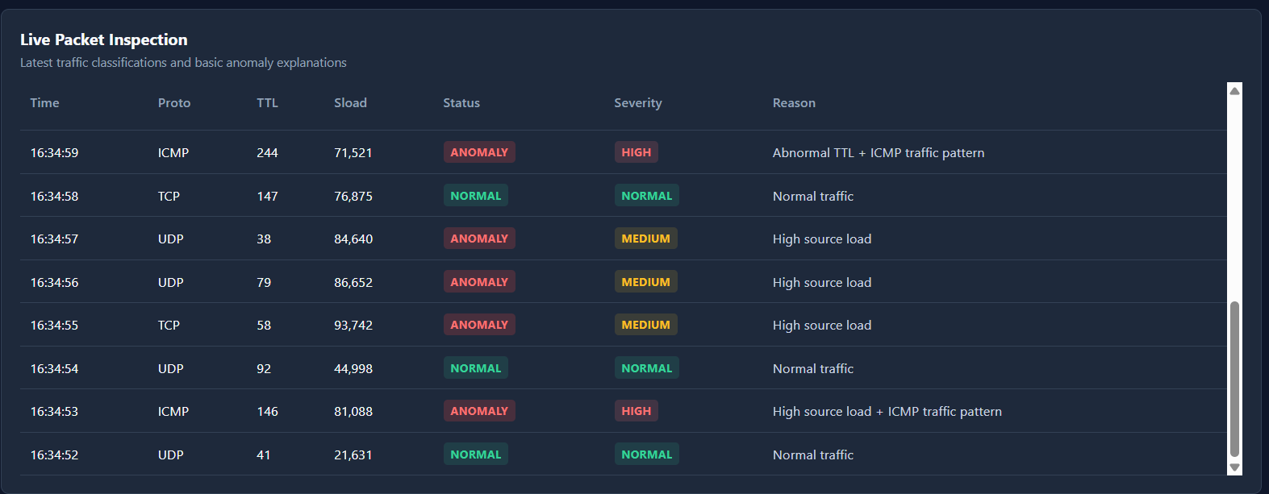
19. ADVANTAGES
The main advantages of the proposed system are:
- Simple and user-friendly interface
- Real-time traffic visualization
- Machine learning-based classification
- Interactive dashboard
- Protocol distribution visualization
- Basic anomaly explanation
- Severity indication
- Start/Pause traffic control
- Responsive frontend
- Clear separation between frontend and backend

20. LIMITATIONS
The current implementation has some limitations:
- The system uses simulated network traffic instead of capturing live packets from a physical network.
- The dataset is generated for academic demonstration.
- The machine learning model is relatively simple.
- The anomaly rules used for generating the synthetic labels may not represent all real-world network attacks.
- The system is not intended to replace a production-level intrusion detection system.
- No database is used in the current implementation.
- The system does not provide enterprise-level security monitoring or incident management.

21. FUTURE SCOPE
The project can be extended in the future by adding:
- Live network packet capture.
- Larger real-world datasets.
- More advanced machine learning algorithms.
- Database integration.
- User authentication.
- Historical traffic analysis.
- Advanced visualization.
- Alert and notification mechanisms.
- Deployment on a cloud platform.
- More detailed network security analysis.
These features are outside the scope of the current academic implementation but could be considered for future development.

22. CONCLUSION
The Real-Time Network Traffic Analysis and Anomaly Detection System successfully demonstrates the integration of full-stack web development and machine learning.
The system uses a React.js frontend, FastAPI backend, WebSocket communication, and a Random Forest Classifier to process and visualize simulated network traffic.
The dashboard provides useful information such as traffic statistics, protocol distribution, anomaly classification, anomaly reason, severity and real-time traffic updates.
The project provided practical experience in connecting frontend and backend components, designing APIs, handling real-time data, processing datasets, and integrating a machine learning model into a web application.
Overall, the project demonstrates how full-stack technologies can be used to create an interactive application for network traffic analysis while keeping the implementation suitable for an academic Full Stack Development project.

23. REFERENCES
- Anil Kumar Jakkani, “Real-Time Network Traffic Analysis and Anomaly Detection to Enhance Network Security and Performance: Machine Learning Approaches,” JECNAM, 2024.
- Course Material, Full Stack Development Basics, Nirma University.
- Course Material, Frontend Frameworks, Nirma University.
- React.js Documentation.
- FastAPI Documentation.
- Scikit-learn Documentation.
- Python Documentation.
- GitHub Link:

