EECS 578

Project Proposal

Uncertain Future Prediction

Motivational Background
Automative systems design a policy to steer the system in desired directions. In the paradigm of model-based control and reinforcement learning, the policy is often designed by predicting the future and adjusting the parameters to achieve better rewards or performance metric. When the dynamics of system is given in uncertain/stochastic form, this procedure involves computing distribution of future states which is analytically intractable for general nonlinear dynamical systems[]. Numerical approaches are therefore employed and simplest one would be doing a Monte Carlo(MC). However, MC is known to be inefficient, often requiring thousands or millions of particles to have good accuracy. Instead, moment matching based approaches that use finite number of particles to preserve moments of distribution have shown enormous success in predicting future states accurately.

Approach:

Suppose we have 1000 particles that represent the distribution of initial state X. Now we pass it through a stochastic nonlinear map F(x), for example, F(x) could be a Gaussian process that describes the dynamics of robot. Since F(x) depends on x, each particle in the distribution of X can lead to multiple possible particles. Suppose we were to map each particles to 10 particles, then that would lead to 10,000 particles representing F(X). When this procedure is repeated over multiple time steps, it leads to an explosion in the number of particles. Therefore, the 10,000 particles are compressed back to 1000 points based on moment matching principle. These 1000 points are selected so as to have the same mean, covariance, and higher order moments of distribution as the 10,000 points, This process makes the algorithm scalable. Fig. 1 illustrates the procedure.

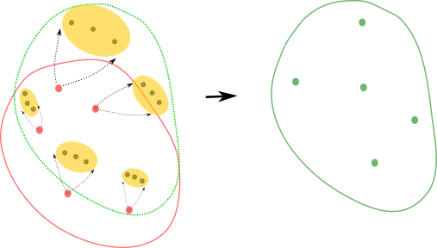

Fig. Each red point is mapped to three points that represent the future that they might lead to. Since the dynamics is state-dependent, the mapping is assymetric across different red points. The resulting 15 points are compressed back to 5 points based on moment matching thus ending one-step prediction. The procedure is repeated for multi-step ahead preediction.

Pseudo Algorithm

Scope of Parallelizing
- The expansion step can easily be parallelized as each particle is independently mapped to its future states.
- The compression step involves
I) First computing moments, upto some user given finite order, of 10,000 points: this operation requires several summation, multiplication operations that can be done in parallel.
II) Second computing 1,000 points that represent these moments. This operation, in some cases, is known to have analytical solutions, or might involve solving an optimization problem.

