Down load eclipse with Scela:

Open Eclipse

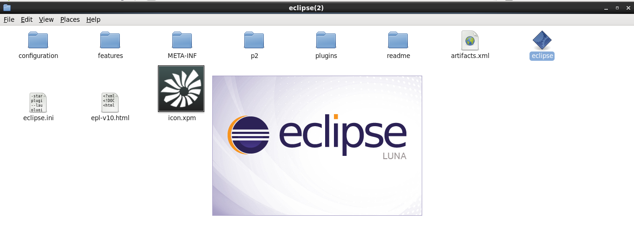

Create WorkSpace

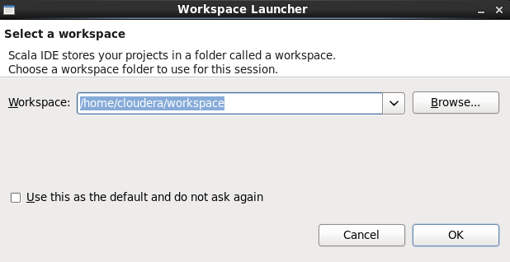

Create scela project

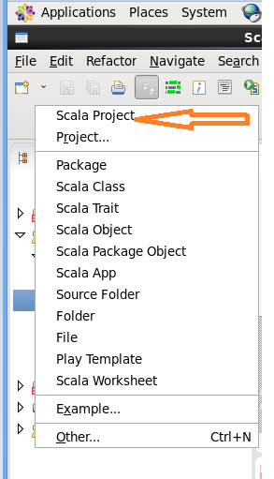

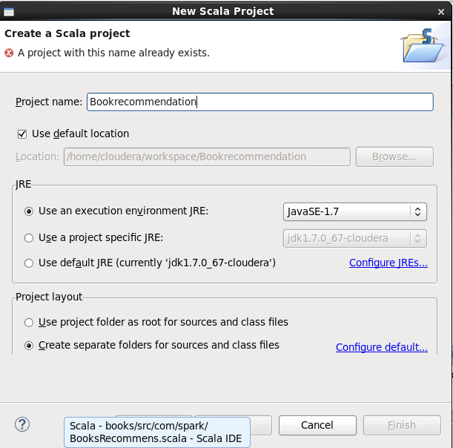

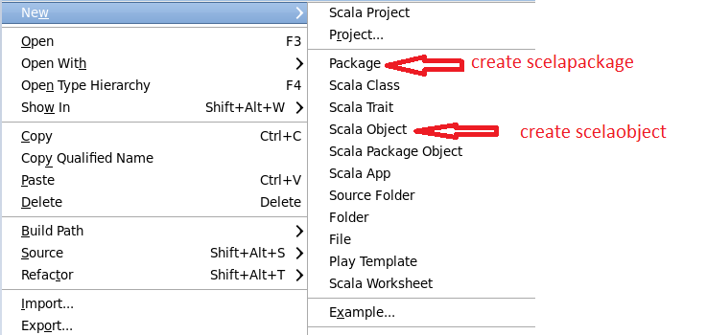

Add all related jar file

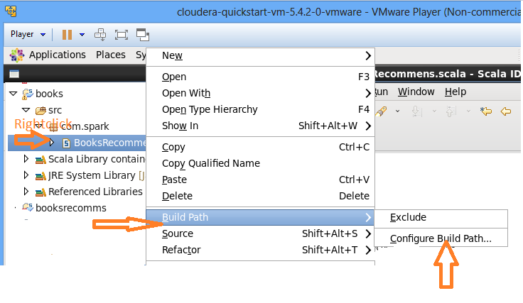

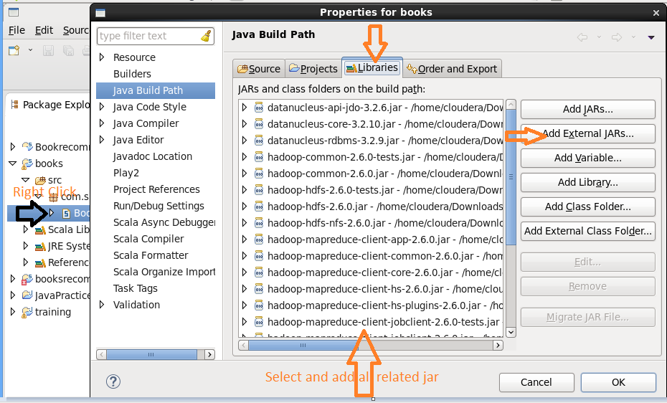

Add Scala code

**Book Recommendation Code here for user id 10, 25, 50, 100**

package com.spark

import org.apache.spark.SparkConf

import org.apache.spark.SparkContext

import org.apache.spark.mllib.recommendation.Rating

import org.apache.spark.mllib.recommendation.ALS

object BooksRecommens {

def main(args: Array[*String*])

{

val conf = new SparkConf().setMaster("local").setAppName("BookRecommendation")

val sc = new SparkContext(conf)

val ratingFile = sc.textFile("/home/cloudera/Desktop/BookRecomFiles/ratings.dat", 1)

val ratingData = ratingFile.map(_.split("::").take(3))

val ratings = ratingData.map {case Array(user,book,rating) => Rating (user.toInt,book.toInt,rating.toInt) }

val userIds = Array(10,25,50, 100)

val noOfRecommendations = 10

for ( i <- 0 to (userIds.length - 1)) {

val books = sc.textFile("/home/cloudera/Desktop/BookRecomFiles/book.dat", 1)

val booksMap = books.map(line => line.split("::").take(2)).map(array => (array(0).toInt,array(1))).collectAsMap()

val bookForUsers = ratings.keyBy(_.user).lookup(userIds(i))

val b1=bookForUsers.sortBy(-_.rating).take(10).map(rating => (booksMap(rating.product),rating.rating,userIds(i)))

sc.parallelize(b1.toSeq).map(x=>s"${x._1}:${x._2}:${x._3}").saveAsTextFile("/home/cloudera/Recommendations")

}

}

}

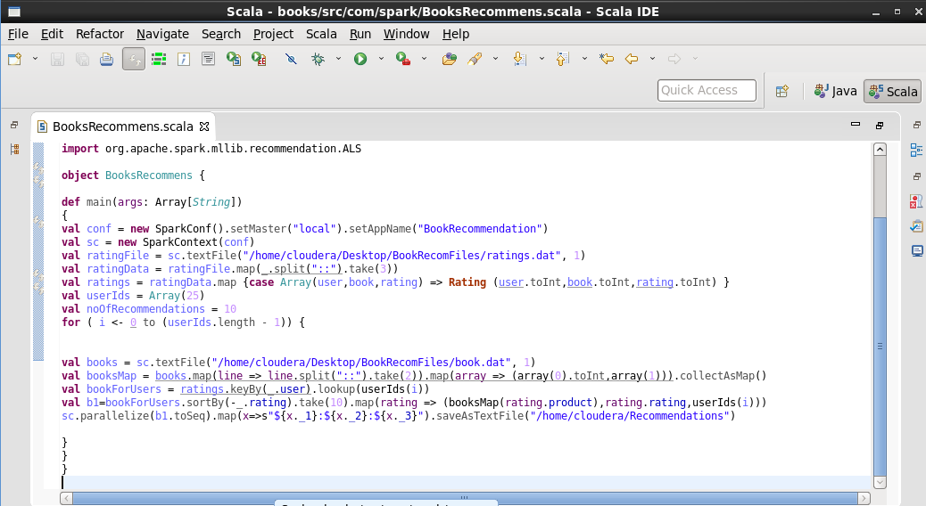

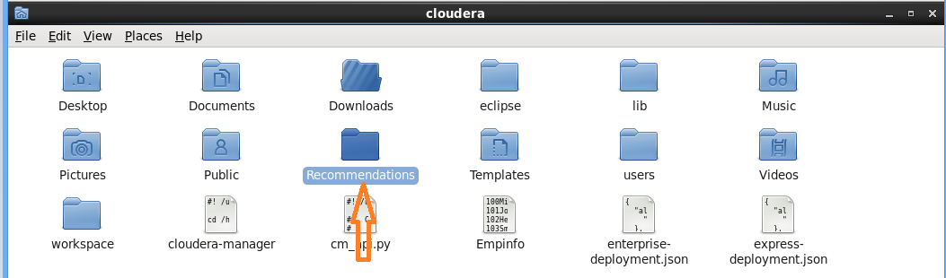

**Hadoop fs –put Recommendation/ /user/cloudera**

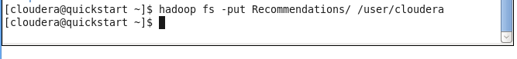

**Store file in hdfs**

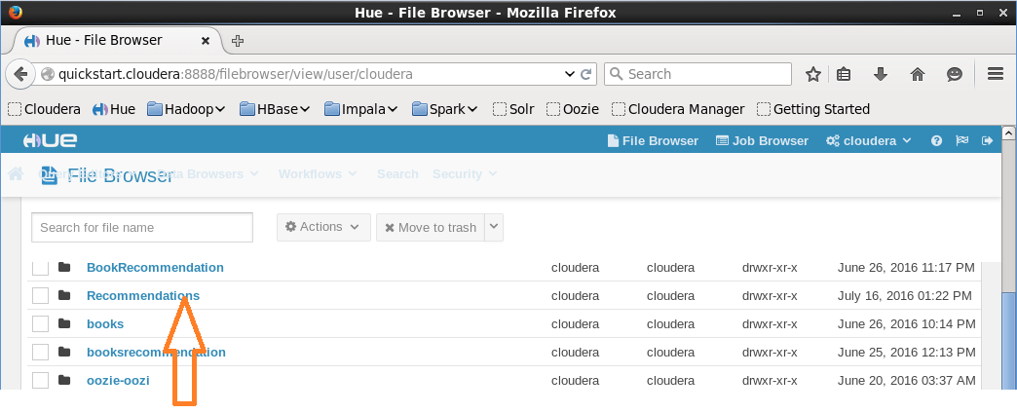

Open Spark-shell

**Cd /usr/lib/spark**

**Bin/spark-shell**

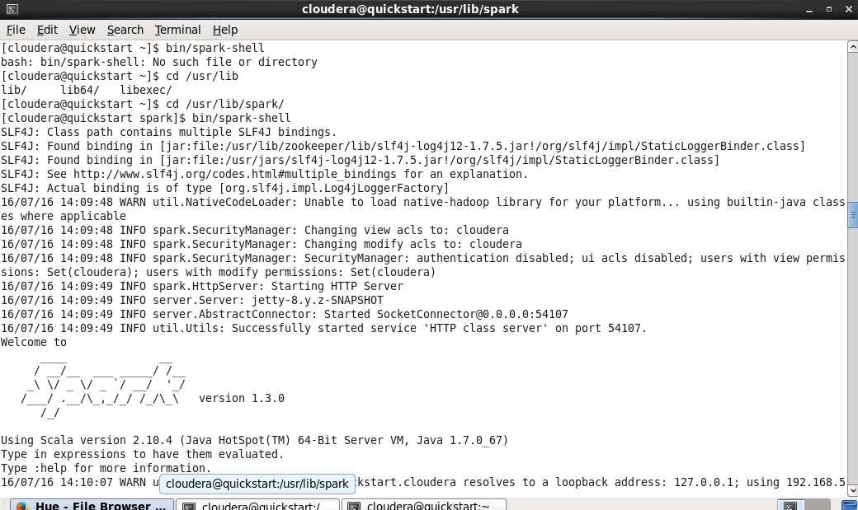

**val sqlContext = new org.apache.spark.sql.hive.HiveContext(sc)**



**sqlContext.sql("CREATE TABLE IF NOT EXISTS recommendations (bookname STRING,rating INT,userid INT) row format delimited fields terminated by ':' lines terminated by '\n' ")**

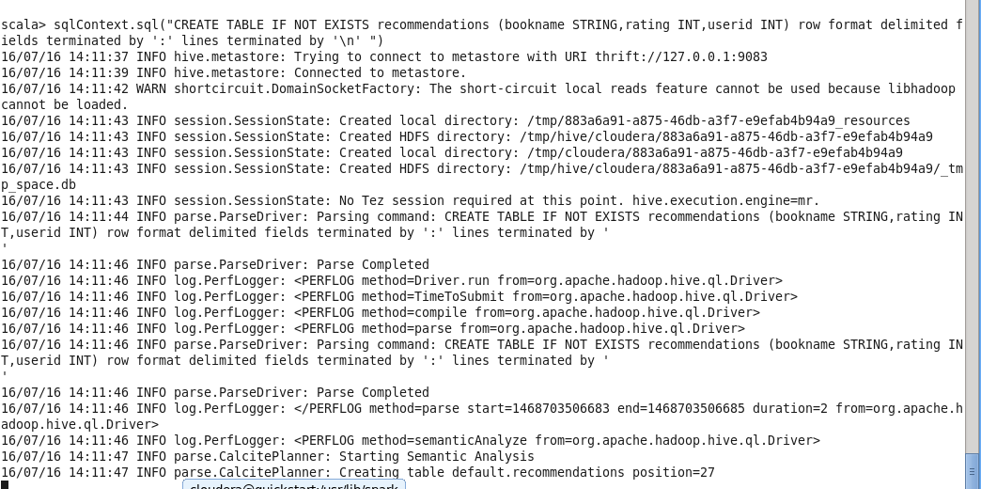

**sqlContext.sql("LOAD DATA INPATH '/user/cloudera/Recommendations' INTO TABLE recommendations")**

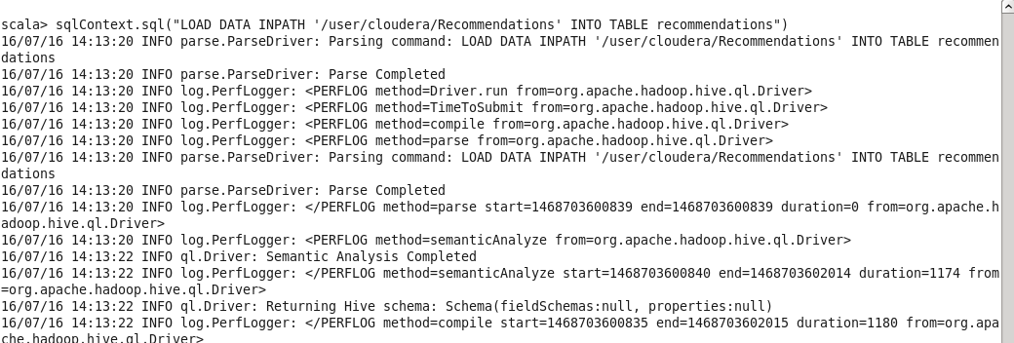

**sqlContext.sql("FROM recommendations SELECT *").collect().foreach(println)**

